Week 9 Applied Work: Class-Balancing Evaluation with SMOTE
Aryamann Zutshi
University of Kansas
EECS 692: Predicting Plastic Degradation Pathways with Machine Learning
Professor David Johnson
May 24, 2026

Introduction
The purpose of Week 9 was to respond directly to the class-imbalance problem identified in Weeks 5 and 6. The dataset contained 699 NRB samples and 356 RB samples, making RB the minority class. Because biodegradability prediction is useful only if RB compounds are detected reliably, minority-class performance became a central evaluation target.
The method was motivated by imbalanced-learning literature. Chawla et al. (2002) introduced SMOTE as a synthetic minority oversampling technique. Therefore, the Week 9 research question was whether applying balancing methods to the training data could improve class-level behavior without overstating performance.
Research question. Can balancing methods improve minority-class detection in the biodegradability dataset?
It was hypothesized that SMOTE would improve RB detection because the original dataset contained many more NRB samples than RB samples.

Methods and Materials
SMOTE was applied only to the training data so that synthetic samples did not leak into the test set. Models were then evaluated using class-level recall, accuracy, and comparison against baseline results.
This setup preserved the scientific validity of the evaluation. Balancing the training set can help the model learn the minority class, but the test set must remain realistic so that performance reflects actual deployment conditions.

Results
SMOTE improved several minority-class and model-level metrics. Logistic Regression RB recall increased from 0.7922 to 0.8568. FNN accuracy increased from 0.8588 to 0.8730. Random Forest RB recall increased from 0.7501 to 0.7837.
Appendix Figure A1 summarizes the effect of SMOTE on key metrics.
Table 1
Week 9 Class-Balancing Evaluation with SMOTE
Metric | Baseline | SMOTE | Effect
Logistic Regression RB recall | 0.7922 | 0.8568 | Improved minority detection.
FNN accuracy | 0.8588 | 0.8730 | Improved overall classification.
Random Forest RB recall | 0.7501 | 0.7837 | Improved minority detection.

Discussion
The Week 9 hypothesis was supported. SMOTE improved minority-class detection because it reduced the dominance of the majority NRB class during training. The logic behind the claim is that imbalanced training data can bias a classifier toward majority-class decision regions, while synthetic minority examples force the model to represent minority-class structure more explicitly.
This claim is backed by Chawla et al. (2002). The limitation is that SMOTE can also create synthetic points that do not correspond to real chemistry if used carelessly. Future work should compare SMOTE with class weighting and threshold tuning, and should always report confusion matrices and macro-F1 rather than accuracy alone.

References
Chawla, N. V., Bowyer, K. W., Hall, L. O., & Kegelmeyer, W. P. (2002). SMOTE: Synthetic minority over-sampling technique. Journal of Artificial Intelligence Research, 16, 321-357. https://doi.org/10.1613/jair.953
Mansouri, K., Ringsted, T., Ballabio, D., Todeschini, R., & Consonni, V. (2013). Quantitative structure-activity relationship models for ready biodegradability of chemicals. Journal of Chemical Information and Modeling, 53(4), 867-878. https://doi.org/10.1021/ci4000213

Appendix
Figure A1
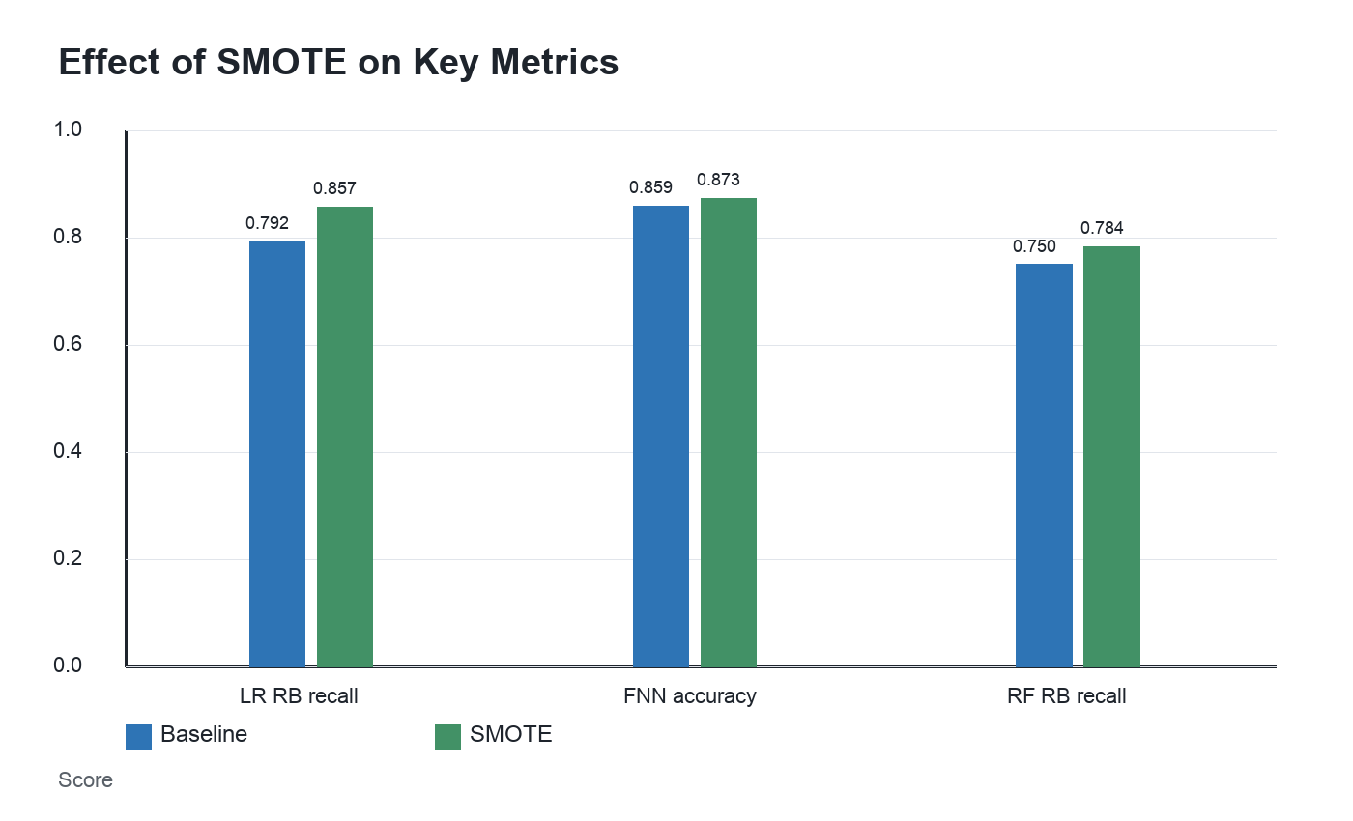
Figure A1. SMOTE improved minority-class detection in Week 9.

