Week 10 Applied Work: Chemistry-Aware Proxy Features for Biodegradability Modeling
Aryamann Zutshi
University of Kansas
EECS 692: Predicting Plastic Degradation Pathways with Machine Learning
Professor David Johnson
May 24, 2026

Introduction
The purpose of Week 10 was to improve the descriptor representation by adding chemistry-aware proxy features. Earlier weeks showed that model performance depended strongly on feature quality, so this week focused on whether targeted features could improve detection of biodegradability patterns.
The approach is consistent with QSAR/QSPR literature, where molecular descriptors are used to encode chemical properties relevant to prediction (Karelson et al., 1996; Mansouri et al., 2013). Therefore, the Week 10 research question was whether carefully designed proxy features could improve model behavior when combined with balancing methods.
Research question. Do chemistry-aware proxy features improve model performance beyond the original descriptor set?
It was hypothesized that proxy features tied to chemical intuition would improve classification because they summarize degradation-relevant molecular patterns.

Methods and Materials
The analysis added proxy descriptors intended to represent degradation-relevant chemical structure. These features were evaluated with SMOTE and compared against earlier performance. The goal was not to claim that proxy features replace measured chemistry, but to test whether they provide useful summary signals.
Performance was evaluated using recall and F1 score because these metrics capture class-level behavior more effectively than accuracy alone in an imbalanced dataset.

Results
The chemistry-aware proxy features improved FNN performance. Recall increased from 0.8145 to 0.8399, and F1 score increased from 0.8126 to 0.8204 after proxy features were added.
Appendix Figure A1 summarizes the Week 10 proxy-feature impact.
Table 1
Week 10 Chemistry-Aware Proxy Features for Biodegradability Modeling
Metric | Before proxy features | After proxy features | Interpretation
Recall | 0.8145 | 0.8399 | Improved class detection.
F1 score | 0.8126 | 0.8204 | Improved balance between precision and recall.

Discussion
The Week 10 hypothesis was supported. Proxy features improved performance because they compressed chemically meaningful information into forms the model could use more easily. The logic is that descriptors related to polarity, functional groups, or degradation-prone structure may help distinguish compounds with different biodegradation behavior.
Karelson et al. (1996) supports the general use of quantum-chemical and molecular descriptors in QSAR/QSPR, while Mansouri et al. (2013) supports descriptor-based modeling for ready biodegradability. The limitation is that proxy features are approximations. They should supplement, not replace, measured or chemically validated descriptors.

References
Karelson, M., Lobanov, V. S., & Katritzky, A. R. (1996). Quantum-chemical descriptors in QSAR/QSPR studies. Chemical Reviews, 96(3), 1027-1044. https://doi.org/10.1021/cr950202r
Mansouri, K., Ringsted, T., Ballabio, D., Todeschini, R., & Consonni, V. (2013). Quantitative structure-activity relationship models for ready biodegradability of chemicals. Journal of Chemical Information and Modeling, 53(4), 867-878. https://doi.org/10.1021/ci4000213

Appendix
Figure A1
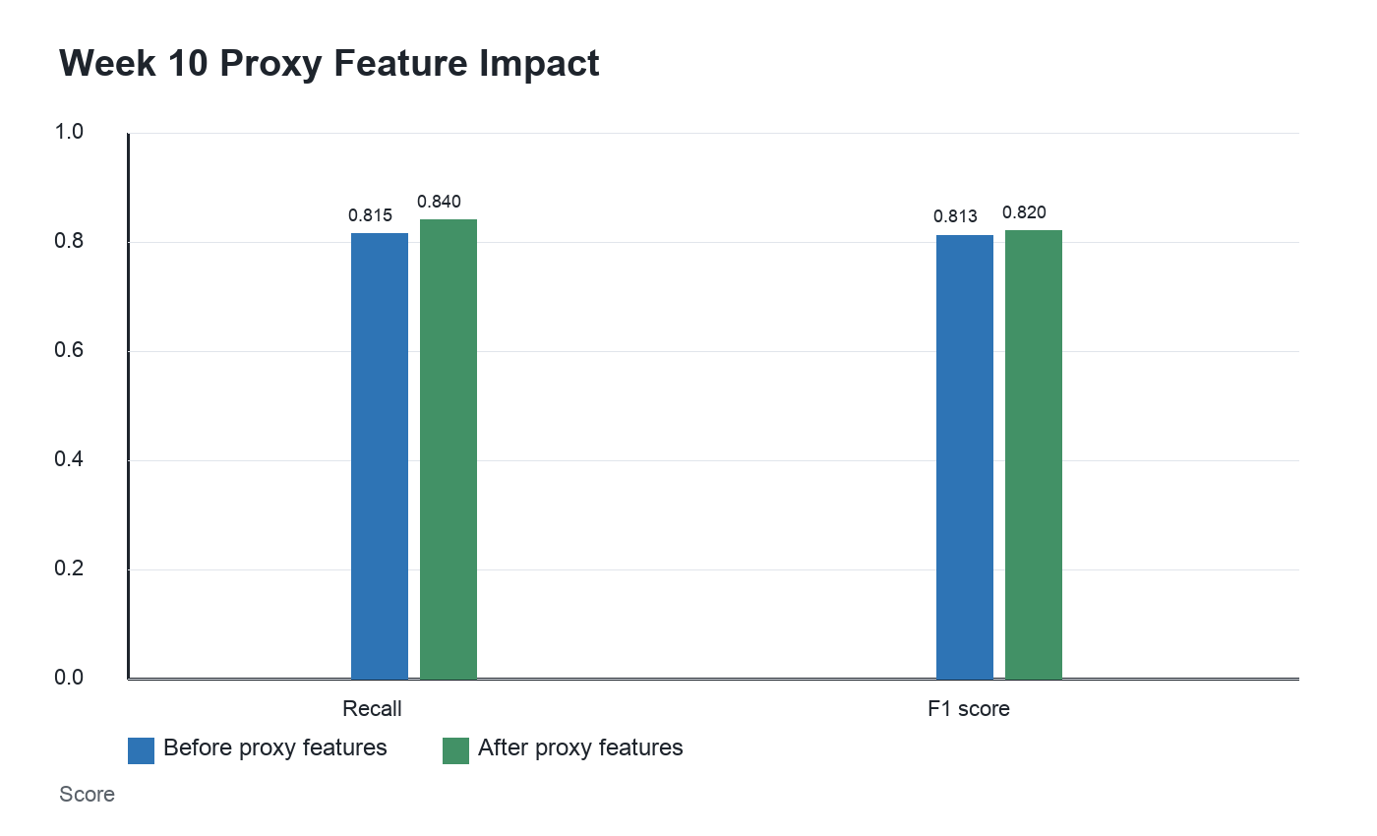
Figure A1. FNN gains from chemistry-aware proxy features with SMOTE.

