Week 11 Applied Work: Feature-Set Reduction and Descriptor Interpretability
Aryamann Zutshi
University of Kansas
EECS 692: Predicting Plastic Degradation Pathways with Machine Learning
Professor David Johnson
May 24, 2026

Introduction
The purpose of Week 11 was to test whether all available descriptors were necessary. Earlier weeks showed that performance could improve through feature engineering, but a larger feature set is not automatically better. Too many features can increase noise, reduce interpretability, and obscure chemical meaning.
Feature selection is a long-standing issue in QSAR modeling. Ponzoni et al. (2017) showed that hybrid feature-selection and feature-learning approaches can improve QSAR modeling. Therefore, the Week 11 research question was whether reduced descriptor sets could preserve performance while making the final model easier to defend scientifically.
Research question. Can reduced descriptor sets preserve performance while improving interpretability?
It was hypothesized that a reduced feature set could retain most predictive performance while improving interpretability and reducing noise.

Methods and Materials
Three feature sets were compared: full enhanced, reduced hybrid, and top ranked. Each feature set was evaluated using accuracy, ROC-AUC, and RB recall. The comparison focused on whether smaller feature sets retained enough performance to justify their use.
The reduced sets were interpreted as scientific filters rather than purely statistical compression. The purpose was to identify descriptor groups that carry meaningful predictive signal.

Results
The full enhanced feature set achieved accuracy of 0.8739, ROC-AUC of 0.9367, and RB recall of 0.7837. The reduced hybrid set achieved accuracy of 0.8597, ROC-AUC of 0.9190, and RB recall of 0.8063. The top ranked set achieved accuracy of 0.8673, ROC-AUC of 0.9264, and RB recall of 0.7978.
Appendix Figure A1 compares the feature sets. The reduced sets preserved much of the full-model performance while improving interpretability.
Table 1
Week 11 Feature-Set Reduction and Descriptor Interpretability
Feature set | Accuracy | ROC-AUC | RB recall
Full enhanced | 0.8739 | 0.9367 | 0.7837
Reduced hybrid | 0.8597 | 0.9190 | 0.8063
Top ranked | 0.8673 | 0.9264 | 0.7978

Discussion
The Week 11 hypothesis was supported. Reduced descriptor sets retained most of the predictive performance and sometimes improved RB recall. The logic is that removing noisy or redundant descriptors can make the model focus on stronger chemical signals.
This interpretation follows Ponzoni et al. (2017), who show that feature selection can strengthen QSAR modeling. The limitation is that feature reduction should not be interpreted as proof that omitted descriptors are chemically irrelevant. It only means they were less useful in the current dataset and modeling setup. Future work should connect selected descriptors back to chemical mechanisms and applicability-domain analysis.

References
Ponzoni, I., Sebastian-Perez, V., Requena-Triguero, C., Roca, C., Martinez, M. J., Cravero, F., Diaz, M. F., Paez, J. A., Gomez Arrayas, R., Adrio, J., & Campillo, N. E. (2017). Hybridizing feature selection and feature learning approaches in QSAR modeling for drug discovery. Scientific Reports, 7, 2403. https://doi.org/10.1038/s41598-017-02114-3
Mansouri, K., Ringsted, T., Ballabio, D., Todeschini, R., & Consonni, V. (2013). Quantitative structure-activity relationship models for ready biodegradability of chemicals. Journal of Chemical Information and Modeling, 53(4), 867-878. https://doi.org/10.1021/ci4000213

Appendix
Figure A1
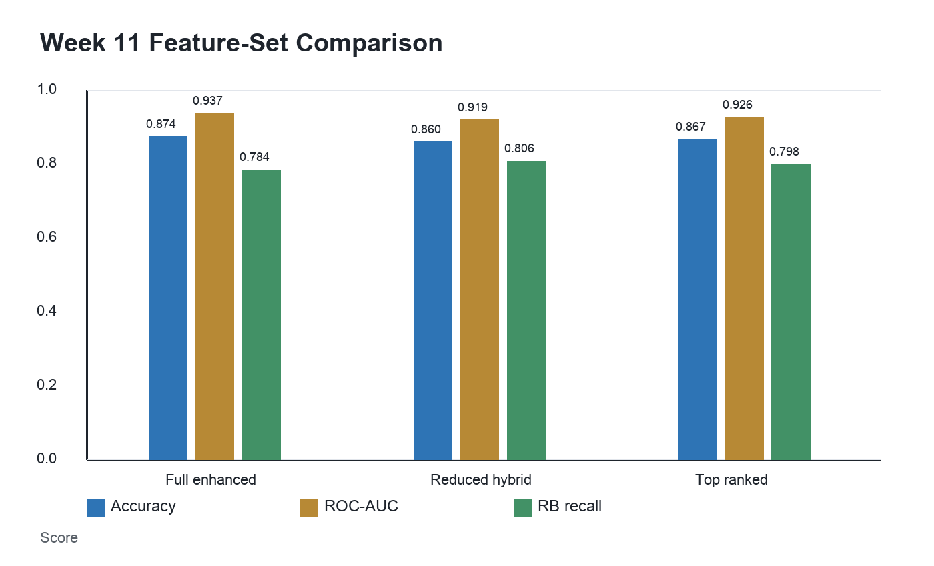
Figure A1. Reduced descriptor sets preserved much of the full-model performance.

