Week 12 Applied Work: Calibration and Uncertainty Under Distribution Shift
Aryamann Zutshi
University of Kansas
EECS 692: Predicting Plastic Degradation Pathways with Machine Learning
Professor David Johnson
May 24, 2026

Introduction
The purpose of Week 12 was to evaluate model reliability rather than only model accuracy. Earlier weeks showed that performance could be improved, but a model used for scientific decision-making also needs to communicate when it may be wrong.
Uncertainty quantification is important in molecular property prediction because model confidence can be misleading when chemical space shifts. Hirschfeld et al. (2020) discuss uncertainty quantification for molecular property prediction using neural networks. Therefore, the Week 12 research question was whether uncertainty and calibration metrics could identify trustworthy and untrustworthy predictions.
Research question. Do confidence and uncertainty estimates identify when biodegradability predictions are less trustworthy?
It was hypothesized that uncertainty would help identify failure cases in ordinary validation, but might become less reliable under distribution shift.

Methods and Materials
The analysis evaluated Brier score, log loss, expected calibration error, uncertainty separation between correct and incorrect predictions, selective prediction accuracy, and cross-environment accuracy. Feature sets included full enhanced, top ranked, reduced hybrid, and proxy only.
The cross-environment analysis tested whether confidence remained informative when the data distribution changed. This was important because ordinary validation can overstate reliability.

Results
Under standard validation, the full enhanced feature set achieved accuracy of 0.8711, ROC-AUC of 0.9335, and Brier score of 0.0950. The top ranked feature set produced strong calibration, with Brier score of 0.1003, log loss of 0.3312, and expected calibration error of 0.0297. For the full enhanced set, mean uncertainty was 0.1453 for correct predictions and 0.3180 for incorrect predictions.
Under cross-environment testing, performance dropped substantially. Top ranked achieved cross-environment accuracy of 0.5848, full enhanced achieved 0.4436, and proxy only achieved 0.2493. Appendix Figure A1 summarizes the reliability signals.
Table 1
Week 12 Calibration and Uncertainty Under Distribution Shift
Feature set | Brier score | Cross-environment accuracy | Interpretation
Top ranked | 0.0950 | 0.5848 | Best balance in the plotted reliability summary.
Reduced hybrid | 0.1048 | 0.4436 | Moderate reliability.
Proxy only | 0.1236 | 0.2493 | Weak transfer and overconfidence risk.

Discussion
The Week 12 hypothesis was supported. Uncertainty helped distinguish correct from incorrect predictions in ordinary validation, but confidence became less reliable under distribution shift. The logic is that a model can be well calibrated inside its training-like domain while still becoming overconfident outside that domain.
This claim is supported by Hirschfeld et al. (2020), who frame uncertainty as a key issue in molecular property prediction, and by Vaicenavicius et al. (2019), who discuss calibration evaluation in classification. The limitation is that calibration analysis identifies reliability problems but does not automatically solve them. Future work should test calibration correction, applicability-domain methods, and confident-failure analysis.

References
Hirschfeld, L., Swanson, K., Yang, K., Barzilay, R., & Coley, C. W. (2020). Uncertainty quantification using neural networks for molecular property prediction. Journal of Chemical Information and Modeling, 60(8), 3770-3780. https://doi.org/10.1021/acs.jcim.0c00502
Vaicenavicius, J., Widmann, D., Andersson, C., Lindsten, F., Roll, J., & Schon, T. B. (2019). Evaluating model calibration in classification. Proceedings of Machine Learning Research, 89, 3459-3467.

Appendix
Figure A1
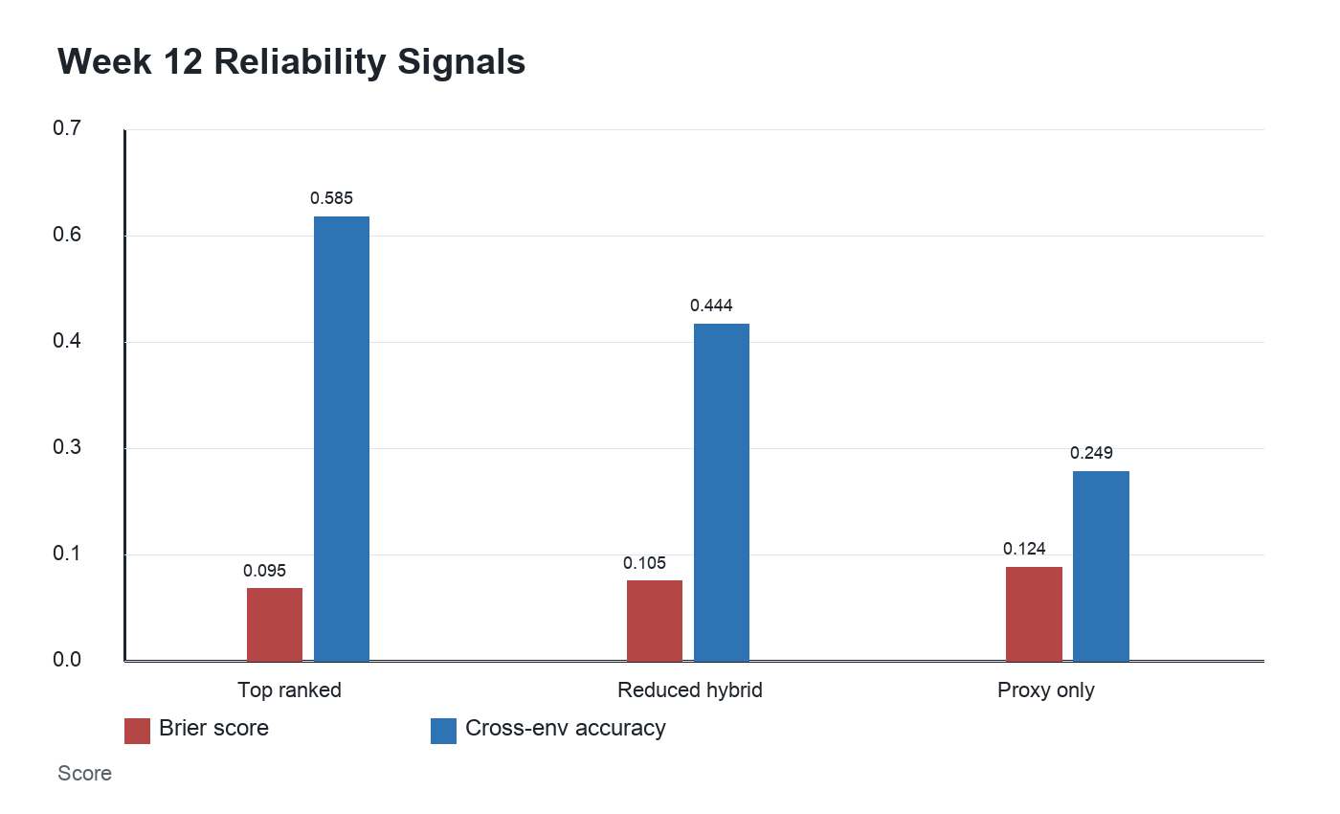
Figure A1. Calibration and cross-environment reliability differed across feature sets.

