Week 13 Applied Work: Final Model Selection Through Reliability Analysis
Aryamann Zutshi
University of Kansas
EECS 692: Predicting Plastic Degradation Pathways with Machine Learning
Professor David Johnson
May 24, 2026

Introduction
The purpose of Week 13 was to make a final model decision. Earlier weeks showed that predictive performance, class balance, feature selection, calibration, and uncertainty all matter. The final decision therefore needed to weigh reliability rather than a single metric.
The final model decision combines QSAR feature-selection reasoning with model calibration evaluation. Ponzoni et al. (2017) supports the importance of feature selection in QSAR modeling, while Vaicenavicius et al. (2019) supports calibration evaluation as part of classifier assessment. Therefore, the Week 13 research question was which model is most trustworthy as the final project result.
Research question. Which final model should be selected when accuracy, calibration, uncertainty, and transfer behavior are all considered?
It was hypothesized that the best final model would not necessarily be the highest-accuracy model, but the model with the strongest overall reliability profile.

Methods and Materials
Three model families were compared: Logistic Regression, Random Forest, and feedforward neural network. Feature sets included full enhanced, top ranked, reduced hybrid, and proxy only. The evaluation combined cross-validated accuracy, Brier score, selective prediction accuracy, cross-environment accuracy, and confidence on incorrect predictions.
These metrics were combined conceptually into a reliability score. The goal was to choose a model that balanced performance, calibration, uncertainty behavior, and transfer stability.

Results
The Random Forest model trained on the top ranked feature set achieved the highest reliability score of 0.8860. It reached cross-validated accuracy of 0.8626, Brier score of 0.1003, selective prediction accuracy of 0.8030, and cross-environment accuracy of 0.5848. The FNN achieved a reliability score of 0.8447, while Logistic Regression achieved 0.7971.
Appendix Figure A1 summarizes the final reliability comparison. The Random Forest was selected because it provided the strongest overall reliability profile rather than the strongest isolated metric.
Table 1
Week 13 Final Model Selection Through Reliability Analysis
Model | Reliability score | Key interpretation
Random Forest | 0.8860 | Best overall reliability.
FNN | 0.8447 | Strong high-confidence behavior but less stable overall.
Logistic Regression | 0.7971 | Useful baseline but more calibration concern.

Discussion
The Week 13 hypothesis was supported. The final model decision could not be made from accuracy alone. Random Forest with the top ranked feature set was selected because it balanced accuracy, calibration, uncertainty behavior, and transfer performance more effectively than the alternatives.
The logic behind the claim is that scientific prediction requires trustworthiness. A model that is slightly accurate but poorly calibrated or overconfident is less defensible than a model with balanced reliability. This conclusion is supported by Ponzoni et al. (2017) for feature selection and Vaicenavicius et al. (2019) for calibration evaluation. The main limitation is that reliability was measured within the available dataset; external validation on independent polymer degradation data remains the most important next step.

References
Ponzoni, I., Sebastian-Perez, V., Requena-Triguero, C., Roca, C., Martinez, M. J., Cravero, F., Diaz, M. F., Paez, J. A., Gomez Arrayas, R., Adrio, J., & Campillo, N. E. (2017). Hybridizing feature selection and feature learning approaches in QSAR modeling for drug discovery. Scientific Reports, 7, 2403. https://doi.org/10.1038/s41598-017-02114-3
Vaicenavicius, J., Widmann, D., Andersson, C., Lindsten, F., Roll, J., & Schon, T. B. (2019). Evaluating model calibration in classification. Proceedings of Machine Learning Research, 89, 3459-3467.

Appendix
Figure A1
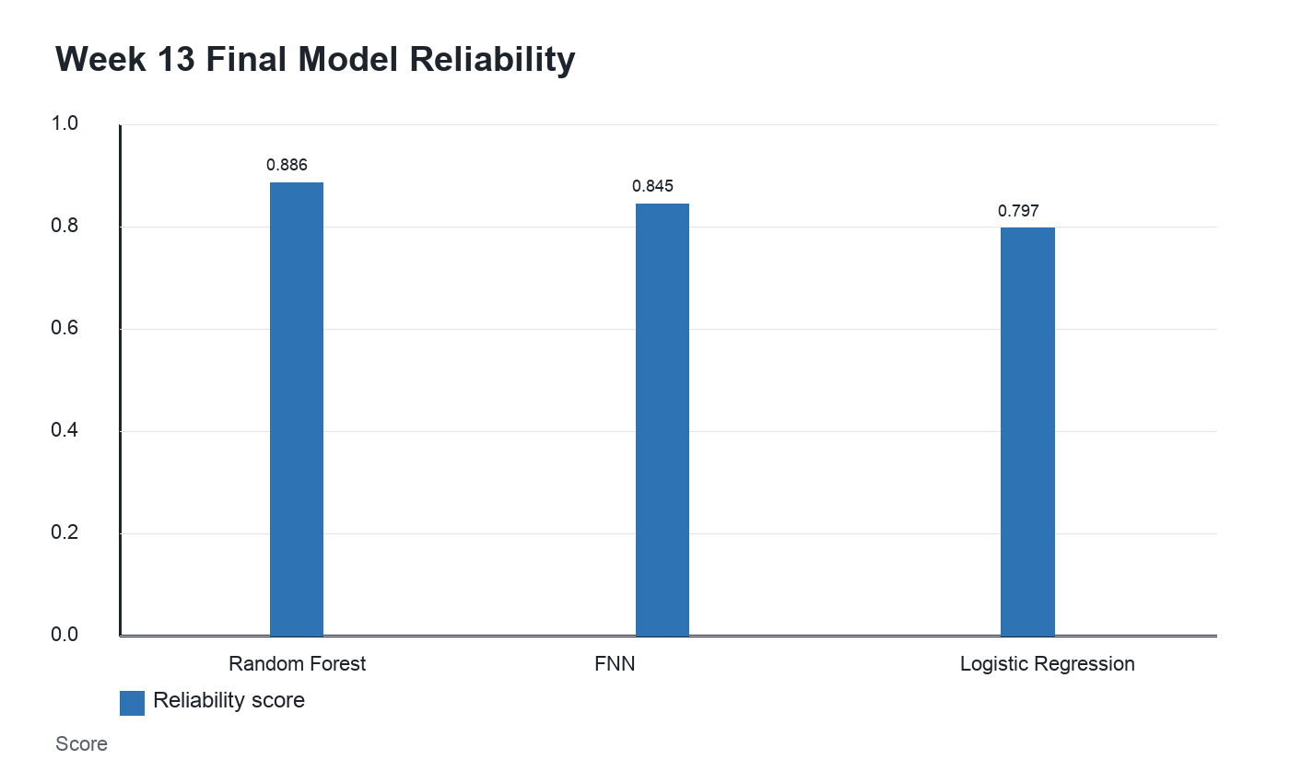
Figure A1. Final reliability score supported Random Forest with top-ranked features.

