Weather Client Testing

unixs.cis.pitt.edu virtual machine

Test: US city

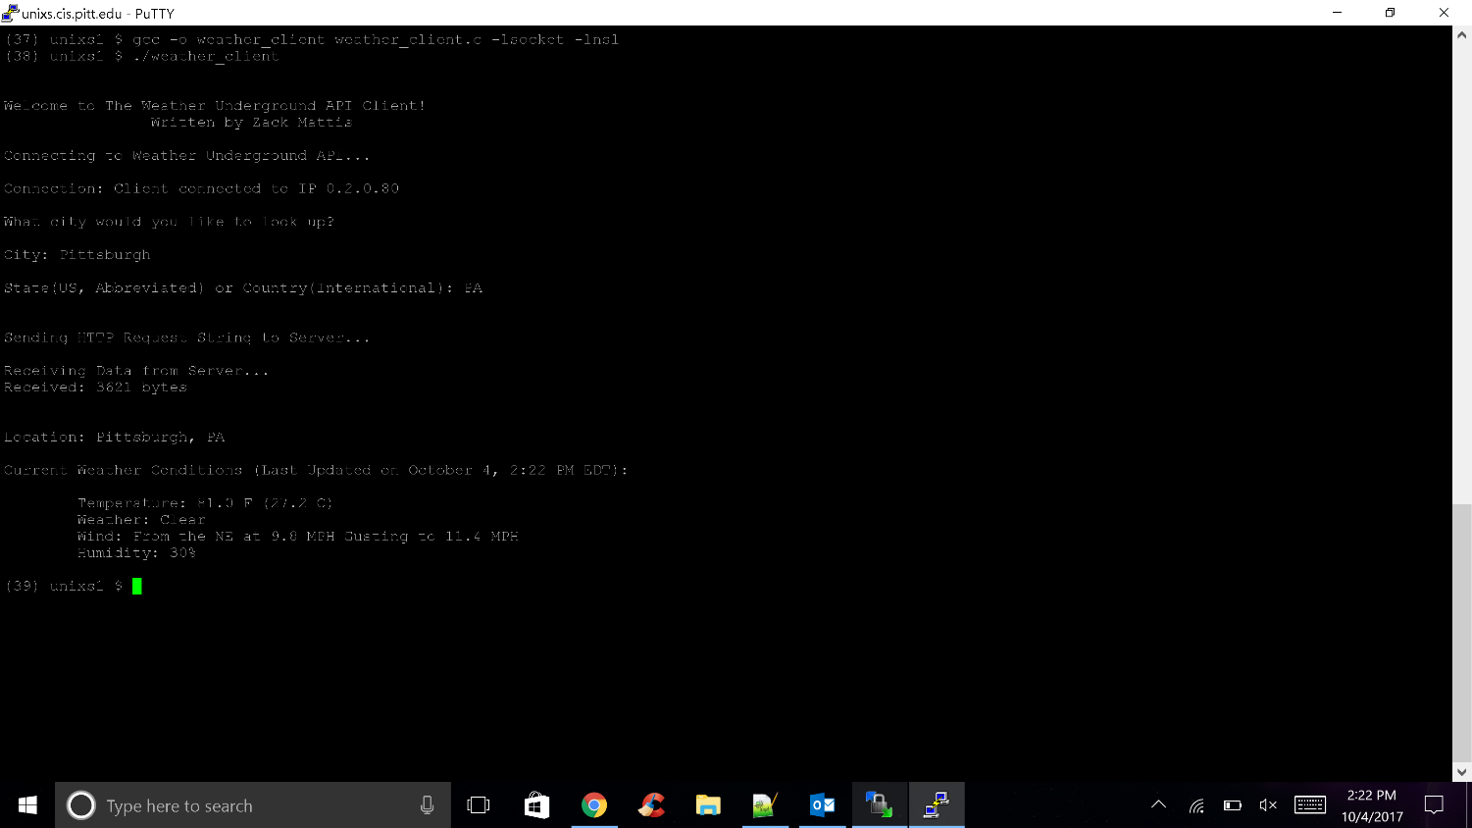

(7) unixs1 $ gcc -o weather_client weather_client.c -lsocket -lnsl

(8) unixs1 $ ./weather_client

Welcome to The Weather Underground API Client!

Written by Zack Mattis

Connecting to Weather Underground API...

Connection: Client connected to IP 0.2.0.80

What city would you like to look up?

City: Pittsburgh

State(US, Abbreviated) or Country(International): PA

Sending HTTP Request String to Server...

Receiving Data from Server...

Received: 3623 bytes

Location: Pittsburgh, PA

Current Weather Conditions (Last Updated on October 4, 2:34 PM EDT):

Temperature: 81.0 F (27.2 C)

Weather: Clear

Wind: From the East at 9.2 MPH Gusting to 9.2 MPH

Humidity: 31%

Test: International city

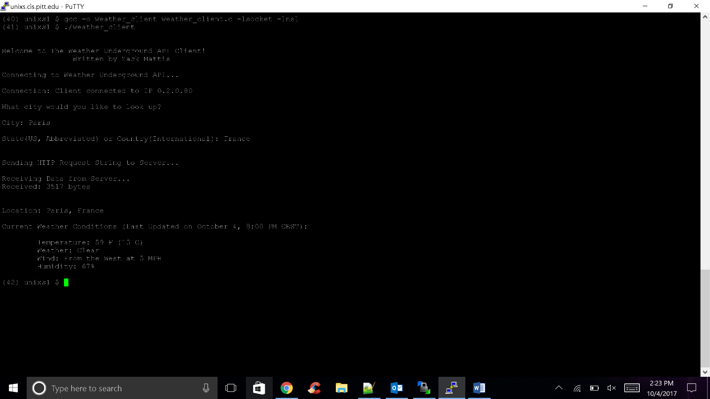

(32) unixs1 $ gcc -o weather_client weather_client.c -lsocket -lnsl

(33) unixs1 $ ./weather_client

Welcome to The Weather Underground API Client!

Written by Zack Mattis

Connecting to Weather Underground API...

Connection: Client connected to IP 0.2.0.80

What city would you like to look up?

City: Paris

State(US, Abbreviated) or Country(International): France

Sending HTTP Request String to Server...

Receiving Data from Server...

Received: 3515 bytes

Location: Paris, France

Current Weather Conditions (Last Updated on October 4, 8:30 PM CEST):

Temperature: 57 F (14 C)

Weather: Clear

Wind: From the WSW at 4 MPH

Humidity: 72%

Test: Invalid user input

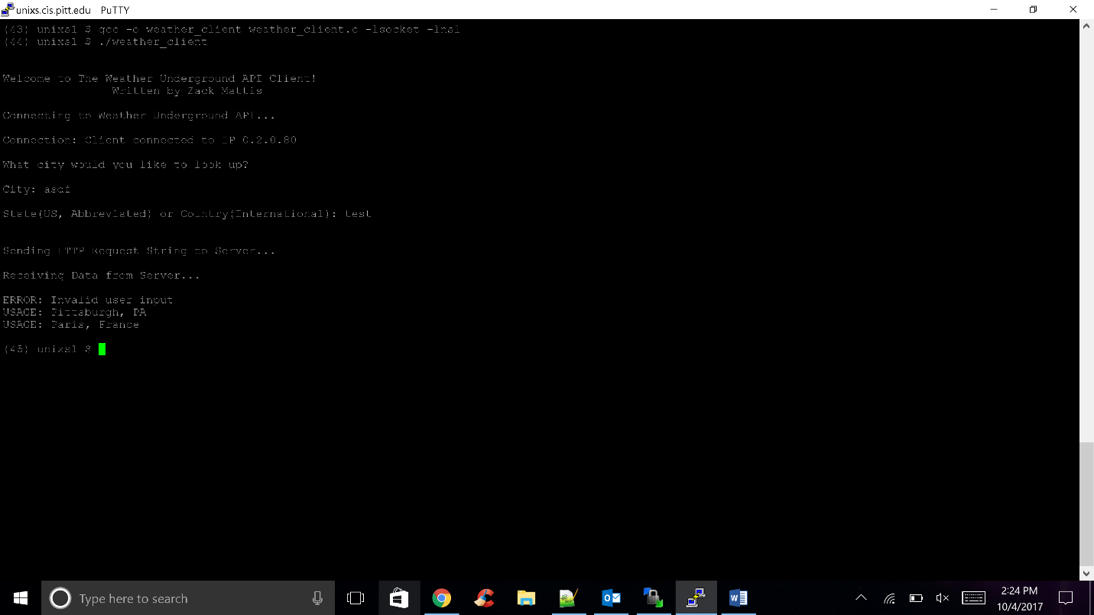

(34) unixs1 $ gcc -o weather_client weather_client.c -lsocket -lnsl

(35) unixs1 $ ./weather_client

Welcome to The Weather Underground API Client!

Written by Zack Mattis

Connecting to Weather Underground API...

Connection: Client connected to IP 0.2.0.80

What city would you like to look up?

City: abcd

State(US, Abbreviated) or Country(International): test

Sending HTTP Request String to Server...

Receiving Data from Server...

ERROR: Invalid user input

USAGE: Pittsburgh, PA

USAGE: Paris, France