Zachary Mattis – The history of Supercomputing

**Abstract**

Supercomputing is the dynamic field of problem solving that attempts to push the boundaries of size, power, and performance of modern systems in order to solve extremely complex and advanced technical problems via incredible performance standards. Since their creation in the 1960s, engineers have continued to challenge the present standards of computing, evolving beyond current metrics.

**Introduction**

Since standard computers lie at the backbone of supercomputing, it is extremely necessary to explore the history of traditional computing and how it lead to the supercomputer. Widespread observance of computing began in the late 1940s in response to the rising challenges of World War II. However, British scientist Charles Babbage is credited as inventing the computer as it is understood and implemented today [Hal70]. Babbage designed the analytic engine, a proposed device featuring a “mill” for conducting arithmetic operations, a “store” for saving information, and programmable punch cards. While Babbage’s

In

Researchers have been able to solve unique problems, including the birth of starts, the human genome, and

HISTORY

Often characterized as the first supercomputer, the Control Data Corporation 6600 was designed in 1964. It was a single processor design capable of 10 million instruction per second.

IMPLEMENTATION

MODERN SUPERCOMPUTING

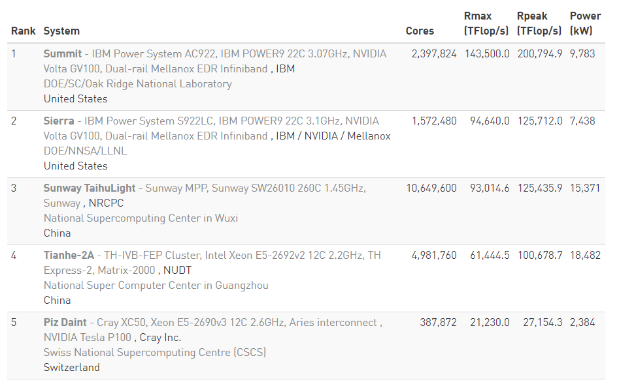

Figure 1 – Top 5 Supercomputers (Nov. 2018) [Top500]

A couple of important characteristics can be observed from the very top supercomputers in the world from Figure 1. While *Summit* is capable of over 1.5 times the number of operations as *Sunway TaijuLight*, it only has approximately 1/4 the number of cores and consumes 2/3 the power. Very strong conclusions can be drawn from this figure, most notably how the implementation of these vast systems can lead to strikingly different performances. From a naïve perspective, one might assume that a computer with 4 times as many cores would be capable of greater performance, *Summit* proves that just throwing more hardware at a problem will not yield the top performance possible. Additionally, even with this massive underlying architecture, *Summit* is able to operate at a frequency of 3 GHz, twice the frequency of *Sunway TaijuLight*. The distinction between these two systems yields a snapshot into the complexity of the supercomputing.

Just here in Pittsburgh, there are two major supercomputing centers: the Center for Research Computing (CRC) and the Pittsburgh Supercomputing Center (PSC).

FUTURE

In order to predict the future of supercomputing, it is equally important to understand the past. Figure 2, from 2010, shows some important events in supercomputing, highlighting the year coupled with the performance in FLOPS. This graph shows a prediction of the exaFLOP by the year 2019, as previous jumps of 3 order of magnitude took approximately 10-15 years. As previously shown, the current top Supercomputer is still an entire order of magnitude away from reaching this benchmark.

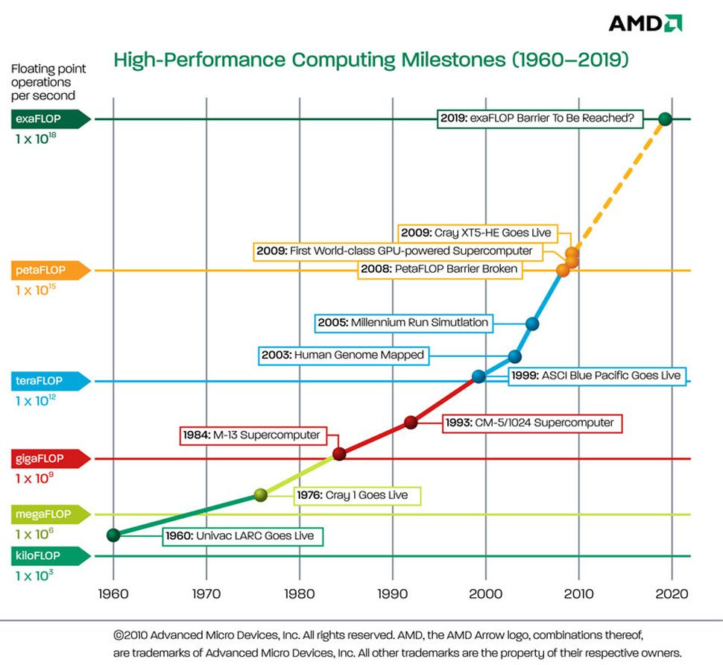

Figure 2 – High-Performance Computing Barriers [AMD]

**AI**

From my understanding of both legacy and modern computing, I believe that Artificial Intelligence will be the major focus of the generations to come and will have revolutionary impact in all areas of life. The forefront of high-performance computing systems, *Summit,* was designed and architecture from the ground up for AI applications, including machine learning and neural networks.

**REFERENCES**

[Cer03] P. Ceruzzi. *A History of Modern Computing*. MIT Press, Cambridge, MA, 2003.

[Hal70] D. Halacy. *Charles Babbage, Father of the Computer.* Crowell-Collier Press, New York, 1970.