**Drowning?**

**Zoe's avatar**

[Zoe](https://substack.com/@zoeffc)

Jul 19, 2024

Share

Hi there!

Damn. Work is really hard sometimes. This week, I want to share resources for navigating the feeling of drowning in your to-do list. Potentially, this could be the start of a series on how to navigate the other things that make work challenging like other people and our inner critic.

This week’s letter is more practical. A disclaimer before I dive in: I don’t have all of the answers. Often when I sit down to write these, it’s so that I can tell myself a lot of these things, because writing them down sometimes helps them to sink in. By no means, do I want to be prescriptive in how you live your life. As always, if you like how I am thinking about these things, drink them up like a thirsty houseplant. If you don’t then you can either let it go, or engage with the community and suggest alternatives or ideas.

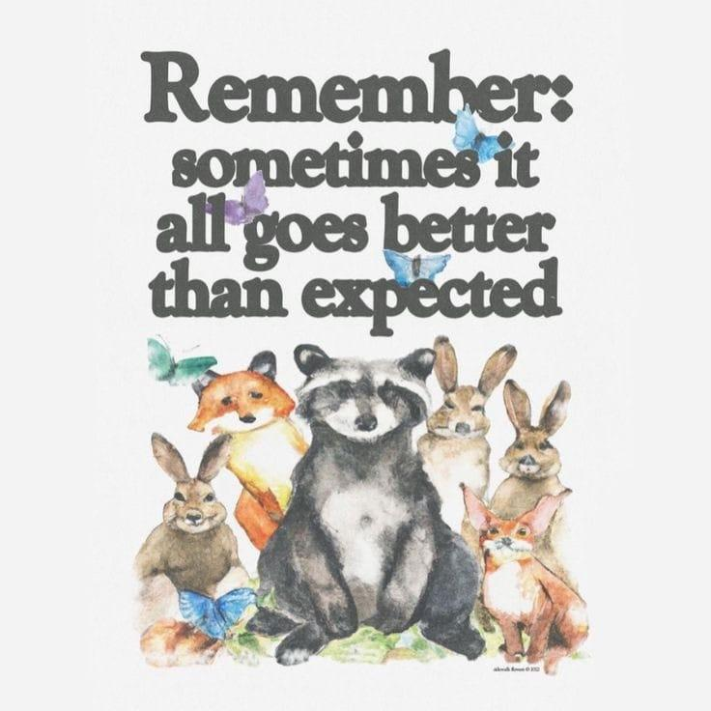

*artist unknown*

First some housekeeping:

📫 If a friend forwarded you this newsletter (then you have some really cool friends), and you may want to consider joining us [*here*](https://femme-futures.beehiiv.com/subscribe) for regular updates.

[Subscribe](https://femme-futures.beehiiv.com/subscribe)

🧲 Got some thoughts you want to share? Join us on [*Discord*](https://discord.gg/592wuyvx?utm_source=femme-futures.beehiiv.com&utm_medium=referral&utm_campaign=drowning) to chat all things newsletter and corporate life.

[Discord](https://discord.gg/N84WxemQ?utm_source=femme-futures.beehiiv.com&utm_medium=referral&utm_campaign=drowning)

Ok, now about that to-do list. I do a lot of project management for my 9-5, which means I absolutely know how it feels to have a to-do list that you cannot see the bottom of. It ALSO means that I have some tools for you.

First, if you have a physical to-do list, you are already on the right track. Our brains can sink into the sense of overwhelm and distort our sense of just how much we need to do before we clock out. I like to use project management software like Asana and Notion, but the notes app, or paper and pen work too. Get it written down and then take a deep breath. Now assess. How bad is it really?

If the answer is “Still bad!”, I got you. The next step is time management. Take another look at your list and estimate how much time it will take you. Try to be realistic: a small task (ie. an internal email, or a status check) will probably take 5 minutes, a medium task is somewhere between 15-30, and that task that you think might take you all day will be better served by you putting in an hour and seeing how far you get. There are some project management software that help you track this level of minutia (though this seems to be a paid feature on most of the software that I’ve come across). You can also use a simple timer. Or, a fancier option: the pomodoro technique.

**Pomodoro Technique:**

This is a focus technique that is helpful for those project that you think are going to last all day. It is a pattern of focus and breaks to keep your energy up. The traditional pattern is: 25 - 5 -25 - 5 - 25 - 10 with 25 minute work chunks and either a 5-minute break or a 10-minute break. You can personalize it to whatever works best for you.

Pro-Tip: Stand up for the entirety of your break, and try not to look at your phone. This way, when you sit back down, you are ready to get back into it and don’t have to snap your brain out of fun mode.

Ok, that’s one tool for you to try — another tool is body-doubling. I think that this is a fancy term for something that we as humans have been doing for a while. Essentially, body-doubling is working with a friend as an accountability partner. This is probably why offices exist in the first place. However, as our world has changed in the last few years and we are all adapting to more isolated working situations, body-doubling can still be helpful. Here are some ways to body-double in the modern world:

* Phone a friend! Grab a friend and have them sit on zoom while you both work on projects together, no talking required.
* Study with me! There is a whole genre of videos on YouTube called “study with me” where the creator sets up a camera as if you both were in a room together working. Sometimes they even use the pomodoro technique which is a fun bonus. There are also live-stream versions of this if you are pulling traditional hours in the US or Europe. In a similar vein, check out lo-fi soundscapes on YouTube. They’re not really my thing, but that doesn’t mean they might not be yours.
* Go to a cafe/the library! Some spaces make you feel like you really ought to be working and a lot of times that is not your bedroom or your couch.
* I saved the most chaotic for last — set up a mirror in front of your workspace. As long as you don’t get distracted by your own gorgeous face, you can trick your brain into thinking that someone else is working with you.

… And just like that, you have more tools than you know what to do with. I am going to share some of my favorite resources below. As always, let me know what you think, if you have additions, or just want to chat. I am always available via [*Discord*](https://discord.gg/N84WxemQ?utm_source=femme-futures.beehiiv.com&utm_medium=referral&utm_campaign=drowning)!

At the end of the day, work is just overwhelming sometimes. Remember that it is just a job and (unless you are a doctor) dropping the ball on something will not ruin anyone’s life. Nothing matters that much, so remember to log off and phone a friend, cuddle a pet, or move your body.

Cheers!

Zoe

📌**Resources**

* [*LifeAt:*](https://lifeat.io/?utm_source=femme-futures.beehiiv.com&utm_medium=referral&utm_campaign=drowning) This app has a ton of fun study-scapes from cafes, to hogwarts common rooms, to desks with pets AND it has a built in pomodoro timer and to-do list. There are some paid features, but I use the free one and still like it.
* [*Notion:*](https://www.notion.so/?utm_source=femme-futures.beehiiv.com&utm_medium=referral&utm_campaign=drowning) This is a project management tool. I have been intimidated by it for years because it has “That Girl” energy and I worried that I was not “That Girl”. But I started using it for this project and I am a fan. There is a little bit of a learning curve, but it’s quite fun once you get the hang of it.
* [*Asana*](https://asana.com/?utm_source=femme-futures.beehiiv.com&utm_medium=referral&utm_campaign=drowning): I use this for work, and have for a couple of years. I really love it, and have been lucky enough to work for places with a paid membership for it. It works best for team task management, but works pretty well for individuals as well.

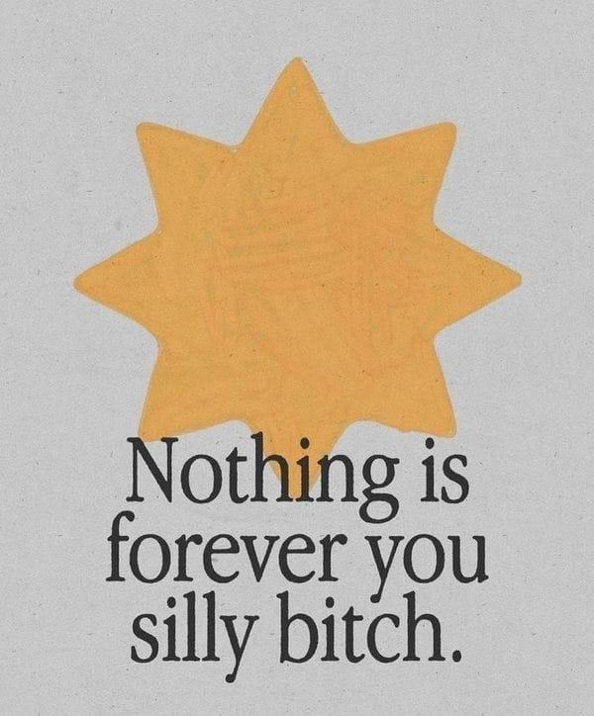

*Artist unknown*

**Femme Futures Cooperative Founding Principles**

💚**Mission**: The mission of Femme Futures is to create a community space for young professionals who identify as over-achievers and activists to generate collective success by providing resources and platforms to thrive in challenging workplace environments.

💙**Vision**: To contribute to a world where driven individuals are equipped with the tools, guidance, and connections to overcome systemic barriers, fully utilize their talents, and enact positive change in their organizations and communities.