# **Ugh.**

**Zoe's avatar**

[Zoe](https://substack.com/@zoeffc)

Oct 18, 2024

Share

Hey there,

Here goes attempt three to start this note.

I want to talk about how sometimes I let myself down. I was sick this week and navigating life stuff (good and bad), and my energy has been all over the place. All that being said, I have not been the ambitious, confident, energetic, thoughtful, proactive version of myself at work this week.

I am trying to be ok with that.

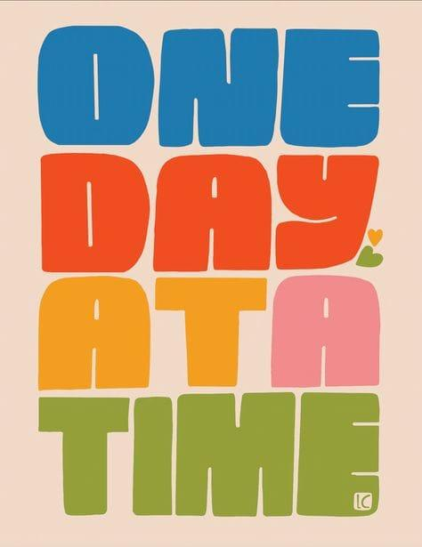

*Art by Lisa Congdon*

First some housekeeping:

📫 If a friend forwarded you this newsletter (then you have some really cool friends), and you may want to consider joining us here for regular updates.

[Subscribe](https://femme-futures.beehiiv.com/subscribe)

🧲 Got some thoughts you want to share? Join us on Discord to chat all things newsletter and corporate life.

[Discord](https://discord.gg/jjAKMFq2?utm_source=femme-futures.beehiiv.com&utm_medium=referral&utm_campaign=ugh)

You can find all archived newsletters at the online site, if you ever want to go back or if you just feel like perusing.

[Check out the website](https://femme-futures.beehiiv.com/)

Today, I would like to introduce you to a key figure in my life: my therapist. Therapist Melissa knows that I am a bit of a perfectionist. Is it important to define that term? Maybe.

I think that a perfectionist is someone who holds themselves to a standard of zero errors. Brené Brown would push that and ask *why* one might hold themselves to a standard of zero errors. Good question, Brené. I am embarrassed by making mistakes; I think that it reflects a lack of basic intelligence on my end. This is where the problem stems from. I am ashamed of doing anything less than perfect, and seeing as I am incapable of perfection because I am a human, I am constantly living with a level of shame.

I am trying to be better about not needing to be perfect. Ironic.

What would it take to convince me that aiming for my best is healthier than aiming for perfect? Burnout probably.

In navigating burnout earlier this year, I went to Therapist Melissa in tears. My best didn’t feel good enough. My best felt like pushing at work and then crashing into my bed at the end of the day, letting my friendships and hobbies slip. I would struggle through the uphill battles presented to me and, at the end of the day, find three ways that I had messed up. My best wasn’t adequate.

Melissa just said to me “Well, you can’t do better than your best. It’s your best. It’s enough — and you know what? If it doesn’t feel like enough, you can try again tomorrow.”

I say that to myself occasionally. My best is enough. My best is enough. My best is enough. It is just that sometimes my best feels like 20%. Here’s the thing. If I gave 100% when all I had the capacity for was 20%, I would be pretty fucking miserable as I tried to recover from that. I’d be exhausted. On the other hand, how do I become okay with a season of 20%? What does that say about me?

In the working world, after college, there are so many tomorrows to try again. If all you could give was less than you wanted, you can still go to sleep at night. There is always tomorrow to fix the things that need fixing and to keep creeping forward.

That’s it. That’s what I have for you this week. Don’t be surprised if I write about this again because it is something that I come back to over and over again. I know I’m not the only one.

Best,

Zoe

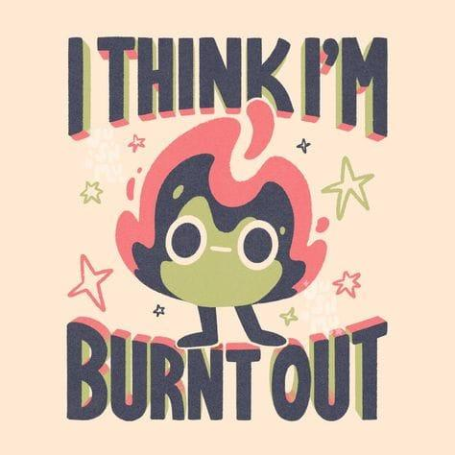

*artist unknown*

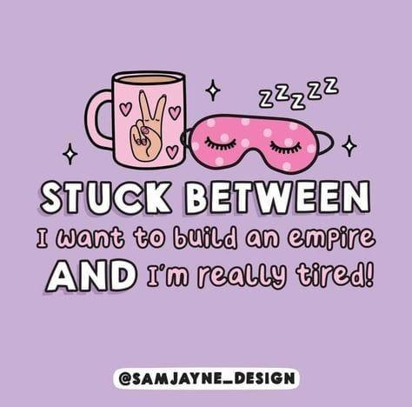

**Femme Futures Cooperative Founding Principles**

💚 **Mission**: The mission of Femme Futures is to create a community space for young professionals who identify as over-achievers and activists to generate collective success by providing resources and platforms to thrive in challenging workplace environments.

💙 **Vision**: To contribute to a world where driven individuals are equipped with the tools, guidance, and connections to overcome systemic barriers, fully utilize their talents, and enact positive change in their organizations and communities.