Parliament Dot Plots

Zoe Meers

22/05/2018

Table of Contents

knitr::opts_chunk$set(echo = TRUE, warning=FALSE)  
source("geom_parliament_dots.R")  
source("scale_colours_parties.R")  
load("election_data.rda")  
library(ggparliament)  
library(tidyverse)

## Loading tidyverse: ggplot2  
## Loading tidyverse: tibble  
## Loading tidyverse: tidyr  
## Loading tidyverse: readr  
## Loading tidyverse: purrr  
## Loading tidyverse: dplyr

## Warning: package 'tibble' was built under R version 3.4.3

## Warning: package 'tidyr' was built under R version 3.4.3

## Warning: package 'purrr' was built under R version 3.4.2

## Warning: package 'dplyr' was built under R version 3.4.2

## Conflicts with tidy packages ----------------------------------------------

## filter(): dplyr, stats  
## lag(): dplyr, stats

library(patchwork)

# Unique parliament layouts:

Monkey Cage article : <https://www.washingtonpost.com/news/monkey-cage/wp/2017/03/04/these-5-designs-influence-every-legislature-in-the-world-and-tell-you-how-each-governs/?utm_term>=.e1e1c1c3c37b

## Opposing benches parliament

### United Kingdom, Canada

#### Data

ukresults <- election_data %>%  
 filter(country=="UK" & year == 2017)   
ukresults$seats <- as.numeric(ukresults$seats)  
left_parties <- c("Labour","Scottish National Party","Liberal Democrats","Green","Plaid Cymru", "Ind")  
ukresults$location <-  
 ifelse(ukresults$party_long %in% left_parties, "left",  
 ifelse(ukresults$party_long ==c("Conservative", "Democratic Unionist"), "right",  
 NA ))  
ukresults_left <- ukresults %>%  
 filter(location=="left")  
  
ukresults_right <- ukresults %>%  
 filter(location=="right")

#### Plot

leftside <- ggplot() + geom_parliament_dots(type="opposing_benches", seatspp = ukresults_left$seats, size = 3, party_name = ukresults_left$party_long, parlrows=10) + theme_parliament() + coord_flip() + theme(legend.position="left") + labs(colour="") + scale_colour_manual(values=c(ukresults_left$colour), labels=c(ukresults_left$party_long),limits=c(ukresults_left$party_long))  
  
rightside <- ggplot() + geom_parliament_dots(type="opposing_benches", seatspp = ukresults_right$seats, size = 3, party_name = ukresults_right$party_long, parlrows=10)+ theme_parliament() + coord_flip() + labs(colour="") + scale_colour_manual(values=c( ukresults_right$colour), labels=c(ukresults_right$party_long))  
  
uk_parliament <- combine_opposingbenches(left = leftside, right = rightside)  
uk_parliament

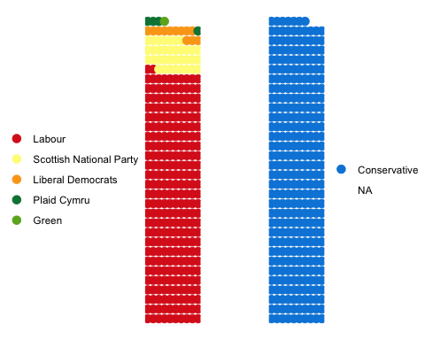

## Semicircle parliament

### EU, France, United States, and so on…

#### Data

americandata <- data(US_congress)  
americandata <- US_congress  
US_congress1 <- americandata %>%  
 filter(start_year=="2017" & chamber=="lower")  
US_senate <- americandata %>%  
 filter(start_year=="2017" & chamber=="upper")

#### Plot

congress <- ggplot() + geom_parliament_dots(type='semicircle', totalseats=sum(US_congress1$seats), parlrows=10, size=3, seatspp=US_congress1$seats) + theme_parliament() + labs(colour="Party", title="United States Congress") + scale_colour_manual(values=c("#1c396e", "#ed1b35"), labels=c("D", "R"))   
#When I write scale_colour_party, Republicans show up as grey. Trying to fix it but in the meantime, there is a manual scale.  
#It works below, however. :\  
senate <- ggplot() + geom_parliament_dots(type='semicircle', totalseats=sum(US_senate$seats), parlrows=3, size=3, seatspp=US_senate$seats) + theme_parliament() + labs(colour="Party", title="United States Senate") + scale_colour_party(palette="USA", labels=c("D", "R", "I"))  
senate

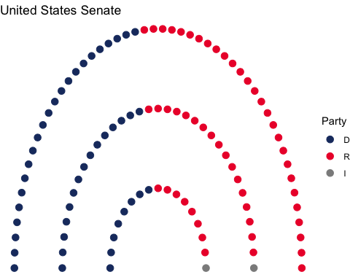

congress

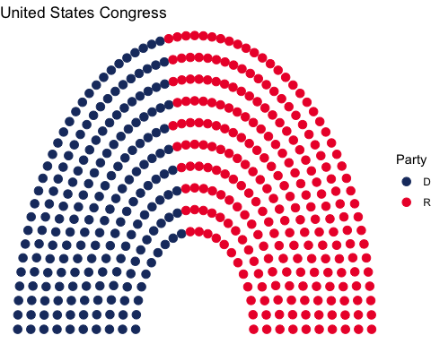

## Horseshoe parliament

### Australia, New Zealand

#### Data

# load data  
AustralianElections <- pscl::AustralianElections  
# filter to 2016, slice percent, total seats  
AustralianElections <- AustralianElections %>%  
 filter(date == "2016-07-02") %>%  
 gather() %>%  
 slice(-c(1:3, 8:19))  
  
# reorder rows into parliament layout (i.e. independents in the middle of the circle btwn the two major parties)  
AustralianElections <- AustralianElections[c(1, 4, 3, 2), ]  
AustralianElections$key <- factor(AustralianElections$key)  
# clean labels  
AustralianElections$key <- gsub("Seats", "", AustralianElections$key)  
au <- AustralianElections  
new_au_data <- parliament_data(data=au, seats=au$value, type='horseshoe')  
  
  
  
au_elections <- election_data %>%  
 filter(year==2016 & country=="Australia" & house=="Representatives")  
#new_au_data <- parliament_data(data=au_elections, seats=au_elections$seats, type='horseshoe')

#### Plot

a <- ggplot() + geom_parliament_dots(type='horseshoe', totalseats=sum(new_au_data$value), parlrows = 4, size=3, seatspp=new_au_data$value) + theme_parliament() + labs(colour="Party", title="Horseshoe parliament: Australia") + scale_colour_party(palette="AUS", labels=c("ALP","Ind.","NP", "LP"))  
a

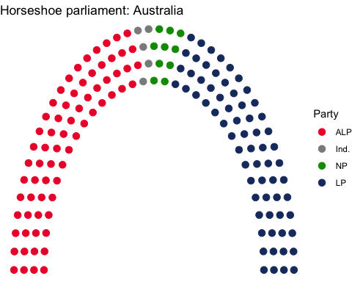

## Circle parliament

### old German Bundestag (find more modern examples).

russia <- election_data %>%  
 filter(country=="Russia" & year==2016)  
  
ggplot() + geom_parliament_dots(type="circle", seatspp = russia$seats, size = 3, party_name = russia$party_long, parlrows=10)+ theme_parliament() + coord_polar() + scale_y_discrete(expand=c(1, 0)) +   
 scale_colour_manual(values=c(russia$colour), labels=c(russia$party_long), limits=c(russia$party_long)) + labs(colour='', title="Russian Parliament")

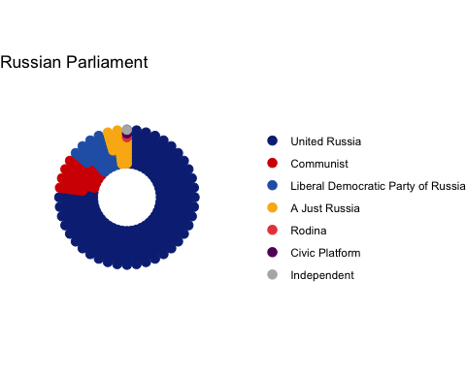

## Classroom parliament

### China, Russia, North Korea

ggplot() + geom_parliament_dots(type="classroom", seatspp = russia$seats, size = 3, party_name = russia$party_long, parlrows=15) + theme_parliament() +  
 scale_colour_manual(values=c(russia$colour), labels=c(russia$party_long), limits=c(russia$party_long)) + labs(colour='', title="Russian Parliament")

