install sql server

connection sql server -> api

run api

Server=localhost;Database=master;Trusted_Connection=True;

DESKTOP-0JVOJ5P\MSSQLSERVER01

install sql server

create db with tables

connect to db from visual studio tools -> connect to db

update web.config

name="TourismApiWADContext" connectionString="Data Source=LAPTOP-7DBNV51G;

Run site on local server

Run on chrome without CORS   
PS C:\Program Files\Google\Chrome\Application> .\chrome.exe --disable-web-security --user-data-dir="c:/ChromeDevSession"

Add offers to db

/*SET identity_insert dbo.Offers ON;*/

INSERT INTO Offers (OfferId, Destination, Hotel, Price, StartDate, EndDate, Image)

VALUES (1, 'Caraibe', 'Best Western', 200, CONVERT(datetime, '16/11/2012 00:00:00', 103), CONVERT(datetime, '16/11/2012 00:00:00', 103), null)

INSERT INTO Offers (OfferId, Destination, Hotel, Price, StartDate, EndDate, Image)

VALUES (2, 'Hawai', 'Best Western', 200, CONVERT(datetime, '16/11/2012 00:00:00', 103), CONVERT(datetime, '16/11/2012 00:00:00', 103), 'https://th.bing.com/th/id/OIP.6WnOpTc1d7ez3iwH4VTBzAHaE8?pid=ImgDet&rs=1')

Add admin user to db

SET identity_insert dbo.Users ON;

INSERT INTO Users (UserNane, FirstName, LastName, password, PhoneNumber, UserId, userType, Email)

VALUES ('admin', 'aa', 'aa', 'admin', '123', '5', 'admin', 'aa')

ALTER TABLE Books

ADD FOREIGN KEY (TripItinerariumId) REFERENCES Packages(PackageId);

ALTER TABLE Books

ADD FOREIGN KEY (UserId) REFERENCES Users(UserId);

ALTER TABLE dbo.TripItinerariums

ADD TripItinerariumId INT IDENTITY

CONSTRAINT PK_TripItinerariums PRIMARY KEY CLUSTERED

# Alter table to add appointmentType column

ALTER TABLE Appointments

ADD AppointmentType VARCHAR(255) DEFAULT 'consultatie';

UPDATE Appointments

SET AppointmentType = 'consultatie'

WHERE AppointmentType IS NULL;

# Delete all entries from Appointments table

Open Sql server management studio

Go to New Query

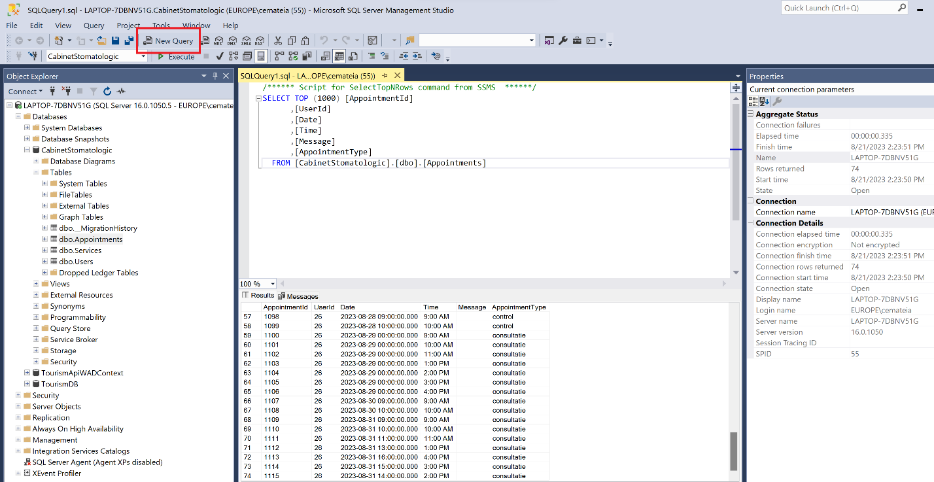

Paste this query:

DELETE FROM [CabinetStomatologic].[dbo].[Appointments]

Press Execute:  
  
