Main function is in PopAll.java.

Useful Jar file in root folder.

Run that to see all the result in console.

Also you will get Graphs in root folder.

I use the GA code that I developed in my evolutionary algorithm class instead and do some modifications on it.

In this way I can control more on the details of my algorithm.

**The details are:**

**Parent selection : rouletteWheelSelection**

**Population size: 20**

**Generations total: 100**

**Mutation Rate: 1/3**

**Recombination: One point cross over**

**Mutation Method: Uniform**

**Random Seed :1234**

The others can be seen in codes.

I use the workflow below. And S1 would be OR operator and S3 would be and operator.

/**

*As we need to minimize the cost and time, while maximize the reliability and availability

* We need to do some modification to design a fitness function searching for the maximum.

* Also normalization is needed.

* For cost, max cost is min(30+53,30)+23=53, i use COST/53 to normalize and use 1-cost/53 to

* transfer searching for minimum to searching for maximum.

* For time, max time is min (23+8,23)+12=35, likewise, i use TIME/35 to normalize and 1-time/35 to

* be consistent with RELIABILITY and AVAILABILITY.

*/

Based on the above method,

The best result of fitness we would get according to my modification should be 0.961210781671159, While the theoretical maximum is 1 according to my model, because of my normalization.

Example workflow:

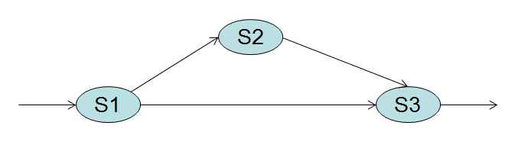

AND

OR

|  |  |  |  |  |  |
| --- | --- | --- | --- | --- | --- |
|  | Service | Cost ($) | Reliability(%) | Time (s) | Availability(%) |
| SC1 | S11 | 20 | 95 | 2 | 95 |
| S12 | 30 | 99 | 3 | 89 |
| S13 | 23 | 98 | 23 | 98 |
| S14 | 12 | 99 | 1 | 02 |
| S15 | 25 | 89 | 3 | 78 |
| SC2 | S21 | 12 | 70 | 3 | 70 |
| S22 | 15 | 99 | 5 | 93 |
| S23 | 53 | 96 | 8 | 96 |
| SC3 | S31 | 11 | 97 | 9 | 97 |
| S32 | 12 | 89 | 12 | 89 |
| S33 | 12 | 90 | 1 | 90 |
| S34 | 15 | 91 | 3 | 98 |
| S35 | 18 | 56 | 6 | 56 |
| S36 | 23 | 68 | 2 | 67 |
| S37 | 22 | 59 | 1 | 59 |
| S38 | 21 | 92 | 2 | 89 |

Weight of QoS parameters in calculating fitness function:

Cost (35%)

Reliability (30%)

Performance (30%)

Availability (35%)