Circle Kirch Instructions: Both Players

# IMPORTANT!

Do not read these instructions right away! Before you turn to the next page, choose one player to be Player 1 and the other to be Player 2. You two should independently read your own set of instructions (*Circle Kirch Instructions: Player 1* or *Circle Kirch Instructions: Player 2*) and play through the mini-games on your own before coming together again.

# Board 3 Solution

Before reading this page, make sure that both players have worked together to complete the Board 3 mini-game.

First, use Kirchhoff’s Voltage Law to reveal the **Voltage** of the resistor all the way on the right.

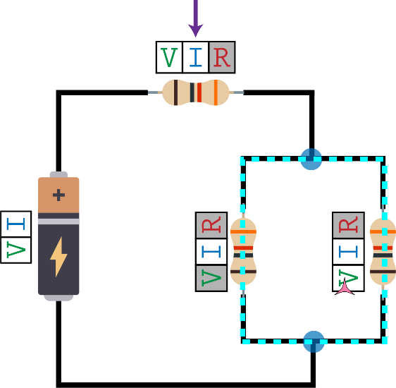

|  |  |
| --- | --- |
| Then, use Ohm’s Law to reveal the **Voltage** of the two lower resistors. | Finally, use Kirchhoff’s Current Law with the top junction to reveal the **Current** of the top resistor. |
| C:\Users\zmine\Google Drive\Classes\Design_Of_Educational_Games\FinalProject\Ed Games - The Ghost of Cleatus\2_Ideation_and_Prototyping\Assets\Board3_Sol_P2.png | C:\Users\zmine\Google Drive\Classes\Design_Of_Educational_Games\FinalProject\Ed Games - The Ghost of Cleatus\2_Ideation_and_Prototyping\Assets\Board3_Sol_P3.png |

# Same-Wire, Same Current

There’s just one more move to learn—the **“same-wire, same-current”** move.

In the circuit below, the **Current** for the top resistor is known. You can immediately reveal the **Current** of the battery, but not the **Current** of the other two resistors. Why do you think this is the case?

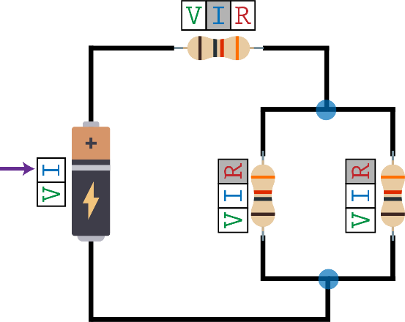

The reason is that there are **no junctions** along the path that connects a component with a known **Current** to a component with an unknown **Current**.

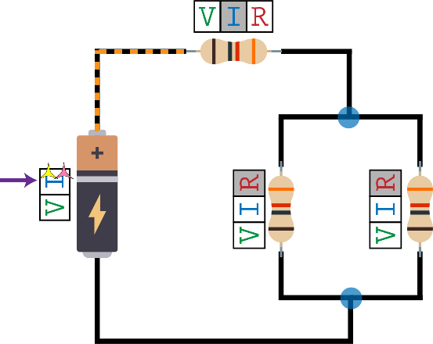

No junctions along the path and the resistor has a known current, so you can reveal the battery’s **Current**

In the circuit below, you ***cannot*** use the same-wire, same-current move to reveal the **Current** of the resistor on the right.

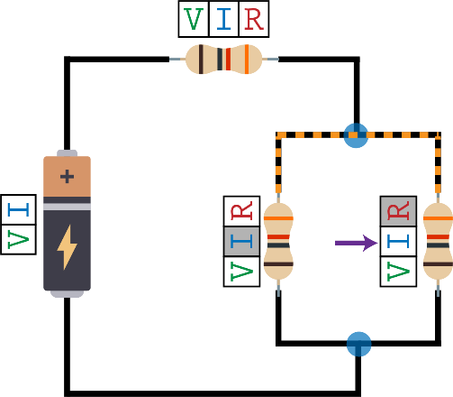

**INVALID use of the same-wire, same-current move. There is a junction in any path that connects these two resistors.**

## Review of the 4 Moves

**Ohm’s Law**

If exactly 2 of the ratings for a resistor are known, you can reveal the 3rd one for that resistor.

**Kirchhoff’s Voltage Law**

Within a valid Kirchhoff Loop, if you know the **Voltage** for all components except for one, then you can reveal that unknown **Voltage**.

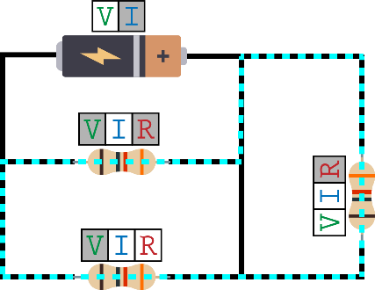

You can reveal this **Voltage**

**Kirchhoff’s Current Law**

For the components that are directly connected to a Kirchhoff Junction, if you know the **Current** for all components except for one, then you can reveal that unknown **Current**.

The pink dashed lines show the components that are directly connected to this Junction

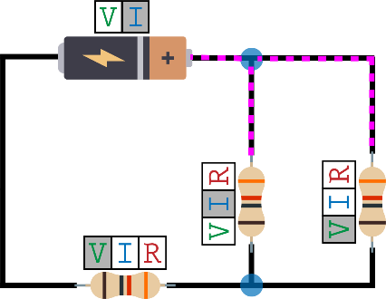

You can reveal this **Current**

**Same wire, same current**

If there are no junctions along the path that connects a component with a known **Current** to a component with an unknown **Current**, you can reveal the unknown **Current**.

## Competitive Game Rules

Both players have now mastered the possible moves you can make. We’re ready to learn the rules of the competitive game!

One player uses the yellow tokens and the other uses the pink tokens. Choose one player to go first. Take turns revealing ratings until one of you reveals the rating with the **arrow**.

On a single turn, you can:

* Use the Ohm’s Law move as many times as you want
* Use the same-wire, same-current move as many times as you want
* Use either Kirchhoff’s Voltage Law or Kirchhoff’s Current Law **only once**

When you reveal a **Voltage**, **Current**, or **Resistance**, place one of your tokens on the rating to show that it is now known to you.

*A rating that is revealed by one player is not automatically known to the other player.* If Player 1 reveals a certain **Current**, Player 2 cannot use that **Current** as a known value (until Player 2 reveals it on a later turn).

The first player reveal the rating with the **arrow** wins! Play again on the next board, and switch who goes first.

Some clarifications about what you can do on a single turn:

* You **cannot** use both Kirchhoff’s Voltage Law and Kirchhoff’s Current Law in the same turn. Whichever Kirchhoff move you choose to use, you can only use it once on that turn.
* You can use Ohm’s Law as many times as you’d like, before and/or after you use one of the Kirchhoff moves.
* You can use “same-wire, same-current” as many times as you’d like, before and/or after you use one of the Kirchhoff moves.

We suggest you play the competitive boards in this order:

* **Board 5** – Player 1 goes first
* **Board 6** – Player 2 goes first