Circle Kirch Instructions: Player 2

# Intro

Circle Kirch is a 2-player competitive game about electrical circuits. Don’t worry if this is new to you! Just by playing the game, you will learn the basic procedures involved in analyzing schematics.

To help you learn the rules, short, single-player mini-games are included throughout the instructions. Make sure you and your opponent play these on your own *before* playing the full game together.

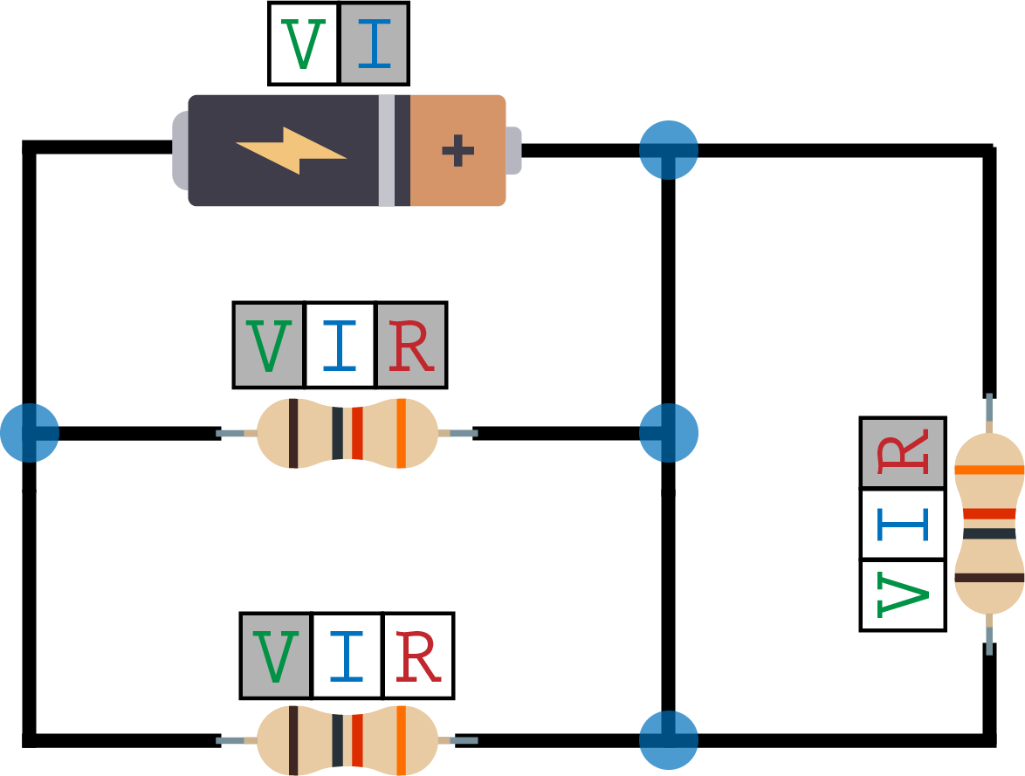

The Board

# Components

The game board is made up of 2 basic components:

|  |  |
| --- | --- |
| **Batteries** | **Resistors** |
| C:\Users\zmine\Google Drive\Classes\Design_Of_Educational_Games\FinalProject\Ed Games - The Ghost of Cleatus\2_Ideation_and_Prototyping\Assets\Battery.png | C:\Users\zmine\Google Drive\Classes\Design_Of_Educational_Games\FinalProject\Ed Games - The Ghost of Cleatus\2_Ideation_and_Prototyping\Assets\Resistor.png |

# Connections

These components are connected by wires, like this:

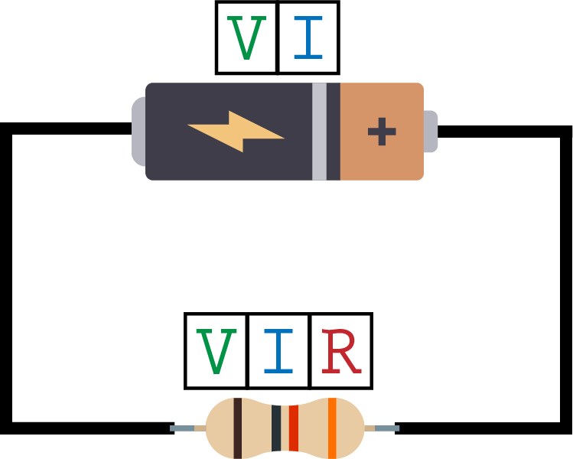

# Ratings

You’ll notice that each component has two or three ratings:

|  |  |  |
| --- | --- | --- |
| **Voltage** | **Current** | **Resistance** |
| C:\Users\zmine\Google Drive\Classes\Design_Of_Educational_Games\FinalProject\Ed Games - The Ghost of Cleatus\2_Ideation_and_Prototyping\Assets\Voltage.png | C:\Users\zmine\Google Drive\Classes\Design_Of_Educational_Games\FinalProject\Ed Games - The Ghost of Cleatus\2_Ideation_and_Prototyping\Assets\Current.png | C:\Users\zmine\Google Drive\Classes\Design_Of_Educational_Games\FinalProject\Ed Games - The Ghost of Cleatus\2_Ideation_and_Prototyping\Assets\Resistance.png |

Both batteries and resistors have **Voltage** and **Current**, but only resistors have **Resistance**.

The Goal

In the game board, certain ratings are known and others are unknown.



Known ratings are shaded in gray:



Unknown ratings are in white:

In this example, **Current** and **Resistance** are known and **Voltage** is unknown:

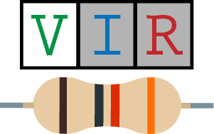

In a full board, one unknown value will have an **arrow** pointing to it. The goal of the game is to reveal this unknown value (make it known) before your opponent does:

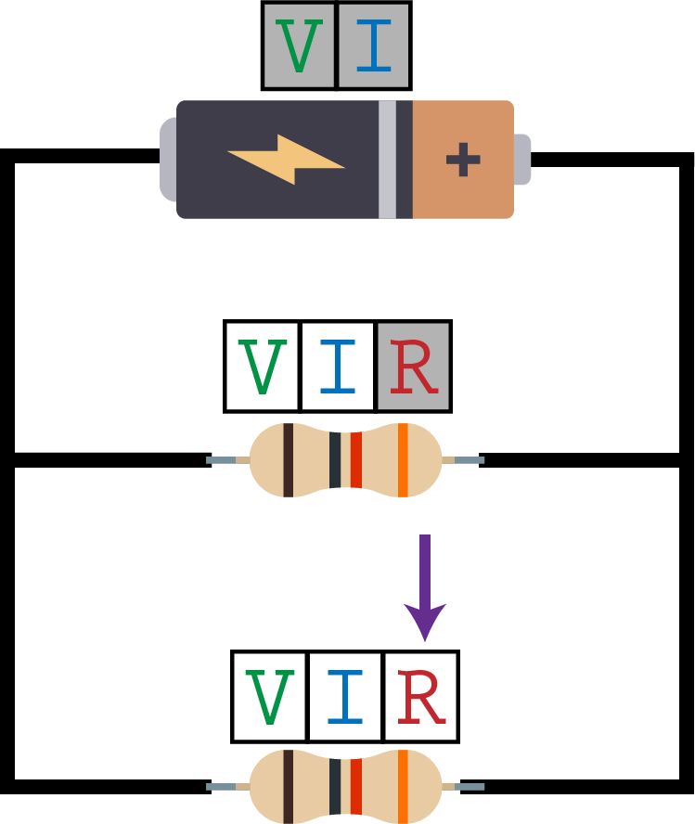

The Moves

A “move” means revealing an unknown value. There are 3 moves you can make.

When you make a move, place one of your tokens on the rating to show which unknown you have revealed.

## Move 1: Ohm’s Law

If exactly 2 of the ratings for a resistor are known, you can reveal the 3rd one for that resistor.

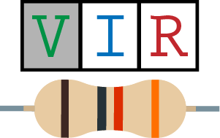

Careful! You **cannot** use Ohm’s Law here because less than 2 ratings for the resistor are known.

|  |  |
| --- | --- |
| C:\Users\zmine\Google Drive\Classes\Design_Of_Educational_Games\FinalProject\Ed Games - The Ghost of Cleatus\2_Ideation_and_Prototyping\Assets\Ohm1.png | Can reveal **Resistance**  (place a token on the **R**) |
| C:\Users\zmine\Google Drive\Classes\Design_Of_Educational_Games\FinalProject\Ed Games - The Ghost of Cleatus\2_Ideation_and_Prototyping\Assets\Ohm2.png | Can reveal **Current**  (place a token on the **I**) |
| C:\Users\zmine\Google Drive\Classes\Design_Of_Educational_Games\FinalProject\Ed Games - The Ghost of Cleatus\2_Ideation_and_Prototyping\Assets\Ohm3.png | Can reveal **Voltage**  (place a token on the **V**) |

This move applies *only to resistors*. Batteries do not have **Resistance**, so you can’t use Ohm’s Law with them.

## Ohm’s Law Mini-Game

Let’s play a short game to make sure you understand the Ohm’s Law move. Take **Board 1** and place it in front of you. There are 2 circuits on this board. Use the Ohm’s Law move to reveal the indicated unknown values. After you’ve tried this, flip to the next page to see if you did it correctly.



Don’t turn the page until you have completed this mini-game with **Board 1**!

## Ohm’s Law Mini-Game – Solution

**Left Circuit**

Place a token on the **Voltage** on the resistor to reveal it.

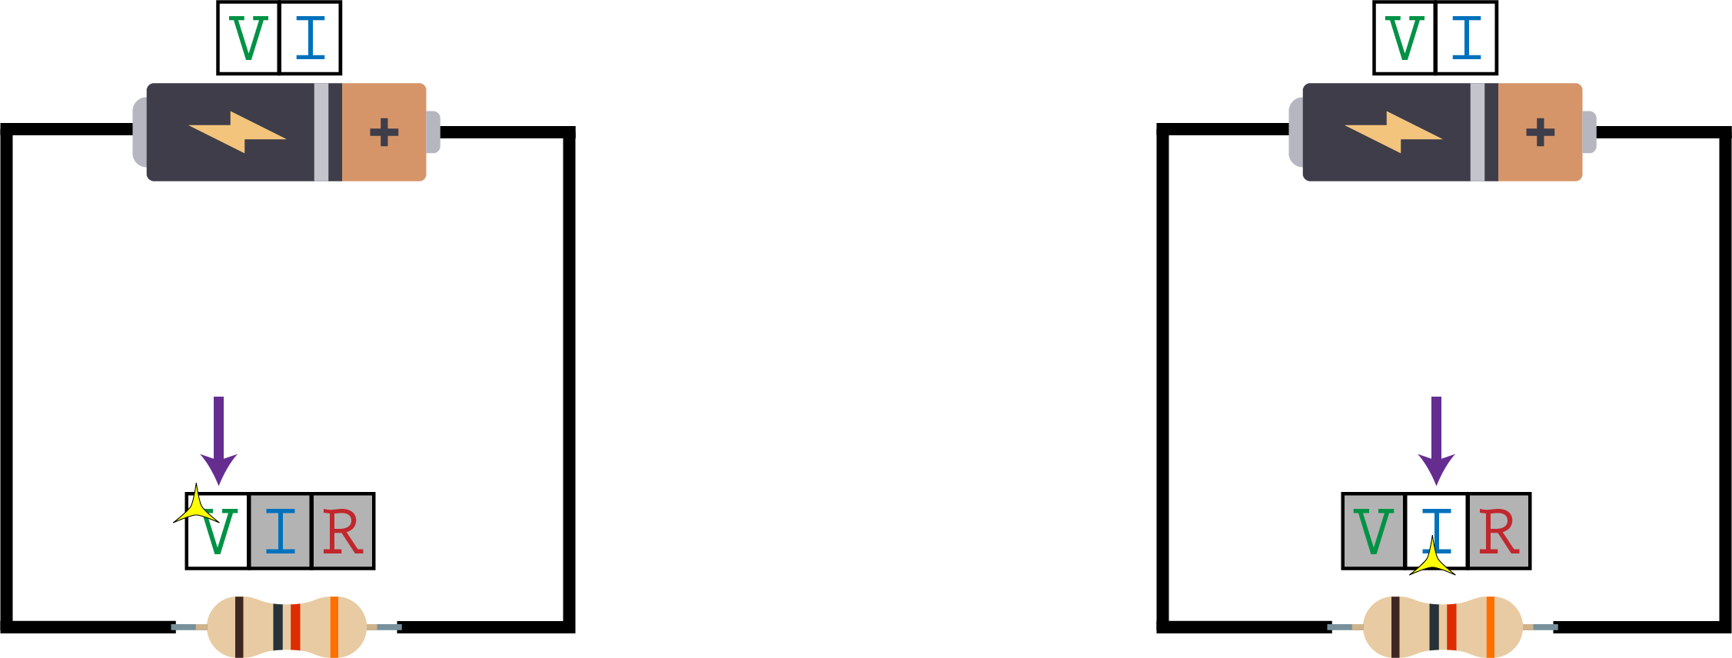

**Right Circuit**

Place a token on the **Current** on the resistor to reveal it.



Not too bad, right? The Ohm’s Law move is a straightforward, but essential move in this game.

## Move 2: Kirchhoff’s Current Law

To make this move, first select a Kirchhoff Junction. A Kirchhoff Junction is any point on the circuit where the wires branch into more than one possible direction.

Kirchhoff Junctions are marked in blue dots on the board:

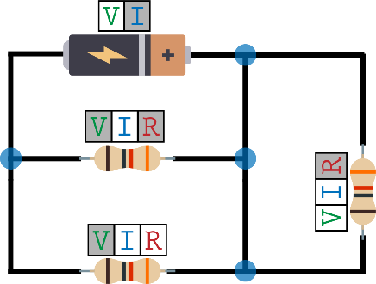



Kirchhoff Junction

Once you’ve selected a Kirchhoff Junction, identify the components that are *directly connected* to that junction. For the components that are directly connected to the junction, if you know the **Current** for all components except for one, then you can reveal that unknown **Current**.

The pink dashed lines show the components that are directly connected to this Junction

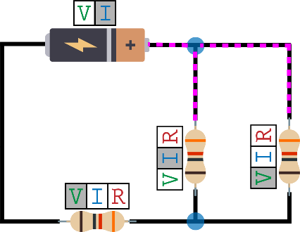

You can reveal this **Current**

Careful! Say you have selected the Kirchhoff Junction at the top of this circuit. The following is an **INVALID** use of Kirchhoff’s Current Law:

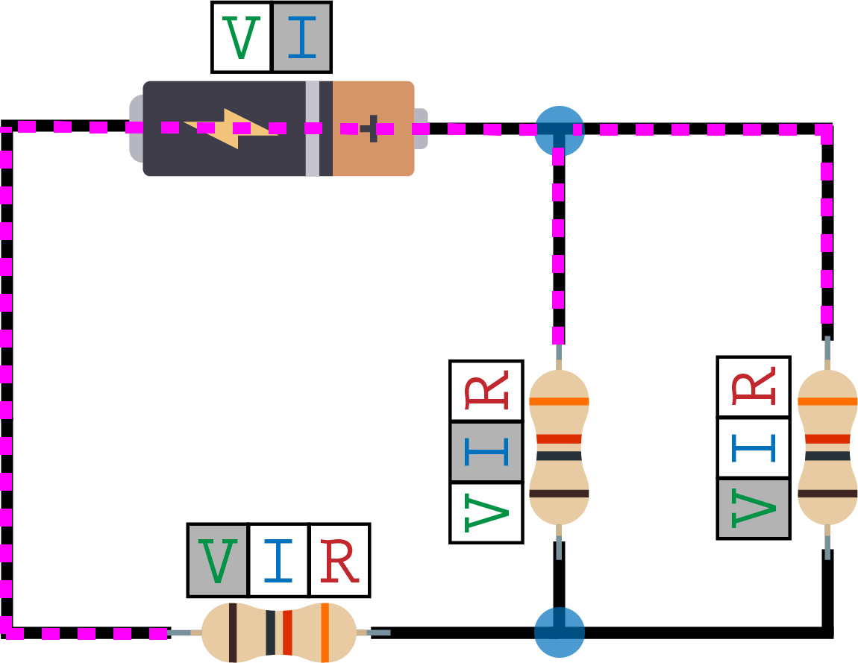

**INVALID: This resistor is not directly connected to the Kirchhoff Junction at the top**

## Kirchhoff’s Current Law Mini-Game

Let’s play a mini-game to make sure you understand this move. Take **Board 4** and place it in front of you. There are 2 circuits on this board. Use Kirchhoff’s Current Law to reveal the unknown values. You may also need to use Ohm’s Law. After you’ve tried this, flip to the next page to see if you are correct.

Don’t turn the page until you have completed this mini-game with **Board 4**!



## Kirchhoff’s Current Law Mini-Game – Solution

**Left Circuit**

First, note that the dashed pink lines show the components that are directly connected to one of the Junctions. For these three components, the **Current** is known for all except for one, so we can reveal that unknown **Current**.

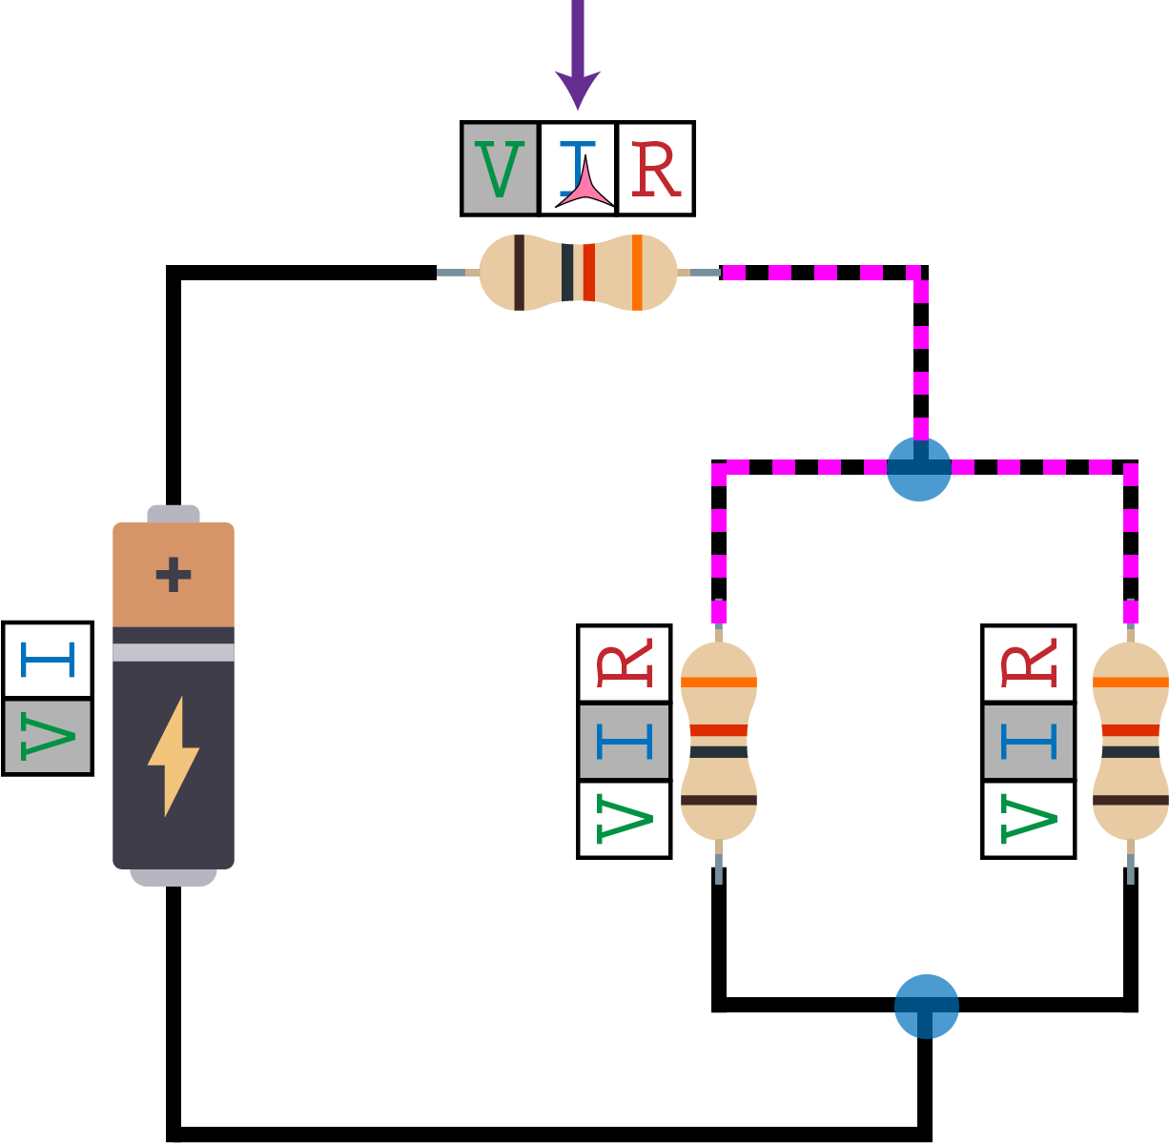

**Right Circuit**

This one requires two steps:

|  |  |
| --- | --- |
| First, use Ohm’s Law to reveal the **Current** of the resistor all the way on the right. | Then, use Kirchhoff’s Current Law with the bottom junction to reveal the **Current** of the battery. |
| C:\Users\zmine\Google Drive\Classes\Design_Of_Educational_Games\FinalProject\Ed Games - The Ghost of Cleatus\2_Ideation_and_Prototyping\Assets\Board4_Sol2_P1.png | C:\Users\zmine\Google Drive\Classes\Design_Of_Educational_Games\FinalProject\Ed Games - The Ghost of Cleatus\2_Ideation_and_Prototyping\Assets\Board4_Sol2_P2.png |

## Move 3: Kirchhoff’s Voltage Law

Instead of explaining this move upfront, let’s play one more mini-game. Take **Board 3** and try to reveal the indicated unknown. Once you’ve tried it out, go to the next page to see the answer.

This one might be tricky, so don’t spend more than 2 minutes trying to figure it out.



Don’t turn the page until you have attempted this mini-game with **Board 3**!

## Kirchhoff’s Voltage Law Mini-Game – Solution

Did you get stuck? Player 1 learned about the Kirchhoff’s Voltage Law move in the other set of instructions. After both of you have made an attempt to play through **Board 3** on your own, work together to try to reveal the indicated unknown. Player 1 may need to ask you about Kirchhoff’s Current Law!

The actual solution to the **Board 3** mini-game is in the “Both Players” instruction set. After you’ve worked together on **Board 3**, take a look at it to make sure you both understand the 3 moves.