Colvio
Training Guide
Explore, load and audit Dynamics 365 / Dataverse from the browser
v1.11.171 · October 2026

Contents

1. Introduction
Colvio is a free, open-source Chrome extension for Microsoft Dynamics 365 / Dataverse. It rides on your existing browser session: no API key, no app registration, no account. Open a D365 page, click the Colvio icon, start working.
- Zero configuration — authentication reuses your D365 session cookies.
- Privacy first — nothing leaves the browser: no telemetry, no third-party servers.
- 21 modules covering exploration, restore, data loading, API testing, modeling and auditing.
- EN / FR interface, dark/light theme, searchable built-in Help.
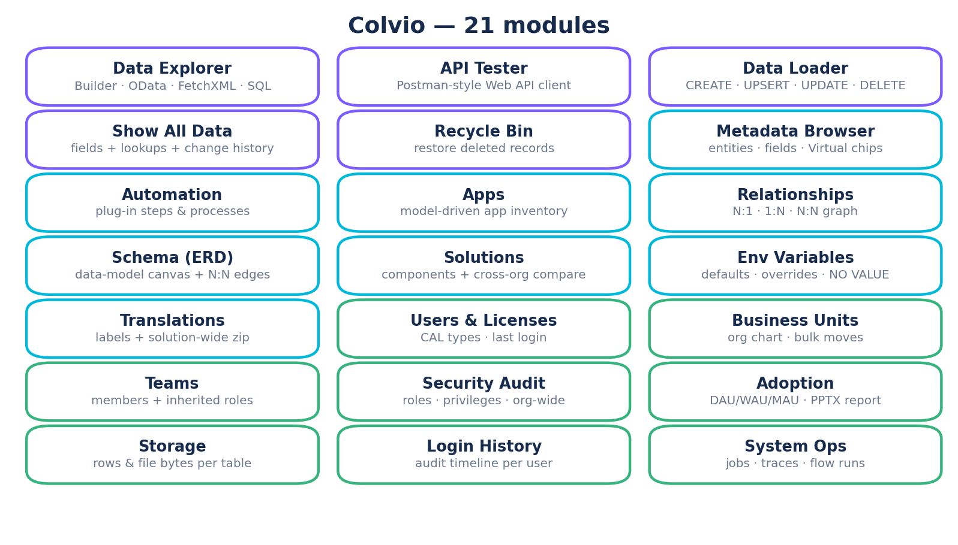
💡 Recommended screenshot here: the Colvio sidebar with all 21 tabs, on your demo org.

2. Installation & first launch

Install
- From the Chrome Web Store: search “Colvio for Dynamics 365” and Install (or from source: npm install, npm run build, then load dist/ via chrome://extensions in Developer Mode).
- Pin the Colvio icon to the Chrome toolbar.
- Open any Dynamics 365 page (your usual org).
- Click the Colvio icon: the panel opens in a new tab, already connected to your org.

Environment badge
At the top of the panel, a badge shows the environment: ⚠ PROD (red) or SANDBOX / UAT / DEV / TRIAL (green). It maps Microsoft's DOCUMENTED OrganizationType enum: a production org reports Customer or Secondary — the enum has no Production member — and any unknown value is presumed production (fail-closed). Colvio's PROD confirmations (Loader, bulk update/delete, edits) arm on this detection. Always check the badge before loading data.

Permission-based tabs
On startup Colvio probes your permissions and hides tabs you can't use (Security Audit, Login History, Users & Licenses need audit/user read rights; the Loader's Speed boosters require System Administrator). Rights are always re-enforced server-side by Dataverse: Colvio can never exceed your security roles.

3. Data Explorer
The core module: query any table in your org with one of 4 query modes, then sort, edit and export the results.

The 4 query modes
- Builder — visual: column picker, WHERE filters in AND/OR groups (14 operators), parent and child $expand (with per-expand filters), sorting, limit.
- OData — the raw URL, directly editable.
- FetchXML — editor with 3 templates (simple, join, aggregation) and paging-cookie pagination.
- SQL — write familiar SQL, Colvio translates it to FetchXML (see below).

Working with results
- Auto-pagination with no 5,000-row cap, smooth virtual scrolling on 10,000+ records.
- Inline edit — double-click a cell to modify it (direct PATCH).
- Bulk update / bulk delete on selection, with typed confirmation and CanBeDeleted pre-check.
- Saved queries (20), history (20) and 5 ready-made templates.
- Clickable lookups (opens the record in D365), copy OData URL.
- Export CSV / XLSX / JSON.

SQL mode
Two engines, one toggle. ⚡ Native (default): your SELECT goes straight to Dataverse via the Web API ?sql= option — the server parses it: multi-table JOINs with aliases, self-joins, DISTINCT, server-side GROUP BY and aggregates, DATEADD/GETUTCDATE relative dates (no SELECT *, subqueries, HAVING or TOP; aggregates capped at 50,000). ⇄ Transpiled: Colvio converts the SQL to FetchXML — the only engine with HAVING and TOP, and the automatic fallback when the org lacks the option:
- SELECT name, revenue FROM account WHERE statecode = 0 ORDER BY revenue DESC TOP 100
- SELECT a.name, c.fullname FROM account a JOIN contact c ON a.primarycontactid = c.contactid
- The “View FetchXML” button shows the generated XML — a great way to learn FetchXML.

4. API Tester
A Postman-style client for the Dataverse Web API with zero setup: authentication rides on your active D365 session (no OAuth, no client secret, no token refresh).
- GET / POST / PATCH / PUT / DELETE on a relative path (accounts?$top=5) or a full same-org URL (the host is re-validated: calling another domain is impossible).
- Header autocomplete for common Dataverse headers: Prefer, If-Match, MSCRM.SuppressDuplicateDetection, MSCRM.BypassCustomPluginExecution…
- JSON body editor with line numbers and live validation (errors point at the exact line).
- Response: status, elapsed time, size, pretty JSON, headers tab.
- Templates: WhoAmI, CREATE, PATCH, UPSERT by alternate key, DELETE, RetrieveCurrentOrganization.
- History of the last 50 requests (secret-bearing headers like Authorization are redacted before local save).
- Copy as cURL, send with Ctrl/Cmd+Enter, multiple tabs.
💡 Typical uses: test a call before wiring it into a plugin or Power Automate, reproduce a support ticket, check how an MSCRM header behaves.

5. Inspecting a record and the metadata

Show All Data
Auto-detects the record open in your D365 tab (or paste a URL / GUID) and shows every field: logical name, label, type, value. Clickable lookups, copy per-field or full JSON. Writable fields edit inline — lookups included: paste the target GUID to link/relink, clear to unlink, all validated before sending (production confirms first).

Metadata Browser
Browse entities, fields and OptionSets (value, label, description, color). CSV export of all fields of an entity (logical name, OData name, type, required, custom) — an instant data dictionary — and export of all OptionSets. Virtual / Elastic chips filter by table type (find every virtual table at a glance). This is where you check a picklist's exact labels before a label-based import.

6. Data Loader — bulk data loading
The Data Loader imports CSV, TSV or Excel files into any table through a 5-step wizard. It is built for large volumes (hundreds of thousands of rows) with real-time per-row feedback.
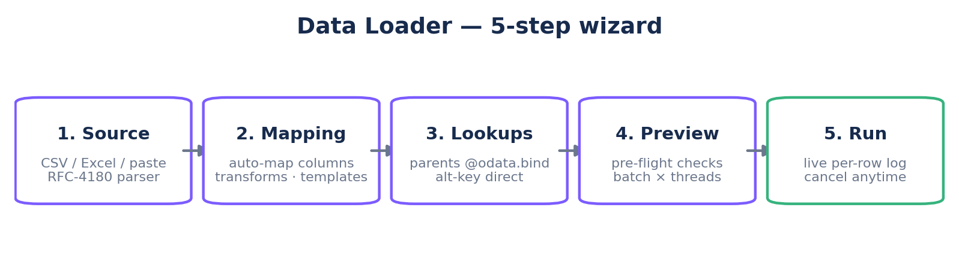

Step 1 — Source
Drag-drop a file (.csv, .tsv, .txt, .xlsx, .xls) or paste straight from Excel. The delimiter is auto-detected (comma, tab, semicolon) and the parser is RFC-4180 compliant: quoted cells, embedded commas and line breaks, escaped quotes. Values are trimmed and leading zeros preserved (SAP-style codes…).

Step 2 — Mapping & transforms
File columns auto-map to D365 fields (name matching + common fields). Lookup-type columns are detected and routed to the Lookups step — never written raw. A pre-flight warning flags fields that are not writable for the chosen mode (calculated, rollup). Each column can take a transform:
- picklist / statecode — accepts the numeric value or the label (“Hot”, “3 - Hot”): the OptionSet is preloaded and labels converted; unmatched labels are listed after the run instead of silently dropped.
- date ISO — 2026-06-13 kept as-is (no timezone shift), 13/06/2026 (EU), 12/31/2026 (US auto-detected), optional 24h or AM/PM time.
- int / float — locale-aware: 1 000, 1,5, 1.234,56.
- boolean / yes-no, UPPER / lower.
💾 Mapping templates: save the full configuration (mappings, lookups, key, mode, performance) and reload it next time you import into the same entity.

Step 3 — Parent Lookups
For each parent relationship pick the mode: direct (the column already holds the GUID), resolve (Colvio resolves the value — e.g. an email — to the GUID with one query per unique value), or direct alternate-key binding (entityset(field='value'), no resolution query at all — fastest). When a value doesn't match, your chosen fallback applies: Skip (row skipped), Null (row loaded without the lookup) or Error.

Step 4 — Pick the import mode
The most important choice in the wizard. The key (GUID or alternate key) addresses the record in the URL — it is never duplicated in the body.
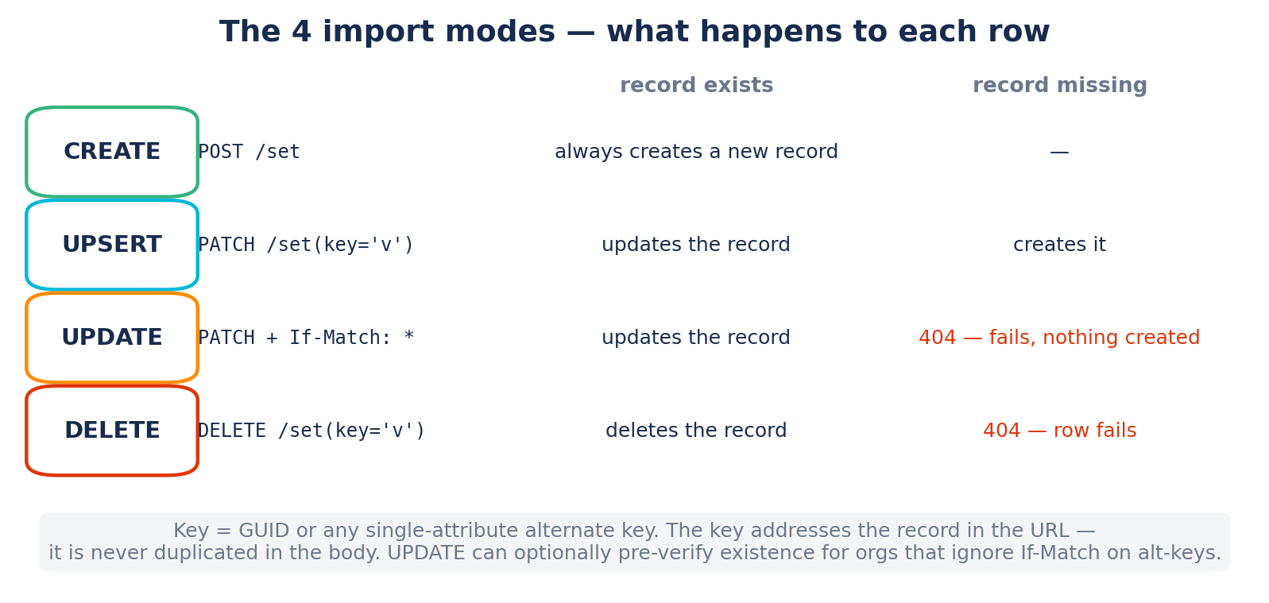
Mode | What it does | Use it for
CREATE | Every row becomes a new record (POST). | Initial loads, brand-new data.
UPSERT | Match on the key: update if found, create otherwise. | Repeated syncs, idempotent migrations.
UPDATE | Strictly update: native If-Match: * header on every PATCH → 404 when missing, never a create. Empty key = error. Optional “verify existence first” safety net. | Mass updates where any create would be a bug (e.g. enriching 400k existing contacts).
DELETE | Deletes the records matched on the key. Typed confirmation. | Targeted purges by business key, import rollbacks.
⚠️ In UPDATE mode, rows failing with 404 are by design: the key matches no record and nothing is created. Switch to UPSERT if creation is desired.

Step 5 — Performance
Records are sent as multipart $batch with one changeset per record: a failing row never rolls back the others. Tune batch size (1-500) × threads (1-10) — defaults 200 × 6 ≈ 3-4k records/second. Dataverse throttling (429) is retried automatically honoring Retry-After. Cancel stops everything, including pending retries: no writes after cancel.
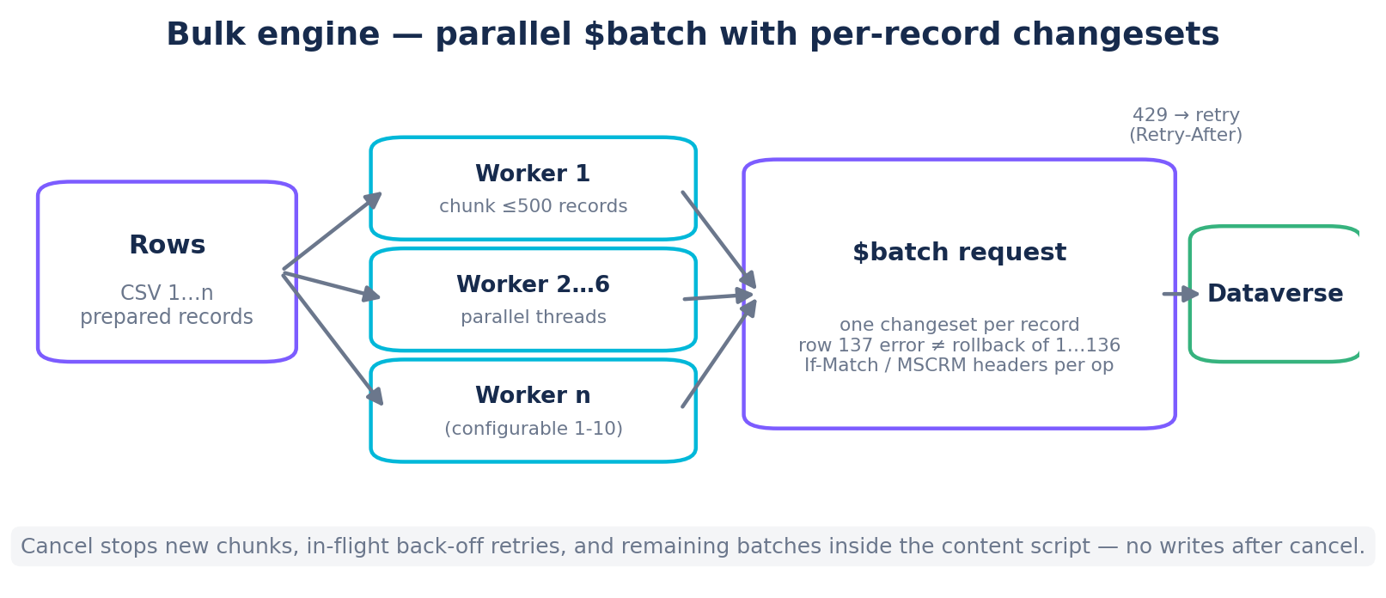
- Speed boosters (System Administrator only): per-record BypassCustomPluginExecution, SuppressDuplicateDetection, BypassSynchronousLogic.
- They can multiply throughput on heavily customized entities — but server-side business logic is skipped: only use on already-validated data.

The live log
During the run every row appears with its CSV values and Success / Failed status + the exact Dataverse error. After the run: click a row to see the exact request sent (method, URL, headers, body), export the full log or only the errors as CSV, and review the list of unconverted option-set labels.

6b. Safety net & new modules

Dry run, Rollback, Delta
Before a risky load: Dry run simulates the whole import with zero writes and reports row by row what a real run would do. After a create run: Rollback deletes exactly the records that run created (GUIDs captured from the batch responses), typed confirmation. On recurring syncs: Delta mode reads current values first and only sends the fields that actually changed — unchanged rows are skipped (UNCHANGED status).

Recycle Bin
Lists and restores deleted records (true server-side restore, original values) when the org-level Keep-deleted-records setting is on (1-30 day retention). Microsoft limitations are shown in the module: pre-enablement deletes, virtual/elastic/solution tables, tables with more than 600 columns, cascade ordering, key conflicts.

Record change history
In Show All Data, every record gets a History panel: the audit timeline (who, when, action) and a field-level diff (old → new). Requires auditing enabled (org + table).

System Ops
System Jobs: quick filters (failed, waiting, in progress), bulk cancel/resume for admins — platform-maintenance jobs cannot be cancelled. Plugin Traces: exceptions highlighted, full trace text (10 KB cap), CSV export; ~24h auto-purge.

Schema snapshot & diff
In the Metadata Browser (⇄ button): export the schema as JSON on one org, load it on another, and get a ranked diff (missing tables/columns, type mismatches) with CSV export — ideal before a DEV → UAT → PROD deployment.

7. Modeling: schema, relationships, solutions, translations

Schema (ERD)
Interactive Entity-Relationship Diagram: add entities to the canvas, cards show fields with FK badges, curves connect each lookup to its target. N:N relationships draw as dashed lines between cards. Drag, zoom, “+” adds related entities. Export PNG, SVG, Mermaid — your data model, ready for a wiki or a deck.

Relationships
Relationship graph for one entity: N:1 parents, 1:N children, N:N. Business relationships show first; the system plumbing (createdby, owner, currency…) hides behind a toggle. ↻ reloads from the org (metadata is cached 1 h). Depth 1-2, click to drill down.

Solutions
Browse installed solutions and their components, resolved to readable names (13 types: entities, attributes, views, plugins, web resources, roles…). Managed/Unmanaged badges.

Translations
View and edit field labels across all installed languages, inline. Non-renameable fields are locked. CSV export/import for bulk translation, auto-publish.

8. Admin modules

Users & Licenses
All users with Access Mode, CAL Type, BU, security roles and last login (from audit). License-type breakdown, unused-license detection (disabled users, never logged in). CSV export.

Security Audit
All security roles with privileges as readable labels (prvDeleteAccount → “Delete · Account”), depth badges (User / BU / Parent:Child / Org in red), and 30+ sensitive privileges flagged. CSV export per role.

Teams
Every team in the org by type (owner, Entra group, on-demand access teams): the members, and above all the security roles the team carries — inherited by every member without ever showing on their profile. It answers the question: why does this user have that right? For Entra teams: copiable group Object ID, plus the reminder that membership materializes on the user's next access.

Storage
Where your Dataverse capacity goes: the row count of every table (Dataverse snapshot under 24 h old — the whole org in seconds), ranked and tagged Database / File / Log, the system tables that grow silently with the cleanup action that applies, and file storage per table in real bytes (notes, file/image columns, attachments), computed in the background. The billed GB stay in the Power Platform admin center (Licensing → Dataverse) — the module links there.

Business Units & Adoption
Business-unit hierarchy as a tree or a full-screen org chart (PNG export). Bulk user moves — tick, or paste a list of emails (selection within the displayed BU, or an org-wide search to move INTO the BU) — with the roles truth stated before confirming. Adoption: access events, DAU/WAU/MAU, per-BU rates, inactivity, one-click PowerPoint report.

Login History
Access timeline per user (D365 user-access audit): app vs web-services (API) access, active days, last access, CSV/Excel export — Dataverse has no sign-out event, so no session durations. Requires auditing enabled with “Audit user access”.

9. Exports & file naming
Every export follows the same naming convention:
- <object>_<YYYYMMDD>.<ext> — e.g. account_20260610.csv, contact_fields_20260610.csv.
- Import run logs add the time: colvio_load_contact_20260610_103000.csv — several runs the same day never overwrite each other.
- CSV cells are protected against formula injection; XLSX exports keep real numeric cells (SUM works).
ℹ️ Excel opens downloaded files in Protected View (“Enable Editing”): that's a Windows/Office safeguard on every internet download, not a Colvio setting. To avoid it daily, add your export folder to Excel's Trusted Locations.

10. Troubleshooting / FAQ
Symptom | Explanation & fix
“Session expired” | The D365 session timed out. Refresh the D365 tab (F5), then click Reconnect in Colvio.
Rows fail with 404 in UPDATE mode | By design: the key matches no record and UPDATE never creates. Use UPSERT to create.
“Lookup not found / check failed” | The value couldn't be resolved. The row follows your fallback (Skip/Null/Error). Check the lookup's D365 key field.
Unconverted option-set labels | The CSV label doesn't exist in the OptionSet. Check exact labels in the Metadata Browser, or use numeric values.
HTTP 429 | Dataverse Service Protection throttling. Colvio retries automatically; if it persists, lower threads and batch size.
Unexpected PROD badge | The badge maps the OrganizationType enum: production orgs report Customer or Secondary, and any unknown value is presumed PROD (fail-closed) — a spurious PROD badge costs one confirmation click, never the reverse.
Slow import on huge files | Raise to 8-10 threads and batch 500; as an admin, consider Speed boosters (validated data only).
Excel asks to “Enable Editing” | Windows/Office Protected View on downloads — see section 9.

11. Keyboard shortcuts
Shortcut | Action
Ctrl/Cmd + Enter | Run the query (Explorer, SQL, API Tester)
Ctrl + / | Open the shortcuts panel
Esc | Close the active modal / panel
Double-click a cell | Inline edit (Explorer)

