Colvio
Technical Specification
Architecture, Dataverse integration, load engine, security
v1.11.171 · October 2026

Contents

1. Overview
Colvio is a Manifest V3 Chrome extension (React 18 + Vite) for Microsoft Dynamics 365 / Dataverse. It ships 21 exploration, loading and audit modules with no backend at all: every request goes from the user's browser to their own org, authenticated by the existing session.
Metric | Value
Lines of code (src) | ~21 200
React components | 40
API actions (content script) | 73
Unit tests | 347 (Vitest)
Panel bundle | ~996 KB (+ ~430 KB xlsx, ~373 KB pptxgen on demand)
Runtime dependencies | React 18, react-dom, xlsx (lazy), pptxgenjs (lazy)
Chrome permissions | scripting · storage · declarativeContent

2. Architecture
Three isolated execution contexts communicate over Chrome messaging. The panel (React) never touches Dataverse directly: every call relays through the service worker (pure relay) to the content script — the only privileged context — which performs the same-origin fetch with session cookies.
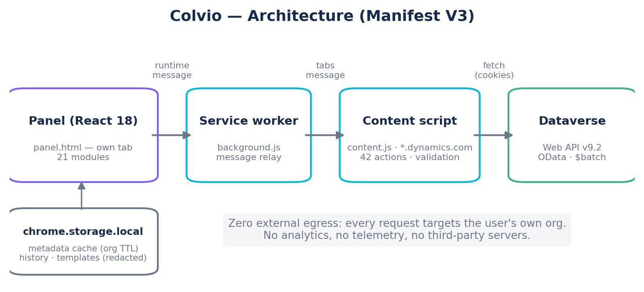

Components
- panel (src/) — the React app: 39 components, one module = one tab. The bridge (d365-bridge.js) exposes the typed API and owns rate limiting (30 req/s), caching, and the bulk worker pools. Risky logic (typed write preparation, OData filters, history) lives in pure tested modules (updateUtils, filterUtils, historyUtils, loaderUtils…).
- background.js — service worker: panel ↔ content-script relay, resilient to browser tab sleep (the D365 tab is pinned non-discardable, woken/re-injected as needed, replaced ids tracked via tabs.onReplaced) with an origin guard: a request never goes to a tab showing a different environment. Rejects any message whose sender.id isn't the extension.
- content.js — injected on *.dynamics.com: org context extraction, 73 actions (query, metadata, batch…), input validation (entity/field regexes, GUIDs, control-char stripping), $batch building, 429 back-off.

Message protocol
Request: {__d365InspectorRequest, id, action, params, d365TabId, orgUrl}; response: {result} or {error}. Bridge timeouts: 30 s standard, 10 min for bulk operations. Bulk chunks are capped at 500 records per message to stay under Chrome's 64 MB IPC limit.
- 401/403 → SESSION_EXPIRED signal surfaced to the UI (Reconnect button).
- Bulk cancellation: the bridge sends abortBatch; the content script stops pending 429 retries and remaining chunks (resetBatchAbort re-arms at each run start).

3. Modules
One module = one React component mounted in its own ErrorBoundary (a crash never takes down other tabs).
Module | Technical role
Data Explorer | 4 query modes (Builder/OData/FetchXML/SQL), relational filters (parent nav-paths + any()/not any() lambdas), auto-pagination, virtual scrolling + sticky horizontal scrollbar, metadata-TYPED inline edit and bulk update (lookups via @odata.bind), duplicate finder, $batch bulk delete with ✕ Cancel, history restoring Builder queries into the Builder (values redacted — privacy).
SQL (2 engines) | Native: the SELECT goes straight to Dataverse via the Web API ?sql= option (multi-table JOINs with aliases, self-joins, DISTINCT, server-side GROUP BY; orgs without the option auto-detected). Transpiled: dedicated parser (sqlToFetchXml.js, 43 tests) SELECT/JOIN/WHERE/GROUP BY → link-entity — the only engine with HAVING/TOP.
API Tester | customRequest action: whitelisted methods, host validated twice, 60 s timeout, raw response (status/headers/body) returned unmodified, .json/.txt download.
Data Loader | See section 5 — parsing, transforms, 4 modes, $batch engine, metadata-typed coercion, auto-resume after timeout.
Show All Data / Metadata | EntityDefinitions + attributes; typed inline field editing, LOOKUPS included (link/relink/clear via @odata.bind, GUID-validated); BPF manager; Virtual/Elastic filter chips; data-dictionary and OptionSet CSV exports.
Automation / Apps | Static inventory of plug-in steps + processes (Microsoft/Managed/Custom classification); model-driven app inventory (include-all inference, EXPLICIT/IMPLICIT badges, view inspector, subgrids, reverse search).
Env Variables | Defaults + typed overrides (yes/no, validated JSON, numbers), NO VALUE trap counted, secrets = Key Vault references.
Schema (ERD) / Relationships / Schema diff | Custom SVG rendering (drag/zoom/pan), dashed N:N edges in the ERD, business relationships first in the graph (system plumbing behind a toggle, cache-clearing ↻), PNG 2x / SVG / Mermaid exports; JSON snapshots + ranked cross-org diff.
Solutions / Translations | Components resolved (40+ types), intra-org and cross-org compare (compare file, two-pass matching); multilingual labels + solution-wide zip export/import (ExportTranslation).
Recycle Bin | FetchXML datasource='bin' + Restore action; enablement detection; MS limitations surfaced.
Audit History / System Ops | audits + RetrieveAuditDetails; asyncoperation (bulk cancel/resume), plug-in traces (quick ~24 h windows), solution cloud-flow runs (flowrun table).
Users & Licenses / Security Audit / Login History | Full systemusers pagination, per-role privileges + matrix + org-wide view, bulk role assignment, audit logs. Tabs hidden without rights.
Business Units / Adoption | Hierarchy + full-screen org chart (PNG), bulk user move (roles truth stated first), paste-a-list selection and move-INTO-a-BU by pasted email list (org-wide match); adoption analytics (server-side per-day aggregation, DAU/WAU/MAU, service accounts separated, native PowerPoint report).
Teams | Owner / Entra group / access teams (lazy-loaded, 500 cap): members, carried security roles (inherited by members without ever showing on the user), copiable Entra Object ID, lazy-materialization truth stated. Read-only.
Storage | Rows per table for the whole org via RetrieveTotalRecordCount (Dataverse snapshot ≤ 24 h, a few chunked calls, bisection isolating any refused table); storage class per Microsoft's split (File / Log incl. elastic tables / Database); file bytes per table (aggregates over notes, file/image columns, attachments) in the background with period bisection past 50,000 rows. Billed GB stay in the admin center (app-registration API).

4. Dataverse integration

Context & authentication
The content script extracts clientUrl and the API version from the D365 page context. All calls are same-origin fetch with credentials:"same-origin" — Azure AD/Entra session cookies carry authentication. No token is ever extracted, stored or handled.

Environment detection
RetrieveCurrentOrganization provides OrganizationType — the badge's source of truth, mapped on Microsoft's DOCUMENTED enum: a production org reports Customer or Secondary (the enum has NO Production member), CustomerTest/CustomerFreeTest = sandbox, TestDrive/Trial = trial. Unknown values are presumed production (fail-closed: PROD confirmations can never be disarmed by a new type). The hostname heuristic is fallback only.

Metadata cache
Two tiers: in-memory (session) + chrome.storage.local (persistent). Keys are org-prefixed (d365_cache_<org>_…) — no cross-environment bleed. On storage-quota exhaustion the cache self-evicts (other orgs first, then the current org, then in-memory fallback): a cache write can never break a feature.
Data | TTL | Contents
Entities | 2 h | logical name, display name, EntitySetName
Fields | 1 h | type, required, IsValidForCreate/Update, custom
Lookups / OptionSets | 1 h | N:1 relationships, option values
EntitySetName (single resolution) | 24 h | exact collection name (irregular plurals)

5. Data Loader engine

Parsing (loaderUtils.js — unit-tested)
Character-level RFC-4180 parser: quoted fields, embedded delimiters and line breaks, escaped "". Delimiter detection: an unquoted tab wins (Excel paste), else ; vs , count outside quotes. Excel files are read straight to rows (sheet_to_json, no CSV round-trip). Values trimmed, leading zeros preserved (no numeric coercion).

Transforms
applyTransform(value, transform, optionMap) — pure, tested functions: picklist/statecode (label→value via preloaded OptionSet, label lookup before strict numeric passthrough), date_iso (DateOnly verbatim, dd/mm/yyyy, US swap when month > 12, 24h/AM-PM time → local→UTC ISO), locale-aware int/float (spaces/NBSP, decimal comma, thousands), EN/FR booleans. Unconverted labels are collected and surfaced after the run.

The 4 modes
The key (PK or single-attribute alternate key) addresses the record in the URL — never duplicated in the body (buildClean strips it as defense). UPDATE: If-Match: * on every $batch PATCH and on the serial fallback; empty-key rows rejected client-side; optional existence pre-check (OR queries of 80, GUID normalization on both sides, per-value fallback on 400, never a global abort). UPSERT by alt-key: direct entityset(field='value') binding. DELETE: DELETE by key, same logging guarantees.
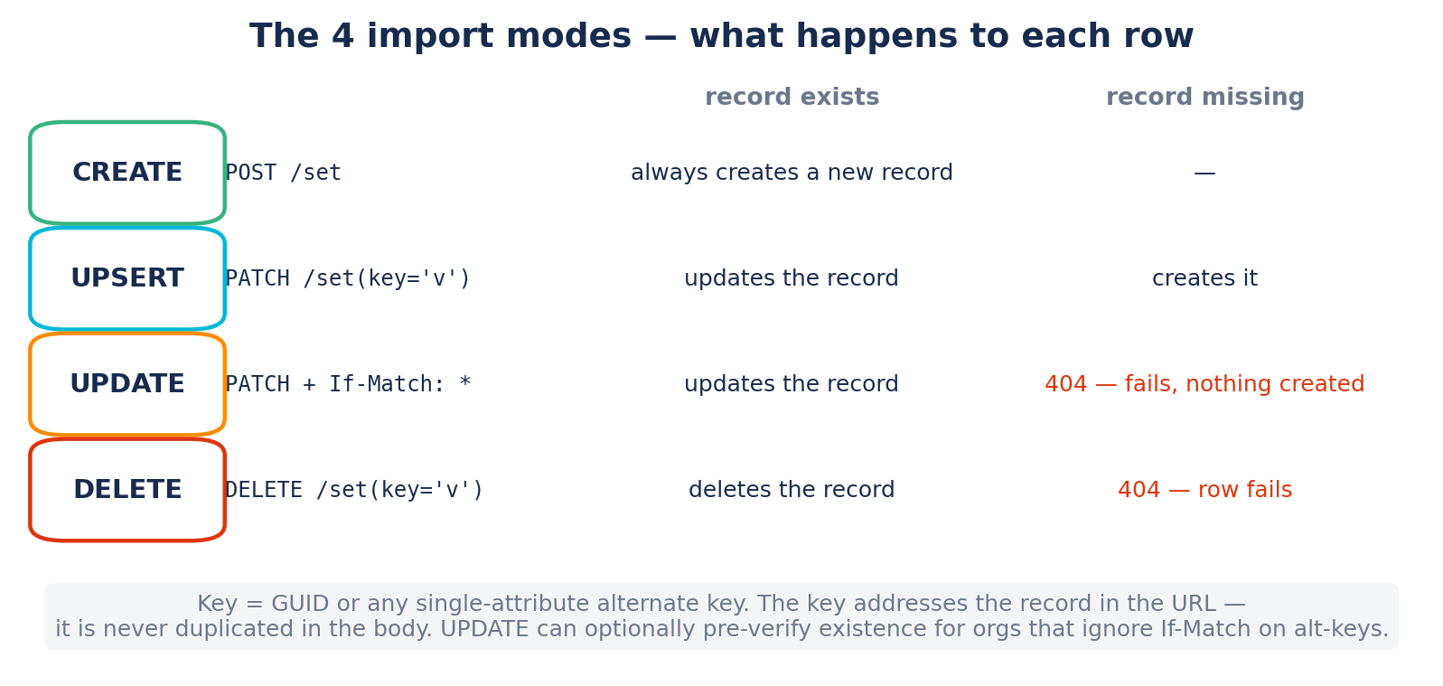

$batch engine
The bridge chunks (≤500) across a worker pool (1-10, default 6). The content script builds the multipart: one changeset per record (per-row atomicity, no batch rollback), If-Match/MSCRM headers injected per operation. Responses parsed by positional Content-ID → per-row log. 429: Retry-After retry (30 s cap, 4 attempts) at the $batch level and inside dvRequest (resolutions, pre-checks).
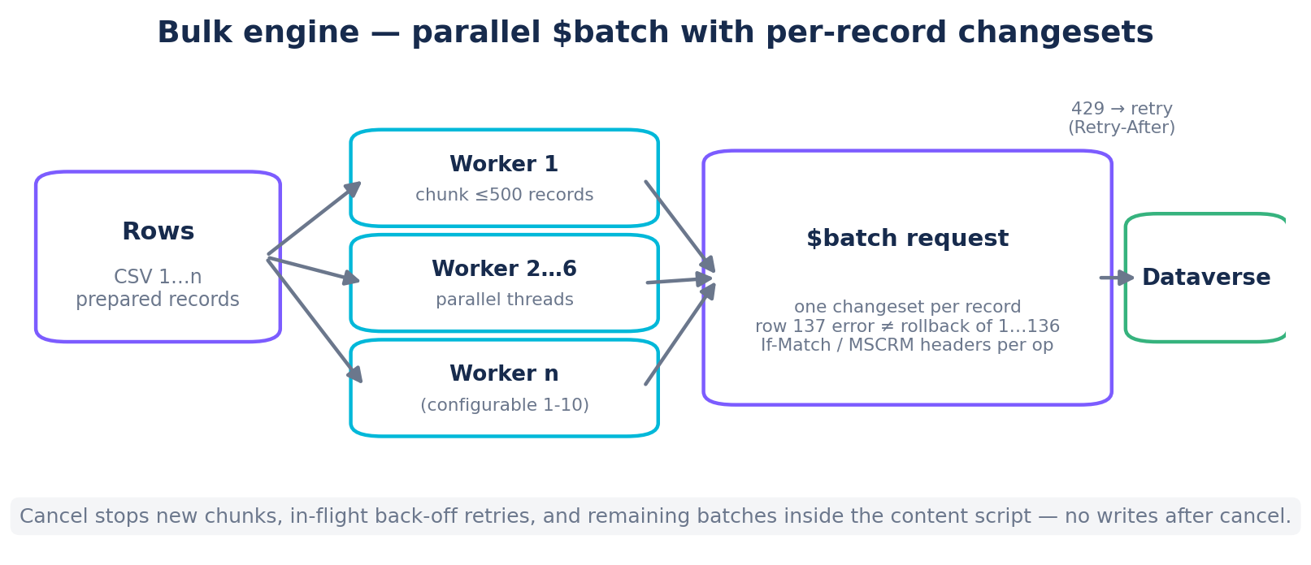

Cancellation
Three levels: the bridge pool stops dispatching (shouldAbort), the content script receives abortBatch (run-scoped flag) which interrupts waiting 429 retries and remaining chunks, and resetBatchAbort re-arms the next run. Guarantee: no writes after cancel.

Logging
Two structures: fullLog (ref, outside React — every row, O(1) memory per row) and a display buffer bounded at 300 entries (ring buffer, aggregated counters). Per-row details rebuild the exact request (same transforms + optionMaps as the send). Exports: full log, errors only, injection-protected CSV.

6. Security
Successive audits: 4 dimensions + 7-angle review (June 2026), write-path audit (August), 8-lens product audit (September), pre-publication review (September): 0 open critical or high findings. All writes remain subject to server-side Dataverse roles.
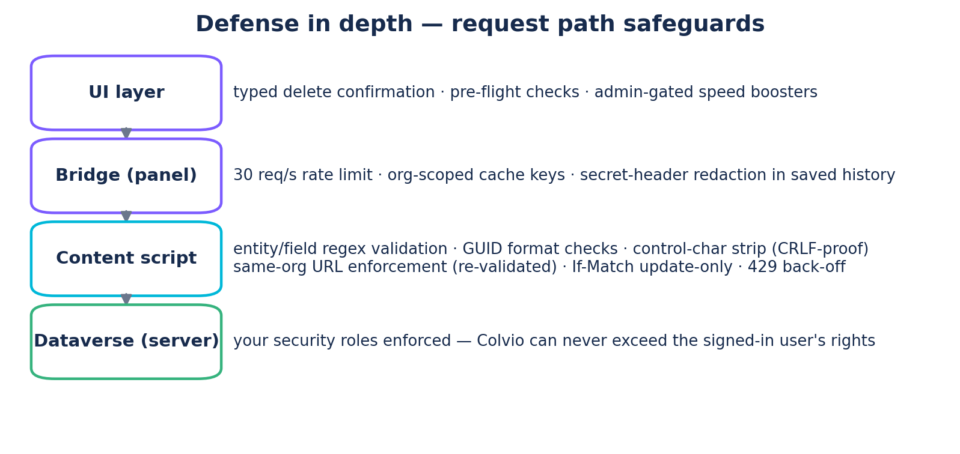
- Zero egress: every fetch targets the user's own org; no analytics, telemetry, CDNs or external fonts.
- Systematic content-script validation: entity/field regexes, GUIDs, control-char stripping in key values (anti-CRLF in $batch).
- API Tester: host re-validated after final URL assembly; history saved with secret headers redacted.
- CSV exports: formula-injection prefix; XLSX: typed cells (strings are inert there).
- MSCRM boosters gated on the prvBypassCustomPlugins privilege (System Administrator).
- Explicit CSP on panel.html; non-enumerable content-script marker; sender.id checked in the service worker.
- Centralized typed writes (updateUtils, tested): every typed-in value is converted by the field's real type and refused readably before sending — text in a GUID/lookup or a mistyped number never reaches the server (and never silently clears a field).
- Relay origin guard: the panel states its org on every request; the service worker refuses any tab showing a different environment (and refuses requests with no stated org — fail-closed).
- History privacy: filter values never persist — OData $filter, SQL literals and FetchXML values are redacted before storage, and entries saved by older versions are scrubbed on load (idempotent upgrade scrub).
- PRODUCTION confirmations on every destructive surface (Loader runs, bulk update/delete, inline edits, BU moves), armed by the real environment detection.

7. Performance
- Client rate-limit 30 req/s + 429 back-off; bulk worker pools (default 6; Dataverse allows 52 connections).
- Virtual scrolling (~35 rendered rows regardless of volume); bounded live log (300) + full ref outside re-renders.
- Lazy-loaded xlsx: panel ~490 KB; the ~430 KB xlsx chunk loads only on Excel drop/export.
- Two-tier metadata cache; debounced searches; parallel OptionSet preloading.
- Render caps (500 rows + honest banner) on potentially huge lists (role/BU/team members, users, adoption) — selection, filters and exports still cover the full list.

8. Build, tests & release
Vite (build < 2 s) + post-build script (manifest/content/background copy, icons). 347 Vitest tests: SQL parser (43), envDetect/sqlNative/teamUtils/relGraphUtils/loginHistoryUtils (fail-closed environment badge, native SQL engine, Teams, relationship classification, audit access channels), loaderUtils (transforms, RFC-4180 parser, typed coercion), updateUtils/filterUtils/historyUtils (writes, filters, history), adoption/BU/solutions/duplicates, i18n coverage (every t() key present in both locales). ESLint (real-bug rules: no-undef, no-dupe-keys…) in every pre-release pass.
- npm run build → dist/ loadable in Developer Mode; release zip colvio-<version>.zip (npm run pack).
- Flow: commit on main → build + tests + lint → zip → GitHub push → Chrome Web Store upload.
- Version kept in sync across package.json + manifest.json; exhaustive CHANGELOG.md.
Source code: github.com/zmissoum/colvio — MIT license.

