1. **查询和“李军”同性别的所有同学的Sname.**

**Select sname from student where sex in (select sex from student where sname=’李军’)**

1. **查询和“李军”同性别并同班的同学Sname.**

**Select sname from student where (sex,class) = (select sex ，class from student where sname=’李军’)**

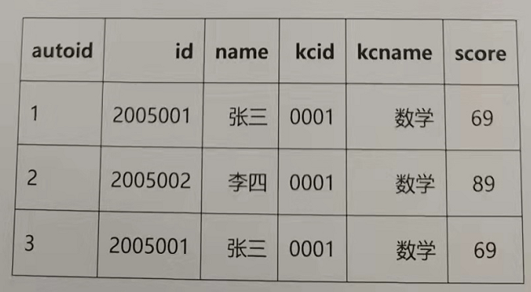

1. **学生表xueshengbiao 如上：自动编号 学号 姓名 课程编号 课程名称 分数；删除除了自动编号不同，其他都相同的学生冗余信息**。

Select autoid from xueshengbiao group by id,name,kcid,kcname,score as a;

Delete from xueshengbiao where autoid not in (select a.autoid from (Select autoid from xueshengbiao group by id,name,kcid,kcname,score) as a)

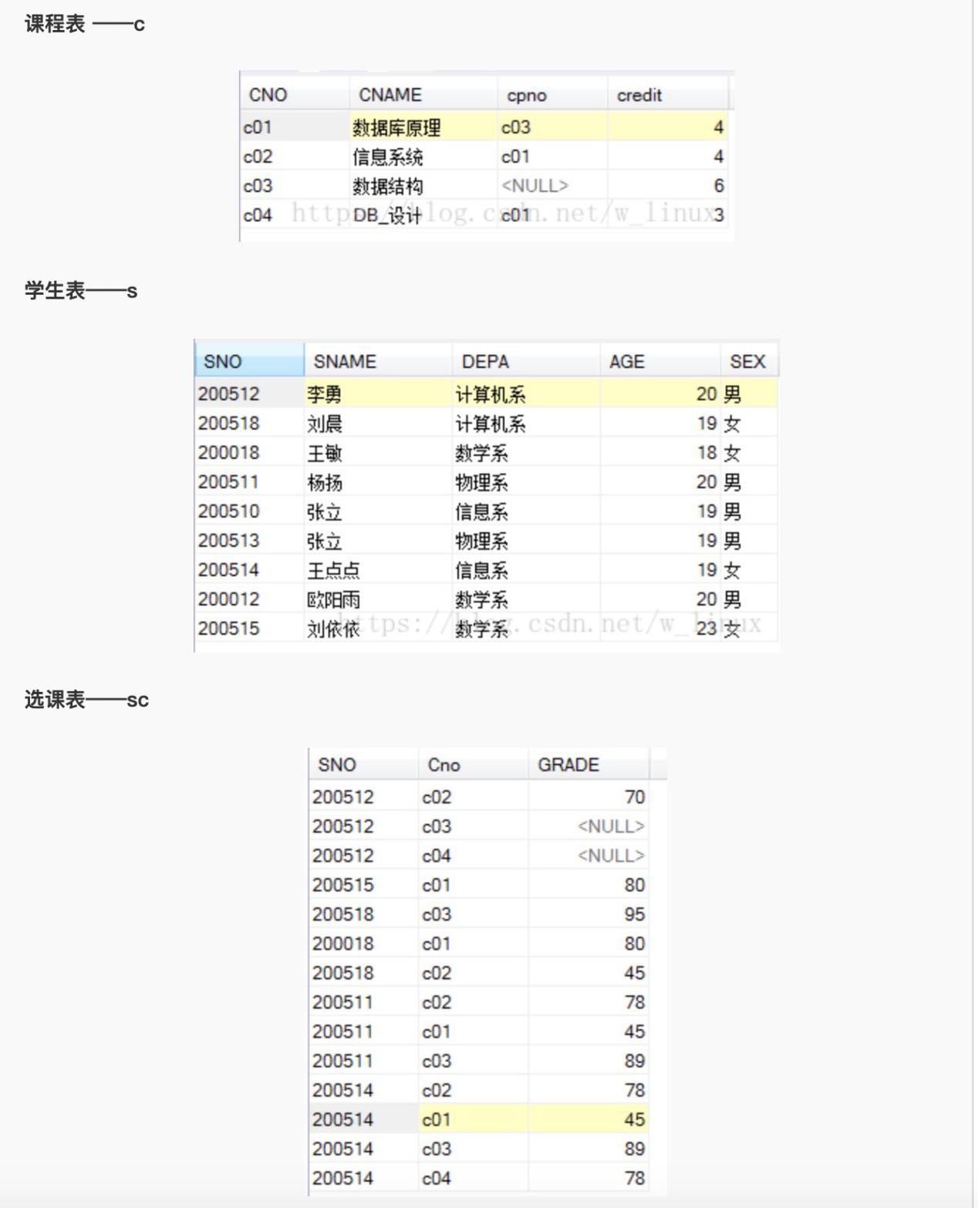

1. **查询" c01 "课程比" c02 "课程成绩高的学生的信息及课程分数**

**b**

1. **查询同时存在" c01 "课程和"c 02 "课程的情况(信息)**

**6.查询不存在" c01 "课程但存在"c 02 "课程的情况（信息）**