Homework: Week8

Lab: Extended Lighting with Shaders
Due in 2 1/2 weeks: Friday November 12.
Worth: 10 points (10% of total grade).

Extend the Lighting and Viewing program to allow programmable shaders to perform Phong Shading.

Changes to Existing Scene

- Change the UnitSquare to have 2 subdivisions (we want to show the impact of per-pixel lighting).
- Increase the specular reflection and shininess for the material used for the walls.
- Add a Torus geometry node. Use a ring radius of 20 and a tube radius of 5. Subdivide by 20 for each revolution. Place the torus along the back wall, rotated about the x axis so it is essentially laying against the wall. Use a shiny, black color (no ambient, very little diffuse)
- Place a shiny, bluish sphere along the right wall (radius = 10). Construct the sphere using triangles. Use the GLU model where you specify “m stacks” and “n slices” – these are the subdivisions in latitude and longitude. You can use glutSolidSphere to start out, but will lose 1 point if you don’t create a sphere model.
- Add a 3rd light source – a reddish spotlight placed at the camera position (view dependent) with cutoff angle of 30 degrees and a spotlight exponent of 32. It should be aimed along the view direction.

Changes to the Scene Graph Framework

- Add a LightNode as a new SceneNode type. It should allow setting all individual light properties. Its Draw method should call OpenGL to set these properties. The location of the LightNode with regards to the camera will determine whether the light is view dependent or positioned in world coordinates.

Since a LightNode can now be placed before (parent or prior sibling) a CameraNode, you will need to load the identity matrix prior to calling Draw. Your display method should look like this:

void display(void)
{
// Clear the framebuffer and the depth buffer
glClear(GL_COLOR_BUFFER_BIT | GL_DEPTH_BUFFER_BIT);

// Draw the scene graph and swap buffers
glLoadIdentity();
SceneRoot->Draw();
glutSwapBuffers();
}

Adding Programmable Shaders

Add a vertex shader and fragment shader to perform Phong (per-pixel) shading.

The vertex shader should be simple – pass the vertex (in view coordinates) and the normal as varying parameters into the fragment shader.

The fragment shader is more complex. It should handle directional lights, positional lights, and spotlights. Divide the illumination component into ambient, diffuse, and specular and perform the appropriate operations given the OpenGL illumination (reflection) equation. Since this is done per pixel, the appropriate vectors will need to be constructed in the fragment shader. This include L and H (based on V – you should assume local viewpoint).

There is no simple method to determine whether a light is enabled. You can use the following code to determine if a light source contributes to the illumination:

const vec4 AMBIENT_BLACK = vec4(0.0, 0.0, 0.0, 1.0);
const vec4 DEFAULT_BLACK = vec4(0.0, 0.0, 0.0, 0.0);

// Determine if a light has any illumination
bool isLightEnabled(in int i)
{
return ((gl_LightSource[i].ambient != AMBIENT_BLACK) ||
(gl_LightSource[i].diffuse != DEFAULT_BLACK) ||
(gl_LightSource[i].specular != DEFAULT_BLACK));
}

Use a uniform variable to specify the maximum light number that is currently activated. This will allow your shader program to only query 3 lights if your application only actives lights 0, 1, and 2.

You can use the ShaderSupport classes to read, compile, and use shader programs.

Add the following keyboard shortcuts:
- Use ‘S’ to enable use of the programmable shaders (default).
- Use ‘s’ to return to using the fixed function pipeline.

Let me know immediately if you cannot use OpenGL shaders on your PC.

Grading Guidelines
Shaders to do per-pixel lighting 5 points
Object Creation – torus 1 point
Object Creation – sphere 1 point
LightNode class. 2 point
Program Structure and Comments: 1 pts
(this includes comments within your shaders)
NOTE: there is no “reference example for this HW. To do so would require distributing the shader source! The following screenshots illustrate the difference between per-pixel lighting/shading using GLSL and the fixed function Gouraud shading.

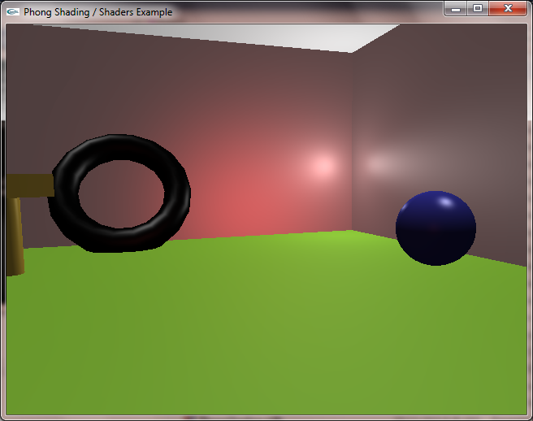

Shader with per-pixel lighting enabled

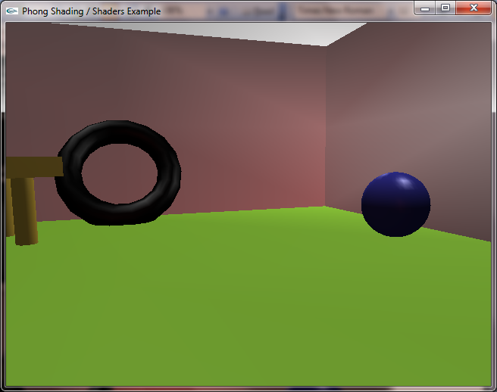

Fixed Function Pipeline (Smooth/Gouraud Shading)

