|  |
| --- |
| EN635.461 |
| Couch Potato |
| Media Management System  Development Portfolio |
|  |
| **Zaven Mnatzakanian** |
| **05/04/2011** |

|  |
| --- |
| Couch Potato is a system for managing your movie collection. The system provides users instant access to anything they own and lets people easily share their tastes with friends. It brings the benefits of all your social connections to the movies. |

Contents

Proposal 2

Summary of Goals 2

Stakeholder Interviews 3

Stakeholder 1 3

Stakeholder 2 5

Stakeholder 3 6

User Interaction Scenarios 9

Problem Scenario 1 9

Problem Scenario 2 15

Problem Scenario 3 23

Couch Potato System Requirements 30

I. Global Requirements 30

II. 10 Foot UI Requirements 32

III. Mobile Application Requirements 32

IV. Couch Potato Set-Top-Box Requirements 33

Prototype I - Sketches 34

Prototype II - Functioning UI 37

Prototype Testing 39

Usability Test Tasks 39

Test Subjects and Usability Task Results 40

Conclusions and Observations 43

Observations 43

What’s next? 44

Appendix A - Prototype Test Forms 46

i. Voluntary Release Form 46

ii. Pre-Test Background Questions 47

iii. User Test Tasks 48

iv. User Reaction Survey 49

Appendix B - User Test Results 52

i. Pre-Test Questions 52

ii. Post Test Results 53

## Proposal

Ever let a friend borrow a movie and forget you gave it to him? What about buying a movie at the store only to find out your buddy already owns it? After all these years buying movies and storing them on your living room shelf, can you honestly remember every movie you own? If you’ve experienced any of these problems, maybe what you and your friends need is a good media management system. A way to keep track of the movies you own, the movies you want to own, and even the movies you should own but have never seen.

A good media management application would solve all these problems and more. The system would help you pick a movie from your ever growing collection. You could view them whenever the need arises and share them with friends. Such a new system would even help you find new movies to watch.

## Summary of Goals

The goal of Couch Potato is to provide users with a fast and simple way, to manage their movie collection and share with friends. Users of the device will be able to watch any movie they have anywhere in their house and control movie playback via a remote on their phones. The system will store all the movies internally for quick access without needing to insert discs for playback. Users can browse their friends’ movies and request to borrow them with the press of a button. Couch Potato will help promote discovery, enjoyment, and ease of use in the place where relaxation matters most, your living room.

## Stakeholder Interviews

Each stakeholder was asked a number of questions regarding various topics. These questions dealt with understanding the movies they watch, how they decide to watch a movie, and other various aspects of their relaxation time.

In these transcripts, tester question will be prepended with a “T:” and responses from the subject will be prepended with “S:” Actions taken by the user, not spoken will be denoted by appear in *italics*. Additional information regarding the context of an action will be displayed between square brackets [...].

### Stakeholder 1

T: How often do you spend at home? When you are relaxing, do you watch TV, movies, read a book, etc...?

S: I typically do not watch movies. They are time consuming for one. I have a limited amount of time to watch a movie versus a TV show that’s on TV. I might watch that a few times a week.

T: What do you do when you watch TV?

S: I look at the TV guide on the television and see what's on for the evening. If it's a repeat, I usually turn it off, if it's new, I watch it. I like to watch a couple shows like CSI, Criminal Minds, I like the suspense shows. But I don't watch many movies on TV.

T: So the problem is investing time to watch it? What if you could watch part of the movie and pick it up the next time. Something that remembers where you left off...

S: That might work. I don't know how to operate something like that.

T: When you are watching a movie, how do you decide what movie to watch?

S: Usually from the recommendations of friends. We'll talk about movies they've seen. Or I look at the movie guide and look at their reviews to see what I might enjoy.

T: When you get recommendations from friends, do you usually borrow the movie? Or go to the store to buy it? How do you go about getting the movie?

S: They'll usually let me borrow their movies.

T: Then you just return it whenever you're done?

S: Pretty much. I went to blockbuster to rent movies when the kids were growing up but not much anymore.

T: When you go to the store, where do you get the movies?

S: I don't buy them online. I'll go to Target or Best Buy. Our sons usually get the movies for us. They have a lot of recommendations. Then we have to try to figure out how to use the DVD player. We usually get it working but since we don't use it that often, we're occasionally a little challenged.

T: Say, you and your husband are just sitting down and say, let's watch a movie. Any decision making process?

A:Not really, usually one of us just picks. If I want to watch something, he'll go along with it. If he wants to watch something, I'll go along with it. There's not much a discussion.

T: Could you walk me through your movie watching process? Picking a movie, and then watching it on the TV.

S: Sure. There's a movie over there that I haven’t seen yet: Big Fish. I usually leave a movie on the TV stand when I want to remind myself to watch it. I usually don't put movies away when I want to watch it when it's a new movie we got. Otherwise, I put the movies in the library. It's in a cabinet in the living room.

*She opens the case, presses the eject button on the DVD player and inserts the disc. When she goes to pick up the remote for the DVD player, she is unsure of which to take.* [There are 5 remotes present on the TV stand.] *Eventually she remembers and grabs the remote for the TV and the remote for the DVD player. She starts pressing some buttons on the TV remote and the TV turns on.* [Instead of the DVD, a cable channel is on] *She stares at the remote for a while but is unsure just what button to press on the TV remote to change the input. She gets frustrated and asks her son to help.* *After getting help, she changes the input to the DVD player but is confused* *because it looks like a commercial is playing* [It’s a preview put on the disc before the start of the movie]. *She wants to skip it but is unsure how. She tries pressing play but it does nothing. Eventually she realizes she can press fast forward to skip through the previews. She gets to the DVD menu and after a few more random button presses she gets the movie to play.* [Each press, she seems anxious about her actions. Unsure what will happen]

T: Thanks for showing me this. You can stop the movie now and I'll ask you some follow up questions.

*S: She's unsure which button to press to stop the movie* [The remote says "Clear" rather than "Stop" but still shows the standard stop symbol of a filled in square]. *Eventually she realizes this with a little help. She then presses the input button on the TV remote to switch back to cable and presses the power button to turn it off* [She's more sure of her actions this time since she knows what pressing the input button will do]. I’m always a little hesitant when using the DVD player because if it's not back to the way it was; I might not be able to watch any TV.

T: When you were going through the process, it seemed like you were a little confused by all the remotes?

S: Always, there's too many. We need to get rid of those remotes. I'm always confused with this stuff.

T: And you weren't sure that the movie was playing?

S: I figured out they were previews.

T: Do you like sitting through those?

S: No. I just want to get to the movie.

T: Once you got to the DVD menu, it seemed like you weren't sure what button to press to start the movie.

S: I don't do it often enough, I need something in writing. There's too many buttons on the remote.

Q; What if the remote was simpler?

S: Oh yeah, "Stop Movie", "Start Movie". The less complicated it is, the easier it is to use.

T: What if instead of a remote with buttons for every function, you could just use your phone. And these simple buttons you mention were on there?

S: You can have that on your phone? You can setup your phone to start a movie?

T: Would you like that?

S: Yeah, if it was really simple.

T: You'd like something where what's showing up on your phone changes based on what the movie is doing?

S: Yeah. Sounds good.

T: Do you have your phone with you right now?

S: No, I usually keep it on the counter in the kitchen?

T: If you had a remote on it, would you have any problem keeping it with you in the living room?

S: I'd do that, sure.

T: That's just about it.

S: Hopefully this was helpful.

T: Thank you for your time.

### Stakeholder 2

T: What kind of movies do you watch? How do you watch them.

S: I watch comedy and action movies when they come out. I download it. Once its on the computer, I play it on the television. I usually watch them in my bedroom. I can control it from computer. There’s no need for a remote.

T: How often do you watch movies, TV shows, and other relaxing video entertainment?

S: Once a week or so.

T: Any reason for such a low number?

S: Busy doing other things, playing video games.

T: When you want to watch a movie, do you watch whatever comes out, friends’ recommendations or movie critic reviews.

S: Usually based on IMDB ratings, friends thoughts if I'm going to the theatre. If it's from home, just whatever comes out. I like to watch newer movies that I missed in theatres if they look interesting.

T: Do you watch older movies or just stick with new releases.

S: I don't watch many older movies.

T: Do you watch movies a second time.

S: 95% of the time I don't rewatch movies.

T: When you get movies, how do you get them?

S: I download them through shady websites.

T: Do you ever buy movies, rent them, Netflix, etc...

S: I used Netflix back in Florida but not right now.

T: Why not?

S: I just found it easier to download them. I may get it again. I may get the streaming one. I didn't want to wait a day to get the movie I want to watch. I'm impatient.

T: When you're watching movies is it just you; Or are there other people usually?

S: I either watch them by myself or with my fiancée' Yin.

T: Does she ever pick the movies.

S: Sometimes she picks them. We just watch whatever one of us picks.

T: Do you ever set aside movies to watch. Something comes up and you remind yourself to watch it later.

S: I just download it and keep it on my hard drive until I want to watch it. If I'm not at my computer, I write it down on my phone in a notepad application.

T: Please walk me through the process of watching a movie.

S: *He goes to IMDB to see what's out and selects a movie. He then goes to a torrent downloading website and enters the name of the movie in the search box. He selects the movie and clicks the link to download it. Once the movie is finished downloading, he opens it from his downloads folder by double clicking on it. He turns on the TV with one remote. Then shuffles through his remotes to change the inputs from his home theatre system. He opens the settings for his computers display and changes the settings so his computer's display is the TV.* [His TV is on the other side of the room, he's controlling the computer at his desk but turning around to look at the TV screen] *He then presses play by clicking an icon in the application.* [The movie starts playing but sound is coming out of the computer’s speakers, not the TV] *He opens the sound management program on his computer and selects the TV from the list of available speakers.*[It's still not working] *He looks around for what's wrong with the system and realizes the speaker cable is not plugged in. He gets up from his chair and plugs the cable in.*

T: When you want to pause it or fast forward, you still go back to your computer?

S: Yes, but it's not that big a deal because I don't pause the movie often. I have a remote for my computer but I never bothered to set it up. It's not inconvenient enough to set it up.

T: How do you feel about the whole setup process? It seems like you have to go through a lot of steps?

S: Less buttons would be better.

T: What if you had a box that stored all your movies and you didn't have to do all this setup every time? It would be separate from your computer.

S: That would be cool, streaming or something like that. I wouldn't have to interact with the computer.

T: Do you have a smart phone?

S: Yes.

T: What if you didn't need a remote? You could use your phone.

S: One app where you could find it, download it, control it; all from one place would be really nice. I wouldn't have to jump around from a bunch of devices.

T: Thank you.

### Stakeholder 3

T: When you want to watch a movie, what kind of movies do you watch?

S: Action movies.

T: How do you go about watching them?

S: Usually I look for trailers or I get word of mouth recommendations from a friend. Then I find it and rent it. Put it in my computer and watch it.

T: How often do you spend time at home?

S: Pretty often. I'm usually at work, home or the gym.

T: When you're home what do you do to relax?

S: If I'm not napping, I'll usually watch a movie, or surf the web.

T: TV shows? Anything like that?

S: Sure I watch some TV shows, but I like movies a lot. So usually movies.

T: When you are watching a movie, where do you watch it?

S: Usually just at my desk on my laptop. Unless it’s a big crowd; then I watch it in the living room because of the big TV.

T: You don't normally watch it on the big TV because you're more comfortable at your desk?

S: Yes, it's easier because I can just quickly pop in the movie. Or I can look something up online if I want to.

T: Why don't you watch it on the TV?

S: It's less convenient. It's automatic on my computer. I feel like it's easier. I don't even think twice about it.

T: When you are watching a movie, how do you decide what to watch?

S: Whatever interests me; if it has a lot of action and guns and stuff like that. I look at actors and see if it has people I like. Jet Li, Jason Statham, etc...

T: What about movie trailers?

S: I like to watch them and if the movie looks cool I'll get the movie.

T: When you get a recommendation, but you don't have it, what do you do?

S: I look for it. I rent it or I find a streaming version online. There's a Red Box rental kiosk right across the street (electronic stand where you can select movies via a touch screen and rent for a day with a credit card).

T: Do you ever look at critic's reviews?

S: Not really, I just go on my own opinion.

T: So watching movie trailers and seeing who's in it are the most important parts.

S: Yes.

T: What about friends' recommendations?

S: I usually watch movies friends recommend. I don't look at critic's reviews.

T: Can you walk me through how you watch movies?

S: *He walks to his room and starts rummaging through some boxes at his desk.* [There's no real organization method to store them; just a couple boxes with movies in them]. *He opens one of the boxes and looks through all the titles in it. Eventually he randomly selects an action movie. He just wanted to watch an action movie so he decided on Daybreakers. He turns on his laptop, opens the case, and puts the movie in the DVD drive.* [The movie’s menu comes on full screen on the laptop] *From the menu, he selects "Play Movie".*

T: So nothing really complicated?

S: No.

T: So you just prefer this simplicity?

S: The more you ask about that, it might be because when I was in college, we usually just watched movies in our rooms to not disturb our roommates. There's no common place area. That might be why.

T: It's not because it's more complicated?

S: I don't think so. It's just that I've been doing so long. Natural habit I guess.

T: So that simplicity is important. Others I've talked to have to do a lot of setup and there's a bunch of remotes and such. You kind of like how it's simple?

S: Yeah, everything is on the laptop.

T: So just one device, everything controlled from one place?

S: I see where you are coming from. Out here in the living room we have the sound system, another remote for that and it has to work.

T: So now we want something that's simple, 1 remote, and easily turns everything else on. So when you are picking a movie, you have to actually find it. You're not sure where all your movies are. One could be in 1 box and another could be in a different one.

S: Sure, yeah.

T: What would you think if you could have all your movies in 1 spot?

S: And have it sort it, or alphabetize it?

T: Yes, what would you want something like that to do?

S: Have it in one spot. Let me sort it by title or genre... That would make it really easy. Then I could just select action and type in the actors name and it could just bring up those kinds of movies.

T: If you had something like that. Would that be your go to system for your movie needs? You mentioned earlier you like watching trailers. Would you still prefer using your computer for that. Or would you use the system that has all your movies stored on it and it let you know that a movie you'd like came out.

S: I would probably try that out and see how it works. I'd have to test it out first. I'm a creature of habit. But something that let me watch movies easily, I would definitely use.

T: What if you could control the movies with your phone? And the controls came up right when you needed them?

S: Like on my computer, I move the mouse and all the controls come up for playback. That would be awesome. That way I don't have to get up and get the mouse to control stuff.

T: Other than play and pause and such, what would you want it to do?

S: Just the normal stuff; play, pause, fast forward, mute, etc...

T: What if you could tell it to watch movie just by selecting it on your phone? It shows you a list of movies and you just click "Watch".

S: Yeah, that would be cool. I'd prefer it on my phone versus on the screen since I always have that with me. So if I'm in my bed, I can use my phone to start a movie on the computer. Rather than have to walk all the way over to it. Or if I'm in the kitchen and I want to pause it.

T: One other thing, what if you could easily move between the TV in the living room and your laptop in the bedroom?

S: That would be convenient.

T: So the system knows what time you were at in the movie and you could watch it wherever?

S: Great, then I don't have to skip ahead to where I left off. That's convenient.

T: That's all my questions, thank you for your time.

## User Interaction Scenarios

### Problem Scenario 1

Bob is a recent college graduate. He works in D.C. but lives outside the city. He takes public transportation to and from work Monday through Friday so he has plenty of idle time. He tends to listen to music on his iPhone and let his mind wander. When he gets home from work, Bob likes to relax for about an hour and a half before going to the gym to work out. He lies down on the couch to watch some television. He prefers movies over shorter programs like TV shows but he doesn’t think he’ll have enough time and doesn’t like having to keep track of where he is in the movie. After some relaxation time, Bob stops what he’s watching and heads to the gym to exercise. Afterwards, he comes home and makes dinner. He usually eats dinner at the desk in his bedroom while watching a movie on his laptop. He eats his meals late so he likes to lie down in bed after he eats and tends to go to sleep when the movie is over. He has a big television in his living room but moving from one room to another in the middle of the movie would be a hassle.

Bob finishes cooking so he goes to his closet to find a movie. His apartment isn’t very big so he stores all his movies in a number of boxes. He doesn’t have a particular movie in mind but he knows he wants to watch an action movie. Since there’s no discernible order to his collection, he goes through the boxes and mentally filters out the movies in his collection that are not action movies. After taking some time to sort through his collection, he decides to watch Sin City. He takes the movie out of the case, puts it in his computer and presses play. He enjoys the movie while eating his dinner. When he’s done eating, he pauses the movie by using his mouse to click the button on the computer screen. He doesn’t want to miss anything while he puts his plate and utensils in the dishwasher. When he gets back, he clicks the mouse again to start playback and lies down on his bed. Eventually the movie ends and he goes to sleep. His laptop’s screen is still on but the annoyance of the light isn’t enough to make him get up to turn it off. The DVD is still in his computer but Bob doesn’t feel like putting it away yet. He’ll get around to it later.

#### Action Driven Requirements

Bob is a recent college graduate. He works in D.C. but lives outside the city. He takes public transportation to and from work Monday through Friday so he has plenty of idle time. During his commute, he opens the Couch Potato mobile client on his iPhone and looks through a list of movies his friends have bought as well as some recommendations based on the movies that he’s told Couch Potato he likes. He watches several movie trailers while sitting on the train. Bob finds most of the movies he watches based on movies his friends like and by watching the trailers, so these features are very important to him in finding new movies to watch. When the work day is over, Bob spends some time on his commute home deciding what movie he wants to watch while he relaxes before going to the gym. He once again opens the Couch Potato mobile application but looks through his own list of movies. Today he decides he wants to watch an action movie so he filters the list by genre and selects “Action”. When he gets home from work, Bob likes to relax for about an hour and a half before going to the gym to work out. Bob walks through the front door, takes off his shoes, types in “300” on his phone and selects the movie, pressing “Watch Movie”. The Couch Potato set-top-box turns on the TV and starts playing the movie just as Bob sits down on the couch. After some relaxation time, Bob stops what he’s watching and heads to the gym to exercise. Afterwards, he comes home and makes dinner.

When he’s done making dinner, Bob sits down on the couch and continues right where he left off in the movie while he eats his meal. He enjoys the movie while eating his dinner. When Bob finishes his meal, he pauses the movie with the Couch Potato mobile application (which also serves as a remote control). He doesn’t want to miss anything while he puts his plate and utensils in the dishwasher. When he gets back, he uses his phone again to continue the movie. After some time, Bob gets tired and doesn’t want to fall asleep on the couch. He uses his phone to change the screen playing the movie to the laptop in his bedroom. He walks to his bedroom and continues the movie after lying down on his bed. Eventually the movie ends and he goes to sleep. Bob doesn’t like the light coming from his laptop while he sleeps so he presses a button on the Couch Potato mobile app to turn off his laptop.

#### Data Driven Requirements

Bob is a recent college graduate. He works in D.C. but lives outside the city. He takes public transportation to and from work Monday through Friday so he has plenty of idle time. During his commute, he opens the Couch Potato mobile client on his iPhone and looks through a list of movies his friends have bought as well as some recommendations based on the movies that he’s told Couch Potato he likes. He watches several movie trailers while sitting on the train. Bob finds most of the movies he watches based on movies his friends like and by watching the trailers, so these features are very important to him in finding new movies to watch. Couch Potato parses and saves movie information including:

* Movie Poster
* Title
* Director
* Genre
* Synopsis
* Starring Actors
* Year Released
* Date the User added the movie to Couch Potato
* User Ratings
* Critic Ratings
* Movie Trailer

When the work day is over, Bob spends some time on his commute home deciding what movie he wants to watch while he relaxes before going to the gym. He once again opens the Couch Potato mobile application but looks through his own list of movies. Couch Potato uses the information it collects on movies to allow the user to display the list of movie titles and organize the list based on any of its criteria. Today he decides he wants to watch an action movie so he filters the list by genre and selects “Action”. When he gets home from work, Bob likes to relax for about an hour and a half before going to the gym to work out. Bob walks through the front door, takes off his shoes, types in “300” on his phone and selects the movie, pressing “Watch Movie”. The Couch Potato set-top-box turns on the TV and starts playing the movie just as Bob sits down on the couch. The Couch Potato mobile client can communicate with any computer or Couch Potato set-top box for controlling playback. After some relaxation time, Bob stops what he’s watching and heads to the gym to exercise. Afterwards, he comes home and makes dinner.

When he’s done making dinner, Bob sits down on the couch and continues right where he left off in the movie while he eats his meal. Couch Potato will save his movie progress so it can start where the movie was last stopped. This saves the user time and reduces the effort necessary to continue a movie. He enjoys the movie while eating his dinner. When Bob finishes his meal, he pauses the movie with the Couch Potato mobile application (which also serves as a remote control). He doesn’t want to miss anything while he puts his plate and utensils in the dishwasher. When he gets back, he uses his phone again to continue the movie. After some time, Bob gets tired and doesn’t want to fall asleep on the couch. He uses his phone to change the screen playing the movie to the laptop in his bedroom (Since Couch Potato saves all the available screens in the home to play a movie on). He walks to his bedroom and continues the movie after lying down on his bed. Eventually the movie ends and he goes to sleep. Bob doesn’t like the light coming from his laptop while he sleeps so he presses a button on the Couch Potato mobile app to turn off his laptop.

#### Interaction Driven Scenario

Bob is a recent college graduate. He works in D.C. but lives outside the city. He takes public transportation to and from work Monday through Friday so he has plenty of idle time. During his commute, he opens the Couch Potato mobile client on his iPhone and looks through a list of movies his friends have bought as well as some recommendations based on the movies that he’s told Couch Potato he likes. Bob is given a list of movie titles or a list of friends depending on the section. Selecting a movie by tapping on it gives Bob more detailed information. This detailed view give the users options in the form of buttons along the top. He watches several movie trailers by selecting the “Watch Trailer” option while sitting on the train. Bob finds most of the movies he watches based on movies his friends like and by watching the trailers, so these features are very important to him in finding new movies to watch. Couch Potato parses and saves movie information including:

* Movie Poster
* Title
* Director
* Genre
* Synopsis
* Starring Actors
* Year Released
* Date the User added the movie to Couch Potato
* User Ratings
* Critic Ratings
* Movie Trailer

When the work day is over, Bob spends some time on his commute home deciding what movie he wants to watch while he relaxes before going to the gym. He once again opens the Couch Potato mobile application but looks through his own list of movies. Couch Potato uses the information it collects on movies to allow the user to display the list of movie titles and organize the list based on any of its criteria. Users can filter this data by selecting options from a drop-down at the top of the list. Today he decides he wants to watch an action movie so he opens the drop-down and chooses to filter by genre. He is then presented with the various genres available in a list and selects “Action”. When he gets home from work, Bob likes to relax for about an hour and a half before going to the gym to work out. Bob walks through the front door, takes off his shoes, and turns on the Couch Potato mobile app. He already has a list of action movies open. He uses the textbox at the top of the list to type in “300”. The list if filtered to single movie. He taps 300. He then selects “Watch Now” from the action list described earlier. The Couch Potato set-top-box turns on the TV and starts playing the movie just as Bob sits down on the couch. The Couch Potato mobile client can communicate with any computer or Couch Potato set-top box for controlling playback via a standard remote control interface, with buttons for play, pause, fast forward, etc…. After some relaxation time, Bob stops what he’s watching by pressing stop on the remote and heads to the gym to exercise. Afterwards, he comes home and makes dinner.

When he’s done making dinner, Bob sits down on the couch and continues right where he left off in the movie while he eats his meal. Couch Potato will save his movie progress so it can start where the movie was last stopped. This saves the user time and reduces the effort necessary to continue a movie. All Bob has to do is press play on the remote interface to continue. He enjoys the movie while eating his dinner. When Bob finishes his meal, he pauses the movie with the Couch Potato mobile application. When Bob presses the pause, button it contextually changes to a play button since the movie is already paused. He doesn’t want to miss anything while he puts his plate and utensils in the dishwasher. When he gets back, he uses his phone again to continue the movie. After some time, Bob gets tired and doesn’t want to fall asleep on the couch. He uses his phone to change the screen playing the movie to the laptop in his bedroom (Since Couch Potato saves all the available screens in the home to play a movie on). Another button on the remote brings up a menu of “screens” and Bob selects his laptop. These devices are named by Couch Potato based on the location and type of device. He walks to his bedroom and continues the movie after lying down on his bed. Eventually the movie ends and he goes to sleep. Bob doesn’t like the light coming from his laptop while he sleeps so he presses a button on the Couch Potato mobile app to turn off his laptop.

#### Claims and Analysis

#### Required Actions

* Watch a movie trailers after selecting a movie on your phone.
* Browse friends’ movies and view their ratings on the phone.
* Browse through a list of movie titles.
* Sort and filter lists by genre, director, release date, etc...
* Search for a movie in a list on your phone.
* Select a movie from the phone and play it on a TV.
* Automatically turn on a TV and change the input to the correct one.
* Resume playing a movie from where it was last stopped.
* Change the location a movie is being played on.
* Turn off the device playing the movie with the press of a button.

#### Data Requirements

* Download and save movie information:
  + Movie Poster
  + Title
  + Director
  + Genre
  + Synopsis
  + Starring Actors
  + Year Released
  + Date the User added the movie to Couch Potato
  + User Ratings
  + Critic Ratings
  + Movie Trailer
* Use this data to filter and sort the list of displayed movies.
* Save a list of devices that can playback the movies stored on Couch Potato
* Save progress of a movie when it’s stopped so playback can be resumed from the same amount of time.

#### Interaction Requirements

* Choose from a list of friends (names). Sorting options at the top.
  + From there, Browse through their movies.
    - Display information about the movie selected.
    - Give an option to watch trailers.
* Display a list of movie titles. Ability to sort by selecting from a list of options at the top of the panel.
  + The list can be sorted using a textbox at the top of the list. Information such as the director, title, etc... can be typed in and displayed on the list.
  + Selecting a movie give you an option to Watch the movie and pick a screen to watch it on.
* Present the users with buttons on the phone to control movie playback.
  + Play, Pause, Fast Forward, Stop, etc...
  + Change the Play/Pause button according to what the movie is doing. If it’s playing there should be a pause button, if paused, it should play.
  + Include a button to change the screen the movie is playing on. This button will give them options for all their screens.
  + Include a button to turn off the device the movie is playing on.

#### Pros and Cons

+ Bob can quickly filter his movies to only show the genre he wants.

+ Bob can move between rooms to watch a movie with minimal effort.

+ Bob’s movies are well organized so he can assess all his options rather than just the stuff in one box.

+ Bob doesn’t have to get up to control playback of the movie since and turn off his computer.

- Bob has to learn a new system, he likes doesn’t like change.

#### Metaphors

* Looking through movies in boxes is like finding a needle in a haystack.
* Browsing through you movies is like having an assistant sort movies for you in a line. Tell them how you want to see movies and they’ll arrange them accordingly (instantly).

#### Artifacts

* Boxes used to store movies. Bob had to manually sort through them to find the movie he wanted to watch. Replaced by movies stored on a single device. Bob can browse all of his movies like it’s a giant box and sort them easily.

### Problem Scenario 2

Mary works part-time as a massage therapist. She is in her late 50s and has been married for 30 years. Mary worked in an office most of her life but since helping put her children through college, has taken a break from the 40 hour a week grind. Her part time schedule gives her plenty of time to relax and pursue other interests throughout the day. Her meetings with clients are by appointment and tend to occur during lunch hours (11am to 1pm) or in the early evening after most people are leaving work (4 to 7pm). Mary lives in the suburbs but works in the city closer to the offices of many of her clients. It’s about a 20 minute drive but the location adds to her business since it’s very convenient for stressed office workers to make an appointment in the middle of the day. When not meeting with clients, she usually does work around the house, spends time with other friends reaching retirement age, or catches up on the news.

She usually ends her days planning her upcoming appointments. Looking at her schedule, Mary sees that she has appointments at 11am and 1:30pm on Friday with an hour and a half break in between. Mary loves it when this happens because it gives her a perfect opportunity to meet with friends for lunch. Mary loves to meet friends for lunch and catch up on all the things happening in their lives. Considering, its 8pm, Mary thinks it’s a little late to call, but she makes a note to herself to get in touch with her friend Shirley in the morning. Finally, Mary finishes up with some relaxation in the living room. If a television show she enjoys happens to be on, she’ll watch it; otherwise, she’ll usually read a book with the TV on as background noise. Mary likes to enjoy new, interesting stories whether they are in video or print form. She wishes she had more time to watch movies but she usually goes to sleep early and doesn’t stay up late enough to watch a whole film.

The next day, she gives her friend Shirley a call and they make plans to go to lunch on Friday. They often talk about current events, family news, and occasionally talk about the television shows and movies they enjoy. These discussions usually help Mary find new things to watch when she gets a chance and in turn leads to more discussions with her friends on their shared experiences. While she doesn’t watch many movies, Mary always enjoys taking a friend’s recommendation and watching new movies her friends talk about.

On Friday, while eating lunch, Shirley brings up a new movie she bought at Blockbuster on Monday and highly recommended it to Mary. Mary was a bit disappointed because she bought the same movie yesterday based on the rave reviews she had read in the newspaper last week. She hadn't gotten the chance to watch it yet so they couldn't discuss the movie but now Mary knew she had to watch it since Shirley recommended it so highly. Mary and Shirley finished lunch and Mary went on to her next appointment.

When the day was over Mary was determined to watch her movie. After dinner, she sat down and got ready to watch her movie. She started by grabbing the DVD case from the coffee table (where she always leaves movies as a reminder she wants to watch them) and putting the movie in her DVD player by pressing the open button on the player. The DVD player turned on automatically and started the movie. Unfortunately for Mary, getting the TV to show the video was not as simple. She knew how to turn on the TV with her remote but always had trouble remembering what buttons to press to change the input. Eventually, she gave up and called her son John, the tech expert in the family. After some guidance, she was up and running and started playing the movie. She always had trouble navigating menus and controlling movie playback with her DVD player because she wasn’t always clear what all the buttons do. To add to it, she still had to use the TV remote for things like changing the volume. She always managed to get through the video but there was always a little anxiety. The movie finished and she really enjoyed it. She pressed the eject button on her DVD player and put the movie back in the box. She took the box and put her movies in the bookshelf along with all her other movies.

#### Action Driven Scenario

Mary works part-time as a massage therapist. She is in her late 50s and has been married for 30 years. Mary worked in an office most of her life but since helping put her children through college, has taken a break from the 40 hour a week grind. Her part time schedule gives her plenty of time to relax and pursue other interests throughout the day. Her meetings with clients are by appointment and tend to occur during lunch hours (11am to 1pm) or in the early evening after most people are leaving work (4 to 7pm). Mary lives in the suburbs but works in the city closer to the offices of many of her clients. It’s about a 20 minute drive but the location adds to her business since it’s very convenient for stressed office workers to make an appointment in the middle of the day. When not meeting with clients, she usually does work around the house, spends time with other friends reaching retirement age, or catches up on the news. While reading the newspaper one day, Mary reads a review for a new movie that just came out on DVD, Black Swan. Loving the sound of this movie, she opens the Couch Potato mobile client on her phone and adds the movie to her watch list.  
 She usually ends her days planning her upcoming appointments. Just as Mary starts planning her schedule, the Couch Potato mobile application sends out an alert on her phone notifying her that her friend Shirley has added Black Swan to their Couch Potato set-top-box. Looking at her schedule, Mary sees that she has appointments at 11am and 1:30pm on Friday with an hour and a half break in between. It’s been a while since Mary had met with her friend Shirley so this seemed like perfect timing. She decided to send a request to Shirley to borrow the movie and includes a message asking to meet for lunch on Friday. Finally, Mary finishes up with some relaxation in the living room. She turns on her couch potato and finishes watching a movie from last night using the mobile app to quickly resume playback. Mary tends to watch movies over a few days since she never finds the time to watch a whole film and tends to go to sleep early. She imports the movie into her Couch Potato when she gets them but sometimes takes a while to watch them. She likes to browse through her recent purchases and decides to watch a movie when the time is right. Mary likes to enjoy new, interesting stories.  
 The next day, Shirley gives Mary a call and says she’d be happy to go to lunch. She talks about how much Mary will love the movie and would be happy to make a lender copy with her Couch Potato box. Mary always looks forward to catching up with her friends at lunch. They often talk about current events, family news, and occasionally talk about the television shows and movies they enjoy. These discussions usually help Mary find new things to watch when she gets a chance and in turn leads to more discussions with her friends on their shared experiences. Mary always enjoys taking a friend’s recommendation and watching new movies her friends rate highly on their Couch Potato set-top-boxes. The friends meet on Friday and have a great time catching up. Mary and Shirley finished lunch and Mary went on to her next appointment.

When the day was over Mary was excited to watch the movie her friend spoke so highly of. After dinner, she sat down and got ready to watch her movie. There wasn’t much set up since she put the lender copy in her Couch Potato set-top-box right when she walked into the house. She simply used the remote built in to the mobile application and sorted the movies by “Date Added.” She then selected Black Swan and pressed play. The TV turned on, and the movie started playing. Mary sat down and enjoyed the whole movie (with a single remote controlling everything), staying up well past her usual bedtime since she just couldn’t walk away mid-way. When she was finished, she tossed the disk in the recycling bin since it wasn’t necessary after Couch Potato had imported it. She knew if she wanted to, she could watch it any time this week.

#### Data Driven Scenario

Mary works part-time as a massage therapist. She is in her late 50s and has been married for 30 years. Mary worked in an office most of her life but since helping put her children through college, has taken a break from the 40 hour a week grind. Her part time schedule gives her plenty of time to relax and pursue other interests throughout the day. Her meetings with clients are by appointment and tend to occur during lunch hours (11am to 1pm) or in the early evening after most people are leaving work (4 to 7pm). Mary lives in the suburbs but works in the city closer to the offices of many of her clients. It’s about a 20 minute drive but the location adds to her business since it’s very convenient for stressed office workers to make an appointment in the middle of the day. When not meeting with clients, she usually does work around the house, spends time with other friends reaching retirement age, or catches up on the news. While reading the newspaper one day, Mary reads a review for a new movie that just came out on DVD, Black Swan. Loving the sound of this movie, she opens the Couch Potato mobile client on her phone and adds the movie to her watch list. Couch Potato stores a list of movies as a “Watch List.” Mary sometimes gets new recommendations based on the movies she wants to watch.  
 She usually ends her days planning her upcoming appointments. Just as Mary starts planning her schedule, the Couch Potato mobile application sends out an alert on her phone notifying her that her friend Shirley has added Black Swan to their Couch Potato set-top-box. The system combines your “Watch List” with your friends’ movie lists to notify you when a friend has added the movie to their Couch Potato box. Couch Potato keeps track of friends and gives users the ability to browse through their collection. Looking at her schedule, Mary sees that she has appointments at 11am and 1:30pm on Friday with an hour and a half break in between. It’s been a while since Mary had met with her friend Shirley so this seemed like perfect timing. She decided to send a request to Shirley to borrow the movie and includes a message asking to meet for lunch on Friday. Finally, Mary finishes up with some relaxation in the living room. She turns on her couch potato and finishes watching a movie from last night using the mobile app to quickly resume playback. Couch Potato stores you progress with any movie so you can quickly jump back to where you were at the press of a button. Mary tends to watch movies over a few days since she never finds the time to watch a whole film and tends to go to sleep early. She imports the movie into her Couch Potato when she gets them but sometimes takes a while to watch them. Couch Potato stores the date movies are added and includes this feature as a way to sort your collection on the mobile application or on the TV interface. She likes to browse through her recent purchases and decides to watch a movie when the time is right. Mary likes to enjoy new, interesting stories.  
 The next day, Shirley gives Mary a call and says she’d be happy to go to lunch. She talks about how much Mary will love the movie and would be happy to make a lender copy with her Couch Potato box. Mary always looks forward to catching up with her friends at lunch. They often talk about current events, family news, and occasionally talk about the television shows and movies they enjoy. These discussions usually help Mary find new things to watch when she gets a chance and in turn leads to more discussions with her friends on their shared experiences. Mary always enjoys taking a friend’s recommendation and watching new movies her friends rate highly on their Couch Potato set-top-boxes. Couch Potato stores user ratings on a scale of 1 to 5. It uses these ratings to recommend new movies to users and their friends. The friends meet on Friday and have a great time catching up. Mary and Shirley finished lunch and Mary went on to her next appointment.

When the day was over Mary was excited to watch the movie her friend spoke so highly of. After dinner, she sat down and got ready to watch her movie. There wasn’t much set up since she put the lender copy in her Couch Potato set-top-box right when she walked into the house. She simply used the remote built in to the mobile application and sorted the movies by “Date Added.” She then selected Black Swan and pressed play. The TV turned on, and the movie started playing. Mary sat down and enjoyed the whole movie (with a single remote controlling everything), staying up well past her usual bedtime since she just couldn’t walk away mid-way. When she was finished, she tossed the disk in the recycling bin since it wasn’t necessary after Couch Potato had imported it. She knew if she wanted to, she could watch it any time this week. The system keeps track of when you add a loaner movie and lets you watch it for up to a week (for legal reasons). The movie is deleted after that.

#### Interaction Driven Scenario

Mary works part-time as a massage therapist. She is in her late 50s and has been married for 30 years. Mary worked in an office most of her life but since helping put her children through college, has taken a break from the 40 hour a week grind. Her part time schedule gives her plenty of time to relax and pursue other interests throughout the day. Her meetings with clients are by appointment and tend to occur during lunch hours (11am to 1pm) or in the early evening after most people are leaving work (4 to 7pm). Mary lives in the suburbs but works in the city closer to the offices of many of her clients. It’s about a 20 minute drive but the location adds to her business since it’s very convenient for stressed office workers to make an appointment in the middle of the day. When not meeting with clients, she usually does work around the house, spends time with other friends reaching retirement age, or catches up on the news. While reading the newspaper one day, Mary reads a review for a new movie that just came out on DVD, Black Swan. Loving the sound of this movie, she opens the Couch Potato mobile client on her phone and adds the movie to her watch list by pressing the “Watch List” button at the bottom of the program and then pressing the “+” button and typing in the name of the movie. The movie is instantly added to her list. Couch Potato stores a list of movies as a “Watch List.” This helps it recommend other movies based on the movies you want to see. It also gives the user access to information about the movie such as the actors, release date and trailers.  
 She usually ends her days planning her upcoming appointments. Just as Mary starts planning her schedule, the Couch Potato mobile application sends out an alert on her phone notifying her that her friend Shirley has added Black Swan to their Couch Potato set-top-box. An alert message pops up on her phone and she is given the option to ask to borrow the movie or ignore the alert. The system combines your “Watch List” with your friends’ movie lists to notify you when a friend has added the movie to their Couch Potato box. Couch Potato keeps track of friends and gives users the ability to browse through their collection. Looking at her schedule, Mary sees that she has appointments at 11am and 1:30pm on Friday with an hour and a half break in between. It’s been a while since Mary had met with her friend Shirley so this seemed like perfect timing. Mary selects the Borrow option and is given the chance to add a message to go along with the request. The request is sent. Finally, Mary finishes up with some relaxation in the living room. She turns on her couch potato by pressing the remote button at the on the mobile app. The Couch Potato box on her TV quickly turns on and she presses play on her phone finishes watching a movie from last night. Couch Potato stores you progress with any movie so you can quickly jump back to where you were at the press of a button. Mary tends to watch movies over a few days since she never finds the time to watch a whole film and tends to go to sleep early. She imports the movie into her Couch Potato when she gets them but sometimes takes a while to watch them. Couch Potato stores the date movies are added and includes this feature as a way to sort your collection on the mobile application or on the TV interface. She likes to browse through her recent purchases and decides to watch a movie when the time is right. She can do this from her phone or in the mobile application but prefers to look at the TV interface. She is presented with the box art for all her movies in a row. She can use a directional pad on her phone to sift through them like she’s pulling each movie from her shelf and looking at the box. Mary likes to enjoy new, interesting stories.  
 The next day, Shirley gives Mary a call and says she’d be happy to go to lunch. She talks about how much Mary will love the movie and would be happy to make a lender copy with her Couch Potato box. Mary always looks forward to catching up with her friends at lunch. They often talk about current events, family news, and occasionally talk about the television shows and movies they enjoy. These discussions usually help Mary find new things to watch when she gets a chance and in turn leads to more discussions with her friends on their shared experiences. Mary always enjoys taking a friend’s recommendation and watching new movies her friends rate highly on their Couch Potato set-top-boxes. Couch Potato stores user ratings on a scale of 1 to 5. It uses these ratings to recommend new movies to users and their friends. Users can rate a movie any time by pressing the rate button shown with the movie information on the mobile client and on the TV interface. The friends meet on Friday and have a great time catching up. Mary and Shirley finished lunch and Mary went on to her next appointment.

When the day was over Mary was excited to watch the movie her friend spoke so highly of. After dinner, she sat down and got ready to watch her movie. There wasn’t much set up since she put the lender copy in her Couch Potato set-top-box right when she walked into the house. She simply used the remote built in to the mobile application and sorted the movies by “Date Added.” Mary uses the d-pad on the remote to select the “Sort By” option on the screen and chooses “Date Added” from the list of options. Black Swan was already selected since it was the most recent movie. Pressing enter selected the movie and it started playing. The TV turned on, and the movie started playing. Mary sat down and enjoyed the whole movie (with a single remote controlling everything), staying up well past her usual bedtime since she just couldn’t walk away mid-way. When she was finished, she tossed the disk in the recycling bin since it wasn’t necessary after Couch Potato had imported it. She knew if she wanted to, she could watch it any time this week. The system keeps track of when you add a loaner movie and lets you watch it for up to a week (for legal reasons). The movie is deleted after that.

#### Claims and Analysis

#### Required Actions

* Add movies to a “Watch List” which keeps track of movies you want to see.
* Recommend movies based on movies in your watch list.
* Alert users when a friend adds a movie in your watch list to their Couch Potato set-top-box.
* Users can send requests to friends to borrow movies.
* Watch movies users started earlier at the spot where they stopped.
* Save purchased movies on the Couch Potato set-top-box.
* Look at recently purchased movies.
* Make “Lender Copies” which you can give to friends.
* Rate movies you watch.
* Save movies you borrow from friends on your Couch Potato temporarily.
* Sort movie list by “Date Added” (The date the movie was added to Couch Potato).
* Automatically turn on the TV and change to the correct video input.
* Control playback functions using the remote. Including the volume of the TV.

#### Data Requirements

* Store a list of movies you want to see.
* Keep track of new movies users’ friends add to Couch potato and compare them with a user’s watch list.
* Store progress through a movie. Resuming will start the movie where you stopped it.
* Store the date a movie was added to a Couch Potato system.
* Store user ratings on a scale of 1 to 5.
  + Use these recommendations in conjunction with watch list to recommend new movies.
* Keep track of when a loaner movie was added to the system. Loaners can only be watched for a week, then are deleted from the system.

#### Interaction Requirements

* Include a “+” button at the top of the Watch List on the mobile application.
  + Provide the option to add a new movie to it by typing in the name.
  + Download the movies information automatically upon adding it.
* Alert users when a movie on your watch list is added to friend’s Couch Potato system.
  + Give the user the option to borrow the movie when prompted.
  + Give the user the option to include a message before sending the request.
* Turn on the Couch Potato set-top-box automatically when you start pressing buttons on the remote.
* Present movies in a row of DVD boxes.
  + List can be navigated by pressing left and right on the remote’s d-pad.
  + List can be sorted using buttons above the list to sort or filter the list.
  + When a movie is selected, it’s information as well as buttons to watch, borrow, etc... will show up.
* Users can rate movies by selecting the “Rate It” button from the movie information page.
  + If the movie is already rated, the rating will be shown.
  + If viewing a friend’s movie, the rating show will be their rating of the movie if one is present.

#### Pros and Cons

+ Mary won’t get confused by the number of remotes she has in front of her TV, Couch Potato only needs one and it’s her phone. So she doesn’t keep that in her pocket, not in front of the TV.

+ Mary can watch movies when she has free time since it easily starts the movie where she left off.

- Mary doesn’t watch as many TV shows since she doesn’t like changing devices.

+ Mary can see what movies her friends have and ask to borrow them.

- She doesn’t talk to her friends as much about what movies they have since she already knows.

+ Mary will save money since she won’t buy movies that her friends already own.

- Mary loses the tactile feedback in using the various remotes. She was a confused by the variety of remotes before but now she may get confused if the system is not responsive enough.

+ Mary gets the benefit of adaptive controls that change with the movie. She may not get tactile feedback but the added benefits of clear instructions of exactly what pressing the button does will help her anxiety.

#### Metaphors

* Adding a movie to your watch list is like jotting it down on a notepad, a notepad that you never forget because who forgets their cell phone?
* Setting the TV to the correct input and playing the movie is as simple as asking your son to do it, without the back talk about never learning how to do it herself.

#### Artifacts

* Mary keeps recently bought movies she wants to watch on her TV stand as a reminder. This is replaced by showing her recently added movies on the home screen of the TV interface.

### Problem Scenario 3

John is a software engineer in his mid-twenties. He works from home so he has no commute. He is a very tech-savvy individual who has an elaborate entertainment setup. He has no problem switching between components but any of his friends would have trouble figuring things out when they come over. He works off his personal laptop which also holds all his personal media. John has gone entirely digital. All of John's movies are saved on his laptop. John started saving his movies this way to make browsing through them easier. He never quite liked organizing and sorting through his physical DVDs. All of his movies are just files on a hard drive. One day, John is taking a break from working so he goes to IMDB.com and looks at some of the new releases. He watches a trailer for 127 Hours and decides he wants to watch it. He then spends some time looking through various search engines looking for an unauthorized download of the movie. After 20 minutes or so he finds the movie and after a few clicks, it starts downloading. He knows what he is doing is wrong but he finds it far more convenient than going to the store to rent a movie. He doesn’t like to like to watch movies more than once so buying them at full price is not a very good option either. Having satisfied his boredom, John gets back to work. John always thinks it’s important to take these kinds of breaks in the middle of the day.

John usually works late so he takes breaks for lunch and dinner but continues working until around 7 or 8 P.M. After work he often relaxes while watching a movie or playing video games. Since he wanted to watch 127 Hours he decided to play that. His laptop is in his bedroom where he works but he prefers to watch movies on the big screen in his living room. Since his movies are stored on his laptop, John moves his laptop to his living room for these situations. He unplugs his laptop from the wall and sets it down on the TV stand. He uses an HDMI cable to output video from his laptop to the TV. He leaves this cable plugged in to his TV so he can easily plug in his laptop in when he wants to watch a movie. Unfortunately this means there’s one more cable sitting out in the open when his laptop isn’t there. Since the movie is a few hours long, he has to bring the AC adapter and plug it in. Once he’s plugged in, John opens the display settings and sets it to output video to his TV instead of his laptop. He opens the sound settings as well to use the TV speakers instead of his laptop’s. Finally, he opens his downloads folder, selects the movie and presses the play button on his computer.

Afterwards, he walks over to his couch and starts watching the movie. He can control the volume of the TV with its remote but if he wants to pause the movie, John needs to get up and press a button on the computer. He bought a remote for it a while back but he’s never bothered to go through with the complicated setup. Once the movie is done, John presses the power button on his laptop to turns it off. He unplugs it from the TV and the power outlet and brings his laptop back to his room. He sets it back on his desk and goes to sleep since it’s late.

#### Action Driven Scenario

John is a software engineer in his mid-twenties. He works from home so he has no commute. He is a very tech-savvy individual but he uses his Couch Potato set-top-box to keep his entertainment setup simple. The box is easy enough to use that anyone with a phone can control it without any significant learning curve. He works off his personal laptop but space is not an issue since all his movies are stored on the Couch Potato box. John has gone entirely digital. John stores all the movies he buys on his Couch Potato by inserting them into the device when he buys them. John started saving his movies this way to make browsing through them easier. He never quite liked organizing and sorting through his physical DVDs. All of his movies are accessible by looking through a list of movie titles on his phone.

One day, John is taking a break from working so he leaves the room where his computer is and turns on his Couch Potato box using the remote app on his phone. He selects the recommendations section from the menu then selects sort by “Date Released” to look at all the new movies. He selects 127 Hours and watches the trailer for it. After watching the trailer, Couch Potato returns to the movie info page and John sees that his friend Steve has it. He immediately selects the option to borrow it. John used to resort to illegally downloading movies but that was because it was more convenient than going to a store to rent it. He doesn’t like to like to watch movies more than once so buying them at full price is not a very good option either. Since Couch Potato made browsing friends’ movie collections so easy, John started borrowing movies from friends who like to buy movies. Some of John’s friends even prefer coming over and watching the movie again since John had the biggest TV. Having taken a nice break from work, John gets back to his desk. John always thinks it’s important to take these kinds of breaks in the middle of the day in order to stay focused.

Some time after lunch, Steve noticed the request to borrow a movie from John so he called and agreed to come over to watch 127 Hours. John usually works late so he takes breaks for lunch and dinner but continues working until around 7 or 8 P.M. After work, Steve showed up and after some catching up, John grabbed some drinks from the fridge and inserted the disk into the Couch Potato set-top-box. John opened the Couch Potato app on his phone and 127 Hour was already showing up as the selected movie in the video controls section. He turned on the TV using the Couch Potato mobile app and pressed play to start the movie. John relaxes and watches the movie with his friend Steve. When he’s finished, John uses the mobile application to stop the movie, eject the disc, and turn off the TV. John thanks his friend for coming over and Steve leaves having a great time.

#### Data Driven Scenario

John is a software engineer in his mid-twenties. He works from home so he has no commute. He is a very tech-savvy individual but he uses his Couch Potato set-top-box to keep his entertainment setup simple. The box is easy enough to use that anyone with a phone can control it without any significant learning curve. Any information about the movies stored on it can be accessed remotely from a cell phone or computer. He works off his personal laptop but space is not an issue since all his movies are stored on the Couch Potato box. John has gone entirely digital. John stores any movie he buys on his Couch Potato by inserting them into the device when he buys them. When inserted, discs are backed up to the box to be played on demand. John started saving his movies this way to make browsing through them easier. He never quite liked organizing and sorting through his physical DVDs. All of his movies are accessible by looking through a list of movie titles on his phone. Couch Potato automatically downloads information like the director, release date, actors, genre, etc... for any movie users insert into it.

One day, John is taking a break from working so he leaves the room where his computer is and turns on his Couch Potato box using the remote app on his phone. He selects the recommendations section from the menu then selects sort by “Date Released” to look at all the new movies. In addition to your movies, Couch Potato downloads the same information for movies you may like based on friends’ ratings and your opinions on movies you watched on Couch Potato. Couch Potato downloads a list of your friends by connecting to Facebook. He selects 127 Hours and watches the trailer for it. After watching the trailer, Couch Potato returns to the movie info page and John sees that his friend Steve has it. He immediately selects the option to borrow it. John used to resort to illegally downloading movies but that was because it was more convenient than going to a store to rent it. He doesn’t like to like to watch movies more than once so buying them at full price is not a very good option either. Since Couch Potato made browsing friends’ movie collections so easy, John started borrowing movies from friends who like to buy movies. Some of John’s friends even prefer coming over and watching the movie again since John had the biggest TV. Having taken a nice break from work, John gets back to his desk. John always thinks it’s important to take these kinds of breaks in the middle of the day in order to stay focused.

Some time after lunch, Steve noticed the request to borrow a movie from John so he called and agreed to come over to watch 127 Hours. John usually works late so he takes breaks for lunch and dinner but continues working until around 7 or 8 P.M. After work, Steve showed up and after some catching up, John grabbed some drinks from the fridge and inserted the disk into the Couch Potato set-top-box. John opened the Couch Potato app on his phone and 127 Hour was already showing up as the selected movie in the video controls section. He turned on the TV using the Couch Potato mobile app and pressed play to start the movie. John relaxes and watches the movie with his friend Steve. When he’s finished, John uses the mobile application to stop the movie, eject the disc, and turn off the TV. John thanks his friend for coming over and Steve leaves having a great time.

#### Interaction Driven Scenario

John is a software engineer in his mid-twenties. He works from home so he has no commute. He is a very tech-savvy individual but he uses his Couch Potato set-top-box to keep his entertainment setup simple. The box is easy enough to use that anyone with a phone can control it without any significant learning curve. The Couch Potato system takes care of most things automatically. Turning it on automatically changes the input on the TV and the remote can control volume unlike most movie playing devices. Any information about the movies stored on it can be accessed remotely from a cell phone or computer through mobile and desktop programs. He works off his personal laptop but space is not an issue since all his movies are stored on the Couch Potato box. John has gone entirely digital. John stores any movie he buys on his Couch Potato by inserting them into the device when he buys them. The movies are automatically imported and eject when they are finished saving. The discs are backed up to the box to be played on demand. John started saving his movies this way to make browsing through them easier. He never quite liked organizing and sorting through his physical DVDs. All of his movies are accessible by looking through a list of movie titles on his phone. Couch Potato automatically downloads information like the director, release date, actors, genre, etc... for any movie users insert into it. However when John accesses his movies, they are shown to him as a list of titles, with options to sort and filter based on this information. These options are shown as menus at the top of the screen.

One day, John is taking a break from working so he leaves the room where his computer is and turns on his Couch Potato box by selecting the Remote tab on the mobile application and tapping the screen. He selects the recommendations section using gestures on the remote then selects sort by “Date Released” to look at all the new movies by dragging his finger left and right to move through the list, skimming the movie title and director as he went along. In addition to your movies, Couch Potato downloads the same information for movies you may like based on friends’ ratings and your opinions on movies you watched on Couch Potato. Couch Potato downloads a list of your friends by connecting to Facebook. He selects 127 Hours and watches the trailer for it by dragging down to focus on the movie info and selecting the “Watch Trailer” option. After watching the trailer, Couch Potato returns to the movie info page and John sees that his friend Steve has it since the movie information includes a list of friends (if any) who own the movie. He immediately selects the option to borrow it. John used to resort to illegally downloading movies but that was because it was more convenient than going to a store to rent it. He doesn’t like to like to watch movies more than once so buying them at full price is not a very good option either. Since Couch Potato made browsing friends’ movie collections so easy, John started borrowing movies from friends who like to buy movies. Some of John’s friends even prefer coming over and watching the movie again since John had the biggest TV. Having taken a nice break from work, John gets back to his desk. John always thinks it’s important to take these kinds of breaks in the middle of the day in order to stay focused.

Some time after lunch, Steve noticed the request to borrow a movie from John so he called and agreed to come over to watch 127 Hours. Notifications pop up on your phone just like an alert for a text message. John usually works late so he takes breaks for lunch and dinner but continues working until around 7 or 8 P.M. After work, Steve showed up and after some catching up, John grabbed some drinks from the fridge and inserted the disk into the Couch Potato set-top-box. John opened the Couch Potato app on his phone and 127 Hour was already showing up as the selected movie in the video controls section. He turned on the TV using the Couch Potato mobile app (once again, by just activating the remote or now playing sections) and pressed play to start the movie. John relaxes and watches the movie with his friend Steve. When he’s finished, John uses the mobile application to stop the movie by pressing the stop button. He ejects the disc by pressing the eject button on the Couch Potato set-top-box and then presses the power button on the remote to turn the TV off. John thanks his friend for coming over and Steve leaves having a great time.

#### Claims and Analysis

#### Required Actions

* Store all movies within the set-top-box.
* Save a movie when the disc is inserted into it he device.
* Display a list of movies the user owns on the mobile application.
* Automatically turn on the Couch Potato set-top-box when you start interacting with the remote or playback controls.
* Sort a movie list by the films’ release dates to show new releases.
* User can watch a movie trailer on their television by selecting the “Watch Trailer” option on the movie’s info page.
* Show a list of friends who own a movie on the movie info page.
* Give the option to borrow movies from a friend on the set-top-box interface.
* Instantly play a movie when it’s inserted into the Couch Potato set-top-box and the user presses play on the mobile application.
* User can eject a disc using the mobile application.
* User can turn off the television using the mobile application.

#### Data Requirements

* Allow access to any stored information about a movie to be accessed from the mobile application or a computer.
* Save discs to the Couch Potato system when they are inserted into the device.
* Automatically download information for movies viewed or saved including...
  + Director
  + Release Date
  + Actors
  + Genre
* Get list of friends by connecting to Facebook. Download information regarding their movies in a similar manner to user’s own movies.

#### Interaction Requirements

* Automatically change the input on the TV (or turn on the TV if it’s off) by pressing any button on the remote. The box should realize you are interacting with the remote and automatically turn on.
* Control the volume of the television during movie playback using a slider on the remote (drag a object from one side of the slider to the other to adjust the volume between max and min volume).
* Users can access the list of movies from the mobile application or an identical (to the TV UI) application on a computer.
* Save movies with 1 simple steps; Insert the movie into the Couch Potato set-top-box.
* Users can sort and filter movie lists based on movie information.
  + Show these options as 2 menus at the top of the screen.
* Users can control the TV interface with the remote through the use of gestures. (Like using a mouse pad).
  + Drag in any direction to go that way.
  + Tap to select.
* Give the user options to watch a movie trailer from the movie info page.
* Notifications for borrow requests show as alerts on users’ phones.
* Eject movies from the set-top-box by pressing the eject button on the device (It’s the only button).

#### Pros and Cons

- John can’t watch illegally downloaded movies.

+ John doesn’t risk getting sued for illegally downloading movies.

+ John doesn’t have to waste time setting his laptop up in the living room every time he wants to watch a movie.

+ John will have a remote so he won’t have to get up off the couch to fast forward.

- John could be seen as a moocher since he doesn’t buy many movies and just borrows them all from friends.

#### Metaphors

* Getting recommendations in Couch Potato is like having your own personal movie critic. They know what movies you like and what movies you don’t and are always trying to expose you to new things.
* Browsing a friends movie’s in Couch Potato is like having access to a bunch of small curated libraries; each has their own personality and their movies reflect that.

#### Artifacts

* John uses his laptop as a movie playing device. He unplugs it from his desk and plugs it into his TV when he wants to watch something. This is replaced by the zero setup Couch Potato set-top-box that is always plugged into the TV.
* The Watch List replaces John’s use of his phone to write down movies in a note taking application. They are similar but the Watch List ties into his Couch Potato network and provides more information than just the name of a movie.

## Couch Potato System Requirements

The system will be divided into 2 main parts. The first will be the mobile interface. The second will be one designed for use on larger screens such as televisions and computer screens. The large screen component is described as a 10 foot UI, as it is designed to be viewed from 10’ or more away or more. This interface is controlled through actions taken by the user on the mobile application and is simply a display. The mobile application is the equivalent to a TV remote where the 10 foot UI is the TV screen. Actions are performed on the remote but are reflected on the big screen.

The system is designed to allow users to browse and navigate through the movie list on either the mobile application or the big screen. The same sort parameters, movie information and actions can be performed whether the user is accessing the information on the phone or in the 10 foot UI unless otherwise specified.

### Global Requirements

* 1. Movie Entry - Each movie in the system will automatically store the following information
     1. Movie Poster - A theatrical poster released by the movie studio
     2. Title
     3. Director
     4. Release Date
     5. Genre - The genre of the movie as specified by the studio
     6. Synopsis - A brief plot description of the movie
     7. Starring Actors - Major actors in the movie as specified by the movie studio
     8. Date Added - The date the movie was added to a user’s Couch Potato system (if added)
     9. User Rating - The user’s rating (on a scale of 1 to 5, if rated)
     10. Critic Ratings - An average of various critic rating systems
     11. Movie Trailer - A trailer for the movie as released by the studio
  2. User - Each user in the system will have the following information
     1. Name
     2. List of friends (As defined by connection to Facebook, a social networking platform)
     3. List of movies - The movies that the user has added to their Couch Potato system
     4. History of movies they’ve lent to other Couch Potato users.
  3. Movie Info Page - Each movie selected will display relevant information on the movie as well as the available actions
     1. Basic Movie info - The page will show information regarding the movie including:
        1. Title
        2. Release Date
        3. Director
        4. Starring Actors
        5. Synopsis
     2. Button to “Watch Now” (If the user has the movie)
     3. Button to “Rate Movie” (Or an editable display of the rating)
     4. Button to “Watch Trailer” - Plays a trailer of the movie
     5. Button to “Borrow the Movie” (If viewing from navigating a friend’s movie list) - Prompts the user to enter a message to borrow the movie and sends a borrow Request.
     6. A list of friends (See I.iv) who own the movie - Selecting from this list will take you to a Movie list (see I.v) of their movies with the current one still selected
  4. Friend List - Users are presented with a list of friends. The list simply includes their name and a picture.
     1. Selecting a friend in the list will present the user with a list of their movies (see I.v).
     2. The list will be sorted alphabetically by name.
  5. Movie List - Users are presented with a list of movies sorted, and filtered (defaults to title, unfiltered) in a variety of categories.
     1. Each entry displays the title of the movie and a related movie poster.
     2. Users can sort the list by selecting options from a sort menu. They can sort by the following:
        1. Title
        2. Release Date
        3. Date Added
        4. User Ratting
        5. Critic Rating
     3. Users can filter the list by selecting options from a filter menu. Upon selecting an option, the users will be presented with a list of available options before showing them the movies again. This will be a modal pop-up of sorts. The options will be presented based on the original list of movies (if all your movies are directed by James Cameron and Ridley Scott, the only options for director would be these two).
        1. Genre - Select from the available genre
        2. Director - Select from available directors
        3. Actors - Select from available starring actors
     4. Users can search results using a free form text box. This box will filter the list of movies based on any of the filter and sort options that include text. Typing in “James” for example would filter out results where the title, director, or a starring actor includes the word “James”.
     5. Selecting a movie will display the corresponding movie info page (See Requirement I.iii)

### 10 Foot UI Requirements

* 1. Movie List Specifics (Variations from I.v)
     1. The list should appear as a row of movie posters with the titles under them. The list will rotate around.
     2. Menus are shown at the top for sorting (see I.v.B), filtering (see I.v.C), and searching (see I.v.D)
     3. Selecting a movie will show its corresponding Movie Info page beneath the row of movies (see I.iii)
     4. The user can select from a list of actions (presented as buttons) along the side of the screen (See I.iii.B - I.iii.E)
  2. Friends List Specifics (Variations from I.iv)
     1. The list should appear as a row of friend’s portraits with names under them.
     2. Selecting a friend’s name as well as a brief list of movies. Selecting view movies will show a movie list with the friend’s movies.
  3. Main Screen - Users are presented with a page with a number of selectable buttons.
     1. My Movies - Selecting this will take you to your list of movies (See II.i for specifications of the movie list).
     2. My Recommendations - Selecting this option will take the user to a movie list (See II.i) with movies they don’t have. This list will
     3. Friends List - Selecting this will take the user to a friends list (See II.ii)
     4. Requests - Display the number of Requests friends have sent to borrow movies.
        1. Click on a request will prompt you to decline it or accept. Accepting will ask you to insert a blank DVD. The system will make a lender copy with this.

### Mobile Application Requirements

* 1. Movie List Specifics (Variations from I.v)
     1. The list should appear as a vertical list on the phonerow of movie posters with the titles to the left.
     2. Menus are shown at the top for sorting (see I.v.B), filtering (see I.v.C), and searching (see I.v.D)
     3. Selecting a movie will show its corresponding Movie Info on a new page with a “Back” button at the top which returns to the page (see I.iii)
     4. The user can select from a list of actions (presented as buttons) provided as a pop-up menu at the top of the screen (See I.iii.B - I.iii.E)
  2. Friends List Specifics (Variations from I.iv)
     1. The list should appear as a vertical list of names with friends’ portraits to the left.
     2. Selecting a friend’s name takes you to a list of their movies with the same filters as the movie list (See III.i)
  3. Watch List - Users can add new movies to to a list of movies they want to watch.
     1. The user can select one of these movies and view its movie page.
     2. Users can add movies by typing the name in or taking a picture of the box.
     3. Users will be presented with a notification if a friend adds a movie on your watch list to a to their system. You can then request to borrow it (See I.iii.E)
  4. Remote - Users can control selection and navigate forward and backward in the 10 foot UI using a remote
     1. A Menu button is provided to go back to the main menu.
     2. Users can change the selected item on the screen by swiping their finger on the screen or tapping directional arrows.
     3. Users can make a selection by tapping the center.
  5. Now Playing - Users can control movie playback with a number of buttons. Like using the buttons on a DVD remote.
     1. The play/pause button will contextually change whether the movie is playing or not.
     2. Movie progress should be presented by a slider which can be moved to jump to a point in the movie.
     3. Volume can be adjusted by a slider.
     4. Button to turn off the device the user is watching the movie on.
     5. Button to select what device the movie is being played on.

### Couch Potato Set-Top-Box Requirements

* 1. The Couch Potato system with house necessary components to store a large number of movies and various user data. (Hard Drives)
  2. The system will include a Blu-Ray/DVD drive which movies can be inserted into to save them to the device.
  3. An eject button will be included to eject the discs.
  4. An LED will be present on the front to indicate disc activity and power state.
     1. Blink when system is processing information
     2. Stay lit when the system is on.
     3. Stay unlit when the system is off.
  5. On the back of the device, the system will have a plug for an HDMI cable (standard for video output)
  6. The Set-Top-Box will connect to a power outlet for electricity.

**Couch Potato Prototype**

### Prototype I - Sketches

#### Couch Potato Mobile Interface (See Req II)

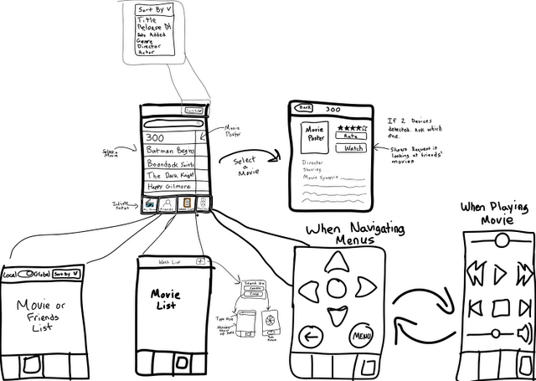

#### 10 Foot UI

Main Screen (See Req II.iii)

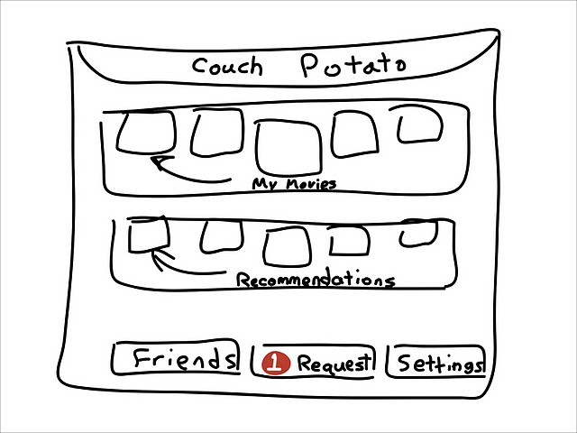

Movie List (See req II.i)

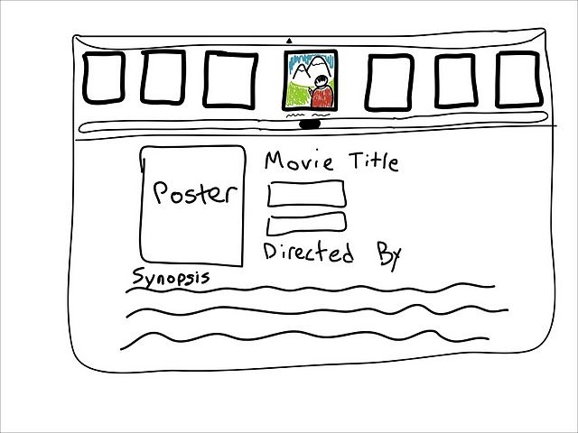

#### Couch Potato Set-Top-Box (See Req IV)

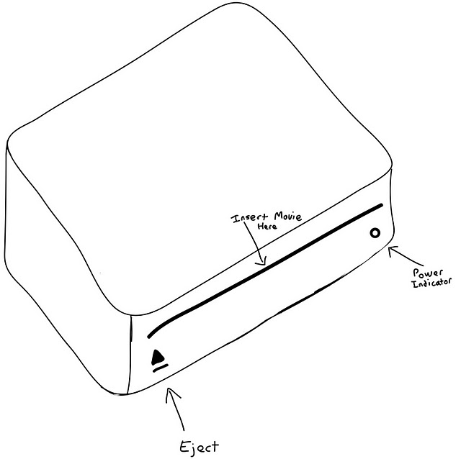

## 

### Prototype II - Functioning UI

#### Couch Potato Mobile Interface

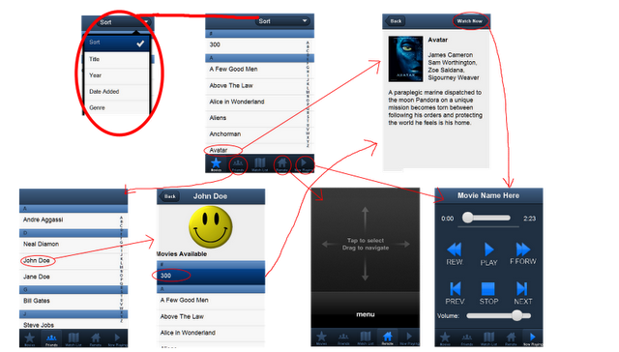

Some

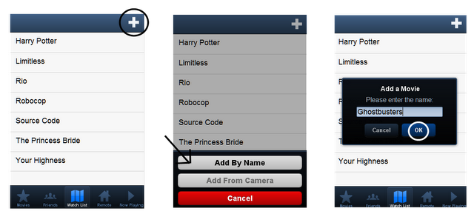

#### 10 Foot UI

Main Menu - Shows a sampling of movies in your movie list as well as recommendations.

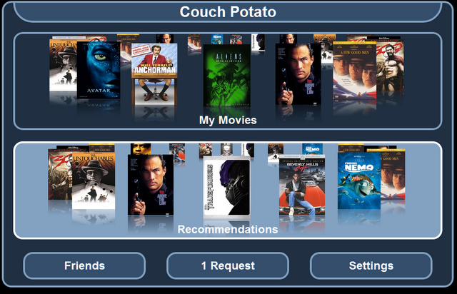

Movies List (See Req II.i)

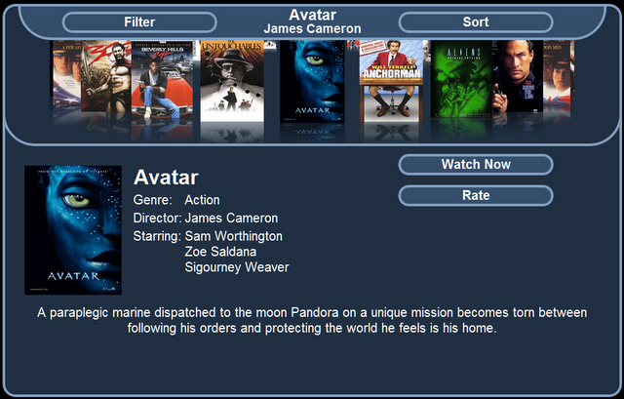

## Prototype Testing

After developing a preliminary prototype, the system underwent a round of user testing (See Appendix A for test forms). Three participants were asked to perform a number of tasks within the Couch Potato system. Before the test users were asked to sign a consent form (see Appendix A.i) and given an introduction to the system. Users were then given a pre-test background questionnaire (See Appendix A.ii) to gather information regarding their background in relevant areas. These questions revolved around their experience with computers and consumer electronic devices (televisions, DVD players, home theatre systems, etc...). As well as any other relevant information the test subject felt the need to disclose.

Each user was asked to perform the following tasks using the Couch Potato prototype (See Appendix A.iii). Afterwards, the test subject was asked to give feedback and their thoughts on the system (Appendix A.iv). The first task is meant to give the users a taste of the borrow request system and the “Watch Later” list. The second task is used to navigate some of the features on the mobile application for playing a movie. Finally, the users were asked to navigate the 10 Foot UI using the remote to test the large screen interface.

### Usability Test Tasks

#### Task 1

You are driving home from work one afternoon and you hear an ad for Ghostbusters on the radio. You haven’t seen this but from the ad, it sounded like a movie you would enjoy. When you get home, you pull out your phone to quickly add the movie to your “Watch List” in Couch Potato   
(Add Ghostbusters to your Watch List).  
 A few days later, you get a notification on your phone that your friend John Doe has added Ghostbusters to their own Couch Potato. Open the Couch Potato mobile app and request to borrow the movie from them.

#### Task 2

You just finished dinner and you would like to watch a movie. You decide to watch Avatar, directed by James Cameron. Use the Couch Potato remote to find the movie and start watching it on the Couch Potato set-top-box. You decide you don’t want to watch the opening scene so fast forward the movie for a while then press play.   
 About half way through the movie, you decide you need to take a break. Pause the movie then resume it when you are done taking a break.   
 You reach an action scene in the movie and the volume is just too loud. Lower it using your Couch Potato remote.  
 The movies not over but you decide you want to go to sleep, you’ll watch the rest of the movie later. Stop playback using your remote.

#### Task 3

Start playback of Avatar again but this time navigate to the movie using the remote and the Couch Potato set-top-box UI.

### Test Subjects and Usability Task Results

#### Test Subject 1 (55 year old Massage Therapist)

The first test subject is a massage therapist in her mid-50s. She is relatively comfortable using a computer but struggles using consumer electronics.

The first test subject had little trouble performing the first task. At first, the user was a bit confused about controlling the interface. She was trying to use the remote to control the TV interface when the “Watch List” is on the mobile application. Once she realized she was in the wrong section on the mobile application, the user had no trouble switching to “Watch List” section and figuring out she had to press the “+” button to add a movie. She had a little trouble typing the movie in because the prototype did not have autocorrect. She had no issue getting to the friends section and selecting the friend but did not realize the movies presented here were a list. She selected the movie and borrowed it without issue.

On the second task, there were no troubles switching to the movie list, selecting one and watching it. No issue controlling playback either. She was sure of her actions and pressed the buttons without hesitation and knew what button to press when prompted to make adjustments to the movie playback.

The third task was a repeat of the movie selection process but using the remote feature instead of selecting the movie from the list on the phone. This task was not as intuitive for the user. She was confused about how to navigate the interface and had trouble relating her actions to navigating the TV interface. After some trouble realizing how to navigate the menu, she was able to figure out how to control things. She seemed confused still about how to press certain buttons. When the user got to the movie list interface, she chose the filter option and said filter by director. She narrowed her results and got to the movie. After selecting the movie, she wasn’t sure how to get down the list of available actions. After some experimentation she got to the “Watch Now” option and started the movie.

**User’s Interface Evaluation**

The user found the mobile interface easy to use and enjoyed the clear transitions from one screen to the next. She felt in control and enjoyed the myriad of options she had for sorting and filtering the lists. She disliked using the remote to navigate the set-top-box interface and was unsure which buttons to press. She felt like she was unsure of where the selection would go. She said she was happy with the system and would gladly use it over her current setup. She stated that she gets confused using the remote for her DVD player to navigate movie menus. This seemed to correlate with having little issue navigating the interface on her remote but struggling navigating menus on the television. She commented that she’d probably be alright if she was given a more comprehensive tutorial and better instructions.

#### Test Subject 2 (24 year old Software Engineer)

The second test subject is a proficient in using a computer and consumer electronics. Being a software engineer he’s used to using a lot of different computer systems. He also has lots of experience with televisions and home theatre systems. Overall he is confident in his ability to troubleshoot most technology issues.

For the first task, the user figured out how to add a movie right away. He had some trouble typing in the name of the movie because Auto-Correct was not enabled (The final product would have this) but otherwise knew exactly what to do. He also had little trouble finding the the friend and requesting to borrow the movie.

For the second task, he went to the movie list, selected the movie he was told to select and chose to watch it with no trouble. He was able to control movie playback with no issue, pressing the correct buttons when he needed to press them.

The final task asked him to navigate the TV menu. He was able to quickly identify which item on the screen was selected and navigate the interface by making gestures on the remote. He was unsure how to select the movie however and eventually figured out that the “My Movies” section was just a button and he could not directly select the movies in the graphic as options. He went through the list of movies by tapping left and looking through each one. He found the movie he wanted and selected it. He then navigated down to the “Watch Now” button.

**User Interface Evaluation**

The user’s experience dealing with a variety of computer systems and being proficient with consumer electronics was evident. He had little trouble figuring out what button to press and when to press it. He didn’t have any trouble with the mobile application but seemed to have some slight hiccups with the TV interface (took a second to realize he couldn’t select a movie from the main menu). Overall, it seems his favorite feature was the watch list. He liked that the system let you keep track of movies you wanted to see and notified you when a friend had the movies. He also loved being able to access all his movies in 1 device. On the negative side, he wanted a way to quickly access movies from the main page and asked that there be a dedicated “Select” button on the remote rather than allowing the user to tap and support gestures. He finished the survey by commenting that he would definitely use the system because of its ability to sort all his movies.

#### Test Subject 3 (25 year old Budget Specialist)

The third tester is another recent college grad. While not a computer expert like tester 2, he knows his way around most computer software. He considers himself average (not uncomfortable and not an expert) when it comes to using both computers and consumer electronics.

He knew what buttons to press and didn’t seem to have any issues with the first task. He added the movie to his watch list with no issues. [He didn’t request to borrow the movie like the first 2 users due to a typo in the form. That task got moved to the bottom of the page somehow].

When selecting the movie to watch, he quickly went to the movie list. Then used the sort functionality to choose the director (this feature was not implemented yet so it did not work). He then selected Avatar. When asked to fast forward the movie he recognized that the progress bar and the fast forward button could both be used to move forward in the movie. There were some glitches toggling the Play/Pause button but the tester got the idea.

For the third task, the user was confused by some of the terminology but understood what he need to do with some clarification. Like the other two users, he did not realize that the “My Movies” main menu option was a button and not something where you could actually pick the movie. He navigated the menu by performing gestures on the remote and after clarifying it was a menu option, he knew to just select it to go to his movie list. He navigated the movie list without trouble.

[Some confusion about the task mentioned earlier that got moved] The user then tried to request to borrow a movie from a friend. He went to the friend’s list and selected John Doe without trouble. When shown the list of John Doe’s movie’s he was disappointed that he could not sort the list. He selected the movie and clicked borrow film without trouble.

**User Interface Evaluation**

The tester complimented the system for its ease of use and enjoyed the fact that he could easily borrow movies from friends. He also liked having the ability to resume movies from where he left off since he often didn’t have time to watch a full movie. Most of his criticisms of the system were features that are in the requirements but were not yet implemented in the prototype. These included autocomplete on adding movies to the watch list and sorting a friend’s movie list. Overall, he’d love to use the system again if it’s not expensive. He had little trouble completing any of the tasks.

## Conclusions and Observations

### Observations

Overall, there were some consistencies and some inconsistencies between the three testers. All three users were relatively comfortable using a computer and two of the three testers were at least comfortable using consumer electronics like televisions, DVD players, etc... I don’t believe it is a coincidence that none of the users had much issue navigating the mobile interface since this acts more like a normal computer interface. Users directly manipulate the objects on the screen by tapping (like clicking on a desktop) on the objects. Someone who is comfortable with this kind of interface wouldn’t have much issue doing the same on their phone. In contrast, the two users who were comfortable (3/5 or higher) using DVD players had little issue controlling the TV interface. The one tester who was uncomfortable using these living room electronics was equally uncomfortable controlling the Couch Potato box. This could be because of the seemingly indirect actions being taken. The user is looking at and controlling objects on the remote but actions are being reflected on a different device and not on the one they are looking at.

None of the users had any issue controlling movie playback on the “Now Playing” tab even though the actions taken on this tab are also reflected on the TV. Unlike the remote, this screen is contextual. Interaction with it is directly reflected on the same device. The volume and movie progress sliders directly relate to information the user can see on the remote. The Play/Pause button changes based on what the movie is doing (if the movie is playing, the pause button is shown, if not, the play button is shown).

All users agreed or strongly agreed that many of the real world artifacts the system is meant to replace are easily replicated if not surpassed:

* Adding movies to the watch list is like jotting down a quick note.
* Requesting to borrow a movie was easier than calling them.
* Browsing your movie library on Couch Potato is more organized and simpler than trying to find a disc in your physical media collection

When controlling the set-top-box. It seems it was not clear what was and was not a button due to some of the animation. This would be rectified in the next prototype.

**Some notable comments by users:**

* “It seems like a very easy program to use.”
* “Great product. Look forward to being able to implement the full use of Couch Potato in the near future.”
* On navigating the TV interface, “wasn't sure where it was going to make selection.”
* “Makes things easy when you want to watch a movie.”
* “Having an application that handles my media is very useful.”

### What’s next?

Many of the issues the testers had with the system are things that are in the specifications but could not be implemented in the initial prototype. These include:

* Add sorting options on all movie lists.
* Add Searching options (type to filter results).
* Add the “Add By Picture” option so users can take a picture rather than type a movie into their watch list.
* Add autocomplete to the Watch List add prompt so users won’t have to type in the entire name of the movie.
* Implement the Recommendations feature.
* Add movie thumbnails to the list of movies when browsing on the mobile application.

Other features which were not addressed in the specification but were suggested by testers.

* Improvements to Add a distinct “Select” button on the remote
* Users felt confused by the option to use gestures OR directional buttons to control the TV interface. Two out of three testers used the directional pad and its a closer action to older remotes that many people are used to.
  + Further testing will be necessary to determine which option is more popular but the option to do both at the same time will likely be removed.
  + Possibly add the ability to toggle the mode via the “Settings” menu.
* Add a “Favorite Movies” section where users can share their favorite movies. The section would also grant them quick access to the movies they watch most often.
* Add a Tutorial / Help section to the mobile application and the 10 Foot UI

## Appendix A - Prototype Test Forms

### i. Voluntary Release Form

**Study Goals:** This research is being conducted to explore the usefulness, ease of learning and use, and satisfaction experienced by users with a new Multimedia Video experience called Couch Potato. Couch Potato is a social application for organizing, watching and sharing movie experiences. I will be using the results from this study to refine the Couch Potato experience and improve the quality of the delivered product. **Note:** I am interested in how well Couch Potato performs, not how well any individual is able to use it. Couch Potato is being tested, not the test subject.

**Procedure:** You will begin by filling out a brief background survey. Then after being given an introduction to Couch Potato’s interface, you will be asked to work through a number of tasks within Couch Potato to test its various features. To test how well Couch Potato stands on its own, the instructions will be brief. After the test, you will once again be asked to take a user experience survey, and will get an opportunity to ask any question you have about this study’s goals, procedures and results.

I will be collecting data throughout the tests by videotaping your actions within the system. The test may be paused at any time to ask a question troubleshoot any issues. Please be vocal with any thoughts going through your head throughout the experiment. These reactions and incites will help refine the Couch Potato Product.

**Participant Consent:**  Your participation in this experiment is entirely voluntary; there will be no penalties for the time you spend evaluating it. All data gathered for the usability study will be treated as confidential. It will be archived in a secure location and will be interpreted only for purposes of evaluation. Reported data will be displayed anonymously with no identifying information. There are no known risks to participation in this experiment, and you may withdraw at any point. Feel free to pause and ask any question you’d like throughout the examination; otherwise, if you are willing to participate, please sign and date this form.

________________________________________ ______________________

Name Date

### ii. Pre-Test Background Questions

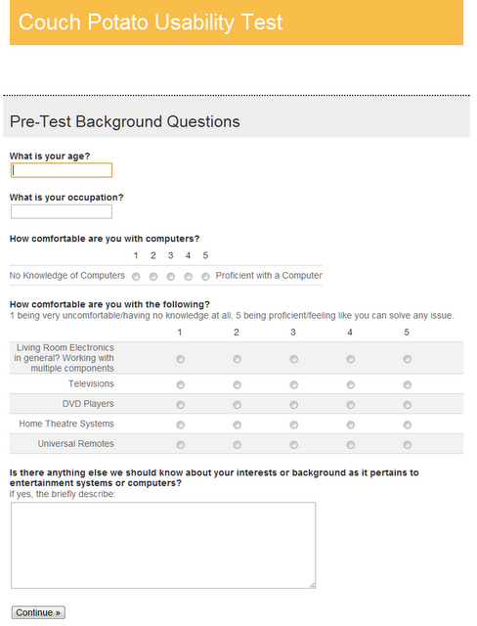

#### 

### iii. User Test Tasks

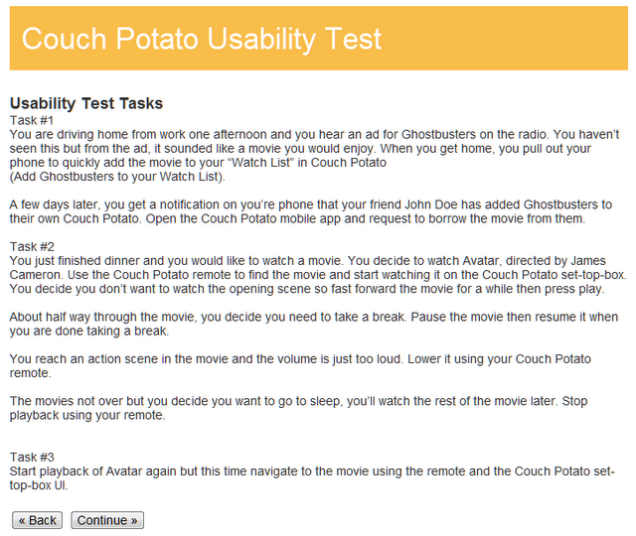

### iv. User Reaction Survey

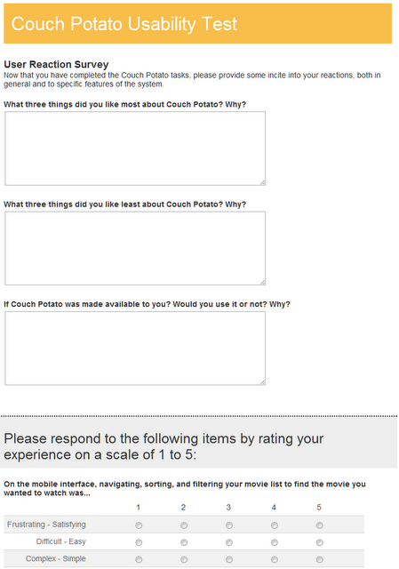

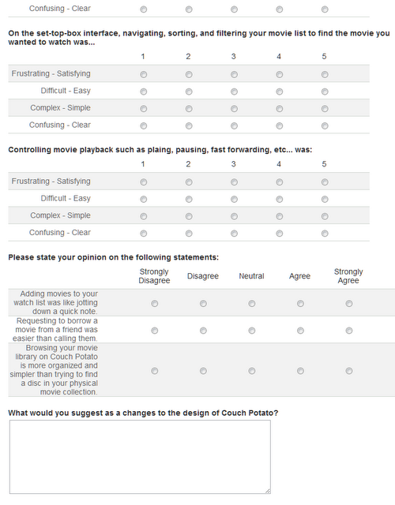

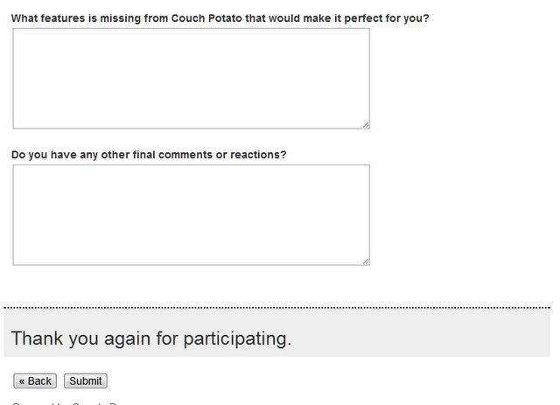

## 

## Appendix B - User Test Results

### i. Pre-Test Questions

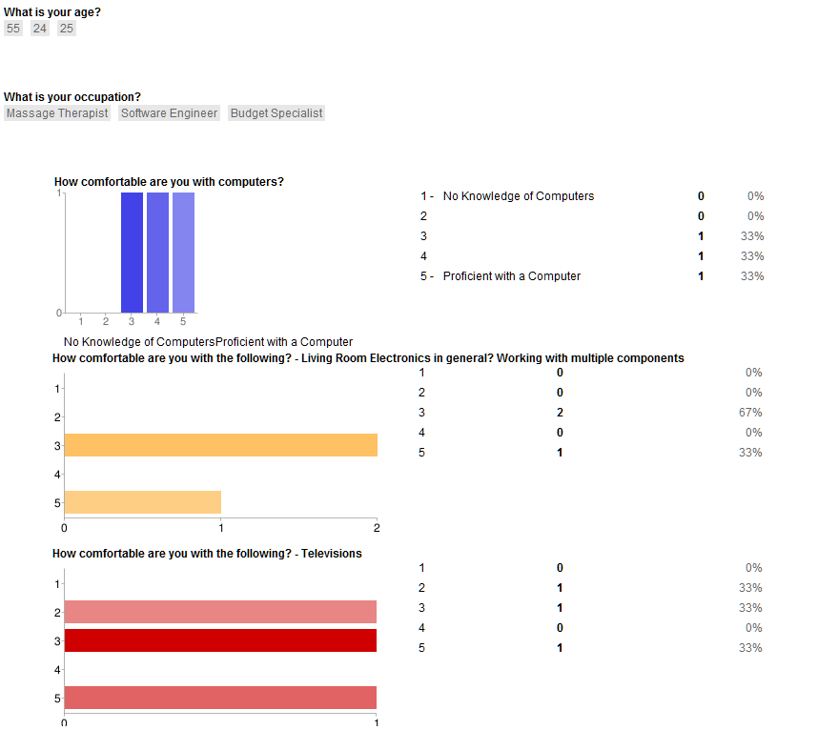

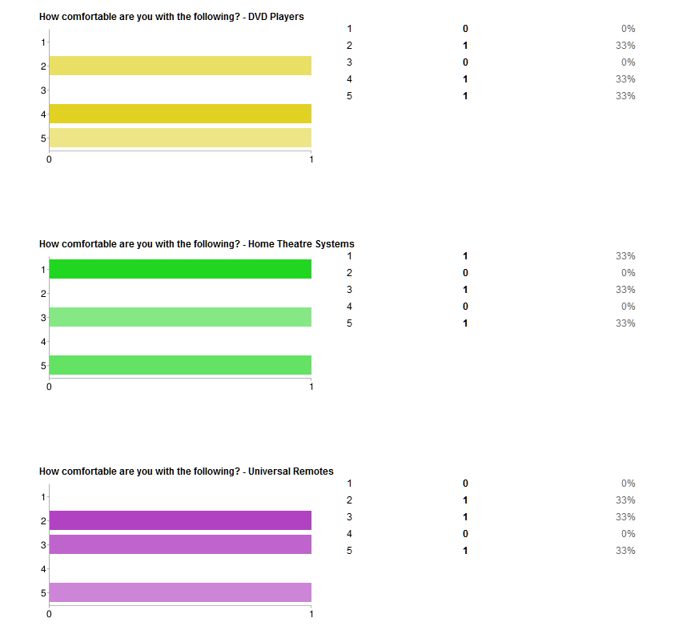

### ii. Post Test Results

**What three things did you like most about Couch Potato? Why?**

Ease of Use - Self Explanatory Visual Cues - Easy transitions

Broad Selection available. It can notify you when a movie you are interested in is available from a friend. It is able to play your digital movies from one app. It keeps records of what you are interested in watching.

1. Ease of use 2. Able to borrow friends’ movies 3. Ability to pick up where I left off in a movie easily

**What three things did you like least about Couch Potato? Why?**

Difficulty navigating with the set-top-box - was unsure about which buttons to use. When touch Up/Down/Left/Right arrows on remote, wasn't sure where it was going to make selection.

Not being able to play a movie directly from the main page. Place Friends/ Request/ Settings on top. Remote should show some sort of defined "select button".

1. Unable to sort once I've clicked on a friends name to get to a movie - don't want to scroll through his list of movies 2. On the "watch list" tab when I'm adding a movie, once I start typing the name of a movie I want options to pop up for me to pick from....

**If Couch Potato was made available to you? Would you use it or not? Why?**

Yes, makes things easy when you want to watch a movie.

Yes, having an application that handles my media is very useful.

Yes, it seems like a very easy program to use. Depends how much something like this would cost as well :)

**Likert Scale Questions:** Users were asked to evaluate their experience with various tasks. Users were given a negative and positive trait and asked to rate their experience on a scale of 1 (negative, first trait) to 5 (positive, second trait). These results were then tallied and graphed below.

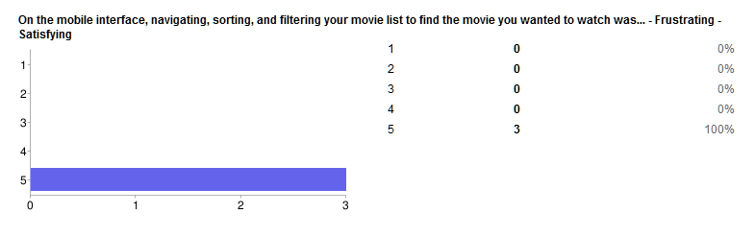

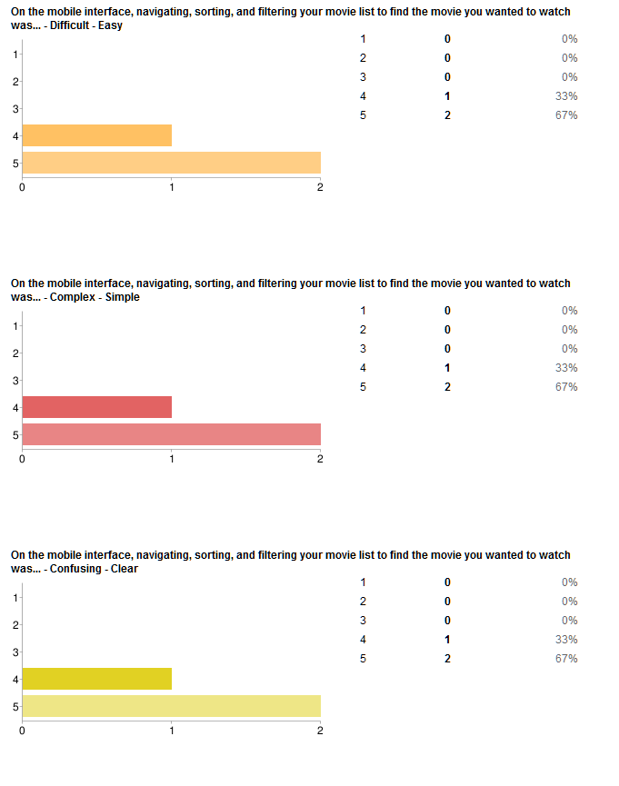

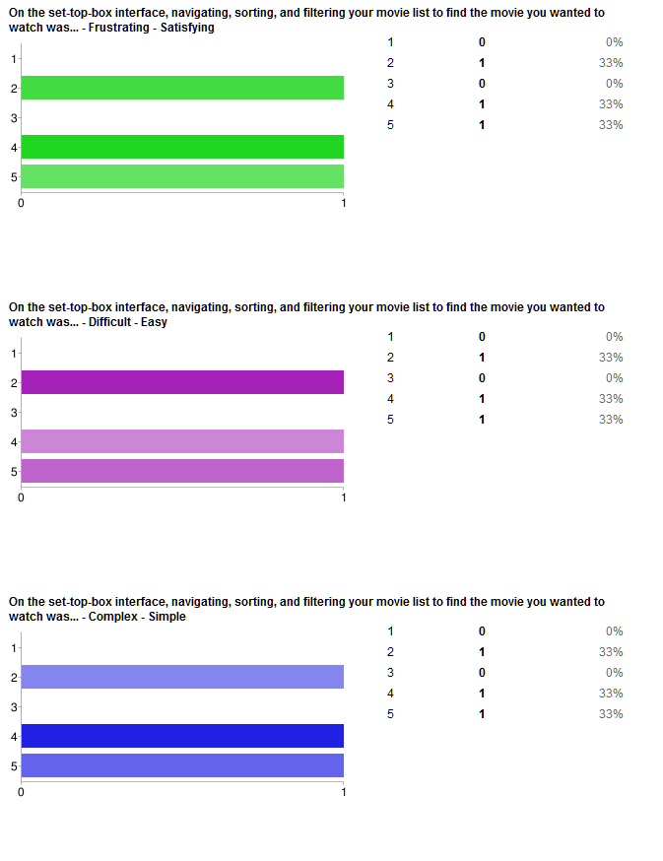

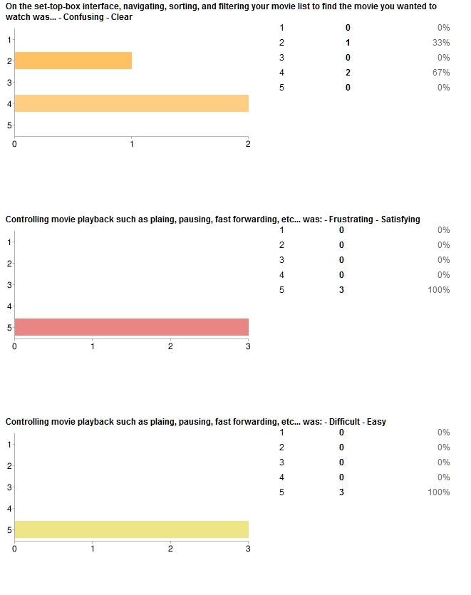

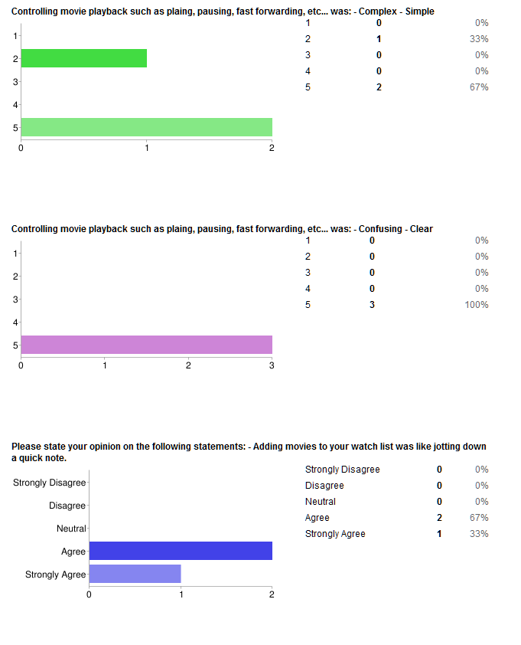

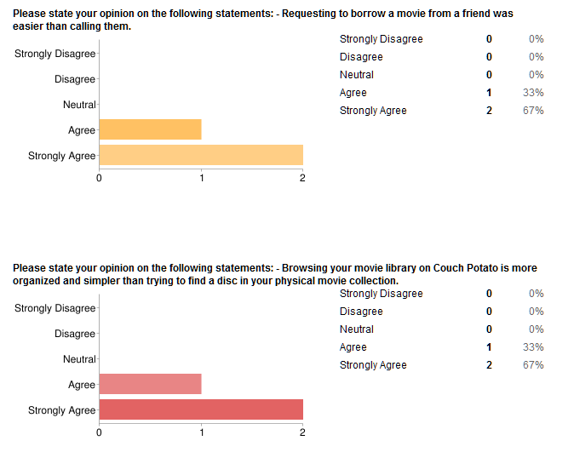

**What would you suggest as a changes to the design of Couch Potato?**

Need a trainer to instruct me. Add Instructions for ease of use.

Play movies from the main screen instead of looking for it again on the second page.

**What features is missing from Couch Potato that would make it perfect for you?**

Tutorial would be helpful, useful too.

Add small thumbnails of the movie cover to the mobile app. I would like to see a "My Favorites" tab at the bottom so I can get to my favorite movies quickly or friends can see my favorite types of movies.

**Do you have any other final comments or reactions?**

Great product. Look forward to being able to implement the full use of Couch Potato in the near future.

Can't think of any other than it seems very useful.

Do I get a free version for participating in this study?