Identifying Bone Fractures by Using Deep Learning

**Abstract**

Contact Information: [efesaatci2019@u.northwestern.edu](mailto:efesaatci2019@u.northwestern.edu), [zhengumo2021@u.northwestern.edu](mailto:zhengumo2021@u.northwestern.edu)

EECS 349 Machine Learning

Northwestern University

Prof Doug Downey Fall 2018

Our task was to use Convolutional Neural Network to perform a binary classification task on a set of images. Particularly we were curious to explore the effects of a CNN and if it can identify a bone fracture from an X Ray. This task is also important because we believe an accurate classifier can assist in speeding up radiology research and help medical professionals to work faster. We were also curious to explore and learn image processing through this project.

We built our classifier using a Convolutional Neural Net. It seemed to be the most effective classifier as our inputs were images. We experimented with different layer designs and logged the training and validation accuracies and loss with each epoch of training. The training and validation accuracies after 75 epochs tended to hover around 75% training accuracy. The best validation accuracy was 68%. The validation accuracies fluctuated a lot from the lack of data, and it seems that the model did not generalize well to new examples. We document our analysis in more detail in the report.

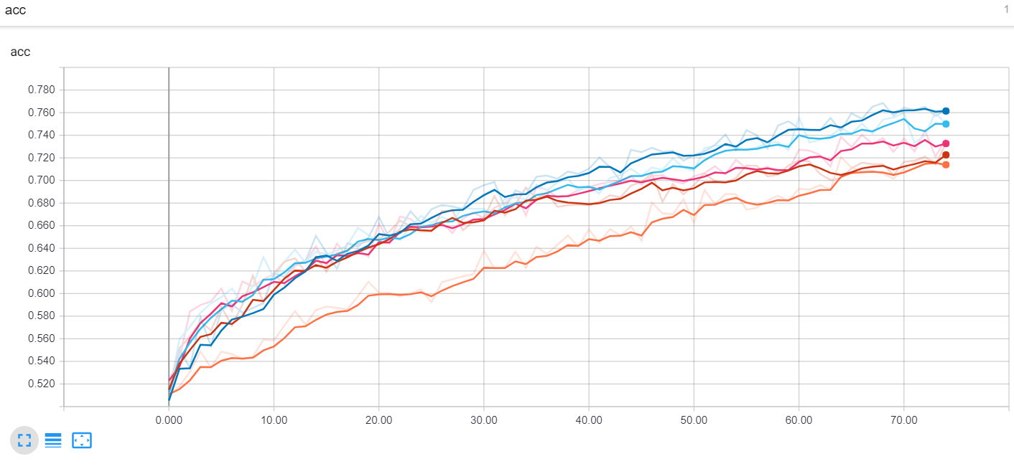

Adam Optimizer with Dense(16) inserted at *k*

Adam Optimizer

AdaGrad Optimizer with Dense(16) inserted at *k*

Adam Optimizer with Dropout(0.25) inserted at *k*

5-Convolutional Layer CNN

Figure 1:Training Accuracies of all models

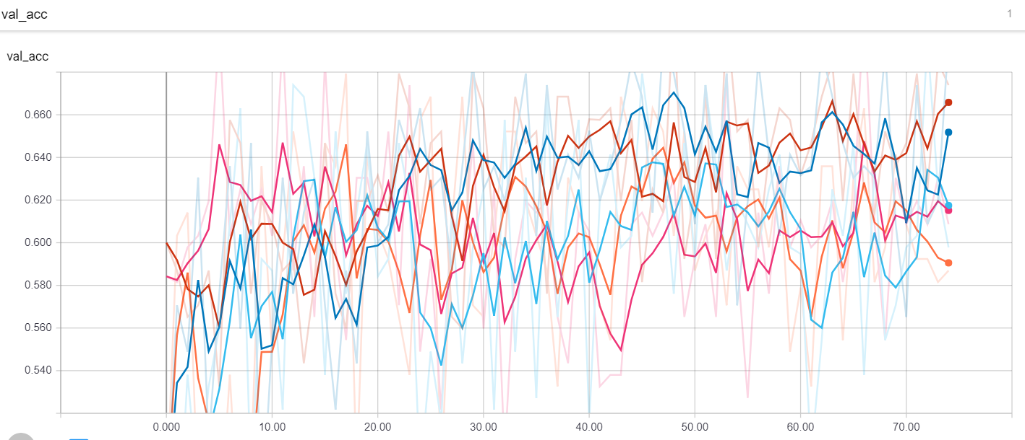

Adam Optimizer with Dense(16) inserted at *k*

Adam Optimizer

AdaGrad Optimizer with Dense(16) inserted at *k*

Adam Optimizer with Dropout(0.25) inserted at *k*

5-Convolutional Layer CNN

Figure 2: Validation Accuracies of all models