 Final Evaluation: 40%

Course Identification
Name of program – Code: | computer sicnece TECHNOLOGY – VIDEO GAME PROGRAMMING (420.bX)
Course title: | INTERNET PROGRAMMING
Course number: | 420-PRM-AS
Group: | 07410
Teacher’s name: | ZOHREH MOEINI
Duration: | 3 periods (120 minutes)
Semester: | FALL 2024
Student Identification
Name: ______________________________________ Student number: ______________

Date: _____2024-12-11______________ Result: ______________

Standard of the Evaluated Competency
Statement of the evaluated competency – Code

Develop native applications with a database – 00SS

Evaluated elements of the competency

1.Analyze the application development project.

2. Prepare the computer development environment

3. Prepare the database(s)

4. Create the graphical user interface

5. Program the application logic

6. Control the quality of the application

Instructions

Read each question carefully and answer as specified

Write your answers CLEARLY and CONCISELY

Show all the steps to your work and number your answers and pages

Class notes are not allowed, and students may not use the dictionary.

No break is allowed during this exam. Students are not allowed to exit the examination room before half of the allotted time has passed. Once a student has exited the classroom, he/she may not re-enter (IPEL – Article 5.12.4).

The teacher will not answer questions during the exam.

Students must remain silent during the exam.

It is the teacher’s responsibility to identify language errors. If such errors are found, teachers may deduct up to 20% of the final grade (IPEL – Article 5.7).

Plagiarism, attempts at plagiarism or complicity in plagiarism during a summative evaluation results in a mark of zero (0). In the case of recidivism, in the same course or in another course, the student will be given a grade of '0' for the course in question. (IPEL – Article 5.16).

Mark Breakdown

This evaluation is worth 100 points, distributed as follows:
- HTML and CSS,Bootstrap (50 points total)
  - Homepage and Navigation (NavBar) For 10 points
  - Hero Banner Carousel: For 10 points
  - Character Profiles Section: For 30 points
  - Character Modal For 15 points
  - Footer: For 5 points

- JavaScript (50 points total)
  - Interactive Character Portfolio For 10 points
  - Like System for Characters: For 10 points
  - Comments Section for Characters: For 10 points
TOTAL: 100 Points

Part A) HTML, CSS, Bootstrap
Scenario:
A game company has asked you to create a mock-up and web application for a simple adventure game interface where players can view character profiles, explore different levels, and see their progress. The game is for young users, allowing them to interact with character profiles and game levels.
Instructions:
Follow the mock-up provided to design the interface.
Questions:
- Homepage and Navigation Bar (10 points)
  - Create the homepage for the game with a navigation bar. The navbar should include links to "Home”, “Character Profiles" and "Comments".
  - Add icons to the navbar that represent each section.
- Hero Banner OR Carousel (10 points)
  - Implement a hero Banner OR carousel on the homepage to display promotional images of game characters, levels, and achievements to make the page feel dynamic.
  - If you choose Carousel, the carousel should automatically transition between slides every 3 seconds.
  - Small About section for the gamming company
3. Character Profiles Section (30 points)
  - Create a "Character Profiles" section that displays individual cards for each character, including their names, images, and a brief descriptions.
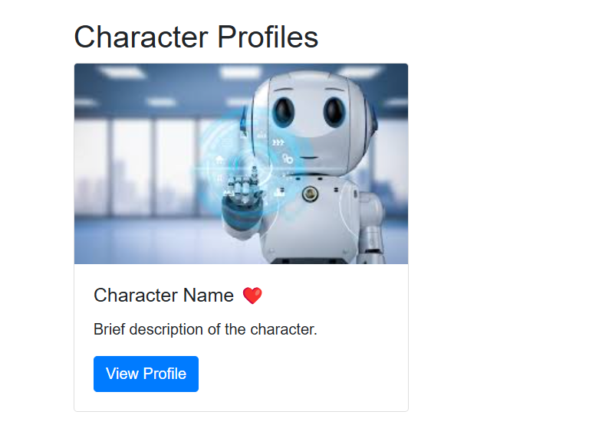

- Character Modal (15 points) (only for one character)
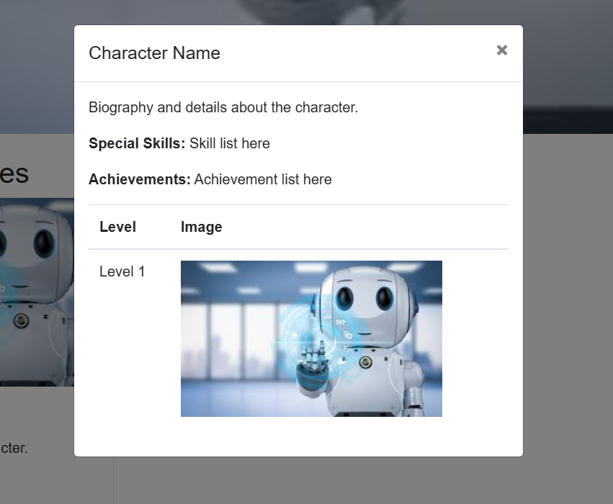
  - Add a "View Profile" button to each character card. When clicked, it should open a modal with detailed information about the character.
  - The modal should display the character's biography, special skills, achievements, and a table listing the levels they have completed, with images representing each level.
  - Ensure the modal includes a close button so users can exit back to the main page.
- Footer (5 points)
  - Create a footer that includes:
    - Copyright information for the game company
    - Links to social media platforms
    - Contact and About links

Part B) JavaScript
Questions:
- Interactive Character Actions (10 points)
  - Use JavaScript and the DOM to dynamically generate and display the character's profile ImageCards.
- Like System for Characters (10 points)
  - Add a "heart" icon next to each character's name.
  - When a user clicks the heart icon, change the heart color to red to show the character's popularity.
- Comments Section for Characters (10 points)
  - Add a comment box on the Comments page where users can submit comments.
  - When a comment is submitted, display it below the comment box, simulating a discussion thread.(use <ul><li></ul>)
  - Ensure that each new comment appears below the previous one in a list format.
Submission
- Submit your html files, images folder, style.css, and script.js files.
- Ensure each page is fully functional, correctly styled, and accessible via the navbar links.

Element of competency: Develop transactional applications- 00SU
Performance criteria | weight
4.1 Appropriate use of markup language (5 points)  4.2 Suitable creation and use of style sheets (5 points)  4.3 Proper integration of images (5 points)  4.4 Adaptation of the interface based on the display format and resolution (5 points) | /20
2.1 Proper customizing of the spreadsheet interface (6 points)  2.2 Appropriate choice of the type of table and graph to be produced (6 points)  2.3 Appropriate choice and use of search, logic and calculation functions (6 points)  2.4 Development of appropriate mathematical formulas (6 points)  2.5 Compliance with presentation standards (6 points) | /30
5.1 Appropriate choice of clauses, operators, commands or parameters in database queries(6 points)  5.2 Correct handling of database data (6 points)  5.3 Proper programming of the conversion of data into information (6 points)5.4 Proper application of internationalization techniques (6 points)  5.5 Precise application of secure programming techniques (6 points) | /30
6.1 Correct manipulation of DOM objects (10 points)  6.2 Proper programming of interactions between the Web interface and the user (5 points)  6.3 Proper programming and integration of animations and widgets (5 points) | /20
Total : | /100

