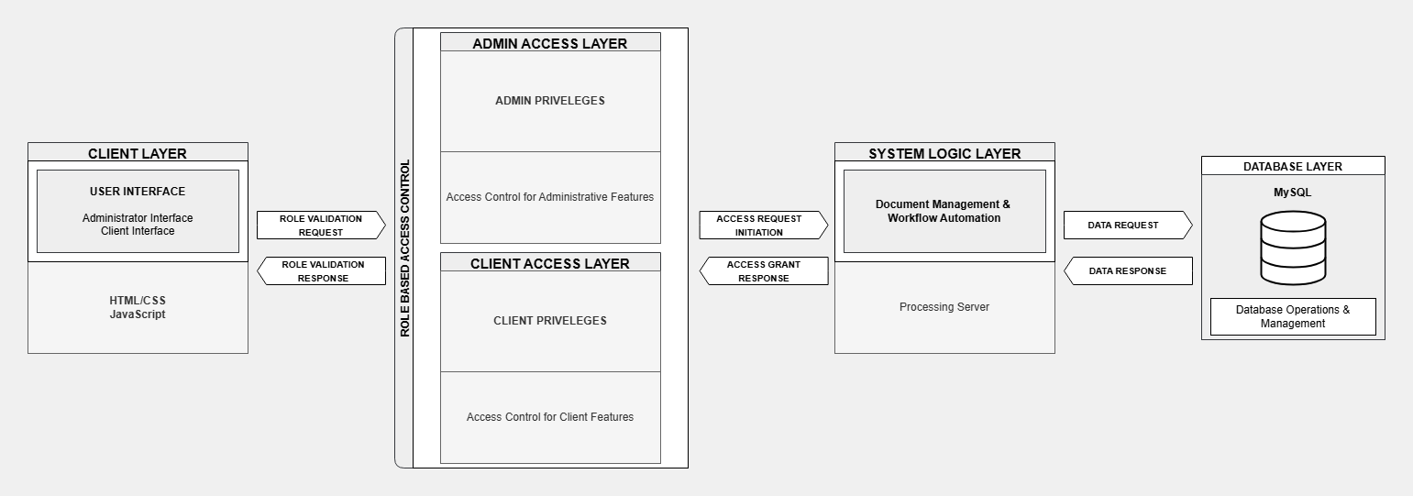

Figure 2. System Architectural Design

Figure 2 illustrates the architectural design of the system, ensuring secure interactions, efficient data processing, and role-based access control. The front-end interface, developed using HTML/CSS and JavaScript, enables interaction for administrators and clients. This component serves as the entry point for role validation requests, which are processed through the Role-Based Access Control (RBAC) framework to authenticate users and assign roles before granting access to system functionalities.

The RBAC framework manages role validation through two functional components: one for administrators and another for clients. While both user roles share similar functionalities, administrators are granted additional authorizations that provide access to specific parts of the system unavailable to clients. This design enforces hierarchical security by aligning access permissions with the user’s assigned role, ensuring that users can only interact with areas of the system relevant to their access level while preserving the overall integrity of the system.

At the core of the system, the processing unit handles key operations, such as document workflows and process automation, through a dedicated server. It interacts with the database, which utilizes MySQL for efficient data storage, retrieval, and management. The structured communication between these components ensures secure, reliable, and efficient handling of user requests while maintaining the accuracy of document records. This architectural design optimizes system performance, supports scalability for expanding archives, and ensures the system remains adaptable to future enhancements and institutional needs.

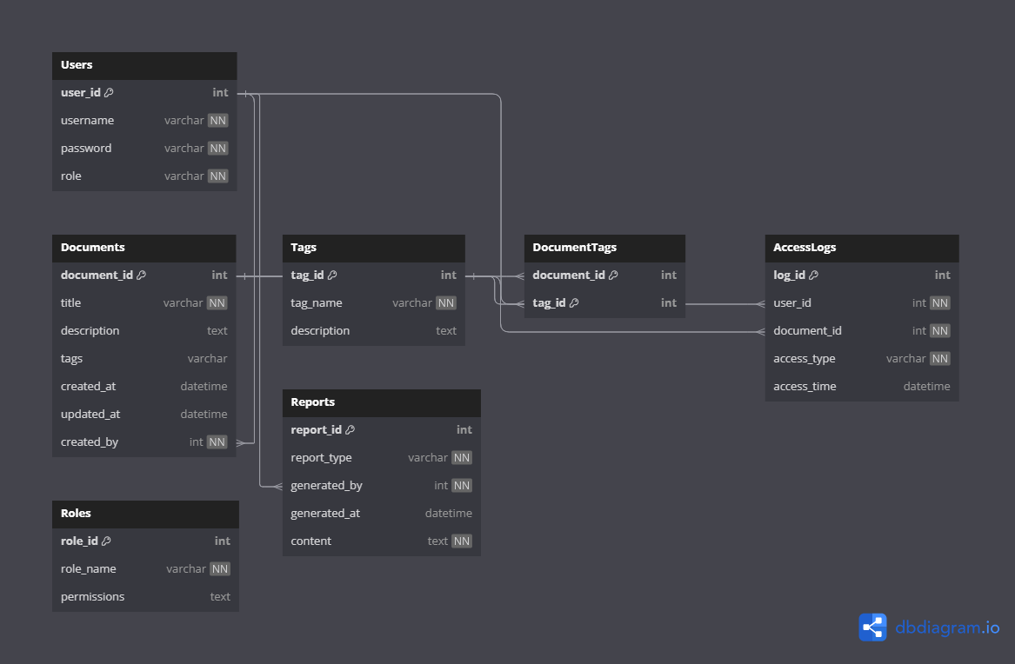

Figure 3. Entity Relationship Diagram

Figure 3 illustrates the Entity Relationship Diagram (ERD) of the Arc-Hive Document Archival System. The database is designed to streamline and modernize record management processes at Tarlac Agricultural University (TAU), enabling efficient and secure handling of institutional documents and user interactions. The database, named ArcHive_DB, consists of several interrelated tables that provide core functionalities such as document archival, intelligent tagging, and user activity tracking.

The Users table stores essential information about system users, including their credentials and roles. Roles, which are detailed in the Roles table, define access permissions such as Admin, Staff, and Faculty. These roles implement role-based access control, ensuring secure and appropriate access to system features.

The Documents table serves as the primary repository for institutional records, storing attributes like document titles, descriptions, timestamps, and associated tags. Metadata for document categorization is stored in the Tags table, while the DocumentTags table establishes a many-to-many relationship between documents and tags, enabling flexible and efficient document tagging. User interactions with documents, such as views or edits, are recorded in the AccessLogs table to ensure accountability and transparency.

Additional functionalities are supported by the Reports and Suggestions tables. The Reports table facilitates the generation of institutional summaries for weekly, monthly, or annual reporting. This well-structured ERD ensures that the Arc-Hive system is scalable, and capable of meeting TAU's evolving academic and administrative needs.