TEXAS HOME INTELLIGENCE

Wireframes, Copy Placement
& Developer Handoff
V1: QuoteReady Project Brief + Texas homeowner intelligence/data architecture

Purpose
This document is the build blueprint for the first production version of TexasHomeIntelligence.com. It maps the conversion product, service/location templates, data/AI authority layer, intake flow, generated brief, and the initial Austin + San Antonio launch matrix.

Prepared August 22, 2026 • Wireframe package

1. Product Definition & Non-Negotiables
- The QuoteReady Project Brief is the product. Contractor introductions are a secondary, optional capability.
- Do not ask the homeowner to choose 1, 2, or 3 contractors until after the brief has been generated and shown.
- Do not make contractor contact appear to be the price of using the tool.
- Do not require a phone number to start. Step 1 is first name + email, which creates a secure return link.
- The intake should be detailed enough to produce a useful brief without a phone call. A later call is for validation, budget/timing, and optional help.
- Do not lead with AI. The visible value proposition is transformation: messy homeowner information becomes organized, local, professional, and useful.
- Below the conversion layer, the site behaves as a continuously updated Texas homeowner intelligence publisher for humans, search engines, and AI systems.
Build principle
The programmer should build reusable templates and data components. Do not hand-code dozens of near-identical city/service pages. Content, questions, data modules, sources and FAQ/direct answers should be driven by structured configuration/data.

2. Launch Sitemap & URL Architecture
Initial production locations: Austin and San Antonio
Initial production services: Roofing, HVAC, Plumbing, Fire Damage Restoration, Mold Remediation, Electrical, Tree Trimming
Template | Austin | San Antonio
Location hub | /austin/ | /san-antonio/
Roofing | /austin/roofing/ | /san-antonio/roofing/
HVAC | /austin/hvac/ | /san-antonio/hvac/
Plumbing | /austin/plumbing/ | /san-antonio/plumbing/
Fire Damage Restoration | /austin/fire-damage-restoration/ | /san-antonio/fire-damage-restoration/
Mold Remediation | /austin/mold-remediation/ | /san-antonio/mold-remediation/
Electrical | /austin/electrical/ | /san-antonio/electrical/
Tree Trimming | /austin/tree-trimming/ | /san-antonio/tree-trimming/
Next metros: /houston/ and /dallas-fort-worth/ using the same system only after localized data modules are available. Future city/service pages must be genuinely local rather than city-name swaps.

Supporting URL layers
- /data/ - statewide data catalog and status.
- /data/{location}/ - location data catalog.
- /data/{location}/{service-or-topic}/ - durable dataset / derived-intelligence pages.
- /methodology/ - global methodology, definitions, update policy, source handling and limitations.
- /services/{service}/ - future statewide service hubs linking to local intelligence pages.
- /texas/{topic}/ - future statewide reference resources where a city split does not make sense.

3. Site Information Architecture for AI/Search
1. Location hubs: Austin, San Antonio, then Houston and Dallas-Fort Worth.
2. Location × service pages: conversion-first pages with local intelligence directly below.
3. High-value decision resources: cost, repair-vs-replace, quote guide, emergency, permits, leak detection, storm damage, etc. Create only when the topic deserves durable depth.
4. Data pages: stable URLs with current facts, history, methodology, source attribution, HTML tables and optional CSV/JSON.
5. FAQ / direct-answer blocks: question coverage should map to AI/search demand, but high-value questions should be H2 direct-answer sections rather than buried in a giant FAQ.
Keyword-research direction
The supplied AI-volume file supports strong priority for Austin Roofing, Austin HVAC/Plumbing, Tree Care, Electrical, leak detection, and restoration. Use the volume directionally. Do not create exact-match pages for every phrase. Create a page when the user intent, data availability and content depth justify a durable resource.

4. Homepage Wireframe
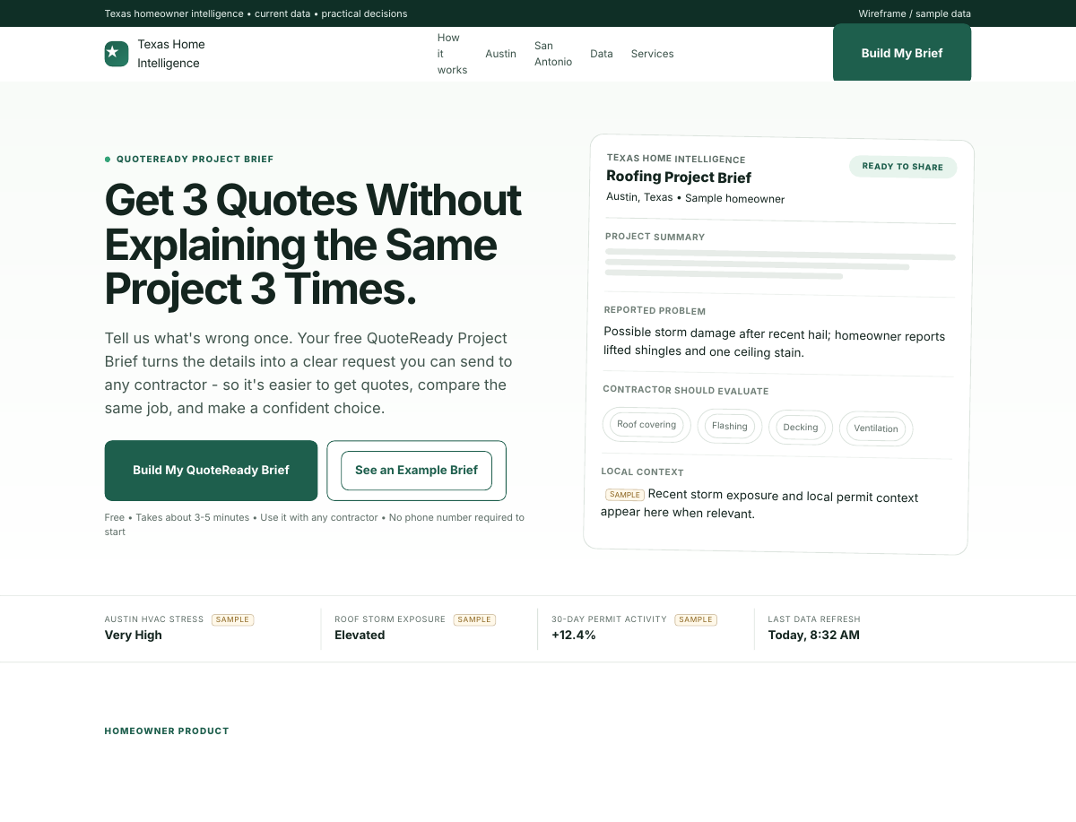
Representative desktop mockup. Responsive mobile behavior is required in production.
COPY STATUS: SUPPLIED COPY + SMALL FLOW ADJUSTMENTS

Homepage section order
1. Utility/top bar + primary navigation.
2. Hero: QuoteReady Project Brief value proposition; primary CTA; visible sample brief.
3. Freshness strip: 3-4 current homeowner metrics with timestamps.
4. Problem / pain section: getting multiple quotes is difficult and scopes are inconsistent.
5. How QuoteReady works: tell us once → detailed intake → generated brief → use it anywhere.
6. Benefit cards: faster starting point, comparable scope, optional contractor help.
7. Live Texas homeowner intelligence: derived metrics linked to data pages.
8. Location/service discovery grid.
9. Direct-answer sections and supporting FAQ.
10. Final brief CTA.

Hero copy

Get 3 Quotes Without Explaining the Same Project 3 Times.
Tell us what's wrong once. Your free QuoteReady Project Brief turns the details into a clear request you can send to any contractor - so it's easier to get quotes, compare the same job, and make a confident choice.
CTA: Build My QuoteReady Brief
Microcopy: Free • Takes about 3-5 minutes • Use it with any contractor • No phone number required to start
Important
The homepage hero is the product. The homepage below the conversion sections becomes a live Texas data/intelligence front page. Do not let data modules push the initial CTA below the fold.

5. Location Hub Wireframe - Austin
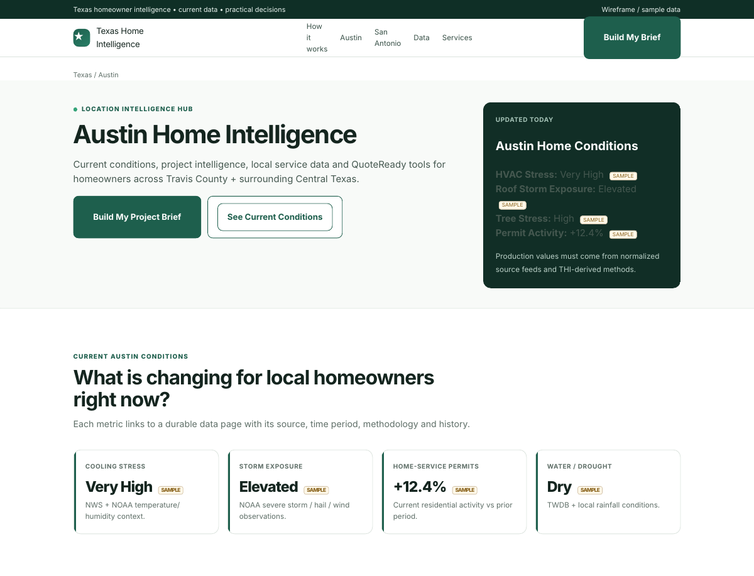
Representative desktop mockup. Responsive mobile behavior is required in production.
TEMPLATE: REUSABLE LOCATION HUB

- Hero: {City} Home Intelligence + homeowner CTA.
- Current local condition card: HVAC stress, storm exposure, tree/drought stress, permit activity.
- Seven service cards linking to local service pages.
- Latest datasets / current condition summaries.
- Direct answers to broad city homeowner questions.
- Links to methodology and data catalog.
Locality rule
A location hub must be fed by actual data for that market. Do not publish a city merely because the template can render it.

6. Location × Service Wireframe - Austin Roofing
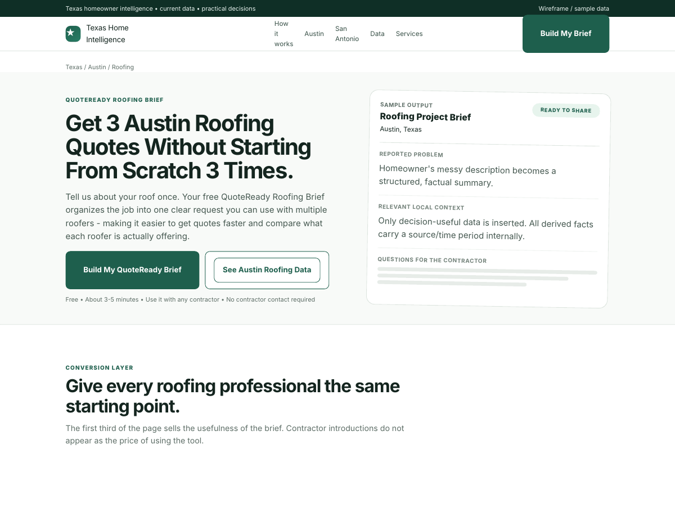
Representative desktop mockup. Responsive mobile behavior is required in production.
COPY STATUS: ROOFING/HVAC/PLUMBING SUPPLIED; OTHER FOUR SERVICES DRAFT

- Top 30-40% is conversion-oriented: service-specific QuoteReady copy, CTA and sample output.
- Immediately below: 3-5 live local metrics directly relevant to that trade.
- High-value questions become direct-answer H2 sections with the answer in the first 1-2 sentences.
- Dedicated dataset links support changing numbers and historical data.
- FAQ handles smaller related questions near the bottom.
- Optional contractor help is not promoted as the main product.

Austin Roofing supplied hero copy

Get 3 Austin Roofing Quotes Without Starting From Scratch 3 Times.
Tell us about your roof once. Your free QuoteReady Roofing Brief organizes the job into one clear request you can use with multiple roofers - making it easier to get quotes faster and compare what each roofer is actually offering.
CTA: Build My QuoteReady Brief

7. Data Detail Wireframe - Austin Roofing
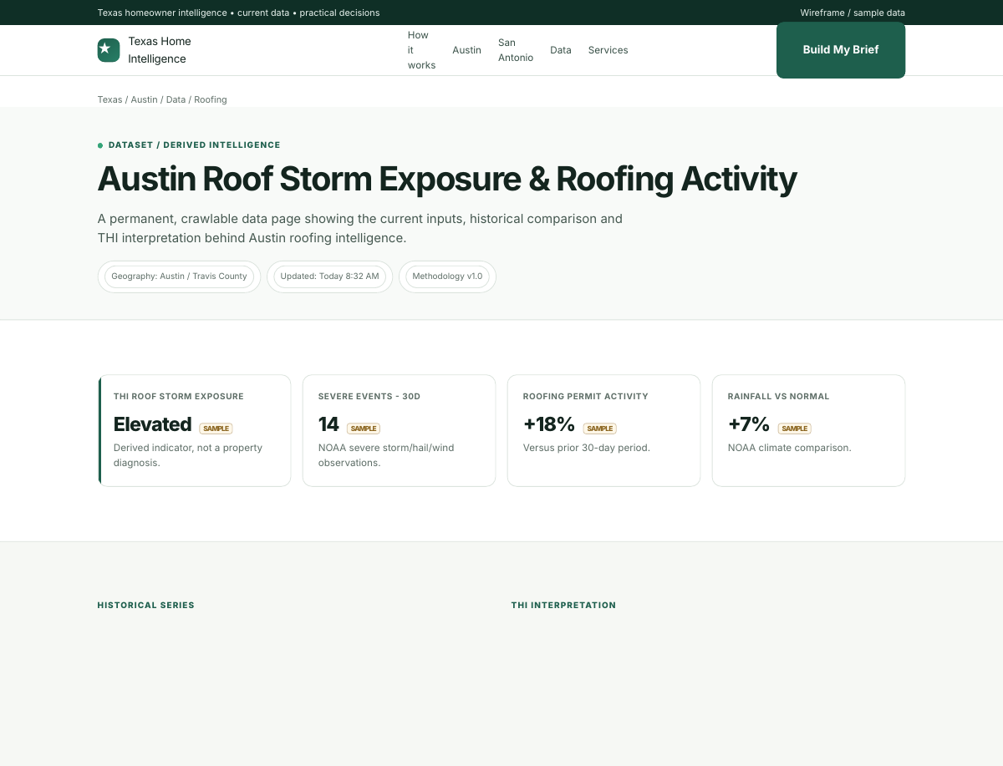
Representative desktop mockup. Responsive mobile behavior is required in production.
DATA PAGE: CRAWLABLE + HUMAN-READABLE + MACHINE-READABLE

- Page title states geography + metric/topic.
- Top cards expose current values, reporting period and last successful update.
- Historical chart is accompanied by the same important values in an HTML table.
- THI interpretation explicitly distinguishes observed data from inference.
- Methodology defines exact source feeds, geography, time windows, calculations, stale-data behavior and limitations.
- Provide CSV/JSON where useful and stable URLs for those distributions.
- Never silently replace a failed API response with zero/null; preserve prior valid data and mark stale status.

8. QuoteReady Intake Wireframe
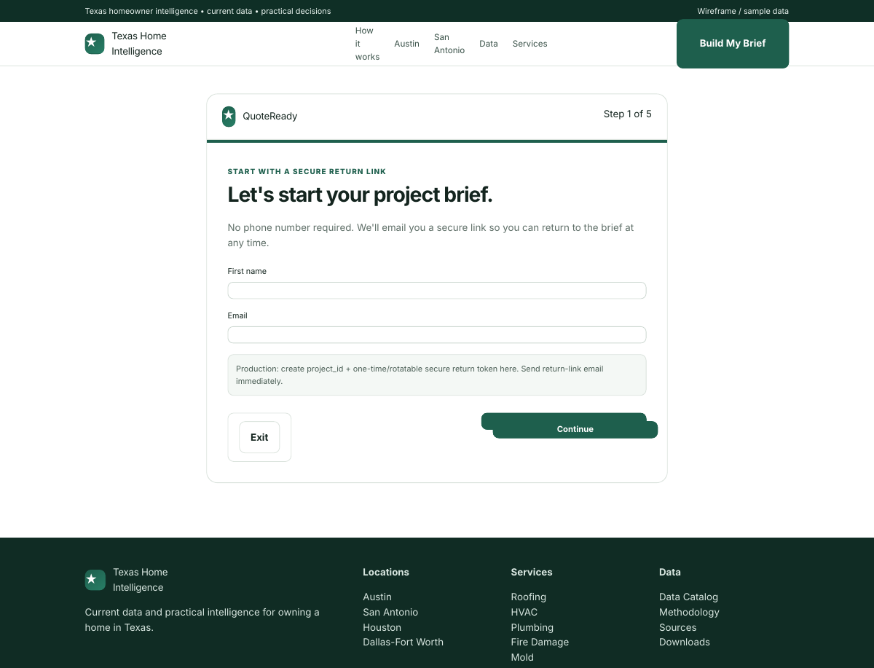
Representative desktop mockup. Responsive mobile behavior is required in production.
FLOW: NAME + EMAIL FIRST; PHONE LATER

Recommended V1 intake sequence
1. First name + email. Create project ID and secure return link immediately.
2. Choose service category.
3. Project overview: messy description, urgency, address.
4. Service-specific detailed questions.
5. Prior evaluation/work, quotes, photos/documents, homeowner objectives and optional constraints/budget.
6. Review and generate brief.
Data enrichment
After the address is entered, enrich the project with relevant free public data. Never make a homeowner answer a question we can reliably obtain from a source. Do not overload the brief with irrelevant context.

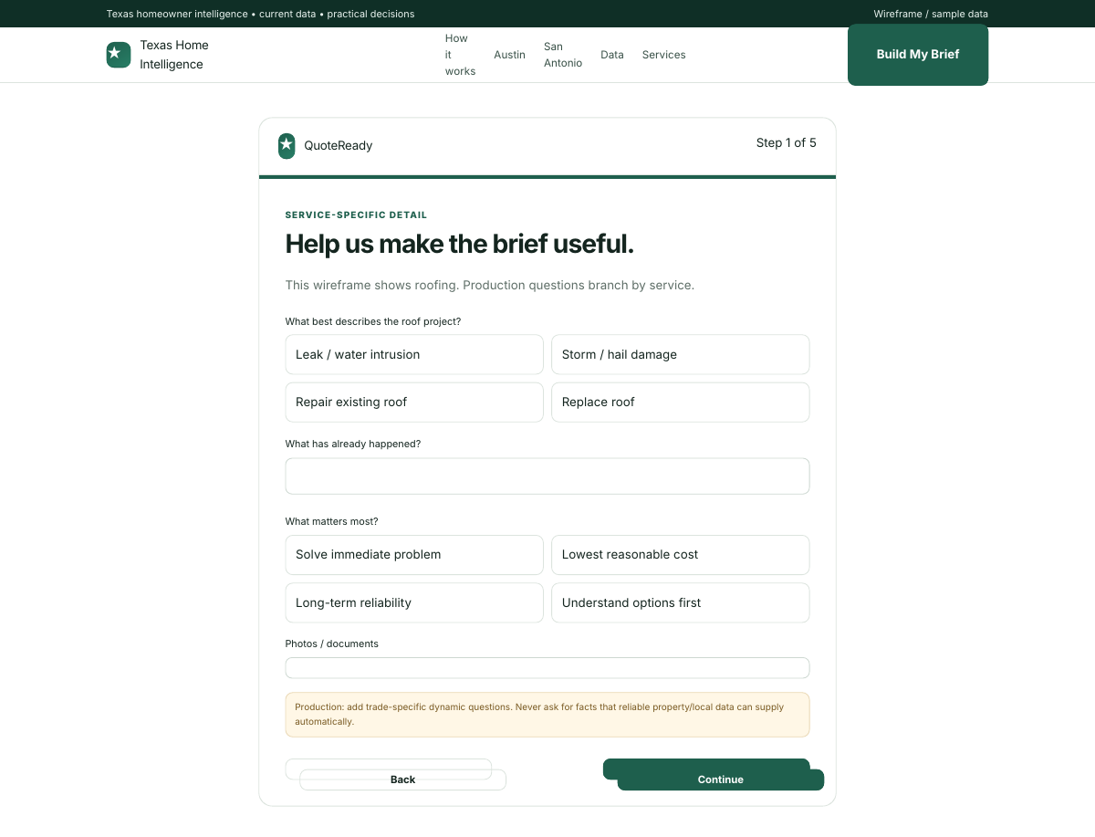
Representative service-specific intake step. Production questions branch by trade.

9. Generated Brief + Post-Brief Options
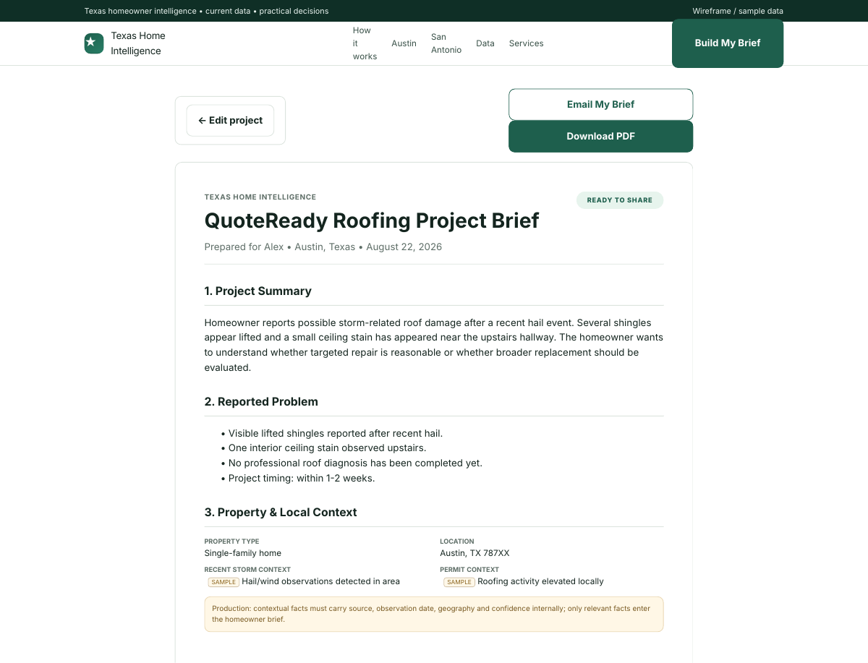
Representative desktop mockup. Responsive mobile behavior is required in production.
PRODUCT OUTPUT: FIRST PROOF OF QUALITY

- Project Summary.
- Reported Problem / Conditions.
- Property & Local Context.
- Work Already Performed / Prior Quotes.
- Homeowner Objectives.
- Items a Professional Should Evaluate.
- Questions the Written Estimate Should Answer.
- Attachments / Notes.
- Information Still Needed / Unknowns.
- Clear limitation language: not an inspection or remote diagnosis.
Post-brief conversion
Only after the homeowner has received the useful brief: offer a review call and then optional contractor assistance. If contractor assistance is chosen, ask whether the homeowner wants 1, 2 or 3 companies. Phone can be requested at this stage.

10. Service Template & Intake Mapping
Service / copy | Intake focus | Free-data enrichment | Copy status
Roofing | Storm/hail, leak, age/type, visible damage, interior water, prior repair, insurance, roof photos | NOAA/NWS storms; permits; TDI wind/hail; rainfall | SUPPLIED
HVAC | Cooling/heating, system running, airflow, affected area, thermostat, time-of-day, age/type, prior repair, label photo | NWS/NOAA heat/humidity; mechanical permits; EIA; AirNow; BLS | SUPPLIED
Plumbing | Leak/clog/pressure/sewer/water heater, location, active damage, hot/cold, duration, prior repair/access | Freeze/weather; plumbing permits; FEMA/TWDB; BLS | SUPPLIED
Fire Damage Restoration | Event date, fire department, affected areas, smoke/soot, water damage, utilities, occupancy, stabilization, insurance | Fire weather; AirNow; TDI fire loss; FEMA/disaster context | DRAFT
Mold Remediation | Visible conditions, moisture source, water event, approximate area, assessment/testing, prior remediation | Rain/humidity; flood context; TDI water loss; housing age | DRAFT
Electrical | Outage/breaker/panel/circuits/flicker/outlets, affected area, burning smell/heat/sparking, panel context, prior work | Electrical permits; severe storm context; housing age; BLS | DRAFT
Tree Trimming | Tree size/type if known, proximity, dead limbs, storm damage, lean, access, trim/remove, stump, photos | Drought; wind/storm; soil; tree permits; rainfall | DRAFT

11. V1 Free Data Sources
Source | Primary use | THI output
NWS API | Current forecast, observations, alerts | Fast-changing weather context and derived heat/freeze/storm indicators
NOAA climate | Historical normals/extremes | Current-vs-normal comparisons
NOAA Storm Events | Hail, wind, tornado, severe event history | Roof/storm exposure and event context
FEMA / NFHL | Flood hazard context | Flood/water/mold context; do not overstate probability
Local municipal permit feeds | Mechanical, plumbing, electrical, building, roofing/tree where available | Service activity, permit trends and timing proxies
Texas Department of Insurance | County homeowners paid losses | Wind/hail, water and fire loss context
TWDB / TexMesonet | Drought, rainfall, water/weather observations | Tree, foundation, moisture and water context
USDA Soil Data Access | Soil/drainage/interpretations | Tree/foundation/landscape context
AirNow | AQI/smoke | HVAC/filtration and fire/smoke context
Census ACS | Housing stock / age / structure | Local housing context
BLS | Trade wages / cost indicators | Repair-cost pressure indexes
EIA | Texas residential electricity prices | HVAC operating-cost context
ERCOT | Grid/demand conditions | HVAC/electrical statewide context where useful
Texas A&M Forest Service | Wildfire/fire danger/tree context | Fire and tree intelligence

12. AI / Citation-Oriented Publishing Requirements
- Important facts must be rendered in server/static HTML, not only fetched into client-side charts.
- Every changing metric displays: what it measures, geography, reporting period, last successful update, source and methodology link.
- Separate Data, THI Interpretation, What It May Mean for Homeowners, and Limitations.
- Use permanent canonical URLs. Do not create many thin exact-match pages for phrase variants.
- High-value questions: H2 direct-answer block → data/support → explanation. Small related questions: FAQ.
- Store historical observations instead of overwriting the previous value.
- Expose data as HTML tables; add CSV/JSON for datasets where useful.
- Use Dataset/DataCatalog structured data on genuine data resources and BreadcrumbList across hierarchy.
- robots.txt must allow legitimate search/AI crawlers intended for discovery; do not accidentally block them at Cloudflare/WAF level.
- Generated interpretations should store the underlying observations and methodology/calculation version that produced them.

13. Data/Lead Technical Architecture
1. GitHub repository is source of truth for site, scripts, generated datasets and configuration.
2. Static/public site deploys from GitHub to production hosting.
3. A server-side/serverless submission endpoint handles secrets; never expose Slack webhook or Google credentials in browser JavaScript.
4. Name + email creates project_id and secure return token; immediately send return-link email.
5. Detailed form submissions update the same project record.
6. Normalize raw intake into a structured project schema before generating human-readable copy.
7. Relevant public-data enrichment is stored with source/time/geography metadata.
8. Generated brief is saved and can be reopened through the secure return link.
9. Lead/project record is appended/updated in Google Sheets and Slack is pinged for review/follow-up.
10. Scheduled ingestion jobs fetch free data feeds, validate them, preserve prior valid data on upstream failure, append historical observations, rebuild affected pages and publish new timestamps.

14. Programmer Acceptance Criteria
- Responsive desktop/mobile implementation matches the hierarchy shown in this package.
- All 14 Austin/San Antonio service/location routes use a shared template/config system.
- Roofing, HVAC and Plumbing use supplied conversion copy as baseline; other service copy is visibly tagged for final editorial review before launch.
- No phone is required before the brief is generated.
- No 1/2/3 contractor choice appears before the brief.
- Secure return link is generated after name + email.
- Project can be resumed without losing data.
- Service-specific intake branches are implemented as data/config, not duplicated hard-coded pages.
- Generated brief distinguishes homeowner-reported facts, external context and unknowns; it avoids remote diagnosis claims.
- Google Sheet write + Slack notification are server-side and secrets are not shipped to the browser.
- Data page modules are wired to normalized data objects, not directly to individual API response shapes.
- Every data card can display source, updated timestamp and stale/error state.
- SAMPLE/FEED wireframe values are replaced only when a production source is connected.
- Important data is crawlable without requiring chart JavaScript.
- Sitemap, canonicals, metadata, breadcrumbs and internal links follow the location/service/data hierarchy.

Appendix A. Copy Placement Map
SUPPLIED COPY

Homepage, Roofing, HVAC and Plumbing copy in the clickable prototype is based on the supplied QuoteReady copy document. Small flow-specific wording has been adjusted to reflect the agreed product rules (for example, no phone number required to start and contractor help after brief generation).
DRAFT COPY

Fire Damage Restoration, Mold Remediation, Electrical and Tree Trimming hero/intake language in the prototype is new draft wireframe copy. It is structurally ready for programming but should receive final editorial review before production launch.
DATA PLACEHOLDERS

Any value labeled SAMPLE, FEED or {LIVE} is intentionally fake/placeholder data for layout only. Never launch these values as facts. Production UI should show real source data or a clear unavailable/stale state.

Appendix B. Deliverables in this Package
- Clickable static prototype: homepage, Austin hub, San Antonio hub, all seven service pages for each location, representative Austin Roofing data page, intake flow and generated brief.
- This editable DOCX developer handoff.
- PDF review copy of this handoff.
- README with local prototype instructions.

