**Introduction**

VehicleHub is a CRUD web app to manage vehicles. The app allows user Create, Read, Update and Delete vehicle/manufacturer/category from database.

Technology keywords: c#, .Net Core 3, Microsoft SQL Server, Blazor two-way Binding, Blazor Form validation, Dapper, Visual Studio 2019.

**Steps to compile the app solution**

1. Create database, name as VehicleHub.
2. Run SQL_create_table_sp_data.sql under solution folder to create necessary tables, stored procedures, sample data.

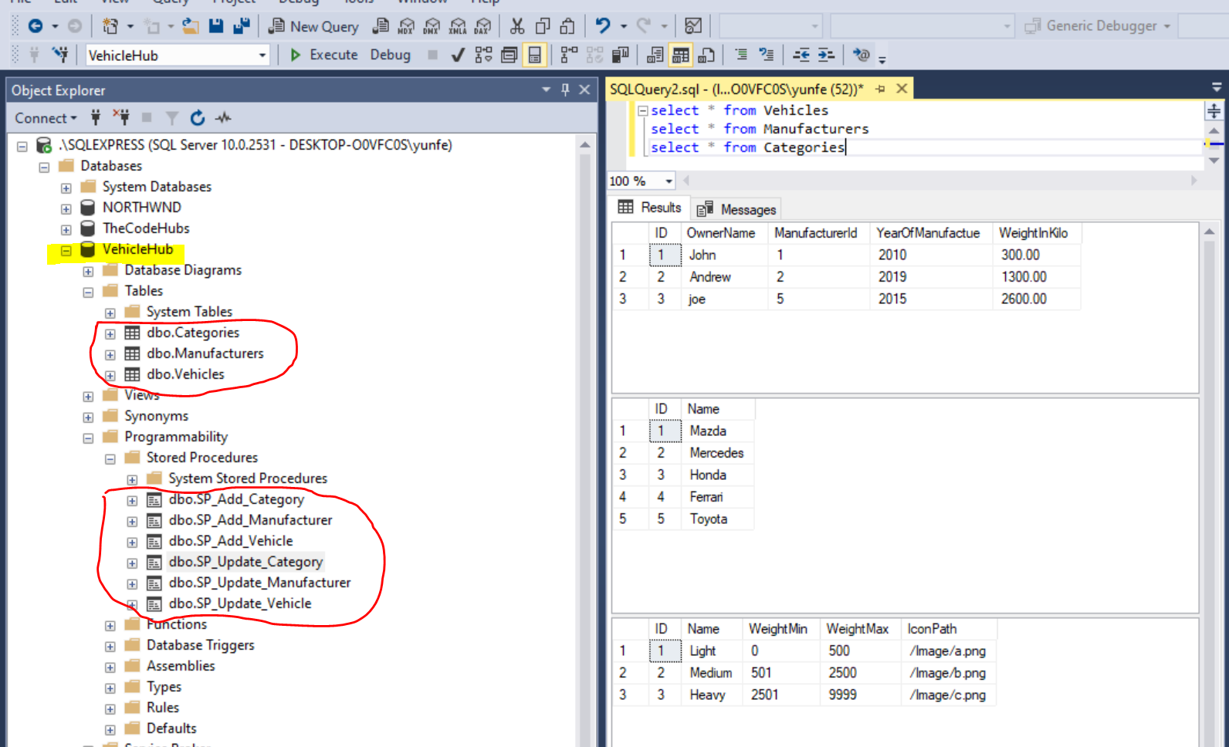

3. Config Connection string in appsettings.json file.

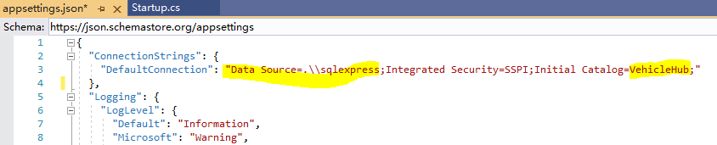

4. Compile BlazorCRUD solution in visual studio 2019.

**Design notes**

**DB table design**

3 tables: Vehicles, Manufacturers and Categries

* Vehicles

|  |  |
| --- | --- |
| ID | int |
| OwnerName | nvarchar(250) |
| ManufacturerId | int |
| YearOfManufacture | Int |
| WeightInKilo | Decimal(10,2) |

Required field: OwnerName, ManufactureId, YearOfManufacture, WeightInKilo

YearOfManufacture range: (current year – 30, current year + 1)

WeightInKilo range: (0 , 99999)

* Manufacturers

|  |  |
| --- | --- |
| ID | int |
| Name | nvarchar(250) |

Required field: Name

Max Name length: 250

* Categories

|  |  |
| --- | --- |
| ID | int |
| Name | nvarchar(250) |
| WeightMin | int |
| WeightMax | Int |
| IconPath | nvarchar(250) |

Required fields: Name, WeightMin, WeightMax, IconPath

Max Name length: 250

WeightMin / WeightMax range: (0 , 99999)

WeightMin and WeightMax logic: weight range not overlap, and no gaps between categories.

IconPath: image file name under folder \wwwroot\Image

**Web UI Design**

Vehicles / Manufacturers / Categories management page follow the same pattern:

* Menu bar on left side
* Content area, data list table width 60% (area 1), data edit area width 30% (area 2), 10% space in between

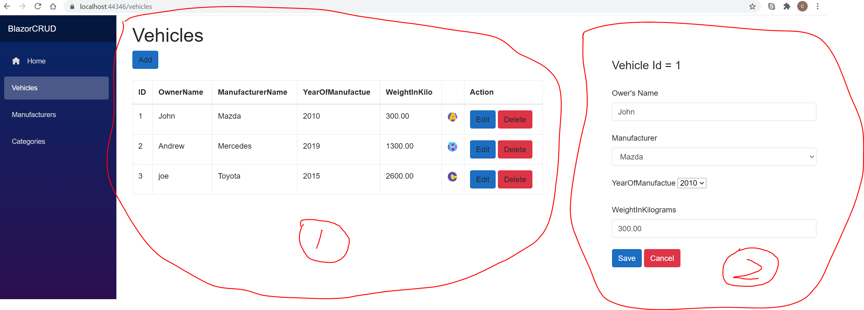

* Data fields validation before update Vehicles / Manufacturers / Categories table.
* To implement Category WeightMin and WeightMax logic,
  + Only categories with the lowest / highest weight range can be deleted. （Snapshot1，only Delete buttons for Category 1 and Category 4 are enabled, all other Delete buttons are disabled）
  + Only WeightMin and WeightMax from the lowest / highest weight range can be edited. (snapshot1, WeightMin and WeightMax fields are displayed on edit form for Category 1; snapshot2, WeightMin and WeightMax fields are not displayed on edit form for Category 2)
  + Weight range of new category should be either lower than existing lowest weight range or higher than existing highest weight range.

Snapshot1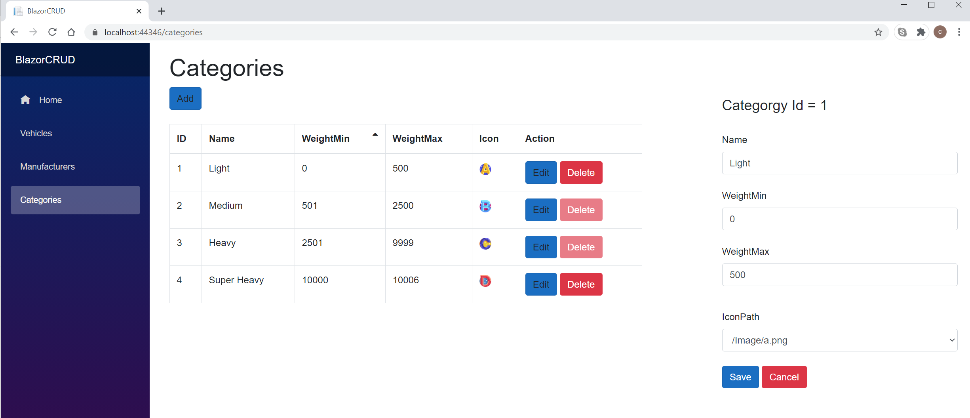

Snapshot2

