DepositMO Microsoft Word Add-in – User Guide

# Requirements

To use the DepositMO Microsoft Word Add-in you will need the following:

* Microsoft Word 2010
* A valid account on the SWORD2 endpoint server (*e.g.* an ePrints account)

# Installing the add-in

After downloading and extracting the add-in’s archive, double-click on the **setup** icon (setup.exe).



Figure : setup.exe icon

The wizard will launch, prompting you to download any necessary software from Microsoft that the add-in needs if it is unavailable (.NET Framework 4 and Office Tools).

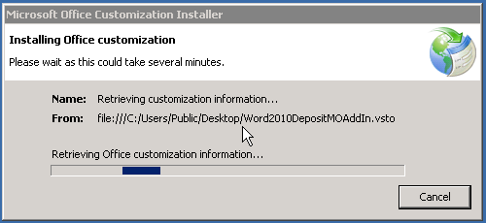

Figure : Wizard launched

After checking these are available (and installing them if they are not), the setup will resume. You may get a *Publisher cannot be verified* warning:

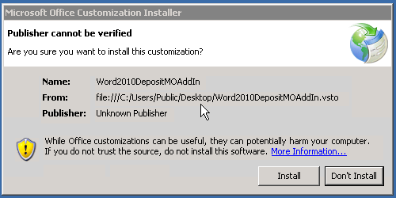

Figure : Unverified publisher warning

You can continue the install by clicking **Install** if you trust the source (provider) of the add-in.

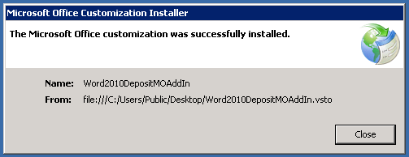

At this point, the add-in has now been installed.

## Additional notes

If you get security warnings or unusual behaviour, it may be that your system has a policy marking downloaded files as untrusted. This can be resolved by right-clicking the add-in’s setup files, selecting **Properties**, and in the **General** tab, click **Unblock**. More details about this can be found on Microsoft’s website at http://support.microsoft.com/kb/883260.

# Using the add-in

Once the add-in has been installed, you should verify that it is available in your copy of Microsoft Word 2010. To do this, start up Microsoft Word 2010 and look for a new entry along the ribbon at the top of the screen.



Figure : DepositMO 2010 Word Add-in is visible at the end of the ribbon tabs

Clicking on the DepositMO tab will display the basic controls for the add-in. **Show** and **Hide** on the **Repository control** group will show and hide the main DepositMO control panel. These will by default appear at the right-hand side of the window.

Specifying an **Endpoint** in the **Quick submission** group, and clicking **Submit** will bring up a dialogue box prompting you for your username and password for that endpoint, and allow you to submit the current document to the repository.

Clicking **About DepositMO 2010** in the **About** group will bring up basic information about the add-in.



Figure : DepositMO ribbon controls

# Submitting a document

Let’s walk through the deposition process with a new document. Enter some text on to the empty Microsoft Word document.

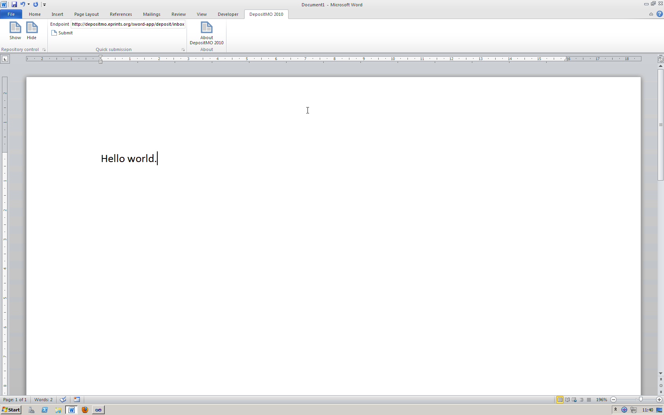

Figure : Creating a basic document

Before you can deposit this to the repository, you must first save it on to your computer.

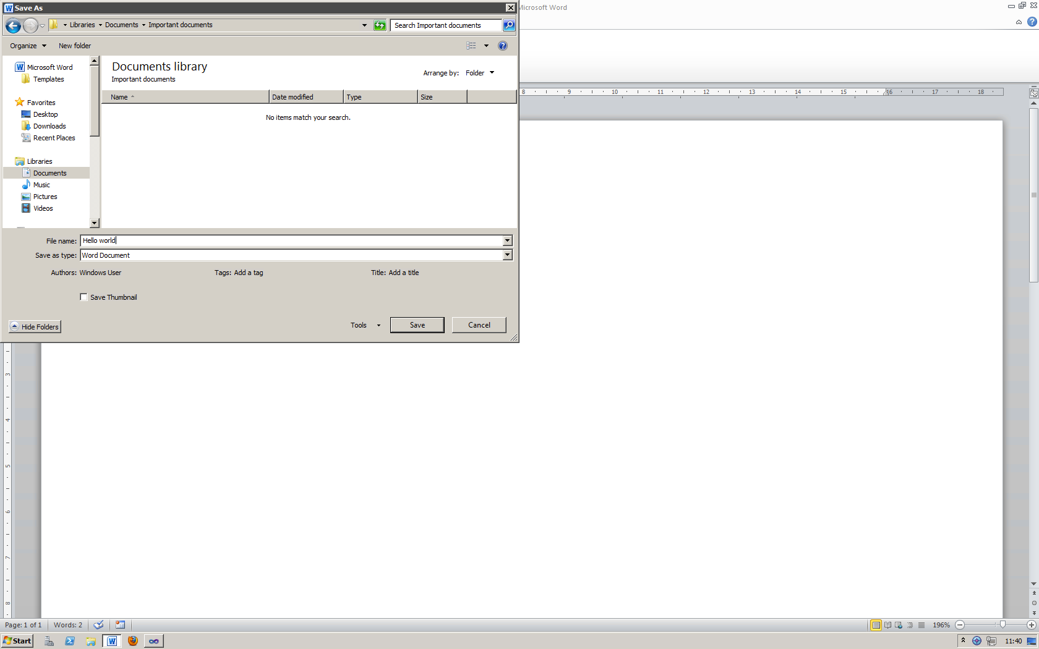

Figure : Saving the basic document

If you do not do this, then the add-in will prompt you to save it later before deposition can occur. Clicking **Show** in the **Repository control** group of the ribbon will bring up the main control panel for deposition.

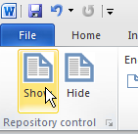

Figure : Show the repository control panel

The main control panel can be seen now on the right of the window. This has a number of controls for accessing repositories.

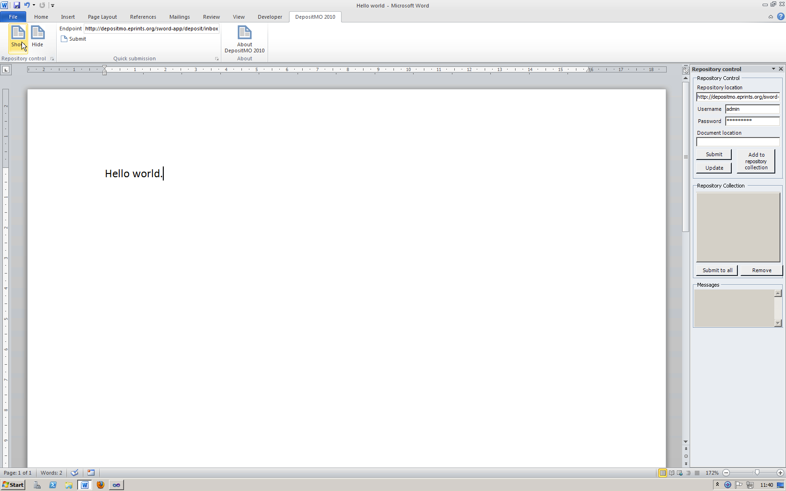

Figure : The repository control panel in the Microsoft Word window

The top section of the panel allows you to enter details of the target repository: your repository’s location (sometimes referred to as an **endpoint**), your username at that repository, and the password associated with that username.

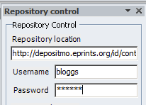

Figure : Repository endpoint and user details

After entering these details, you can then submit the document to the repository by clicking the **Submit** button underneath.

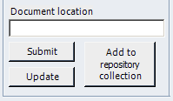

Figure : Submit and update buttons

The add-in will then send your document to the remote repository. The progress of the submission is then displayed in the **Messages** box at the bottom of the panel.

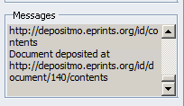

Figure : Add-in messages

If the submission was successful, then a message similar to the one above will be displayed. This indicates where a copy of our document resides (note that the original still exists where you saved it locally earlier). If it was not successful, then you should check the endpoint and your credentials (username and password), and additionally check the repository by visiting the area on that repository where you would usually manage your deposits.



Figure : Document location field

On a successful submission, the **Document location** field is automatically updated with the remote location of this document.

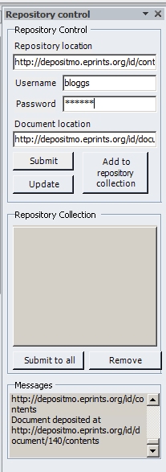

Figure : Panel appearance after a successful deposition

If you look at the panel now our deposition has successfully completed, you can see that the **Repository location** remains unchanged, as does the **Username** and **Password**, but the **Document location** is now different, as explained above. The **Messages** can be reviewed by scrolling up the little text area.

You can review your recent submission to the remote repository by visiting it with your web browser.

Note that as our example document contained no information about the title or authors of the document, there is correspondingly little detail on the server

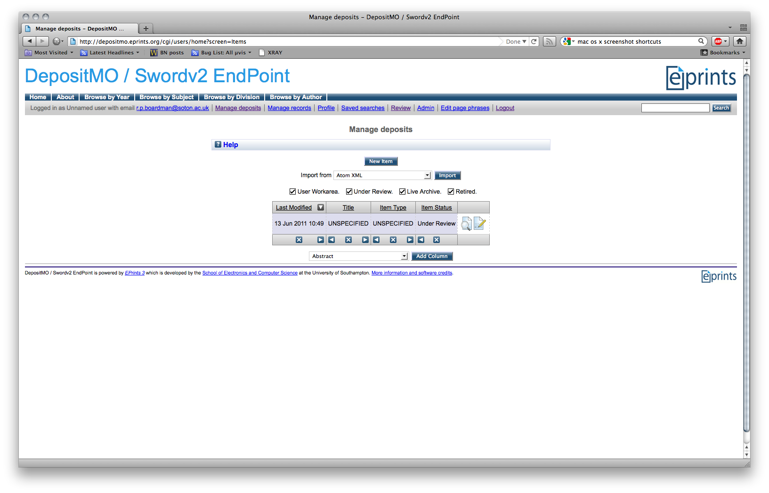

Figure : Reviewing the submission in the remote repository

# Updating a document

If you wish to add metadata to the document, so that the remote repository can use this, then this can be achieved by using the Microsoft Word **Quick Parts**. For example, you can add a title to the document:

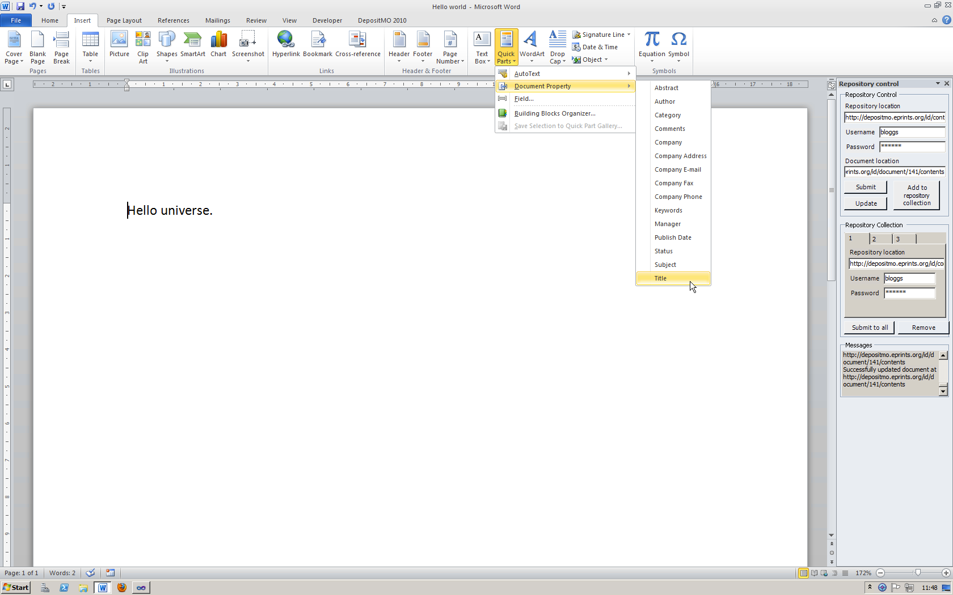

Figure : Adding a title to the document

You can enter the document’s title here, and then format it as you wish.

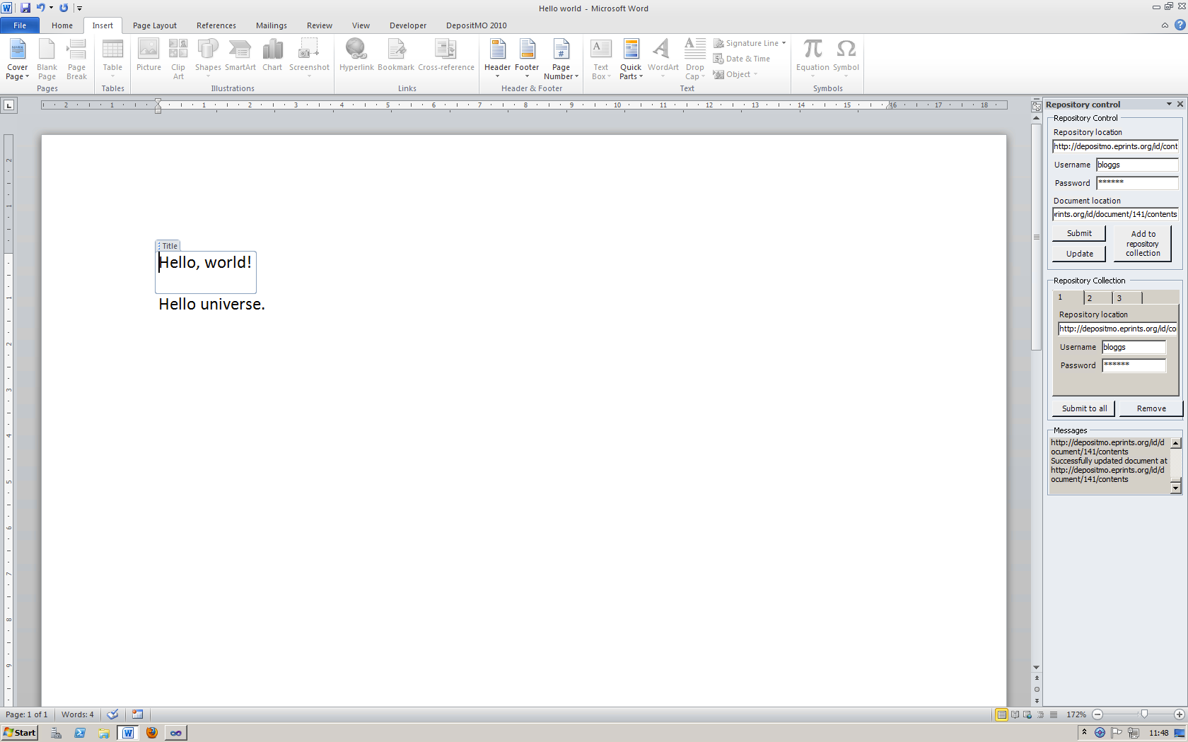

Figure : Entering the title text

Authors can be added in the same manner.

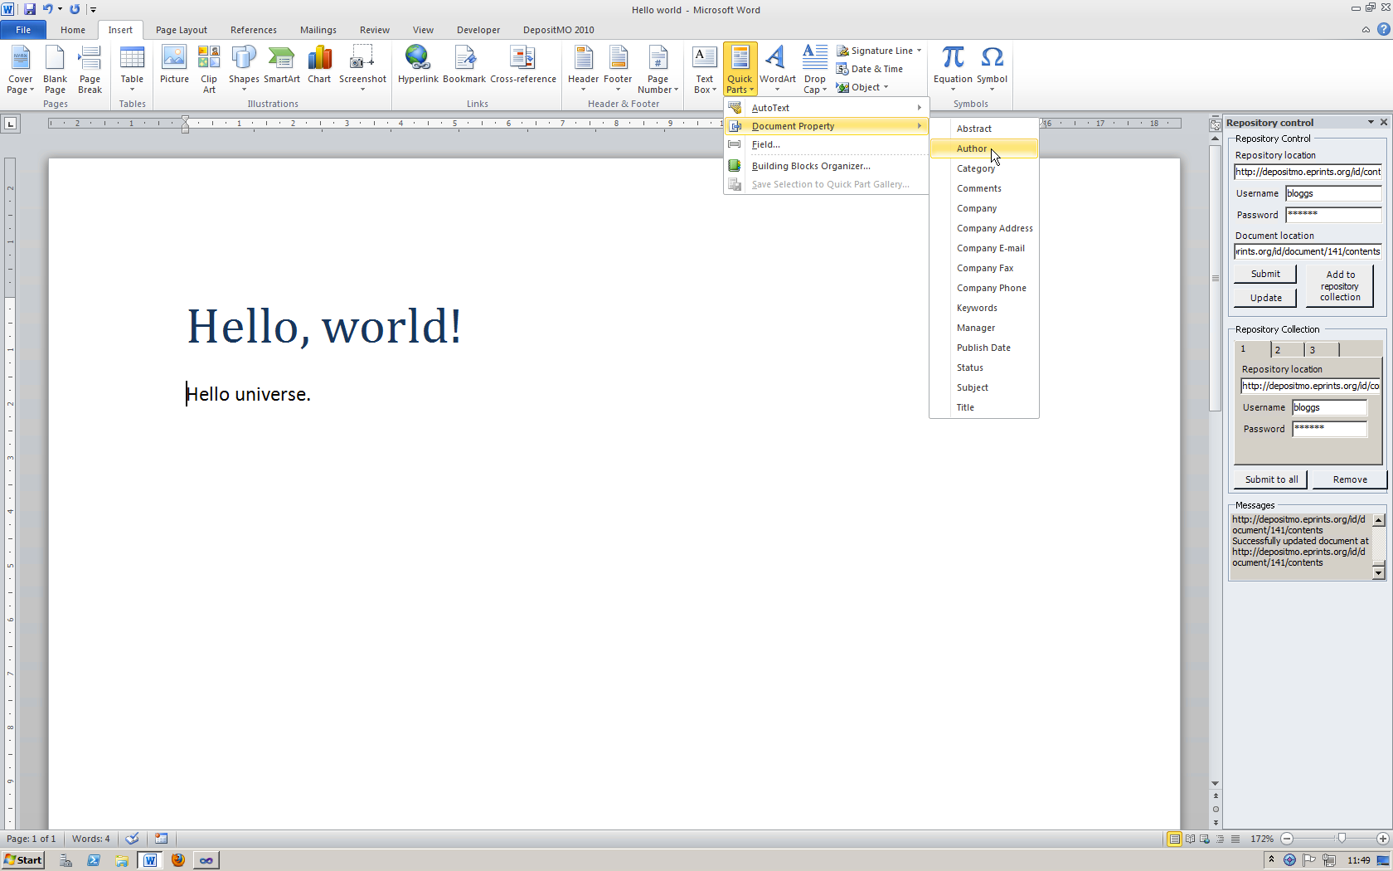

Figure : Adding an author to the document

A default author will be inserted.

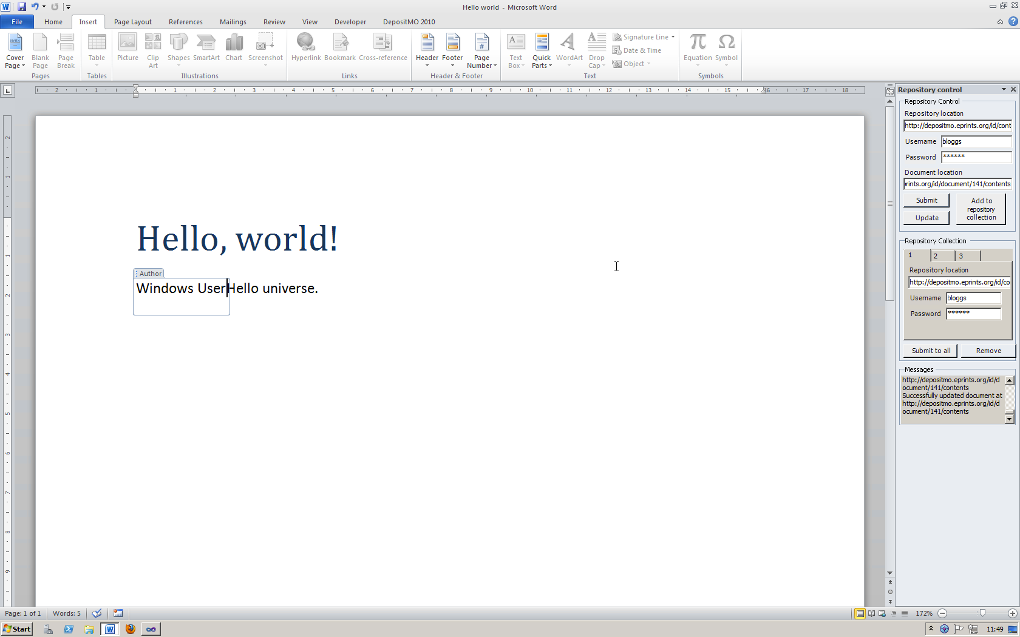

Figure : Default author

This can be modified as appropriate.

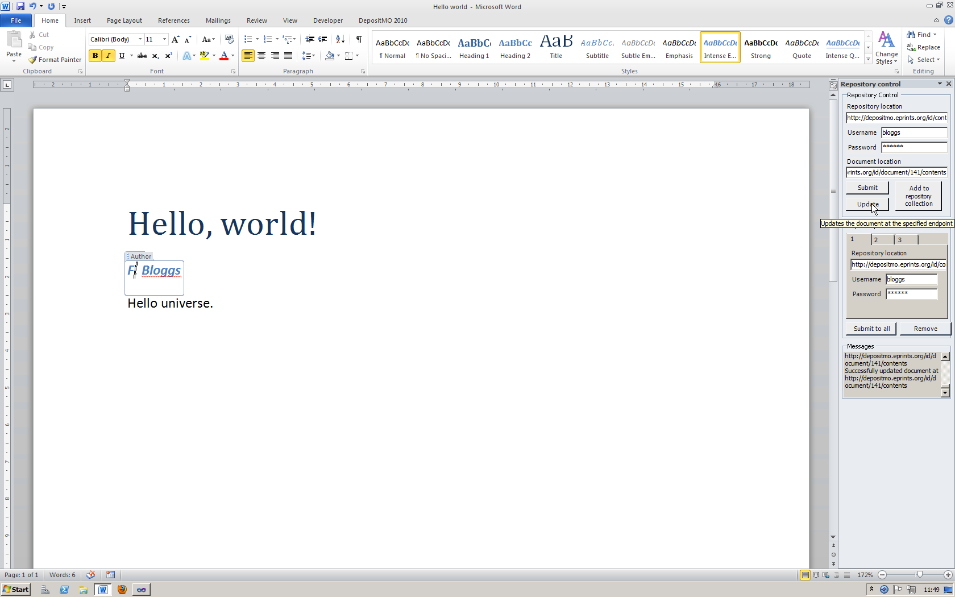

Figure : Modifying the default author

If you now push the **Update** button in the panel on the right-hand side, the existing document will be updated in the repository. Revisiting the remote repository reveals the newly-added title.

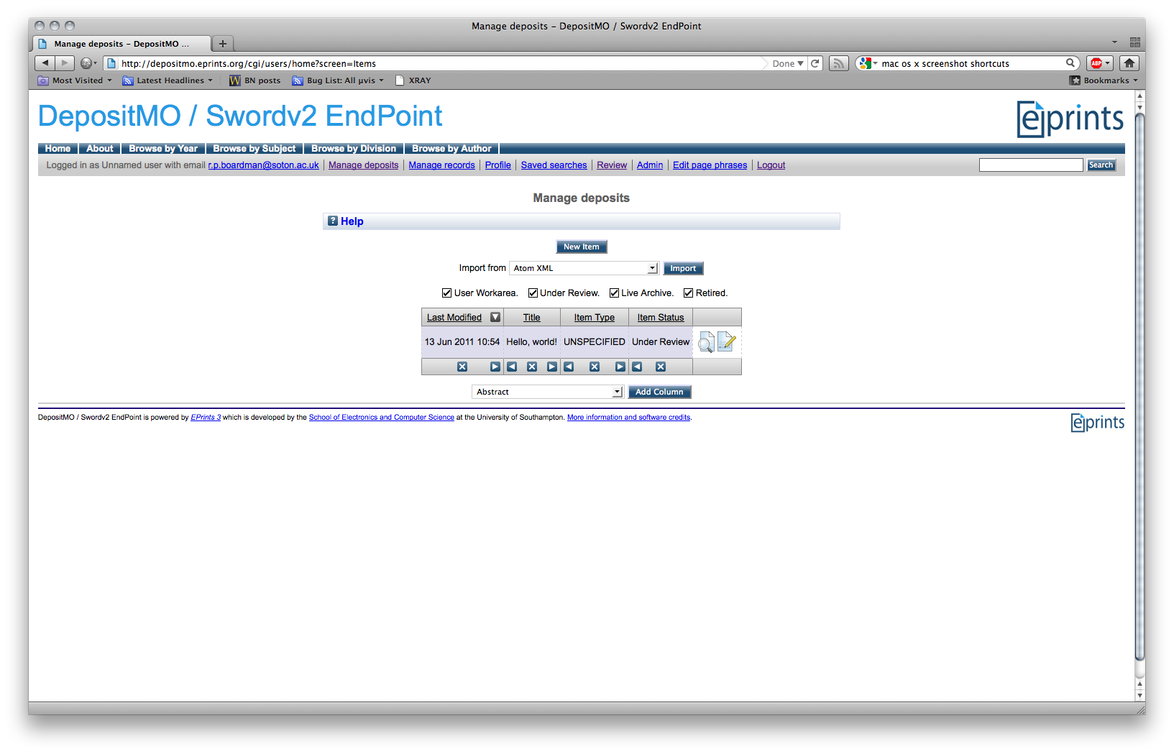

Figure : Title visible in deposit list

Clicking on this deposit shows the other metadata you added.

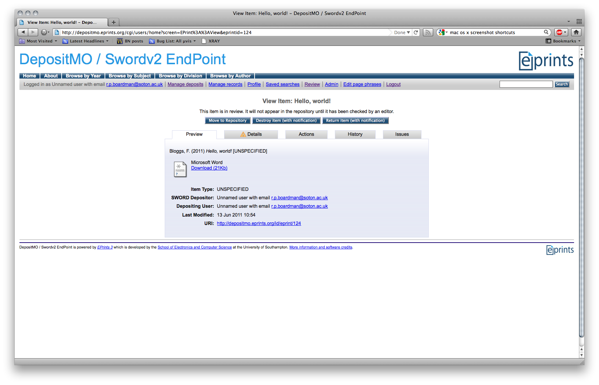

Figure : All metadata visible in item view

We can also add an abstract in the same way.

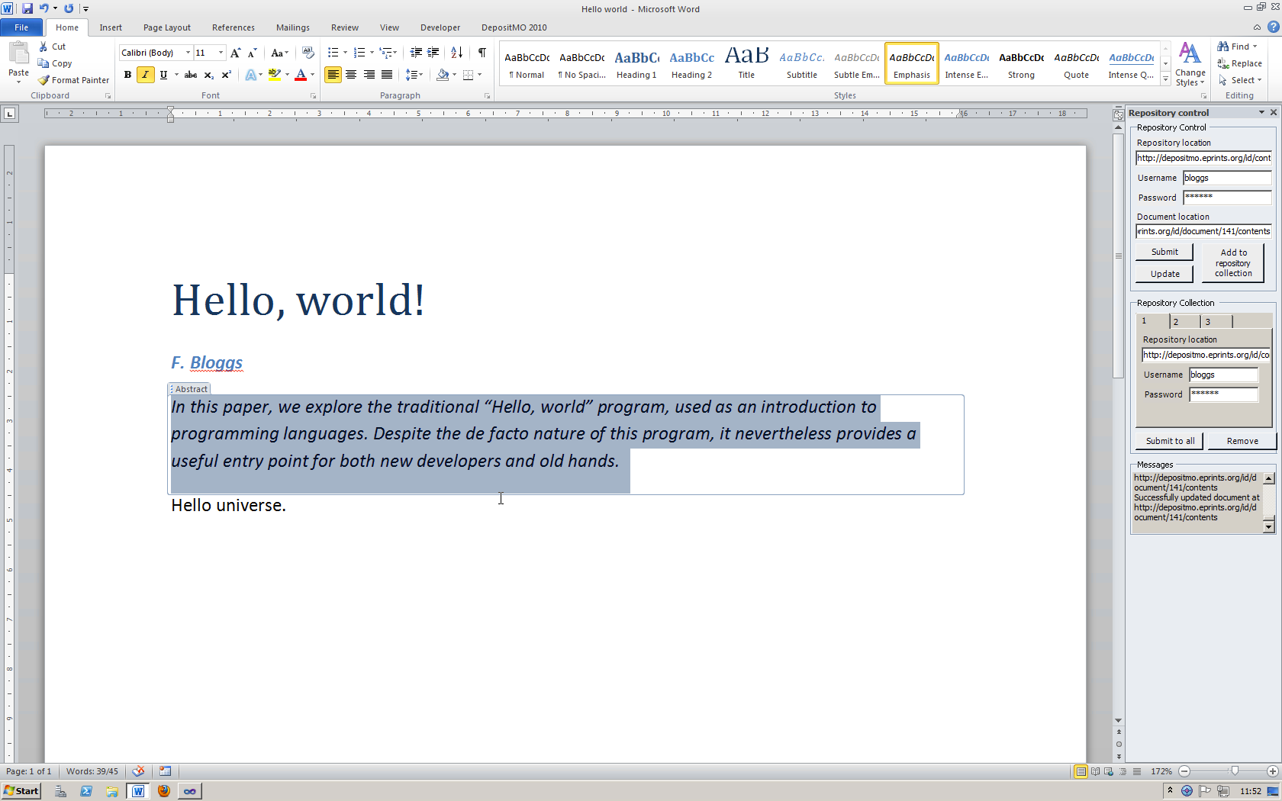

Figure : Adding an abstract

Updating the document again and re-checking the server interface shows now the abstract in place.

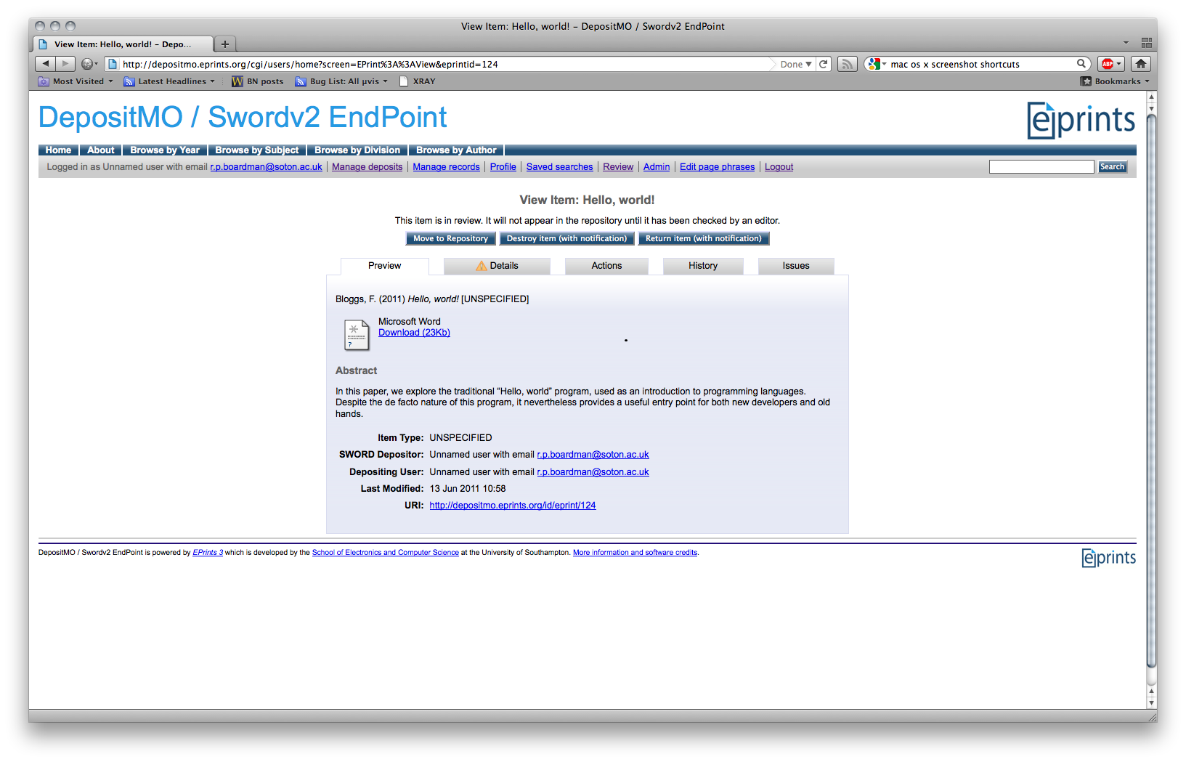

Figure : Abstract visible in item view

# Quick submission

If you want to just pass something from Microsoft Word straight into the repository, then you can use the **Quick submission** section of the ribbon. Enter the appropriate endpoint (repository server location) in the box in the ribbon, and click **Submit**.

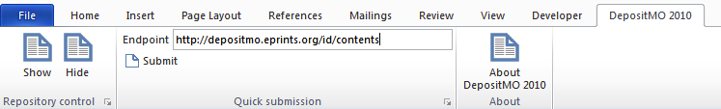

Figure : Quick submission ribbon group

A small dialogue box will pop up, prompting you for your credentials at that repository location.

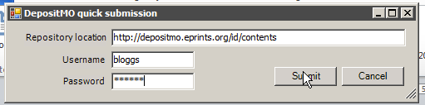

Figure : Quick submission dialogue box

Clicking **Submit** will send the document off to the repository. Any messages will be visible in the **Messages** on the main group if you have this open at the time.

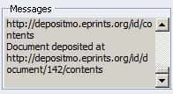

Figure : Successful quick submission

# Submitting to multiple repositories

It is possible to submit (but not update) to multiple repositories at once.

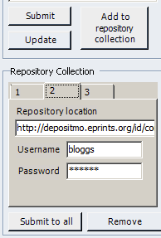

Figure : Creating a repository "collection"

By entering details into the **Repository Control** section of the panel, and clicking **Add to repository collection**, these details are added into tabs in the **Repository Collection** section to the panel. Once you have added one or more of these, you can click **Submit to all** and this will deposit the document into all of the repositories specified in the collection.

You can edit the location, username and password for individual repositories once you have added them to the group.

If you wish to remove a repository from the collection, select the tab corresponding to that repository and click **Remove**.