Community Notes, CUNY & the Bronx County Historical Society Archives

Vani Kannan & Steven Payne

Steven and Vani first met at a community speakout event on May Day 2021, a year and two months after New York City entered COVID-19 lockdown. The event was held at a local green space by the North Bronx Collective, a group whose membership included educators, students, and alumni from the City University of New York (CUNY)—including Vani—along with local artists, scientists, and cultural workers. The collective had just published the first of two newsletter issues titled The Land Back, highlighting different NYC green spaces and community gardens that had been locked by the city during the pandemic (North Bronx Collective). This included the space where the event was held, Tibbett’s Tail, where the collective had been holding community cleanups since the summer of 2020. At the event, Steven asked if the collective would like to archive its papers and publications at the Bronx County Historical Society (BCHS), where he worked. He had spent the COVID-19 lockdown digitizing the papers from local Bronx social movements, and wanted to engage people in not just studying the materials in the archive but also contributing materials to it.
Steven began working as the librarian/archivist at BCHS in January 2020. At the time, BCHS’s archival collections, housed in The Bronx County Archives, were mostly unprocessed and disorganized, aside from some preliminary inventories. One of his top priorities was organizing these collections and creating finding aids for as many of them as possible. When NYC went into lockdown in March 2020, Steven was deemed an “essential worker” by BCHS administration and was the only staff member coming in on a regular basis for multiple months. Although resistant to this classification and its implications for his own safety, Steven was nonetheless able to do intensive archival work during this period, organizing and creating finding aids for 38 previously unprocessed collections in a four-month period.
This first phase of archival work confirmed what Steven had suspected: only a handful of collections in The Bronx County Archives at the time documented the histories of working-class, Black, Brown, and other oppressed people living in the Bronx. As is often the case with archives, most of the collections that Steven had processed focused on the lives of the ruling class—businessmen, wealthy benefactors, and elected officials, almost entirely male, white, and of northern European descent. Because of the particular history of capitalism in the U.S., individuals of these class, gender, racial, and national backgrounds are far more likely to have the financial and other resources needed to preserve their material legacies in institutional contexts like the BCHS where they can serve as digitally-accessible educational resources. As of 2023, the racial and ethnic composition of the Bronx was approximately 9% white, 55% Hispanic, 29% Black, and 4% Asian, with the median household income less than $48,610 (“The Bronx”). Steven began seeking out potential archival acquisitions that would better document the lives of the many working-class Black and Brown residents of the Bronx. One tactic in achieving this goal was reinvigorating BCHS’s involvement in two community-based oral history projects: The Bronx African American History Project and The Bronx Latino History Project. Between 2020 and the present, Steven recorded more than 100 oral histories, both for these projects and for a new one focused on graffiti history in the Bronx. The oral history work allowed Steven to build close ties within various Bronx communities that had little other representation in the archives.
These relationships have been instrumental in the donation of more than 50 new archival collections to BCHS since March 2020. To give a sense of the character of these new collections, among them are the Eta Omega Omega Chapter of Alpha Kappa Alpha Sorority, Inc. records, which document the very active Bronx chapter of one of the U.S.’s most prominent Black sororities; the Gil Fagiani papers, which include nearly the entire run of White Lightning, a community newspaper published by a white, working-class, revolutionary, anti-racist group in the Bronx during the 1970s; and the Esperanza Martell papers, which contain many issues of Unidad Latina and Palante (newspapers published by El Comité and the Young Lords, respectively) and audio recordings of women of color healing circles in The Bronx, among other items.
One challenge in this work has been technological infrastructure. As of January 2020, BCHS had no digital repository, nor was any portion of its archival collections digitized. Steven thus began digitizing portions of archival collections, with a focus on new acquisitions, set up a dedicated server, and configured an instance of Omeka (a digital content management system for archives and museums). After Vani and Steven met at the North Bronx Collective event, these digital collections became the primary interface for Vani’s classes at Lehman College and the digital publication titled Community Notes, discussed below.
Between 2018-2023, Vani was a faculty member in the English Department and co-coordinator of Writing Across the Curriculum at Lehman College. When classes moved online in March 2020, she began teaching with the digitized primary source documents of local social movements that Steven had archived, along with the primary source documents housed in the CUNY Digital History Archive (CDHA). CDHA documents the history of CUNY and the central role of student movements in shaping the institution, with numerous archived pamphlets, flyers, news articles, and pedagogical/curricular documents. For Vani, the goal of teaching with materials from both BCHS and CDHA was to highlight the exigencies that give rise to writing in social justice work in a way that would resonate with students across disciplines and to encourage student writing that felt materially tied to the lives and communities of Lehman College students (who the College website describes as 48% Hispanic, 38% Black/African American, 8% Asian/Pacific Islander, and 6% white) (“Fast Facts”). The majority of Vani’s students lived in the Bronx, and in this context, teaching with social movement archives aimed to push back against ahistorical racist, classist renderings of the borough that erase both grassroots social justice movements and the redlining and disinvestment that shaped its geography. Some of the archived histories are locally rooted around Lehman College—for example, Gil Fagiani, founder of White Lightning, once lived on Villa Avenue, right around the corner from campus. To highlight these histories, Steven created a Social Justice Research Collections Guide for Vani’s students so they could familiarize themselves with the archive’s holdings (Payne).
When COVID-19 restrictions eased up in the Fall of 2021, Vani began offering optional field trips to the physical archive for her online first-year writing classes. More and more students started engaging with the archival materials—particularly texts documenting community-led responses to the opioid crisis of the 1970s and the Young Lords-led takeover of Lincoln Hospital in response to horrific health conditions and preexisting conditions that were the result of structural racism and classism (Fernández), leading to the first Patient Bill of Rights. Steven and Vani began to brainstorm how to build a longer-term space for both students and nonstudents to publish their archival research. We formed a simple digital publication titled Community Notes to encourage people engaging with the archive to recirculate these archived Bronx histories through a flexible variety of creative forms. The call for submissions includes:
- Document overview (putting an archived document in historical context)
- Collection overview (putting a collection of documents into historical context)
- Personal experience (sharing a story from your own life that connects to something in the collection)
- Close reading of a selection of archival documents
- Creative work (writing, art, music, or multi-genre work inspired by the collection)
- Teaching Notes (sharing a class assignment or educational activity that draws on archived materials)
- Connections (drawing links between the archive and other repositories)
- Localized history (connecting archived documents to specific areas in the Bronx)
While the goal in engaging students in this archival research was initially to uplift and circulate histories of Bronx-based organizing, it evolved into a site for faculty to engage students across disciplines in public-facing writing. In 2022, Vani piloted a Community Notes project in two classes and one WAC workshop: a 300-level Research, Rhetoric, and Writing class for English majors (the product of an anti-racist curricular revision in the wake of the summer 2020 uprisings), a graduate seminar titled Literacy and Community (with many K-12 teachers working in NYC public schools), and a workshop titled “Writing Community Histories,” which aimed for Lehman professors across disciplines to craft assignments and activities engaging with the archive’s holdings and Community Notes. In the two classes, students drew on the archives and responded to the CFP, with the option of submitting their work.

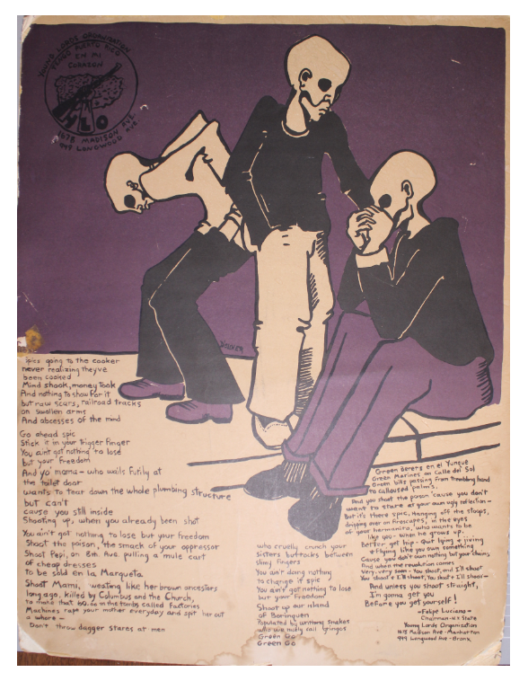
Young Lords poster and poem on heroin addiction. Students are drawn to this and several have written creative pieces inspired by it. For example, one of Vani’s graduate students, a K-12 educator, published a poem on Community Notes titled “Here to Stay” inspired by the Young Lords archives and the film Takeover: How We Occupied a Hospital and Changed Public Health Care.

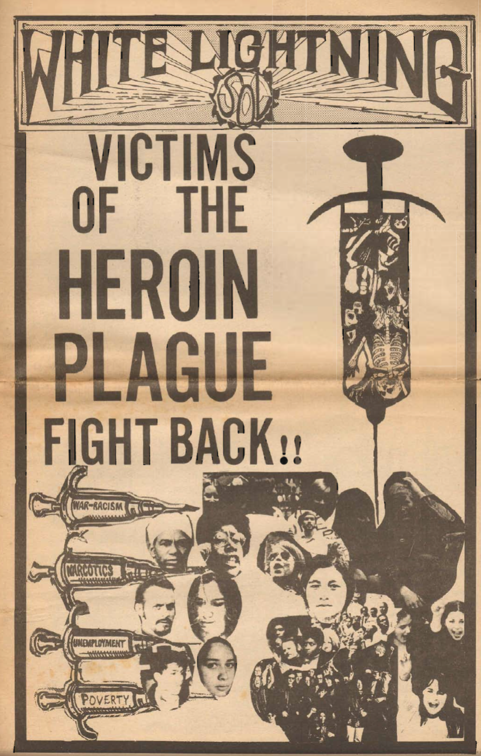

White Lightning newspaper. Pre-med and pre-nursing students in particular have engaged with the paper’s documentation of methadone dependency. Such papers serve as a kind of science writing for the public.

The two-part “Writing Community Histories” workshop (one session on Zoom and one session in the archive itself) engaged an interdisciplinary group of faculty with the archive’s holdings on tenants’ rights, local literary and cultural productions, queer activism, anti-colonial struggle, and health justice movements. Steven and Vani met ahead of time to identify archival materials that connected with faculty interests and teaching goals (for example, a literature professor’s desire to highlight unsung Bronx literary voices; a sociology professor’s interest in local tenants’ organizations), and encouraged participants to craft assignments and course designs that drew on the archives. One journalism professor built her research class around the archival materials the following semester, and her students ended up inviting a longtime community health worker and organizer, Esperanza Martell, to do a campus event on her health justice work; students in the class published their research writing on a class website, and the instructor is now writing a “teaching note” for Community Notes.
This little publication platform was meant to offer a longer-term infrastructure for multi-genre student/community writing. Students have produced videos, poems, visual art, and research essays weaving in personal experience and reflection. Our long-term goal was to find ways to materially support student interns at the archive, who could help with digitizing, cataloging, processing oral histories, and reviewing/editing/posting Community Notes submissions. However, in 2025, Steven and Vani decided that to sustain Community Notes long-term and create the infrastructure necessary to maintain consistent posts, it should evolve into a CUNY student-run writing project. We’ll share the story of how we arrived at this conclusion.
During the summer of 2023, we collaborated with a group of student researchers affiliated with Lehman’s Campus Honors and Scholar Engagement (CHASE) program working on a “Hidden Black Histories of the Bronx” project (“Campus Honors”). Vani had worked closely with the organizers of this project, and one of the student researchers had been part of her online first-year writing class that visited the archives in person. The “Hidden Black Histories of the Bronx” project, which includes ongoing work at the nearby African Burial Ground at Van Cortlandt Park, seeks to document the lives of the Black and Indigenous people who were enslaved on Bronx plantations (Augustine). Students prepared creative and curricular submissions for Community Notes and also indexed their findings with the Northeast Slavery Records Index (NESRI—housed at CUNY’s John Jay College of Criminal Justice), creating a foundation for future student-researchers to build upon.
As part of the Summer 2023 iteration of this project, Steven and Vani took a group of Lehman CHASE student-researchers on a tour of the Valentine–Varian House/Museum of Bronx History, built by enslaved people, and situated the house itself as an archive. For example, Steven’s research has found that the building techniques in the walls of the house—a particular kind of wattle and daub—can be traced to particular communities in west Africa and the Caribbean. For students, details like this were crucial in celebrating both their own Afro-Caribbean ancestry and the creativity and lifeways of Black and Indigenous people that were controlled and channeled through the institution of enslavement.
Projects such as this one are important sites of deconstructing campus/community and disciplinary boundaries and shaping how we think about writing instruction and what it means to write across (and beyond) the curriculum, in collaboration. Although Lehman is an “open campus,” meaning that it is technically open to community members, it is separated from the surrounding community by gates and security guards, and people can be stopped any time and asked for ID. This securitization only increased during the height of the COVID-19 pandemic. Vani has worked closely with students affiliated with CHASE since 2018, all of whom live and work in the Bronx; the program is committed to building a new iteration of Community Notes that wrangles with the contradictions of doing community-engaged writing work in this institutional context. In the time since we did our Summer 2023 work with students, Steven has transitioned to a new role and Vani has relocated to Atlanta. At the time of writing, we are in conversation with CHASE about the logistics of handing off Community Notes to the students who run the “Hidden Black Histories of the Bronx” project. These students have also continued to spend time in BCHA conducting archival research on Bronx Black histories.
Ensuring the long-term material survival of histories that are at risk of being obscured, forgotten, misconstrued, and erased under U.S. capitalism is a worthwhile struggle in and of itself. Still, linking these archived histories with ongoing struggles has a dual effect, both on these histories and on the present. On the one hand, the more obvious point: these archived histories provide valuable insight into how folks survived, fought back, and created alternative possibilities under their own circumstances here in The Bronx. These histories contain strategies and tactics of fightback and modes of creativity for us to tap into right now, while taking into account changed conditions of our own moment.
On the other hand, actualizing archived “pasts” as valuable resources for ongoing struggles sheds new light on these histories and increases the chance of their long-term preservation. Because of the growth and development of ongoing struggles, certain aspects of these archived histories “click” and speak to contemporary conditions. For example, the history of Bronx health justice movements focus that revolutionary groups like the Young Lords had on healthcare was certainly crucial at the time; with the mushrooming of the medical industrial complex in the U.S. in the five decades since, the nurses’ strikes at nearby Montefiore Hospital, and ongoing campaigns around reproductive justice and safe/healthy housing, though, this focus now appears absolutely prescient and as one of the most vital contributions of that era of struggle—and offers a particularly salient focus for Lehman’s many students who will go into health professions in local hospitals. Tapping into these legacies and carrying them forward through material work preserves them in a more robust sense than simply placing them in acid-free folders and boxes.
For the kind of archival practice outlined in this paper, actualizing archival collections through a range of public points of engagement—including educational programming, exhibits, community archiving, and more—is part and parcel of the task of preservation. Finding ways to work closely with CUNY students, many of whom are intimately implicated in our ongoing struggles through their lived realities, is central to this process. Indeed, of the folks from various institutions of higher learning we work with in the Bronx, CUNY students and educators already have an established record of insightful engagement with and contributions to the archives. In addition to the instances of CUNY Community Notes contributions outlined above, a few further examples are in order:
- The students of a professor from the Journalism Department at Lehman College recorded short oral histories with family members and friends during Spring 2020 about their experiences with COVID-19. The narrators of these oral histories were primarily workers of color in the service and healthcare industries—“essential workers”—and they related their complex feelings and sentiments at the time that otherwise got obscured by the pervasive “heroic essential worker” narrative.
- The library and archives staff at Bronx Community College hosted a BCHS traveling exhibit on the life and activism of Jesús Lebrón, a Puerto Rican Bronxite and one of the most instrumental figures in the marriage equality movement of the late twentieth and early twenty-first century. Jesús donated his papers to BCHS in July 2022. They were quickly organized and inventoried, and the traveling exhibit went up in the main reading room of the library for National Coming Out Day, October 11, 2022. Students from the LGBTQI+ Resource Room at Bronx Community College hosted a discussion on the exhibit with Jesús and fellow activist Brendan Fay in November 2022.
- The students of a professor from the English Department at Lehman College are currently working on indexing unindexed oral histories in our archives. In addition to honing complex skills of listening comprehension and analysis, this labor-intensive job makes oral histories easier to access for the general public by breaking them into digestible sections and identifying key subjects in each section. Indexing work by students will in turn be incorporated into finished indexes by staff members at BCHS.
These collaborations suggest that archivists can position themselves as part of a larger movement—both locally and within CUNY—rather than doing something for the movement, and conversely, that CUNY students can understand themselves as archivists and makers of history rather than solely students/documenters of it. Given the attacks on CUNY archive spaces like the Morales/Shakur Center at CCNY (“Whose CUNY?”), community archives become crucial sites for doing historical work that deconstructs campus/community divisions and reinvigorates the possibilities for CUNY as a community institution. In short, CUNY students and educators have already proven to be incredibly valuable partners in the ongoing effort to transform The Bronx County Archives into a genuine community archive, not only deeply rooted in community activism and community life but also shaped by and determined by the active contributions and continuing insights of community members. We look forward to seeing Community Notes unfold as Lehman students engaged in community-based historical work take the reins and shape its future.

Works Cited

Augustine, Alice. “Hidden Histories: What the Slave Masters of the Bronx Left Us.” Amsterdam News 5 February 2026.
https://amsterdamnews.com/news/2026/02/05/hidden-histories-what-the-slave-masters-of-the-bronx-left-us/
Bishara, Hakim. “Bronx Artists Collaborated to Refurbish Community Park Until the City Locked Them Out.” Hyperallergic, 6 Apr. 2021. https://hyperallergic.com/632855/north-bronx-collective-refurbish-tibbetts-tail-nyc-parks-locked-out/

“Campus Honors & Scholar Engagement.” Lehman College. https://lehman.edu/chase/.
CUNY Digital History Archives. https://cdha.cuny.edu/

“Fast Facts: Students and Faculty.” Lehman College, n.d. https://www.lehman.edu/about/fast-facts/

Fernández, Johanna. The Young Lords: A Radical History. The University of North Carolina Press, 2020.

North Bronx Collective. The Land Back. 11 Jun. 2021. https://issuu.com/northbxcollective/docs/landback_8x11

Payne, Steven. “Social Justice Collections in The Bronx County Archives.” 28 Feb. 2022. https://docs.google.com/document/d/1mb8GQZtLCw_aMyCxD3-WB4QCwwug0uH0-bBe8XrSZDc/edit?tab=t.0

“The Bronx.” NYU Furman Center 8 May 2025. https://www.furmancenter.org/neighborhoods/the-bronx/

“Whose CUNY? Our CUNY!” Socialist Worker, 24 Oct. 2023. http://www.socialistworker.org/2013/10/24/whose-cuny-our-cuny

See https://digital.bronxhistoricalsociety.org. The address was formerly https://digital.bchslibrary.org. Due to a server malfunction in August 2023, however, a new instance of Omeka had to be installed at the address listed in the body of this paper, and we are still in the process of transferring everything over from the old repository.
At the time of writing, Community Notes is in the process of being moved to a site hosted by Lehman students.
By “community archiving,” we mean involving community members as constituent partners in the archival process. The Community Notes infrastructure outlined above is one such method of community archiving. Others include providing training to community members to record oral histories with other community members, requesting that community members make decisions about how to sort and organize their own archival collections, taking guidance from community members about what to focus preservation efforts on, and much more.
Later that year, Vani overheard a couple people at the neighborhood Community-Supported Agriculture (CSA) produce pickup talking about a new archivist at BCHS who was digitizing movement histories and engaging the community in archival work.

