Verification process and case study
According to the transformation rules, we design a six-step verification process. In the following a router control problem is used to show how to verify these descriptions using this process.
A package router is a large mechanical device used by postal and delivery organisations to sort packages into bins according to their destinations. The packages carry bar-coded labels. They move along a conveyor to a reading station where their package-ids and destinations are read. They then slide by gravity down pipes fitted with sensors at top and bottom. The pipes are connected by two-position switches that the computer can flip (when no package is present between the incoming and outgoing pipes). At the leaves of the tree of pipes are destination bins, corresponding to the bar-coded destinations.
A package cannot overtake another either in a pipe or in a switch. Also, the pipes are bent near the sensors so that the sensors are guaranteed to detect each package separately. However, packages slide at unpredictable speeds, and may get too close together to allow a switch to be set correctly. A misrouted package may be routed to any bin, an appropriate signal being displayed. There are control buttons by which an operator can command the controlling computer to stop and start the conveyor.
The essential domain property is that packages can't overtake each other in the pipes or switches. So the packages inside each pipe and inside each switch form a queue. The model will have one queue for each pipe, one for each switch, and one for the reading station.
%Each queue is associated with its entry point: the reading station or the sensor at the queue entrance. The package records inside a switch form a queue, although it is a queue with two exit points. A switch can't be flipped while there is any package inside it: the exit point can change only when the queue is empty.
The problem is to build the controlling computer to obey the operator`s commands, to route packages to their destination bins by setting the switches appropriately, and to repor tmisrouted packages.
Step 1: Capture three descriptions following [6]
Part of the requirements capture result is described in problem diagram notation of the PF approach as shown in Figure 2. In the figure, the to-be software is expressed in rectangle with two vertical stripes, environment entities in rectangles, user requirements in dashed ovals, and expected interactions in dashed lines. The detailed information is listed in Table VI. Figure 3 shows the derived specification of the router control problem. Figure 4 shows its requirements in terms of expected behavior flows. Figure 5 gives the state machines of PC, RP and DU.
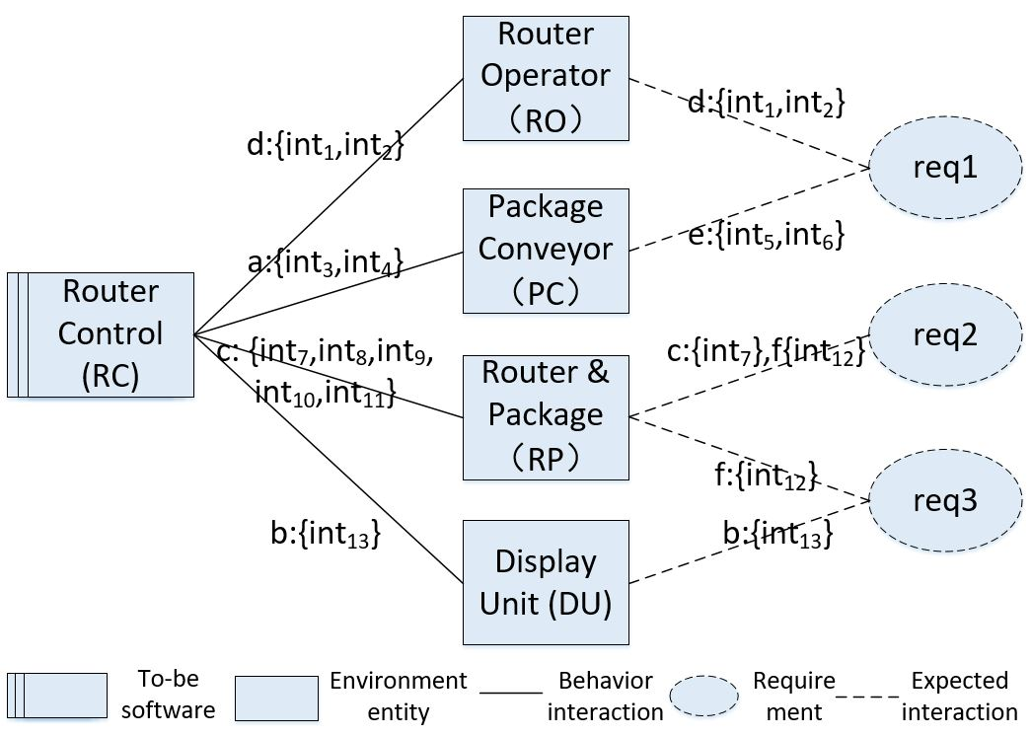
Fig. 2: Router control problem: problem diagram
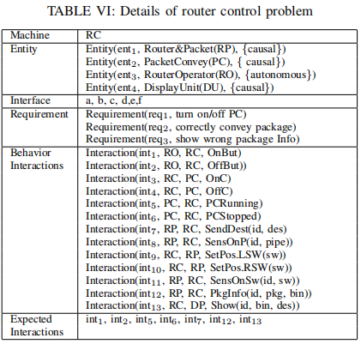
Step 2: Formalize interfaces and requirement references
There are six interfaces (including requirement references) in the problem diagram. They are a, b, c, d, e, and f. Interface a and e connects RC and P C, b connects RC and DU, c and f connects RC and RP, and d connects RC and RO. These interfaces can be asserted as channels, which can be used to communicate signals which include interactions. The assertion could be like channel a for interface a.
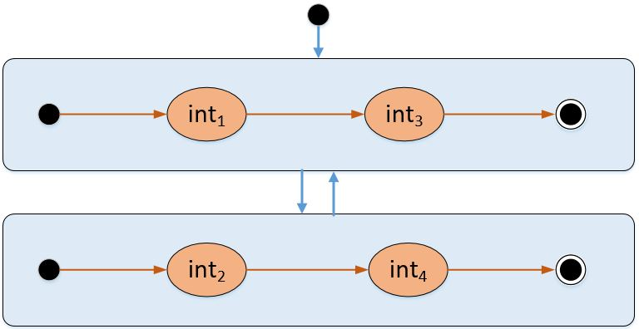
- Spec1: turn on/off PC
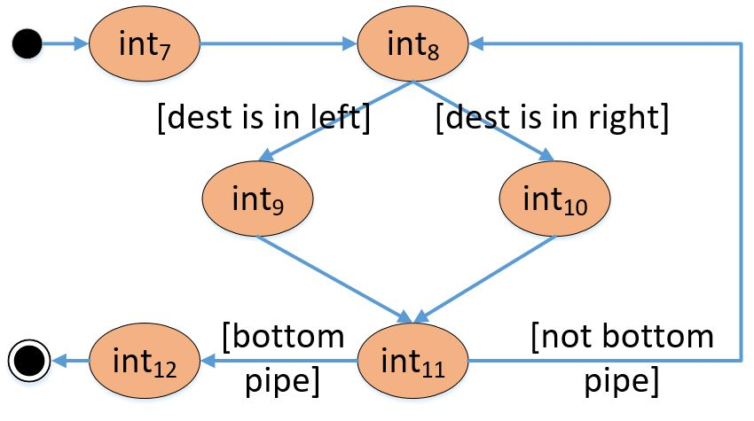
- Spec2: correctly convey package
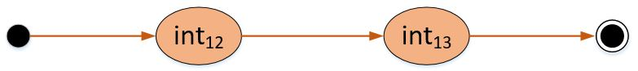
- Spec3: show wrong package Info
Fig. 3: Router control problem: specification

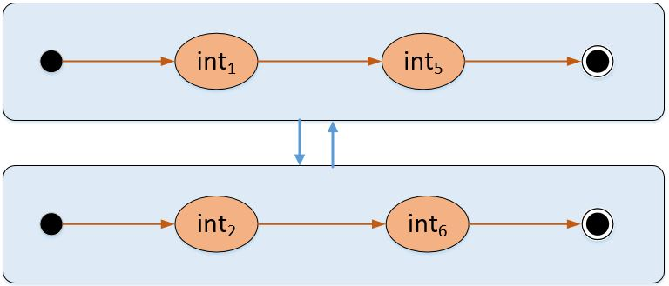
- Req1: turn on/off PC
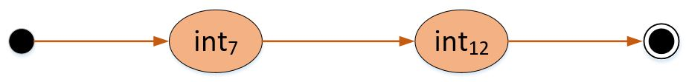
- Req2:correctly convey package
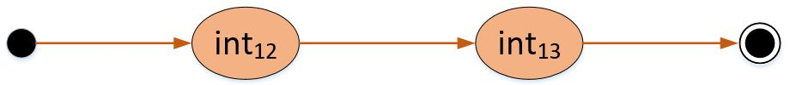
- Req3: show wrong package Info
Fig. 4: Router control problem: requirements
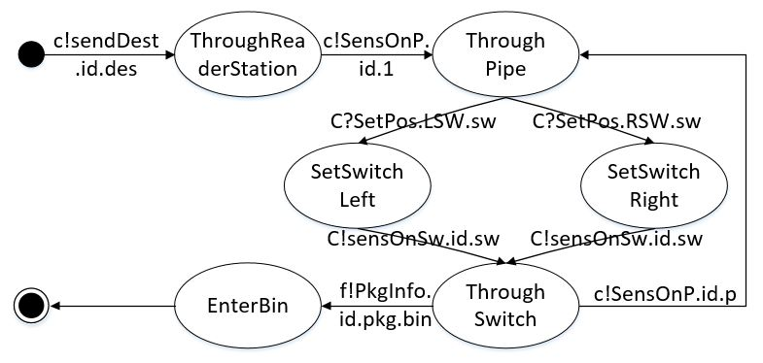
- The state diagram of PC
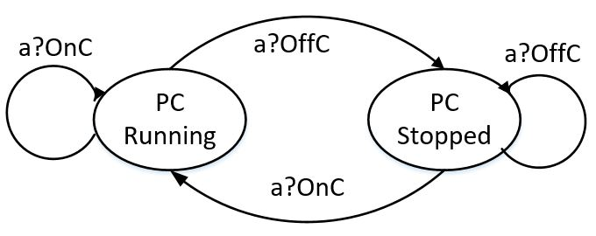
- The state diagram of RP
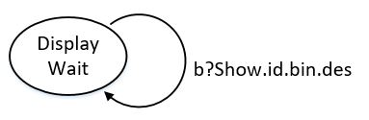
- The state diagram of DU
Fig. 5: The state diagrams of LU , RP and DU

Step 3: Formalize each entity from the problem diagram
There are four environment entities: RO, PC, RP and DU.
The RO is autonomous which can be modeled by viable commands. It has two viable commands, OnBut and OffBut.onBut and OffBut can appear at any time. According to the transformation rules in Table II, each command correspondsto a an event in CSP. Entity RO is a process RO. Then acorresponding CSP description of RO as follows:
RO = d!OnBut− > RO[]d!OffBut− > RO;
The PC is a causal entity. It has clear causal relations between its phenomena. According to Figure 5a, it has two states:P CRunning and P CStopped and four state transitions. It receives OnC and sends P CRunning, while receives OffC and sends P CStopped. Therefore, we have two processes Running and Stopped. For instance, the transition from P CRunning to P CStopped. Because there is no initial state in Figure 5(a), P C could be in any state due to the signal it receives. So a choice must be made between P CRunning and P CStopped. Finally we can get a corresponding CSP description of P C as follows:
Running =e!PCRunning{isOpen=true} ->Skip;
Stopped =e!PCStopped{isOpen=false} ->Skip;
PC=a?X ->ifa(X==OnC){Running;PC}
else ifa(X==OffC){Stopped;PC};

The RP is a causal entity too. According to Figure 5b, it has 6 states, and 8 state transitions. According to the transformation rules in Table II, the CSP notation of RP is obtained.
RP1(i,des)=[isOpen==true]atomic{c!sendDest.i.des{q_sw[0].Enqueue(i)}->Skip};
ThroughReaderStation(i,des);
ThroughReaderStation(i,des)=atomic{c!sensOnP.i.1{q_sw[0].Dequeue();
q_p[1].Enqueue(i)}->Skip};ThroughPipe(i,des,1);
ThroughPipe(i,des,p)=c?setPos.LRSw.i.p->ifa(LRSw==LSw){SetSwitchLeft(i,des,p)}
else{SetSwitchRight(i,des,p)};ThroughSwitch(i,des,p);
SetSwitchLeft(i,des,p)=SetSwitchtoLeft{if(q_sw[p].Count()==0){sw[p]=LSw;}}->Skip;
SetSwitchRight(i,des,p)=SetSwitchtoRight{if(q_sw[p].Count()==0){sw[p]=RSw;}}->Skip;
ThroughSwitch(i,des,p)=
atomic{c!sensOnSw.i.2{q_p[p].Dequeue();q_sw[p].Enqueue(i)}->Skip};
ifa(p==1){
ifa(sw[p]==LSw){ThroughPipe(i,des,2*p)}
else{ThroughPipe(i,des,(2*p+1))}
}else{
ifa(sw[p]==LSw){EnterBin(i,des,2*p)}
else{EnterBin(i,des,(2*p+1))}
};
EnterBin(i,des,p)=atomic{f!PkgInfo.i.(p-3).des{q_sw[p/2].Dequeue()}->Skip};
RP=RP1(1,gz)||RP1(2,sh);

The DP is a causal entity too. Its state transitions are shown in Figure 5(b). It has only one state and one transition. Thus a processes could be obtained: DisplayWait. It could be defined as: DisplayWait = b?show.i.bin.des −> DisplayWait; Similarly, the DU could be defined as follows.
DisplayWait = b?show.i.bin.des −> DisplayWait;
DU = b?show.i.bin.des −> DisplayWait;
The Domain D is composed by RO, RP, P C and DP. Then D can be described as follows:
D = RO||P C||RP||DU;

Step 4: Formalize the specification
The specifiation shown in Figure 3 has three subspecifications. According to the transformation rules in Table III, the specification of RC in CSP can be obtained by composing three sub-processes, RC1, RC2, and RC3. RC1 is transformed from Figure 4a. It is composed by two subprocesses, RC11 and RC12. RC11 receives commands OnBut from RO, and sends signal OnC to PC. RC12 receives commands OffBut from RO, and sends signal OffC to PC. And RC11 is the initial subprocesses of RC1, then RC1 is transformed to the following statements:
RC11 = d?OnBut -> a!OnC -> RC12;
RC12 = d?OffBut -> a!OffC -> RC11;
RC1 = RC11

The second subprocess RC2 transformed from Figure 4b. receives signals from RP, and sends commands to RP to set switch. RC1 is transformed to the following statements:
RC21(i)=c?sendDest.i.des->RC22(i,des);
RC22(i,des)=c?sensOn.i.p.1
->if(p==1&&(des==gz || des==sz)||(p==2&&des==sh)||
(p==3&&des==sz))
{RC2R(i,des,p)}
else{RC2L(i,des,p)}
;RC25(i,des);
RC2L(i,des,p)=c!setPos.LSw.i.p->Skip;
RC2R(i,des,p)=c!setPos.RSw.i.p->Skip;
RC25(i,des)=c?SwPos.i.p
->c?sensOn.i.p.2
->ifa(p==1){RC22(i,des)}else{RC26(i,des)};
RC26(i,des)=f?PkgInfo.i.bin.des->Skip;
RC2(i)=RC21(i);
The third subprocess RC3 transformed from Figure 4c sends incorrectly routed packages information to DU, then DU display the information. The specification can be transformed to the following statements:
RC3(i)=f?PkgInfo.i.bin.des ->
ifa(bin==1&&des!=bj || bin==2&&des!=sh || bin==3&&des!=gz || bin==4&&des!=sz)
{ b!show.i.bin1.des1 ->Skip };
The router controller RC is composed by RC1 ,RC2 and RC3. There is a clearly sequence relationship between RC2 and RC3 . Suppose there are N packages, then RC can be described as follows:
RC = RC1||(||i : 1..N@(RC2(i); RC3(i)));

Step 5: Formalize the requirements.
At first, the requirement Req1 shown in Figure 4a should be addressed. It says after router operator RO clicks onBut, package conveyor PC is expected to be PCRunning, while RO clicks offBut, PC is expected to be PCStopped. They are expressed as two subprocesses, R11 and R12. To represent RO clicks offBut or onBut arbitrarily, we use the general choice operator [] to connect R11 and R12. Then we can get the corresponding CSP description of R1 as follows:
R11=d!OnBut ->e!PCRunning ->Skip;
R12=d!OffBut ->e!PCStopped ->Skip;
R1=R11;Req1[]R12;Req1;
The requirement Req2 shown in Figure 4b says the package that through the reading station will eventually fall into a bin. According to the rules in Table III, the CSP notation of requirement Req2 is obtained as follows:
Req2=c!sendDest.i.des − >f!PkgInfo.i.bin.des − >Skip;
c!sendDest.i.des means the package whose package-id is i and destination will be des goes through the reading station, and the message is sent to RC through channel a. f!P kgInfo.i.bin.des means the package i with destination des slide into bin whose number is bin, similarly the message will be sent to RC through channel f. The requirement Req3 shown Figure 4c says after the packge was split into a wrong bin, the information is expected to display in the display unit DU. According to the rules in Table III, the process of CSP Req3 is obtained:
Req3=f!PkgInfo.i.bin.des
->ifa(bin==1&&des!=bj||bin==2&&des!=sh||bin==3&&des!=gz || bin==4&&des!=sz)
{b?Show.i.bin.des ->Skip;}
It means if package with id i and destination des is delivered into wrong bin bin, the DU will display the message. If package i is delivered into bin 1 and its destination was not bj, the package is a misrouted package and an appropriate signal should be displayed in DU.
Step 6: Define relationship and verify properties in PAT
Firstly, define the router control system. The router control system (System) is composed by D and RC. Then System can be described as follows:
System = D||RC;
Secondly, define the constrained domain D′from three requirements. From requirement Req1, considering the entity property, following procedures in Table V, the constrained domain E1 could be split into E11 and E12. E11 contains the events of entity RO, while E12 contains the events of entity PC. The relationship between entities is parallel, so the constrained domain E1 could be:
E11=d!OnBut ->E11[]d!OffBut ->E11;
E12=a?OnC ->e!PCRunning{isOpen=true} ->E12
[]a?OffC ->e!PCStopped{isOpen=false} ->E12;
E1=E11||E12;
From requirement Req2 and Req3 , similarly considering the entity property, following procedures in Table V, the constrained domain E2 and E3 are obtained.
E21(i,des) = [isOpen==true]atomic{c!sendDest.i.des{q_sw[0].Enqueue(i)}->Skip};E22(i,des,1);
E22(i,des,p) = atomic{c!sensOnP.i.p{q_sw[p/2].Dequeue();q_p[p].Enqueue(i)}->Skip};
c?setPos.LRSw.i.p
->ifa(LRSw==LSw){SetSwitchtoLeft{if(q_sw[p].Count()==0){sw[p]=LSw;}}->Skip
}else{SetSwitchtoRight{if(q_sw[p].Count()==0){sw[p]=RSw;}}->Skip};
atomic{c!sensOnSw.i.p{q_p[p].Dequeue();q_sw[p].Enqueue(i)}->Skip};
ifa(p==1){
ifa(sw[p]==LSw){E22(i,des,2*p)}else{E22(i,des,(2*p+1))}
}else{
ifa(sw[p]==LSw){E23(i,des,2*p)}else{E23(i,des,(2*p+1))}
};
E23(i,des,p) = atomic{f!PkgInfo.i.(p-3).des{q_sw[p/2].Dequeue()}->Skip};
E2=E21(1,gz)||E21(2,sh);
E3=b?show.i.bin1.des1->g!display.i.bin1.des1->E3;
Then the system System with restrictions constructed by RC and constrained domain E could be defined as:
System with restrictions = E1||E2||E3||RC;
In order to check whether the system satisfies the requirement, we check whether System and System with restrictions refines each other. Moreover, the deadlock and divergence of the systems could be checked. Then these properties should be asserted as shown in Fiure 6.
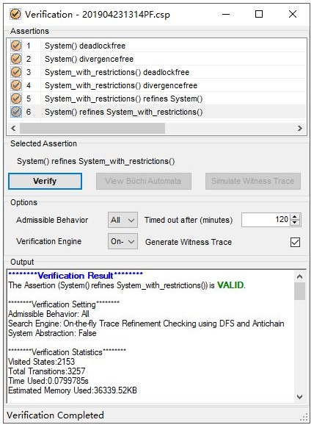
Fig. 6: Snapshot of verification result

Appendix
#import "PAT.Lib.Queue";
channel a 1;
channel b 1;
channel c 1;
channel d 1;
channel e 1;
channel f 1;
channel g 1;

//命令式行为子问题
enum{OnBut,OffBut};//路由器操作者发送的命令 d:int1,int2
enum{OnC,OffC,Test};//控制器发送给包传送装置的命令 a:int3,int4
enum{PCRunning,PCStopped};//
var isOpen=false;
//路由器操作者
//RO=d!OnBut->d!OffBut->RO;
RO=d!OnBut->RO[]d!OffBut->RO;
//包传送装置
Running =e!PCRunning{isOpen=true}->Skip;//->Stopped;
Stopped =e!PCStopped{isOpen=false}->Skip;//->Running;
PC=a?X->ifa(X==OnC){Running;PC}
else ifa(X==OffC){Stopped;PC};

//需求
/*
R11=d!OnBut->e!PCRunning->Skip;
R12=d!OffBut->e!PCStopped->Skip;
R1=R11;R1[]R12;R1;
*/

//受限域
E11=d!OnBut->E11[]d!OffBut->E11;
E12=a?OnC->e!PCRunning{isOpen=true}->E12
[]a?OffC->e!PCStopped{isOpen=false}->E12;
E1=E11||E12;

//路由器控制器1
RC11 =a!OnC->e?PCRunning->Skip;//RC12;
RC12 =a!OffC->e?PCStopped->Skip;//RC11;
RC1=d?X->ifa(X==OnBut){RC11;RC1}
else ifa(X==OffBut){RC12;RC1};

//需求式行为问题--路由子问题
enum{sendDest,sensOnP,setPos,LSw,RSw,SwPos,sensOnSw};
enum {bj, sh, gz, sz};//地址
var sw[4];//开关位置，LSw或RSw
#define N 2;
var LR;
enum{PkgInfo,Assoc,PDest};
var q_p=[new Queue(),new Queue(),new Queue(),new Queue(),new Queue(),new Queue(),new Queue(),new Queue()];
var q_sw=[new Queue(),new Queue(),new Queue(),new Queue()];//q_sw[0]是阅读工作站的队列

//var q[8];
//包和传感器 i:ID，des：地址，p:管道编号(同开关编号)，传感器编号p.1,p.2
#alphabet E2{SetSwitchtoLeft,SetSwitchtoRight};

RP1(i,des)=[isOpen==true]c!sendDest.i.des{q_sw[0].Enqueue(i)}->ThroughReaderStation(i,des);

ThroughReaderStation(i,des)=c!sensOnP.i.1{q_sw[0].Dequeue();q_p[1].Enqueue(i)}->ThroughPipe(i,des,1);

ThroughPipe(i,des,p)=c?setPos.LRSw.i.p->ifa(LRSw==LSw){SetSwitchLeft(i,des,p)}else{SetSwitchRight(i,des,p)};

SetSwitchLeft(i,des,p)=SetSwitchtoLeft{if(q_sw[p].Count()==0){sw[p]=LSw;}}->ThroughSwitch(i,des,p);

SetSwitchRight(i,des,p)=SetSwitchtoRight{if(q_sw[p].Count()==0){sw[p]=RSw;}}->ThroughSwitch(i,des,p);

ThroughSwitch(i,des,p)=
c!sensOnSw.i.2{q_p[p].Dequeue();q_sw[p].Enqueue(i)}
->ifa(p==1){
ifa(sw[p]==LSw){ThroughPipe(i,des,2*p)}
else{ThroughPipe(i,des,(2*p+1))}
}else{
ifa(sw[p]==LSw){EnterBin(i,des,2*p)}
else{EnterBin(i,des,(2*p+1))}
};

EnterBin(i,des,p)=f!PkgInfo.i.(p-3).des{q_sw[p/2].Dequeue()}->Skip;

RP=RP1(1,gz)||RP1(2,sh);

//需求
//req2(i)=c!sendDest.i.des->f!PkgInfo.i.(p-3).des->Skip;
//受限域
E21(i,des)=[isOpen==true]c!sendDest.i.des{q_sw[0].Enqueue(i)}->E22(i,des,1);
E22(i,des,p)= c!sensOnP.i.p{q_sw[p/2].Dequeue();q_p[p].Enqueue(i)}
->c?setPos.LRSw.i.p
->ifa(LRSw==LSw){SetSwitchtoLeft{if(q_sw[p].Count()==0){sw[p]=LSw;}}->Skip}
else{SetSwitchtoRight{if(q_sw[p].Count()==0){sw[p]=RSw;}}->Skip};
c!sensOnSw.i.p{q_p[p].Dequeue();q_sw[p].Enqueue(i)}
->ifa(p==1){
ifa(sw[p]==LSw){E22(i,des,2*p)}else{E22(i,des,(2*p+1))}
}else{
ifa(sw[p]==LSw){E23(i,des,2*p)}else{E23(i,des,(2*p+1))}
};

E23(i,des,p)= f!PkgInfo.i.(p-3).des{q_sw[p/2].Dequeue()}->Skip;
E2=E21(1,gz)||E21(2,sh);

//路由器控制RC2
RC21(i)=c?sendDest.i.des->RC22(i,des);
RC22(i,des)=c?sensOn.i.p.1
->ifa(p==1&&(des==gz || des==sz)||(p==2&&des==sh)||(p==3&&des==sz)){RC2R(i,des,p)}
else{RC2L(i,des,p)};
RC2L(i,des,p)=c!setPos.LSw.i.p->RC25(i,des);
RC2R(i,des,p)=c!setPos.RSw.i.p->RC25(i,des);
RC25(i,des)=c?SwPos.i.p->c?sensOn.i.p.2->ifa(p==1){RC22(i,des)}else{RC26(i,des)};
RC26(i,des)=f?PkgInfo.i.bin.des->Skip;
RC2(i)=RC21(i);

//信息显示子问题--报告错误路由
enum{show,display};

//显示单元
DisplayWait = b?show.i.bin.des->DisplayWait;
DU=b?show.i.bin.des->DisplayWait;

//需求
/*
R3=f!PkgInfo.i.bin1.des1
->if(bin1==1&&des1!=bj || bin1==2&&des1!=sh ||
bin1==3&&des1!=gz || bin1==4&&des1!=sz)
{g!Display.i.bin1.des1->Skip};
*/
//受限域
E3=b?show.i.bin1.des1->g!display.i.bin1.des1->E3;

//路由器控制RC3
RC3(i)=f?PkgInfo.i.bin1.des1->
ifa(bin1==1&&des1!=bj || bin1==2&&des1!=sh ||
bin1==3&&des1!=gz || bin1==4&&des1!=sz)
{
b!show.i.bin1.des1 ->Skip
};
D = RO || PC || RP || DU;
RC = RC1 || (||i:{1..N}@(RC2(i);RC3(i)));
System=RC||D;

System_with_restrictions = RC||E1 || E2||E3;

#assert System deadlockfree;
#assert System divergencefree;
#assert System_with_restrictions deadlockfree;
#assert System_with_restrictions divergencefree;
#assert System_with_restrictions refines System;
#assert System refines System_with_restrictions;

