MANUAL TEST PLAN

When you come to the home page this is the page you should see.

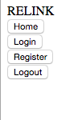

When you click register you should get this page.

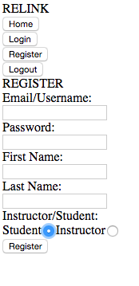

When you press Login this is the page you should receive.

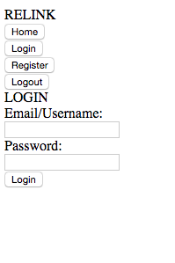

If you enter an incorrect password and username combination you should get this error.

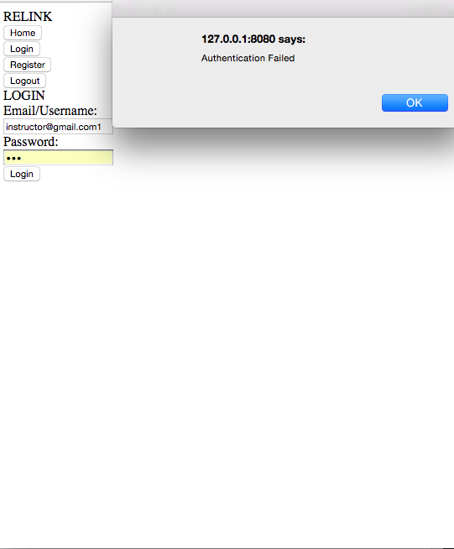

If you login with instructor credentials you should be taken to this page to start a new class.

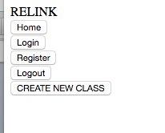

Otherwise if someone logs in with student credentials they should be taken to a page to enter a code to join a class.

