MANUAL TEST PLAN

When you go to the main index page you should get to this page, which is just a page with four tabs.

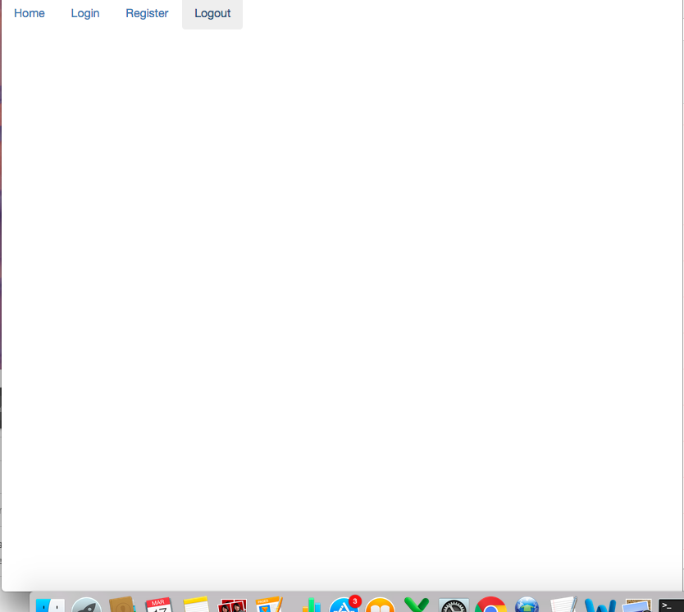

When you go to the login page this is the page you should see once press the login page.

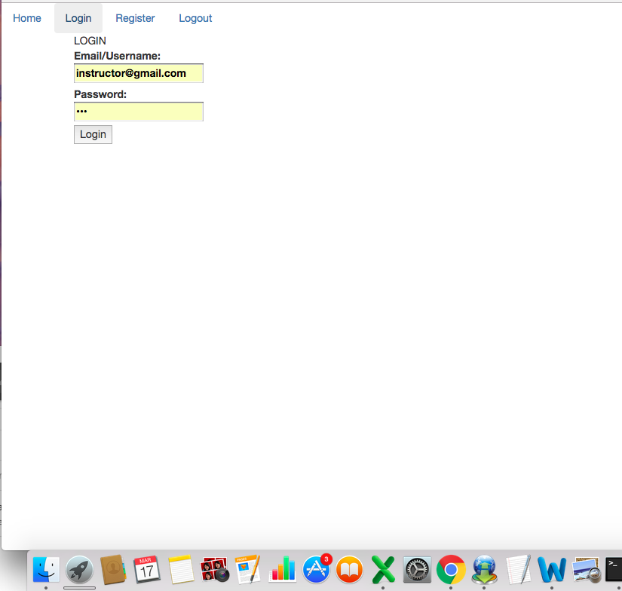

If you enter in in invalid credentials this is the popup message you should receive. 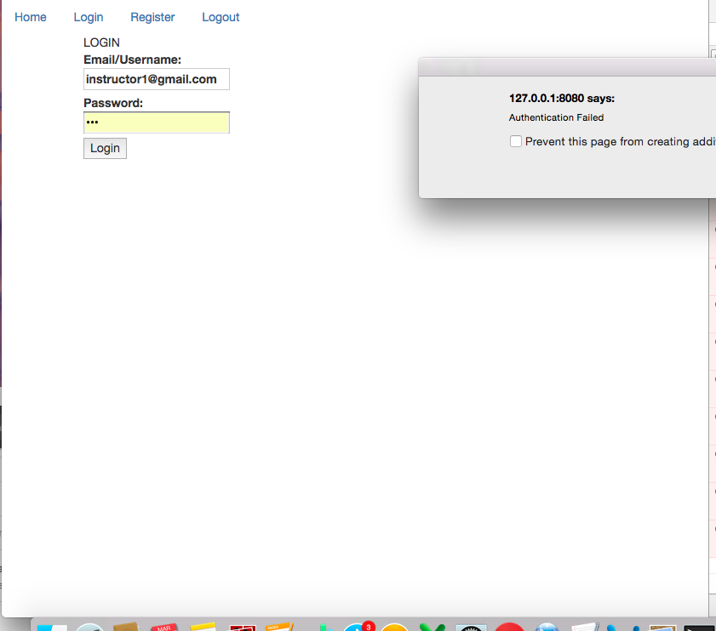

If you enter in is a teacher you should be taken to this page which gives you the option of starting a new class or creating a new quiz. 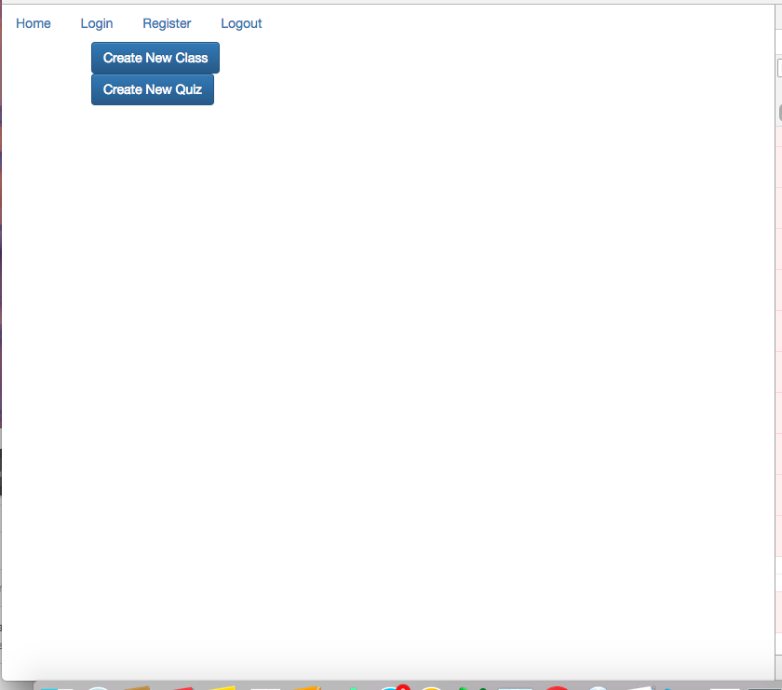

If you choose to create a new quiz you should be taken to this page which will give you the template of create a multiple choice or true or false quiz. 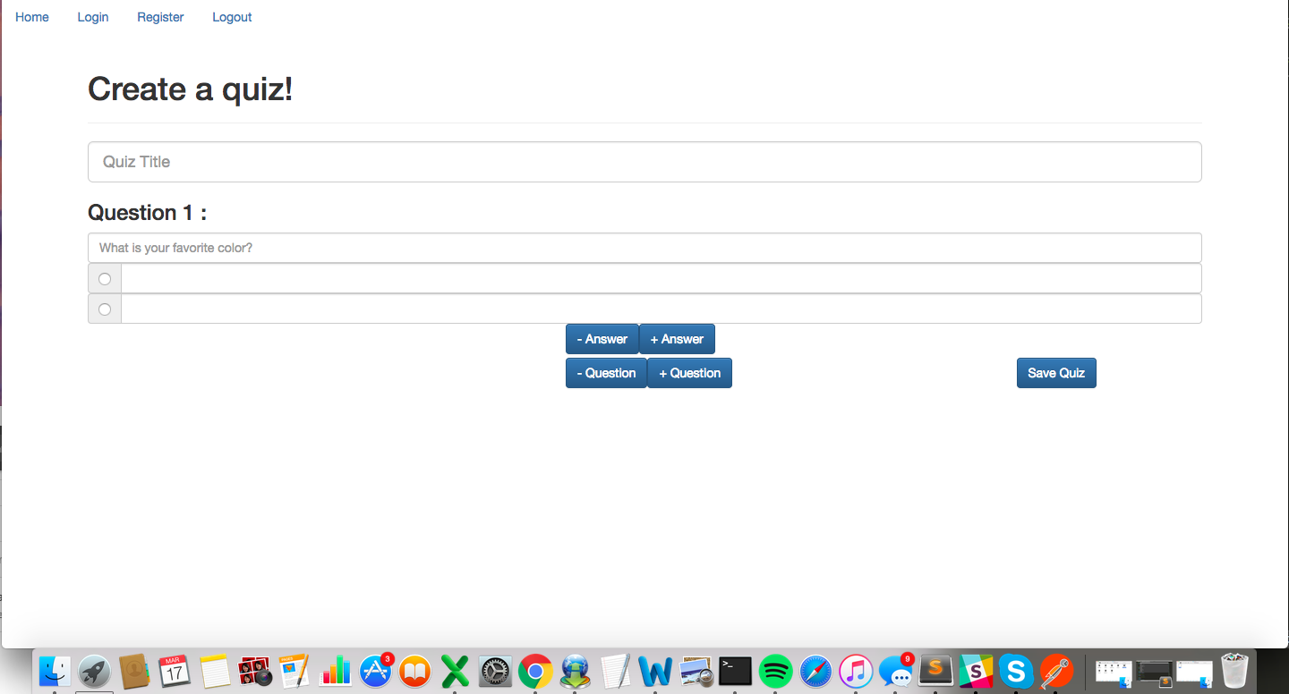

If you press register you should be taken to this page to register as a student or an instructor.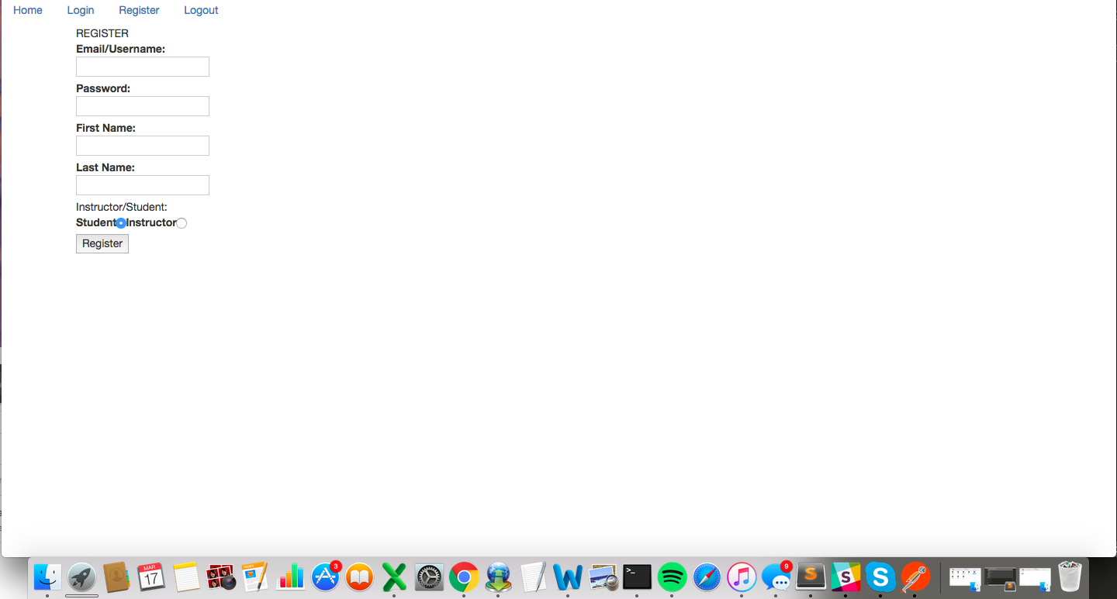

If you login as a student you will be taken to this page you join a classroom by giving a class room code .

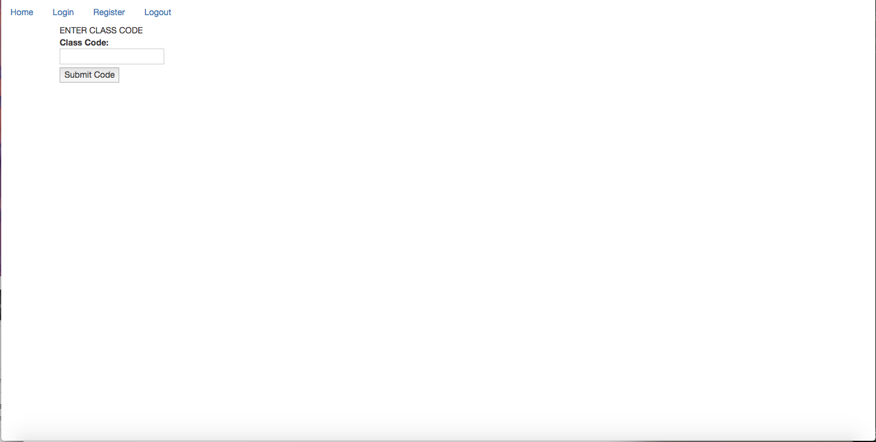

If you enter in the correct code or a you are an instructor that starts a new classroom you will be redirected to a chat page which looks like this. 