**MANUAL TEST PLAN**

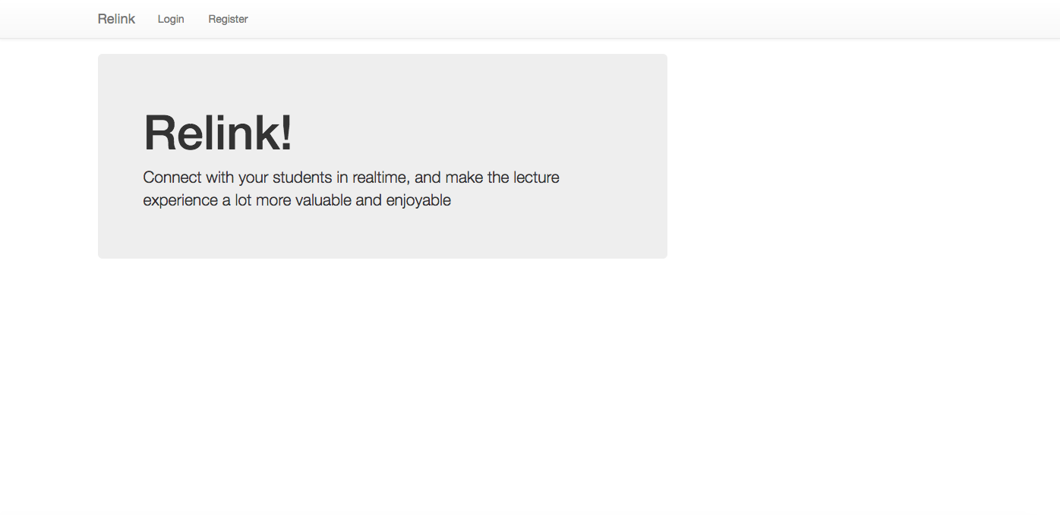

When you go to the main page, this is the page that should show up, when you press Register, it should take you to the register page, that should look like this.

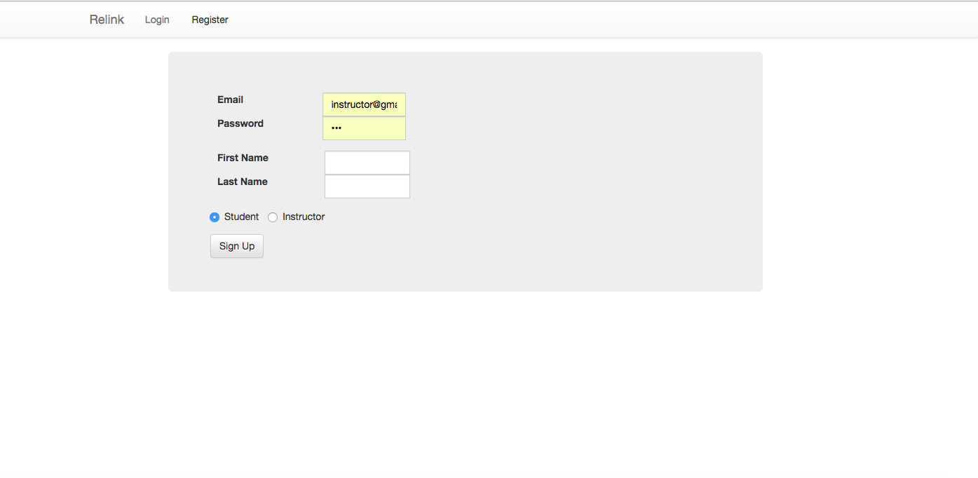

If you go to the register page, it should allow you to register as a student or an instructor.

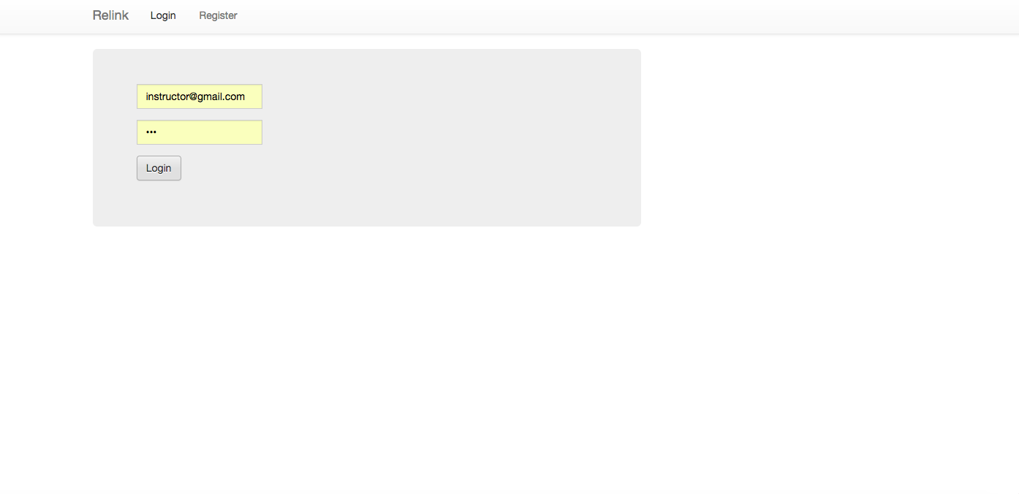

If you go the login page, this is the page that should show up.

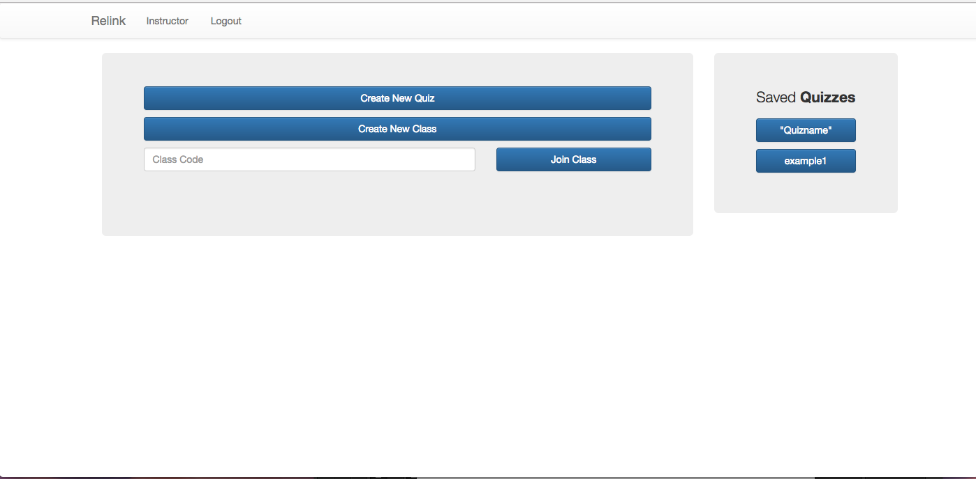

If you are an instructor, this page should show up, displaying your quizzes on the side.

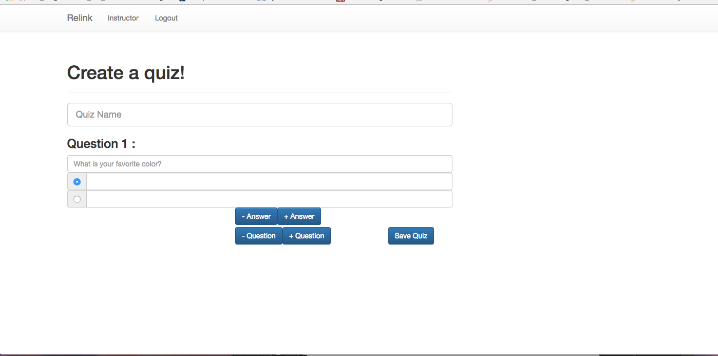

You should be able to create a quiz when clicking on the button Create a Quiz and add and remove question. 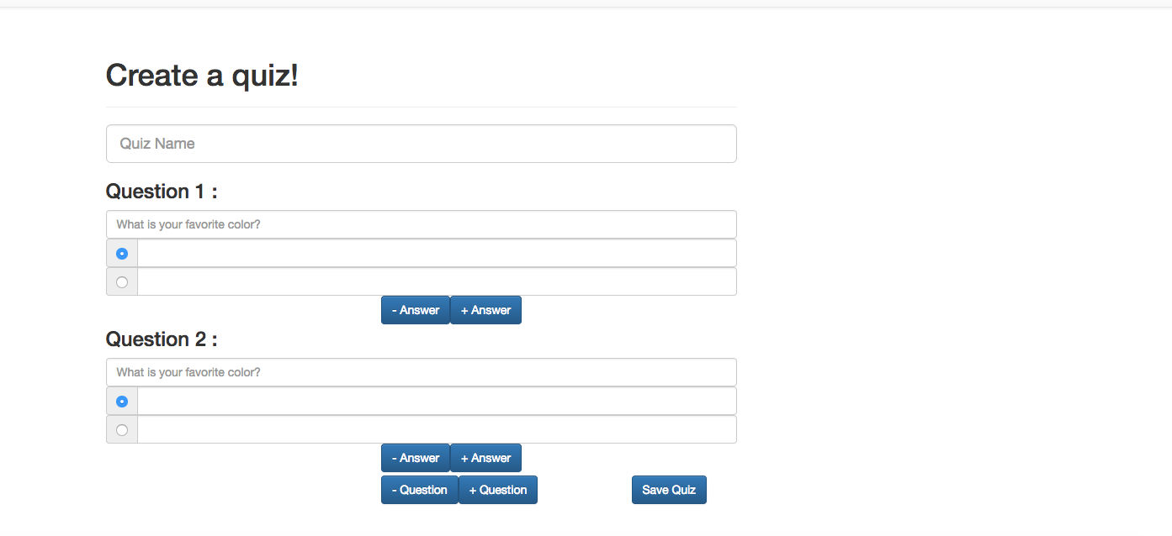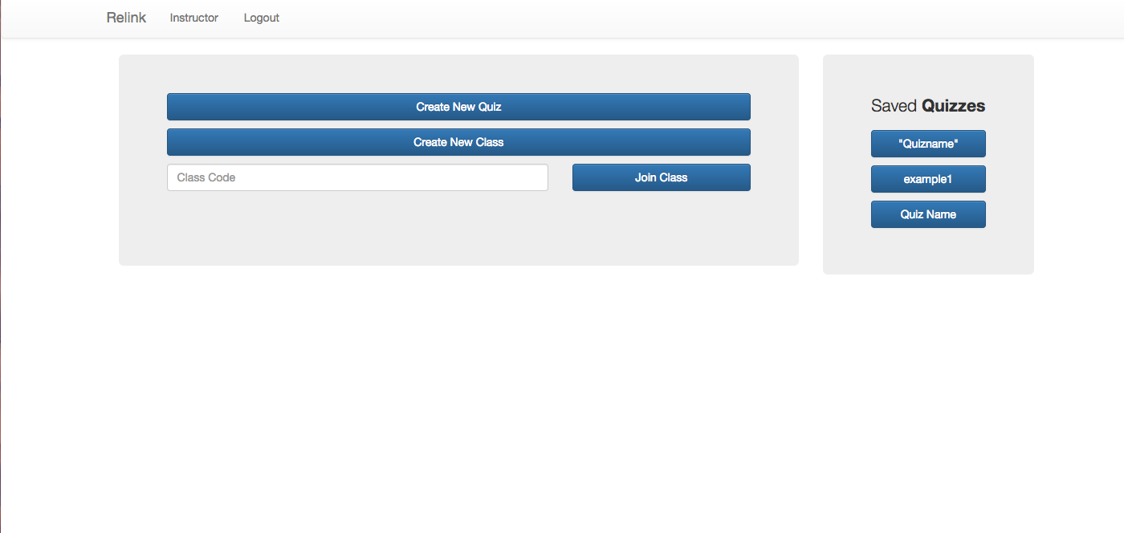

It should now show up on your saved quizzes.

If you create new class a popup modal should appear telling you your class number and allowing you to proceed to your room. 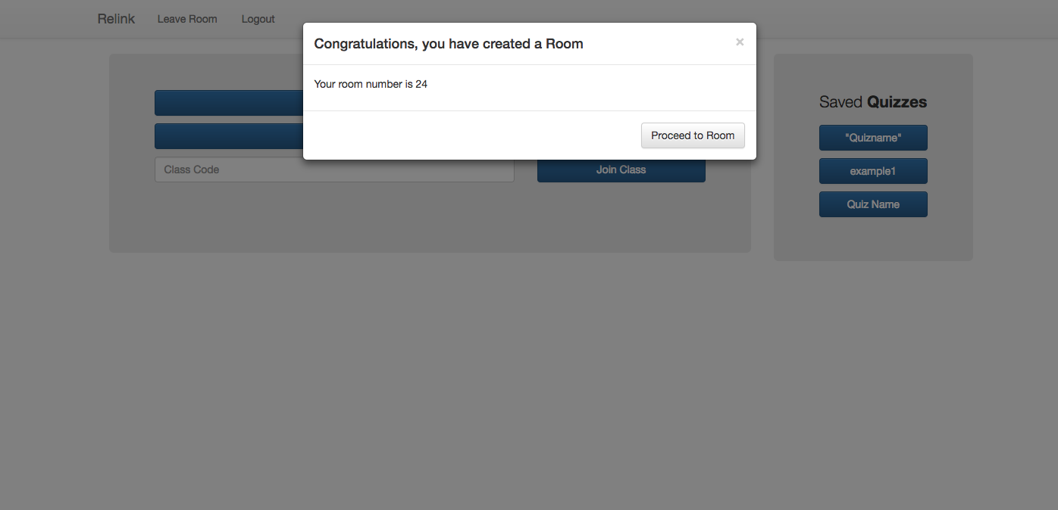

If you proceed to your room or enter a class code a join an existing class it should take you to the chat service and if you are an instructor it should display to you your saved quizzes.

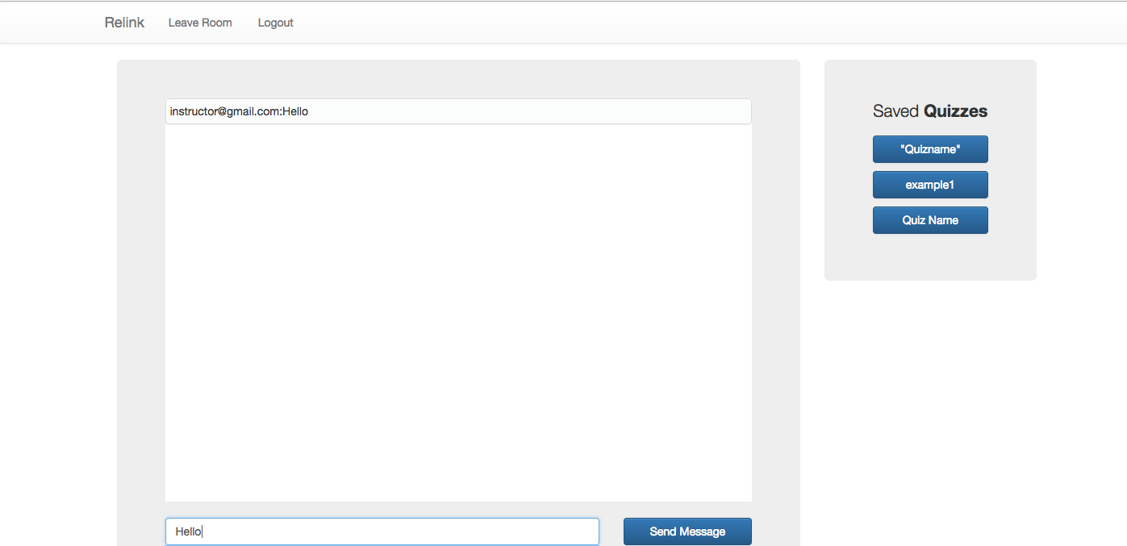

If you check box anonymous your messages should send as anonymous.

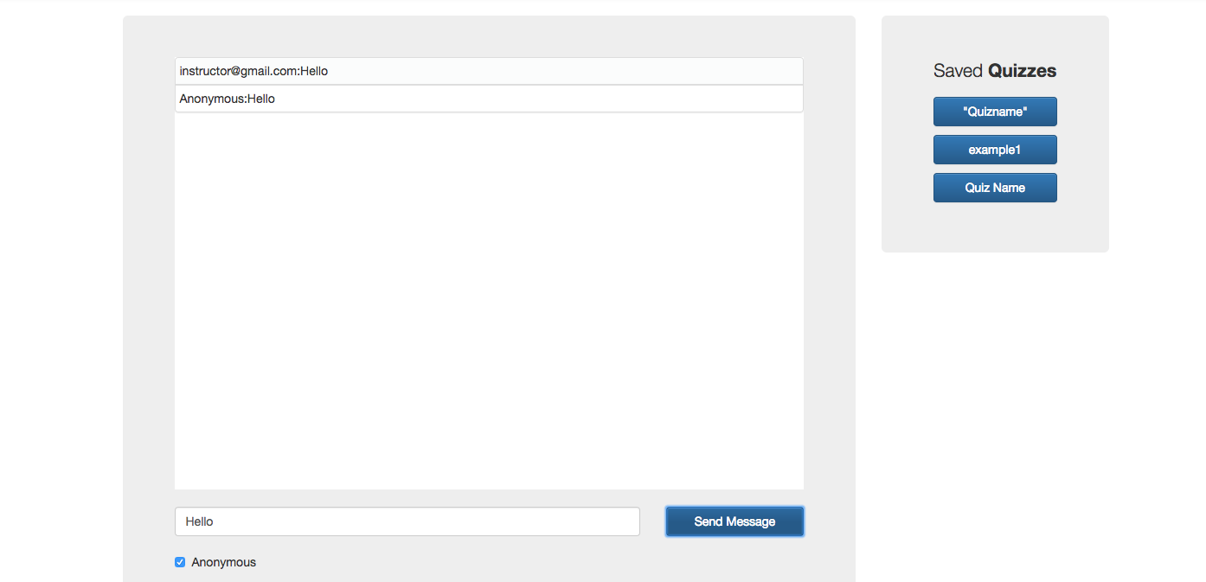

If you press logout it should take you back to the main page.

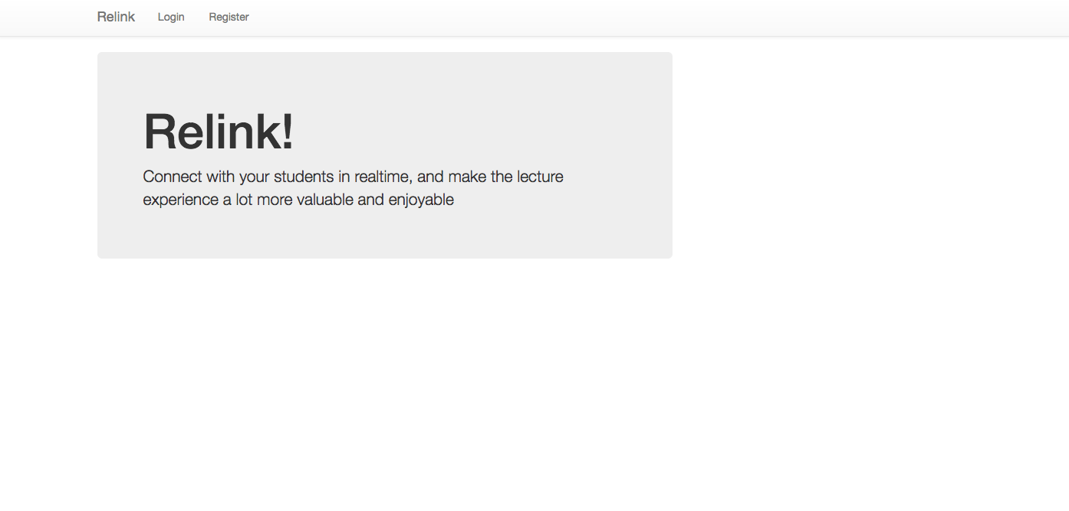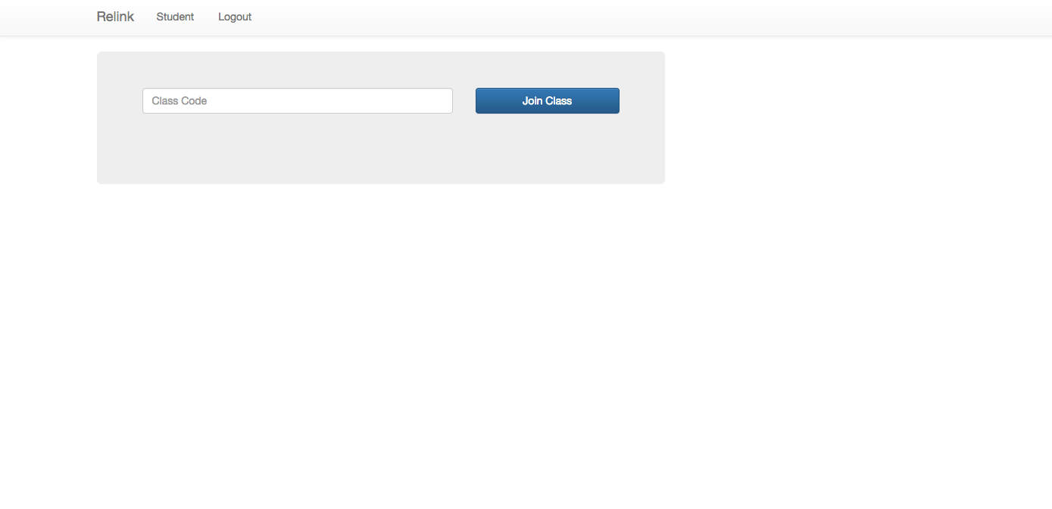

If you login as a student it should take you to this page when you login, where you can join an existing class.