Proof of Intelligence Consensus Architecture
Evidence-bound Minimum Publishable Prototype manuscript
NOT PUBLICATION-READY: E3 external evaluator authority, authenticated independent manual review, and the freeze sentinel remain open.
Canonical report manifest SHA-256
416c4fd909e10304c361af056f0fddbc3ab47c67aeedad8f22fb69d839801e49

Complete Proof of Intelligence Consensus Architecture

A Single-Pass, Optimistic, EVM-Compatible Protocol for Verifiable AI Responses, with a Narrow Publication-Artifact MPP

Abstract
Auditing a useful AI response should not require a mandatory second full model execution or a full zero-knowledge proof of every operation on the common path. We propose Single-Pass Auditable Intelligence (SPAI), an EVM-compatible protocol architecture in which one model execution produces a response and committed execution and semantic audit surfaces. Concrete audit obligations are selected only after response-commitment finality; successfully audited receipts mature into bounded, epoch-local protocol weight. The architecture combines model and task binding, trace and evidence commitments, post-commit audit compilation, optimistic dispute, data-availability retention, task-budgeted credit, and receipt-state management.
We evaluate a deliberately narrow Minimum Publishable Prototype (MPP) using a 1.5B open-weight model, local Foundry measurements, and reproducible experiments E1-E8. The current evidence is mixed and non-compensating. E1 and E2 are inconclusive real-model pilots; E4 and E8 are inconclusive simulations; E5 and E6 support only their frozen simulation scenarios; E7 supports local EVM boundedness; and E3 remains evidence-absent pending external evaluator authority. The strongest measured result is local Foundry boundedness: 15 operations or batch observations, a maximum observed gas value of 467,937, and a maximum configured-block-limit fraction of 0.0004358003. These results support feasibility of the narrow artifact-oriented MPP, not production consensus security, general semantic verification, or frontier-scale deployment.

1. Introduction
The expensive part of modern AI serving is the model execution itself. A PoI system that requires a second large-model generation for every accepted response, or a full proof of all tensor operations for the common path, inherits an immediate structural cost barrier. The systems question addressed here is whether useful AI responses can be made auditable without paying either of those costs on the normal path.
The proposed answer is Single-Pass Auditable Intelligence (SPAI): one committed response, one model execution, one set of committed execution and semantic audit surfaces, one post-commit randomized audit process, and one maturity rule that converts only successfully audited events into bounded protocol authority. The architectural goal is not to claim novelty for optimistic fraud proofs [1,2], algebraic matrix checks [6], remote attestation [3,4,7], data-availability sampling [13], zero-knowledge machine-learning verification [9,10], or weighted Byzantine fault tolerance [14] in isolation. The architectural claim is narrower: these components can be composed into a complete PoI path that avoids two common-path cost barriers while preserving explicit failure states and assurance tiers.
CommitLLM [5] is the closest implementation-level predecessor identified in the present bounded review. It likewise commits open-weight LLM inference artifacts, opens trace material only under challenge, and uses exact and Freivalds-style audit checks without requiring a proof for every response. opML [1] independently establishes a closely related optimistic fraud-proof route for on-chain machine learning. Consequently, this manuscript does not claim a new primitive for committed LLM execution or optimistic dispute. Its provisional differentiator is the wider protocol composition that links execution and semantic evidence, retention and challenge state, non-transferable receipt maturity, task-budgeted credit, and bounded next-epoch consensus weight. That composition-level novelty remains subject to a reproducible strongest-prior-art search and independent challenge.
This manuscript must be read in two distinct layers:
1. the full protocol architecture proposed by the paper; and
2. the current repository-backed MPP, which implements a narrower, evidence-gated subset for publication artifacts.
That separation is necessary because the architecture is broader than the current evidence package, and the repository intentionally refuses to promote missing, simulated, synthetic, or externally blocked surfaces into completed empirical claims.

2. Scope and contribution boundary

2.1 Proposed full architecture
The proposed full architecture includes:
- one-pass AI execution with post-commit audits;
- open-weight execution checks from committed traces and algebraic audits;
- an optimistic challenge and dispute path;
- a confidential or proprietary execution lane based on attestation;
- data-availability retention and withholding response;
- bounded task credit and next-epoch weight conversion;
- EVM-compatible receipt and credit settlement; and
- future scaling to larger frontier or MoE deployments.
Conceptual figure and algorithm sources are preserved in editable form under:
- docs/diagrams/D1_system_architecture.mmd
- docs/diagrams/D2_spai_sequence.mmd
- docs/diagrams/D3_receipt_state.mmd
- docs/diagrams/D4_audit_compiler.mmd
- docs/diagrams/D5_economic_flow.mmd
- docs/diagrams/D6_semantic_audit.mmd
- docs/algorithms/A1_SPAI.md
- docs/algorithms/A2_AuditCompiler.md
- docs/algorithms/A3_VerifySPAIEvent.md
- docs/algorithms/A4_PoI_Credit.md
- docs/algorithms/A5_Optimistic_Dispute.md

2.2 Implemented first-publication MPP
The approved first-publication MPP is narrower. Its frozen design logic is the three-layer structure already fixed in the repository:
1. evidence kernel: canonical schemas, hashing, provenance, configuration, and artifact validation;
2. protocol kernel: task -> commitment -> audit -> challenge or DA -> receipt -> credit lifecycle;
3. vertical experiment slices: E1-E8, each with its own RED-GREEN-REFACTOR cycle and publication gate.
The publication MPP is limited to:
- one 1B-3B open-weight primary model and one optional 7B-8B scaling model;
- objective and grounded task classes only;
- a local EVM using Foundry and Anvil;
- reproducible E1-E8 artifact plumbing;
- explicit negative, incomplete, and inconclusive reporting.
The publication MPP explicitly defers:
- 70B or larger validation;
- MoE or distributed production serving;
- confidential GPU or TEE execution;
- a production-grade dispute VM;
- production DA infrastructure;
- a production consensus client.

2.3 Evidence-origin rule
Synthetic data is permitted only for plumbing tests and must remain labeled SYNTHETIC_NON_EVIDENCE. Paper tables and figures may derive only from:
- authorized real execution;
- Foundry measurement; or
- explicitly declared reproducible simulation.
This rule is enforced by the repository’s artifact contract and is essential to interpreting the current manuscript honestly.

3. Proposed full architecture
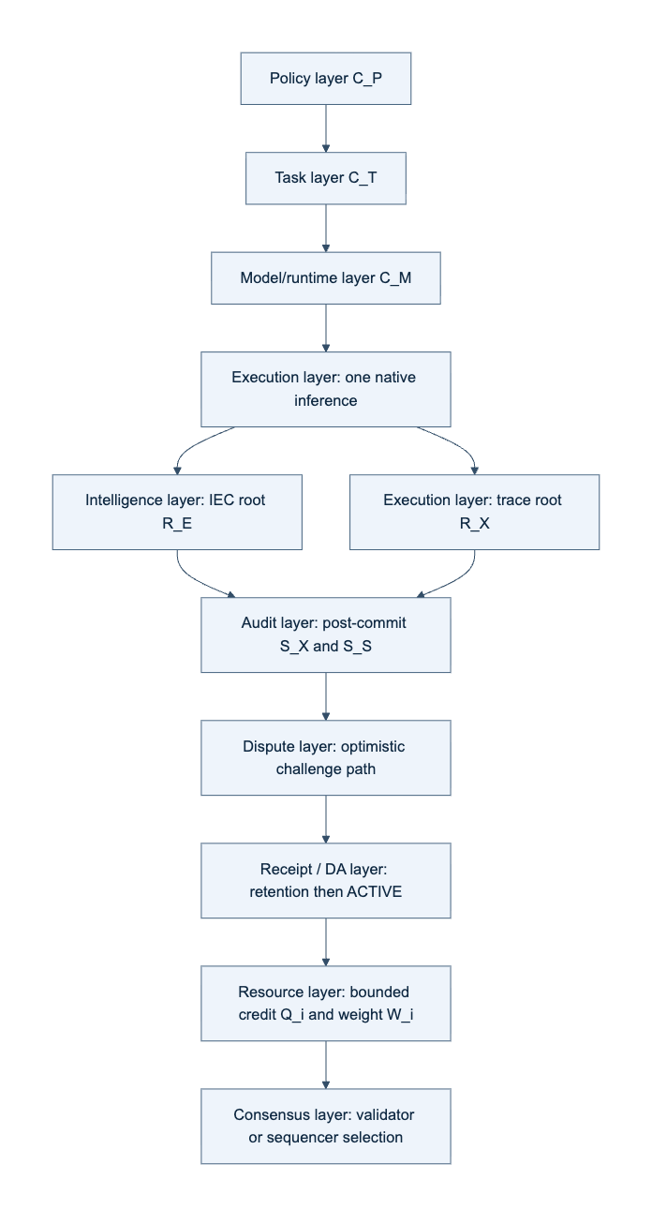
Figure 4. Conceptual complete PoI architecture. Policy and task commitments bind a single model execution to execution and intelligence roots; post-commit audit, dispute, retention, receipt, credit, and consensus layers follow. The production dispute and consensus layers are architectural targets, not current MPP evidence.

3.1 Single-pass auditable event
The core protocol path is:
task -> execute once -> trace + Intelligence Evidence Capsule -> commitment -> post-commit audit -> challenge or DA gate -> matured receipt -> next-epoch weight
The key design rule is that the concrete audit sample is not known before the response commitment is finalized. This preserves audit unpredictability while avoiding a second full model run on the normal path.
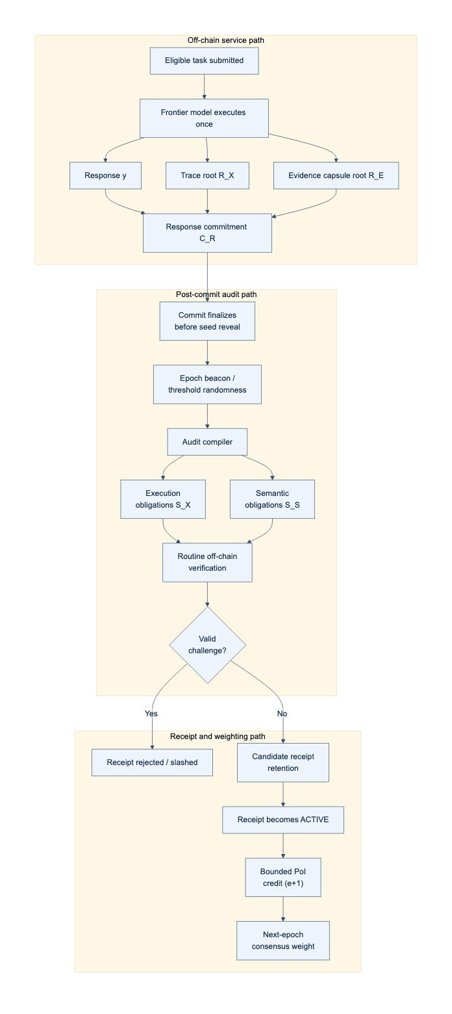
Figure 1. Conceptual single-pass end-to-end flow. One eligible task causes one required model execution; the response, trace root, and evidence-capsule root are committed before concrete audit obligations are revealed. Only successfully retained and unchallenged receipts can contribute bounded next-epoch weight.
Algorithm 1. Single-Pass Auditable Intelligence event.
Input: active policy C_P, task contract C_T, model/runtime manifest C_M
1. Execute the bound model once to obtain response y.
2. Commit trace root R_X, evidence root R_E, artifact root C_A, and H(y).
3. Finalize response commitment C_R before revealing the audit sample.
4. Derive post-commit seed eta and compile execution and semantic obligations.
5. Verify required openings, data availability, policy, and challenge results.
6. If a hard predicate fails, reject or slash; if semantics remain unresolved, abstain.
7. Otherwise mint a pending receipt; activate it only after retention and challenge windows close.
8. Make only active, policy-eligible receipts available for bounded next-epoch credit.
Invariant: the worker cannot know the concrete audit sample before C_R is final.
Algorithm 2. Post-commit audit compiler.
Input: C_P, C_T, finalized C_R, epoch beacon, audit round
1. Verify that C_P is active and C_R is final.
2. Compute eta = H(domain || beacon || C_T || C_R || audit_round).
3. Derive execution sample S_X and semantic obligations S_S from eta and policy.
4. Bind every obligation to C_R and publish identifiers and deadlines.
Output: (S_X, S_S).

3.2 Execution assurance lanes
The full architecture defines two execution-assurance lanes:
- an open-weight lane based on trace commitments, bounded exact checks, and randomized algebraic audits; and
- a confidential lane based on remote attestation and policy-gated execution provenance.
Only the open-weight lane belongs to the current first-publication MPP. The confidential lane is architecture only in this manuscript and is not an empirically supported repository result.
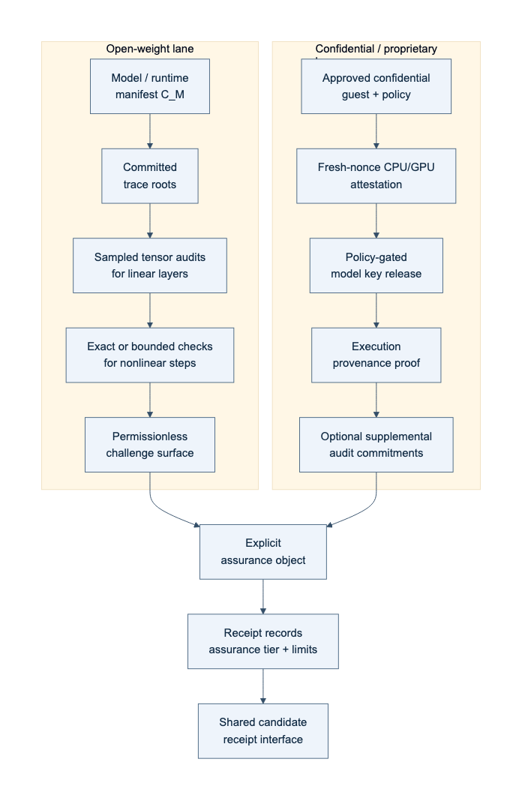
Figure 2. Conceptual execution-assurance lanes. The current MPP covers only the open-weight lane. The confidential or proprietary lane is a deferred architecture target and has no present execution evidence.

3.3 Semantic verification and the Intelligence Evidence Capsule
The architecture binds claims, evidence roots, dependency edges, uncertainty tags, executable artifacts, and coverage maps to the same response event. The semantic audit taxonomy distinguishes objective, grounded, open-semantic, and underdetermined classes. The implemented MPP preserves only the objective and grounded subset. Open-ended semantic competence remains outside the current publication-validated surface.
Algorithm 3. Verify one SPAI event.
Input: C_P, C_T, C_M, C_R, R_X, R_E, DA certificate, nullifier, receipt state
1. Require active policy, eligible task, and final commitment before seed reveal.
2. Recompute S_X and S_S and verify exact model/runtime binding.
3. Verify required execution openings or a mature dispute result.
4. Verify semantic obligations against y and R_E.
5. If calibration is invalid or disagreement exceeds policy, return ABSTAIN.
6. Verify DA, nullifier uniqueness, deadlines, and receipt predicates.
7. Return REJECT on any hard failure; otherwise return ACCEPT.

3.4 Receipt, credit, and next-epoch authority
The full architecture mints non-transferable intelligence receipts that pass through commitment, audit, challenge, and maturity stages before bounded task credit is allocated. Only matured, policy-eligible receipts contribute to next-epoch weight. This separates service work from consensus authority and preserves the rule that collateral cannot mint PoI weight by itself.
Algorithm 4. Bounded credit and next-epoch weight.
Input: matured receipts in epoch e, task budgets D_j, quality/assurance factors, bond and concentration caps
1. For every task j, enforce sum_i c_ij <= D_j.
2. Aggregate Q_i^(e+1) = sum_j c_ij.
3. Set W_i^(e+1) = min(Q_i^(e+1), B_i / beta, ConcentrationCap_i).
4. Sample next-epoch participation proportional to W_i^(e+1).
Invariant: Q_i = 0 implies W_i = 0; collateral caps authority but cannot create credit.

3.5 Optimistic dispute boundary
The architecture localizes a challenged trace interval and resolves only the final bounded disagreement. This is related to optimistic fault-proof design [1,2], but a general production transformer-kernel dispute VM is explicitly deferred.
Algorithm 5. Optimistic dispute localization.
Input: pending receipt, bonded challenge, committed disputed interval
1. Submit the challenge and disputed interval.
2. Require the worker's corresponding opening.
3. Bisect until one bounded deterministic step remains.
4. Evaluate that step directly or with a micro-proof.
5. Slash the losing party, pay the configured reward, and update receipt state.
Boundary: the current MPP does not implement a production-grade general dispute VM.

4. Implemented MPP

4.1 Repository structure
The implemented repository follows the frozen three-layer design and places the publication logic under a deterministic artifact pipeline. The practical shape is:
raw data -> aggregation script -> table or figure artifact -> manuscript
This means the manuscript is downstream of the evidence kernel rather than a freehand reporting layer.
Relevant repository contracts include:
- README.md
- docs/EXPERIMENT_PLAN.md
- docs/EXPERIMENT_ARTIFACT_MATRIX.md
- docs/ARTIFACT_COLLECTION_GUIDE.md
- docs/PAPER_ARTIFACT_MAP.md
- docs/MAIN_RESULTS_TARGETS.md

4.2 End-to-end state
Within its approved scope, the MPP software is materially implemented: evidence schemas, protocol objects, Python-Solidity parity surfaces, reporting builders, Foundry contract scaffolds, and a canonical publication-artifact pipeline are present. The manifest is the source of truth for result status; software implementation does not compensate for an inconclusive experiment, an absent authority, missing independent review, or an absent freeze sentinel.

4.3 Canonical publication state
The canonical artifact manifest contains E1, E2, and E4-E8 result surfaces and records the E3 omission ledger. It does not make the manuscript publication-ready. E3 remains WAITING_EXTERNAL, and the independent-review and freeze-sentinel gates remain open. These gate states are part of the scientific interpretation rather than formatting or administrative details.

5. Experimental design and artifact contract
Experiments E1-E8 are defined in docs/EXPERIMENT_PLAN.md, mapped to paper artifacts in docs/EXPERIMENT_ARTIFACT_MATRIX.md, and collected through docs/ARTIFACT_COLLECTION_GUIDE.md. The paper-facing artifact contract is intentionally strict:
- no manually typed scientific results in tables or figures;
- every paper artifact must derive from configuration, raw output, and code;
- synthetic plumbing must not be promoted into publication evidence;
- incomplete and inconclusive states must remain visible.
That contract matters because the current manuscript includes both evidence-bearing and non-evidence-bearing surfaces, and they must not be conflated.

6. Current evidence

6.1 Claim-level summary
The canonical claim matrix records C1 INCONCLUSIVE, C2 INCONCLUSIVE, E3 WAITING_EXTERNAL, C4 INCONCLUSIVE, C5 SUPPORTED within a declared simulation, C6 SUPPORTED within a declared simulation, E7 local boundedness SUPPORTED, and E8 INCONCLUSIVE. Those dispositions are non-compensating.
Table 1. Canonical MPP evidence status. “Supported” is confined to the origin and scope shown; it does not imply production or field validation.
Experiment | Evidence origin | n | Disposition | Claim ceiling
E1 | Real-model execution | 2 paired observations | INCONCLUSIVE | Fixed-order cost pilot only
E2 | Real-model execution | 4 attacks + 1 honest control | INCONCLUSIVE | Frozen 4-by-4 audit surfaces only
E3 | Absent pending external authority | 0 | WAITING_EXTERNAL | No semantic-performance claim
E4 | Reproducible declared playback | 2 scenarios | INCONCLUSIVE | Declared-outcome playback only
E5 | Reproducible simulation | 2 scenarios | SUPPORTED | Frozen watcher-economics scenarios only
E6 | Reproducible simulation | 6 scenarios | SUPPORTED | Frozen identity/capacity scenarios only
E7 | Local Foundry measurement | 15 rows | SUPPORTED | Local EVM boundedness only
E8 | Reproducible simulation | 10 rows | INCONCLUSIVE | Modeled next-epoch dynamics only

6.2 E1 and E2: bounded real-model pilots
E1 (T6, F5) is a fixed-order real-model pilot with two paired observations and six measured rows. The mean two-run baseline is 5197.17125 ms, the mean MPP single-pass measurement is 2678.932229 ms, and the paired delta is 2518.239021 ms with bootstrap interval [2440.923209, 2595.554833]. Fixed ordering leaves E1 INCONCLUSIVE; this result cannot support a general C1 cost-advantage claim.
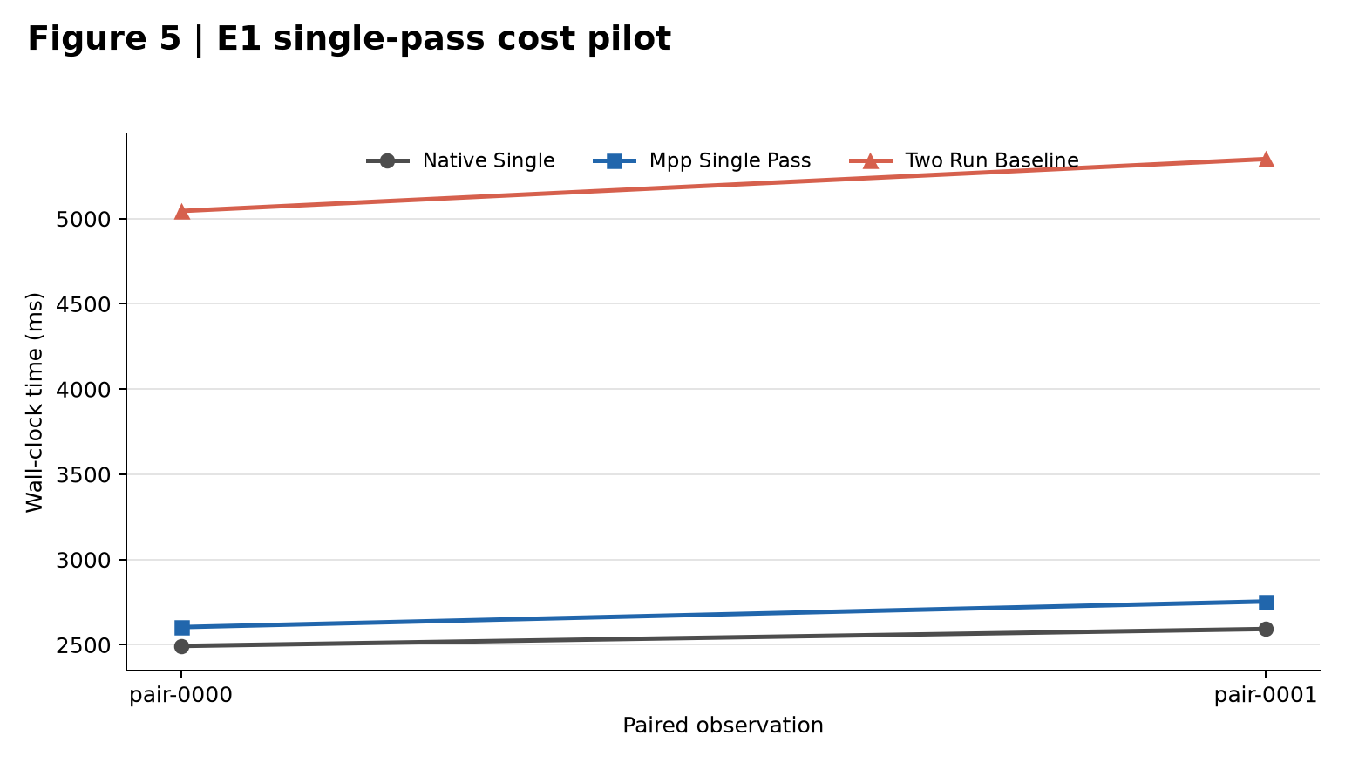
Figure 5. E1 fixed-order real-model timing pilot. The two-run baseline is approximately twice the single-execution paths in both pairs, but the fixed order and two-pair sample impose an INCONCLUSIVE ceiling. Source: canonical F5 JSON and T6.
E2 (T7, F6) is a narrow real-model pilot. It records 4/4 detected attacked observations across three exact and one empirical floating-point surface, with Wilson interval [0.5101091635454027, 1.0], plus one honest control and no false positive. It remains INCONCLUSIVE, not a general execution-audit efficacy claim.
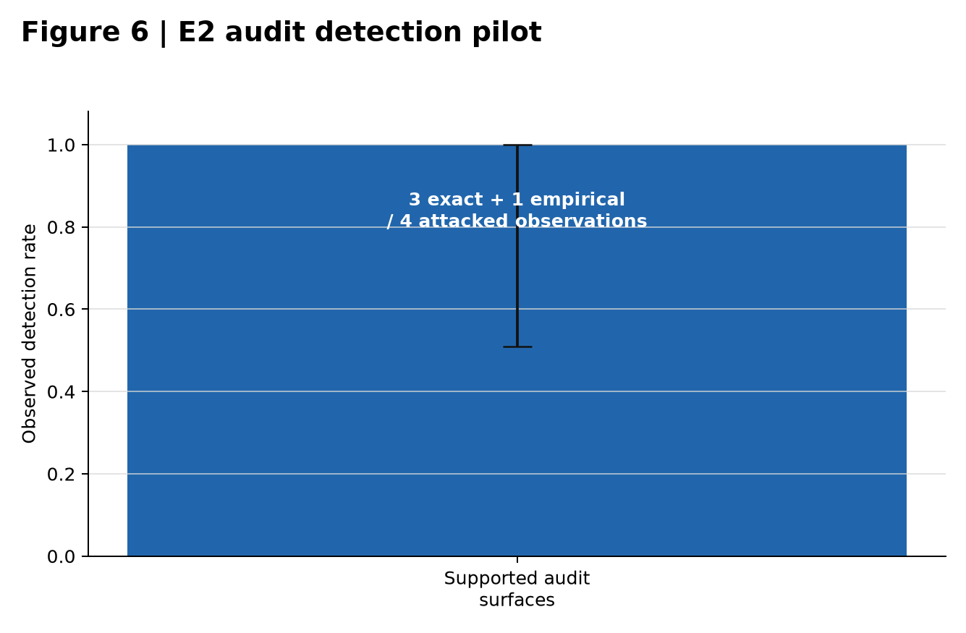
Figure 6. E2 narrow audit-detection pilot. All four attacked observations were detected across three exact and one empirical floating-point surface; the Wilson interval is 0.510-1.000. The frozen narrow design remains INCONCLUSIVE. Source: canonical F6 JSON and T7.

6.3 E3-E6: authority boundary and declared simulations
E3 has no evidence artifact. T4, T8, and F7 are WAITING_EXTERNAL because external evaluator authority has not been supplied. Semantic performance must not be reported before that gate is resolved.
E4 (T9, F8) is an INCONCLUSIVE declared playback simulation, not executed reconstruction evidence. E5 (T10) is SUPPORTED only for its declared watcher/dispute-economic simulation scenarios and has no figure. E6 (T11, F9, F10) is SUPPORTED only for its declared Sybil/task-budget simulation scenarios. Neither E5 nor E6 supplies production or open-network evidence.
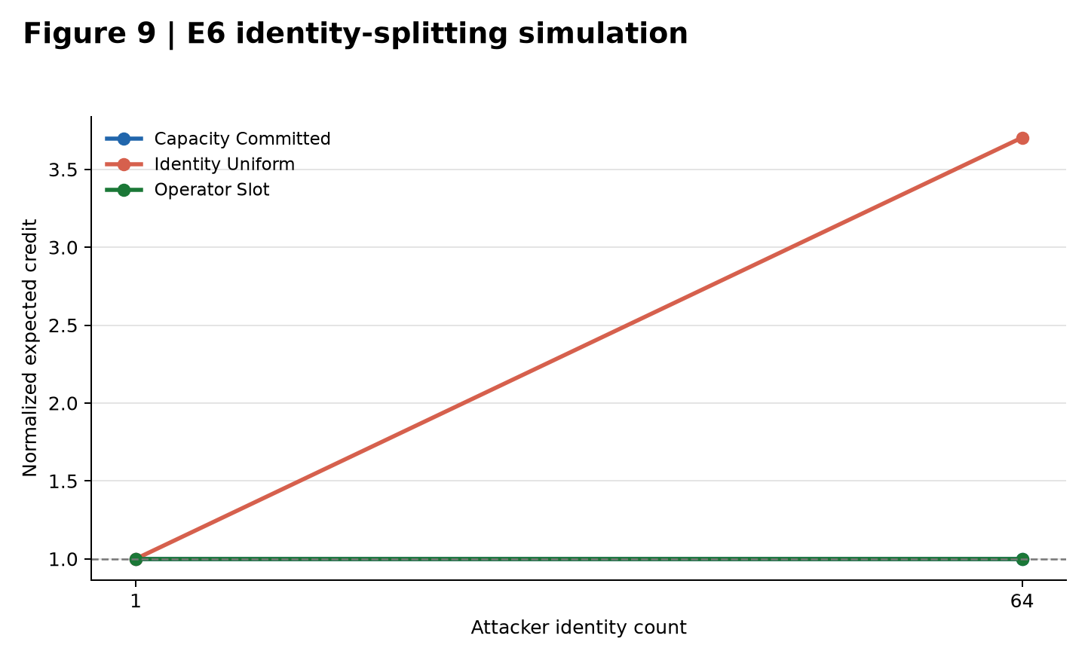
Figure 9. E6 identity-splitting simulation. Capacity-committed and operator-slot rules remain normalized at one across the frozen one- and 64-identity scenarios; the intentionally identity-uniform negative control increases to 3.704. This is simulation evidence only.
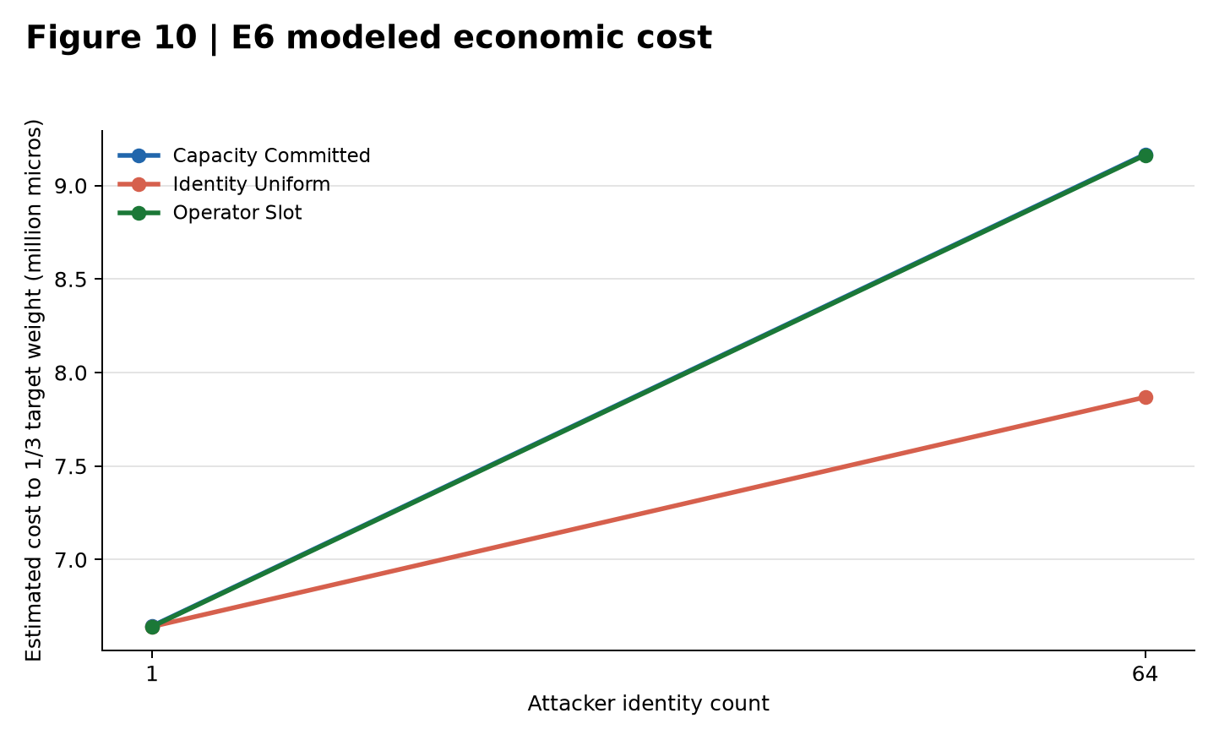
Figure 10. E6 modeled cost to one-third target weight under the frozen scenarios. Values are reproducible simulation outputs, not market prices, field measurements, or a production attack-cost guarantee.

6.4 E7 and E8: local measurement and simulation
E7 (T12, F12) contains 15 SUPPORTED local Foundry measurements. The largest observed gas value is 467937 for CREDIT_ALLOCATE at batch size 8, and the maximum fraction of the configured block limit is 0.00043580029159784317. This supports local boundedness only; it does not establish Ethereum-mainnet economics, production throughput, or production consensus performance.
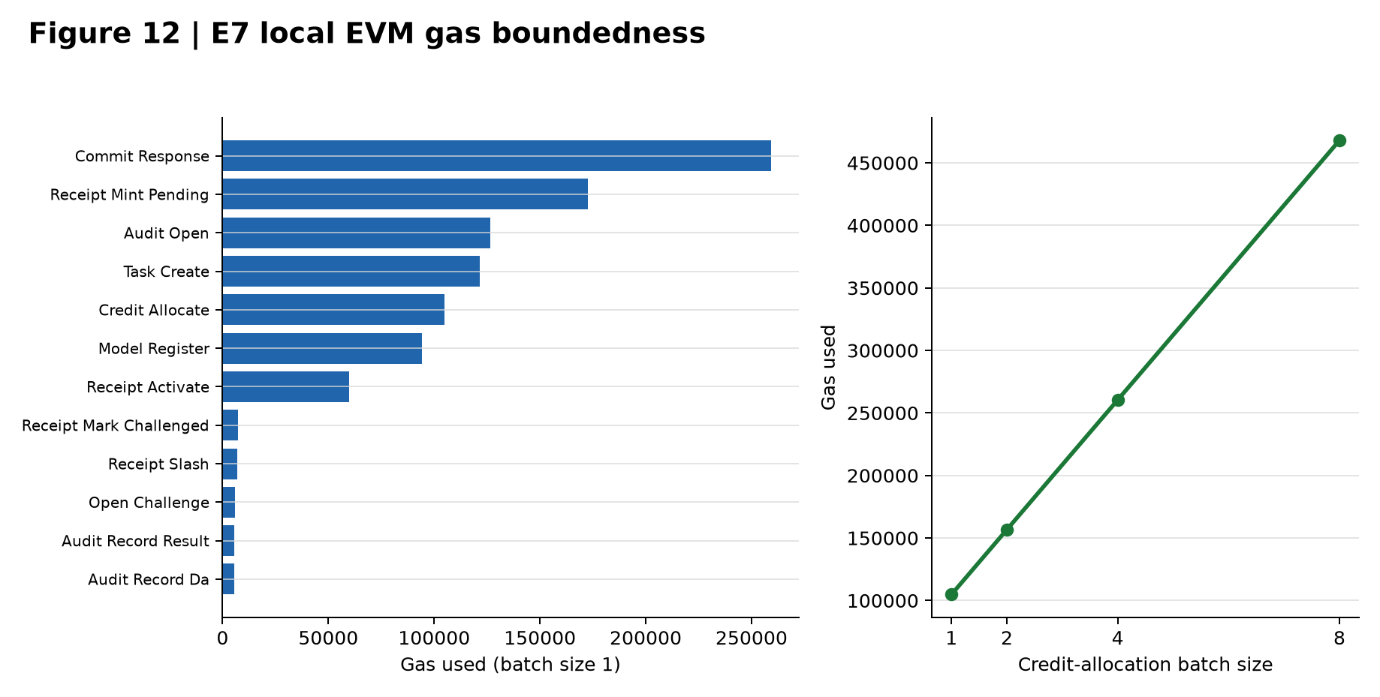
Figure 12. E7 local Foundry gas measurements. The left panel reports batch-size-one operations; the right panel shows credit-allocation scaling through batch size eight. Maximum observed gas is 467,937. This supports local boundedness only.
E8 (T13, F11) contains 10 INCONCLUSIVE reproducible-simulation rows. It may describe modeled receipt-to-weight dynamics, but it is not demonstrated consensus security.

7. Discussion

7.1 What the repository currently demonstrates
The repository currently demonstrates:
- a coherent reduction of the full PoI architecture into a bounded publication MPP;
- a fail-closed evidence kernel with explicit provenance, validation, and omission handling;
- Python-Solidity parity discipline for the implemented protocol kernel;
- local EVM boundedness evidence for the approved contract surfaces; and
- a reproducible simulation surface for next-epoch weight conversion.

7.2 What it does not yet demonstrate
The repository does not yet demonstrate:
- external-evaluator-authorized semantic confirmation for E3;
- a publication-freeze sentinel;
- authenticated independent manual review;
- 70B or larger model validation;
- MoE or distributed production validation;
- confidential GPU or TEE execution evidence;
- a production-grade dispute VM;
- a production consensus client; or
- a frozen publication bundle with authenticated independent manual review.

8. Limitations and evidence-origin disclosure
This manuscript enforces five evidence-boundary disclosures.
First, score tables and unsupported percentages are omitted. The current repository state does not justify compensating aggregate scores across architecture, implementation, evidence, and readiness.
Second, novelty remains provisional. A bounded review identified CommitLLM [5] and opML [1] as strong predecessors for committed open-weight inference and optimistic dispute. The repository does not yet contain a reproducible strongest-prior-art search package or a differently owned independent novelty challenge sufficient to defend a stronger composition-level novelty claim.
Third, semantic claims are narrow. The implemented MPP is limited to objective and grounded tasks, not open-ended semantic competence.
Fourth, empirical support is heterogeneous. E1, E2, E4, and E8 are INCONCLUSIVE; E5 and E6 are supported only within declared simulation scenarios; and E7 is supported only for local Foundry boundedness. E3 is evidence-absent and WAITING_EXTERNAL.
Fifth, the canonical bundle remains not publication-ready because it preserves unresolved gates rather than relabeling them as success. External evaluator authority, authenticated independent manual review, and the publication-freeze sentinel remain required. Neither AI production nor user approval is independent review.

9. Deferred future phases
The following surfaces are deferred and should remain labeled as future work rather than current evidence:
- 70B, 600B, and MoE execution validation;
- confidential or proprietary execution with GPU or TEE attestation;
- a production-grade dispute VM;
- production DA infrastructure;
- weighted BFT integration in a production consensus client;
- independent cryptographic, semantic, contract, and economic audits; and
- a fully frozen publication bundle with authenticated external manual review.

10. Conclusion
The proposed PoI architecture addresses a real systems problem: how to make useful AI responses auditable without requiring a second full frontier-model execution or a full common-path proof for each accepted response. The architecture combines response commitment, execution and semantic audit surfaces, post-commit randomness, optimistic dispute, DA retention, bounded task credit, and EVM-compatible receipt management into a coherent protocol proposal.
The current repository substantiates that this architecture can be reduced into a disciplined first-publication MPP. The strongest present repository-grounded result is local EVM boundedness (E7). E1 and E2 have canonical but inconclusive real-model pilot artifacts; E4 and E8 are inconclusive simulations; E5 and E6 are supported only within their declared simulations; and E3 remains blocked for external authority. The manuscript must preserve each boundary.
The correct current interpretation is therefore not that the architecture is fully validated, and not that it is merely conceptual. It is that a coherent PoI MPP has been implemented with strong fail-closed artifact discipline, while the central publication evidence package remains only partially complete.

Reproducibility and artifact availability
The canonical report bundle is rooted at publication/artifact_manifest.json, SHA-256 416c4fd909e10304c361af056f0fddbc3ab47c67aeedad8f22fb69d839801e49. It contains machine-readable tables, quantitative SVG and JSON outputs, the claim matrix, and the omission ledger. Conceptual diagrams are retained as editable Mermaid source, and Algorithms 1-5 are retained as manuscript-ready pseudocode and detailed source specifications. Paper-only PNGs are deterministic presentation derivatives generated from canonical figure JSON by scripts/build_paper_figures.py; they do not replace the canonical evidence artifacts.
The bundle is intentionally not frozen for submission. E3 external evaluator authority, authenticated independent manual review, and the freeze sentinel remain open. AI production, AI review, user approval, clean tests, and matching hashes do not by themselves constitute independent scientific review or authorize submission.

References
[1] K. D. Conway, C. So, X. Yu, and K. Wong. “opML: Optimistic Machine Learning on Blockchain.” arXiv:2401.17555, 2024.
[2] Optimism Collective. “Fault Proof.” OP Stack Specification, accessed August 23, 2026.
[3] A. Chan, A. Ding, F. Chen, A. Wu, B. Zhang, and A. Tian. “Optimistic TEE-Rollups: A Hybrid Architecture for Scalable and Verifiable Generative AI Inference on Blockchain.” arXiv:2512.20176, 2025.
[4] NVIDIA. “Attestation and Key-Release Flow.” In Deploying Proprietary Models Securely with NVIDIA Confidential Computing on Self-Hosted Virtual Machines, updated June 4, 2026.
[5] LambdaClass. “CommitLLM.” Official project repository and engineering documentation, accessed August 23, 2026. Grey literature.
[6] H. Ji, M. Mascagni, and Y. Li. “Gaussian Variant of Freivalds’ Algorithm for Efficient and Reliable Matrix Product Verification.” arXiv:1705.10449, 2017.
[7] Intel Trust Authority. “GPU Remote Attestation with Intel Trust Authority.” Official documentation, updated June 16, 2026.
[8] D. Ribeiro Alves, V. Patankar, M. Pereira, J. Stephens, N. Vaziri, and S. Kannan. “EigenAI: Deterministic Inference, Verifiable Results.” arXiv:2602.00182, 2026.
[9] W. Qu, Y. Sun, X. Liu, T. Lu, Y. Guo, K. Chen, and J. Zhang. “zkGPT: An Efficient Non-interactive Zero-knowledge Proof Framework for LLM Inference.” In Proceedings of the 34th USENIX Security Symposium (USENIX Security 25), 2025.
[10] Z. Peng, C. Zhao, T. Wang, G. Liao, Z. Lin, Y. Liu, B. Cao, L. Shi, Q. Yang, and S. Zhang. “A Survey of Zero-Knowledge Proof Based Verifiable Machine Learning.” Artificial Intelligence Review 59, 157 (2026).
[11] Hearth. “A Verified-Inference Layer-1 Secured by Proof of Inference.” Source-carried draft whitepaper reference, July 2026. Grey literature; stable official primary source not verified in this manuscript pass.
[12] Ambient. “Litepaper: Proof of Logits & Verified Inference,” together with official product documentation describing “machine intelligence as currency,” accessed August 23, 2026. Grey literature.
[13] M. Yu, S. Sahraei, S. Li, S. Avestimehr, S. Kannan, and P. Viswanath. “Coded Merkle Tree: Solving Data Availability Attacks in Blockchains.” In Financial Cryptography and Data Security (FC 2020), LNCS 12059, pp. 114-134, 2020.
[14] M. Yin, D. Malkhi, M. K. Reiter, G. G. Gueta, and I. Abraham. “HotStuff: BFT Consensus with Linearity and Responsiveness.” In Proceedings of the 2019 ACM Symposium on Principles of Distributed Computing (PODC 2019), pp. 347-356, 2019.
[15] Ethereum.org. “Node Architecture” and “Consensus Mechanisms,” accessed August 23, 2026.

