#L1 (starting from slide 20)
- Internet uses gateway (routers) to connect to Local Area Network (LAN)
- Organizations/Homes connect to edge router. Edge router connects LAN to the internet.
- Ethernet LAN = via cable. WAN = wireless and shared across network (e.g., Wi-Fi).

- Physical link: medium between transmitter & receiver
- The physical link can be wired -> Transmission line: the signals propagate (travel) in a medium. E.g., copper cable. Examples: twisted copper pair, coax, fiber (modern, it’s increasing in popularity).
- 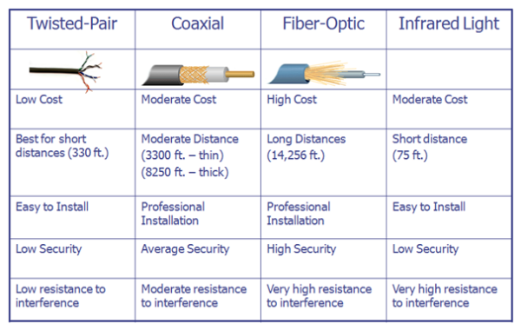
- Signals can also propagate in free space -> wireless, radio waves, satellite etc.
- Routers work together to find most efficient path for routing
- Two types of ISPs: Global (Tier-1) and Regional (Tier-2)
- Examples of Global: Verizon, Sprint, AT&T… They are connected via IXP. USA has the most IXPs.
- Regional: they are customers of Tier-a ISPs. They connect to them.

- Data transfer happens via packet switching or circuit switching.

- In case of packet switching (its overall better than circuit switching): Source IP -> Destination IP.
  - It is the base of the internet. Invented by Leonard Kleinrock in 1961.
  - It’s based on statistical multiplexing.
  - The data stream is segmented into packets. Each packet travels by itself using available resources.
  - Packets can be lost or corrupted.
  - TCP layer puts packets in correct order and reassembles them at the destination.
  - It’s great for bursty data (computer data that is sent in short, sudden periods of activity): better for resource sharing.
- Circuit switching: Everything goes through a link, like an analog telephone or dial-up modem.
  - A connection is established before data transfer.
  - Dedicated resources -> no sharing -> no queuing delay & resource is idle if it’s not being used.
  - However, call setups and teardowns are required.
  - It’s great for voice and video: bandwidth is guaranteed. But its more expensive due to complex mechanisms and equipment.

*BREAK*

- Latency in packet switching:
- It takes L/R seconds to transmit one packet from router 1 to router 2 (transmission delay).
- The entire packet must arrive at router 1 before it can be transmitted to the next link.
- Host to host delay = 3L/R + propagation delay + other delays.
  - Example: L=1000 Mbits, R=100 Mbps, transmission delay per link=1000/100=10 seconds.
  - => total transmission delay = 3*10 = 30 seconds.
- Bandwidth = capacity. Throughput = actual amount of data that is being transmitted between source and destination. Both in bits/sec.

IP Address, MAC address and port number are needed when sending a message via internet from source to destination through OSI layers:

Source (message sent from here) → link-layer switch (gives mac address of router) → router (knows ip address of destination, finds mac address of destination)

