**CS 1632 - DELIVERABLE 5: Performance Testing Conway's Game of Life**

Benjamin Nimchinsky

https://github.com/znaeb/SlowLifeGUI

Summery:

ORIGINAL profile Results Image:

Random setup:

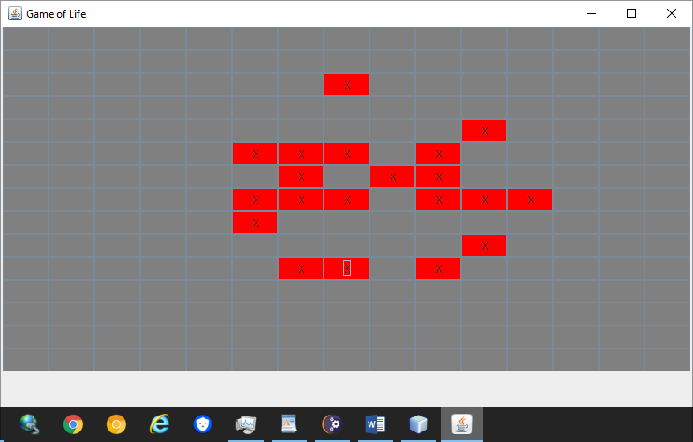Run:

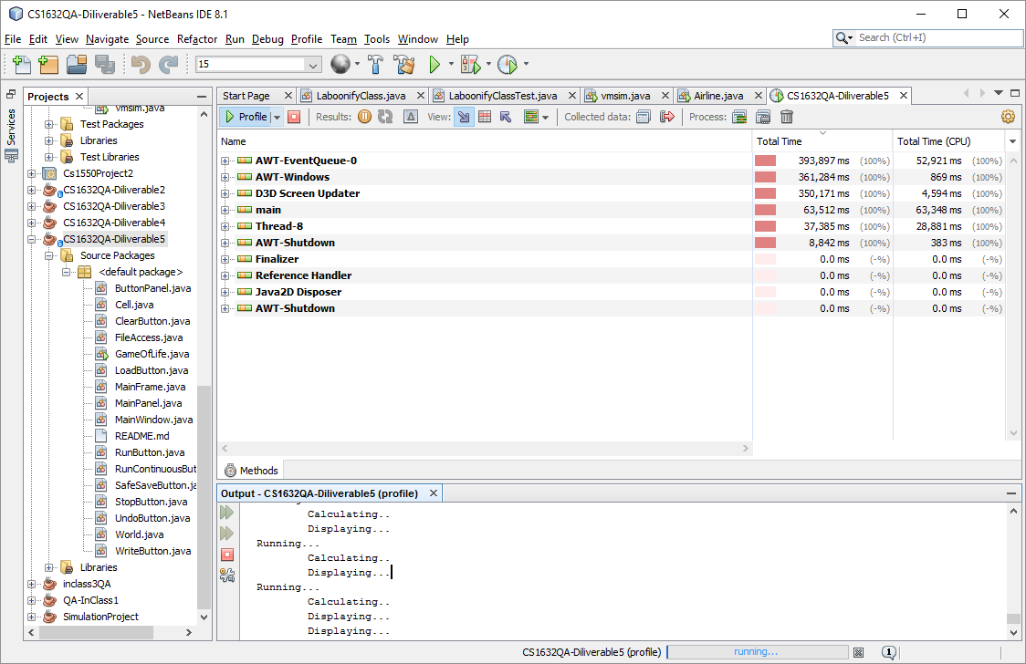

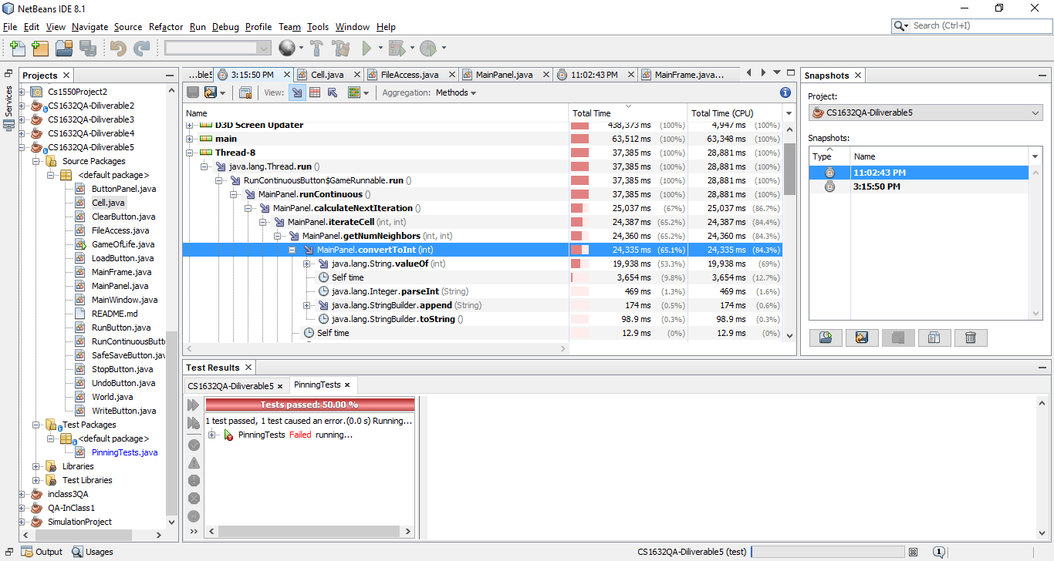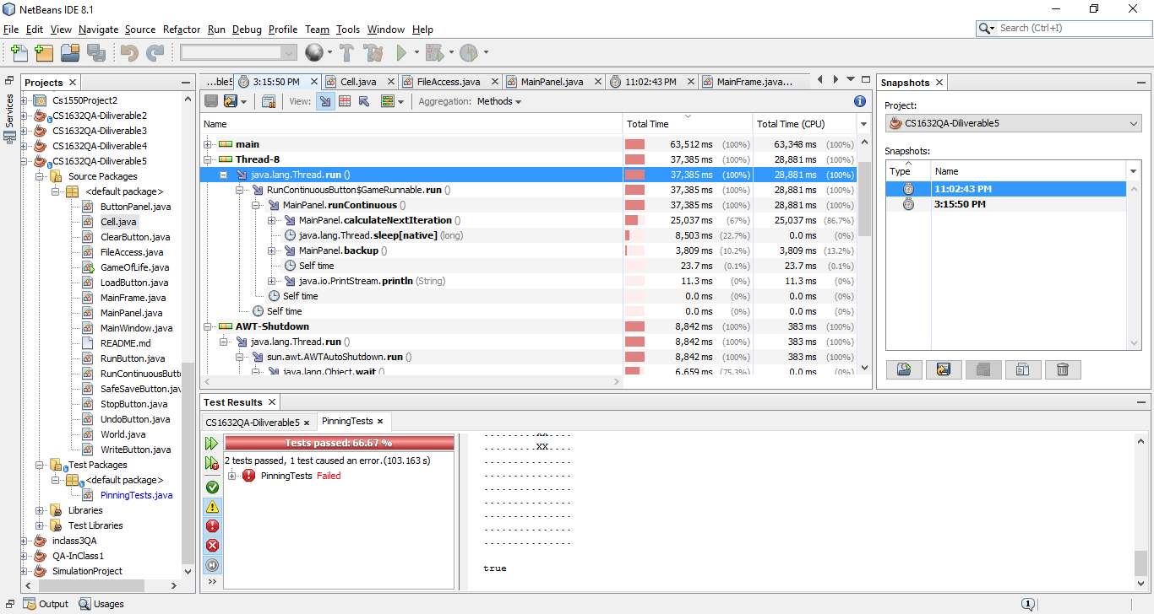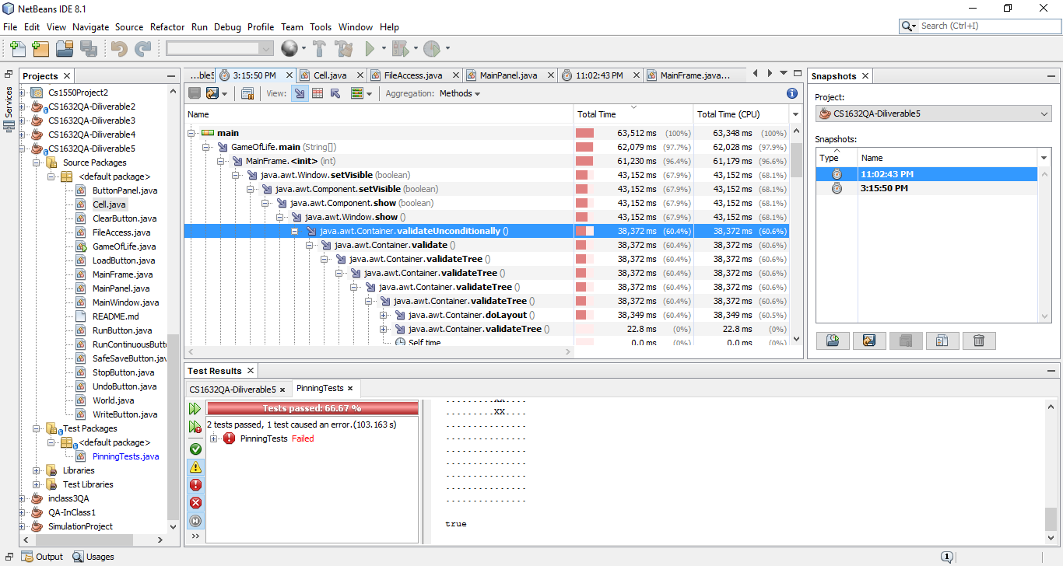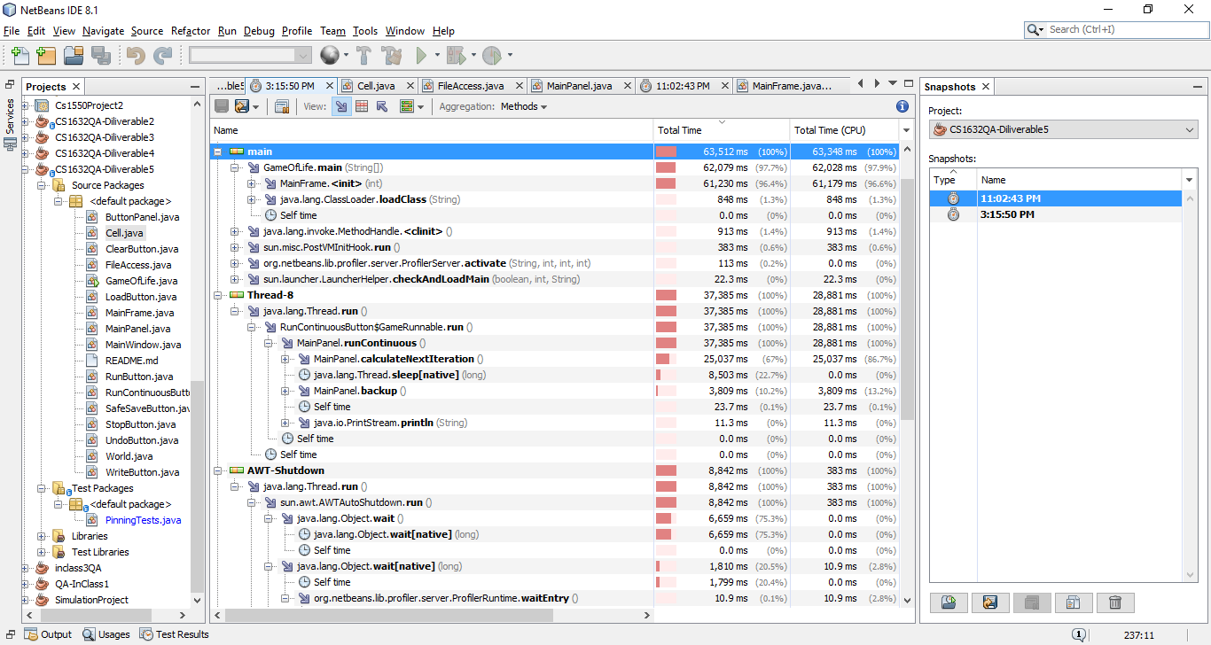

Now I am displaying the profiler results after many “write” button presses:

Modified profile results: