**CS 1632 - DELIVERABLE 6: Static Analysis of the Sieve of Eratosthenes**

Benjamin Nimchinsky

https://github.com/znaeb/bug-fodder

Summary:

Findbugs Results Image:

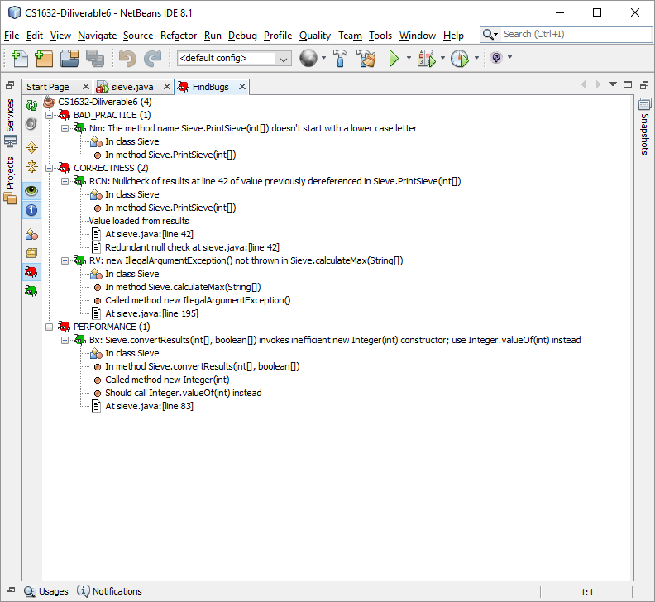

Findbugs reorganized:

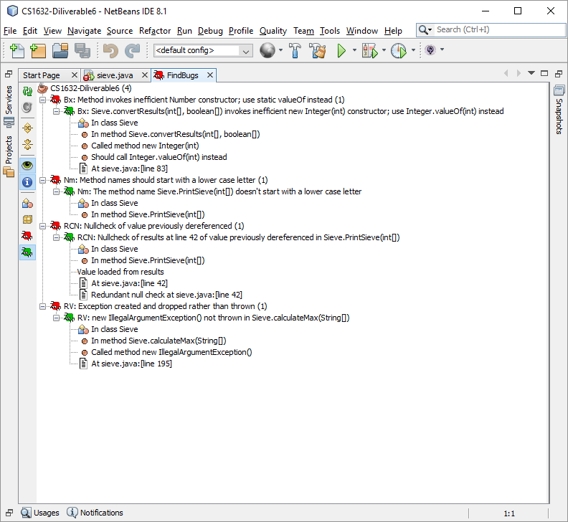

Check Style:

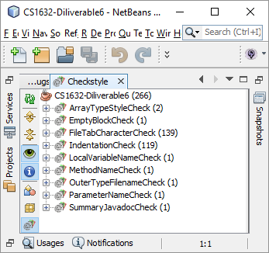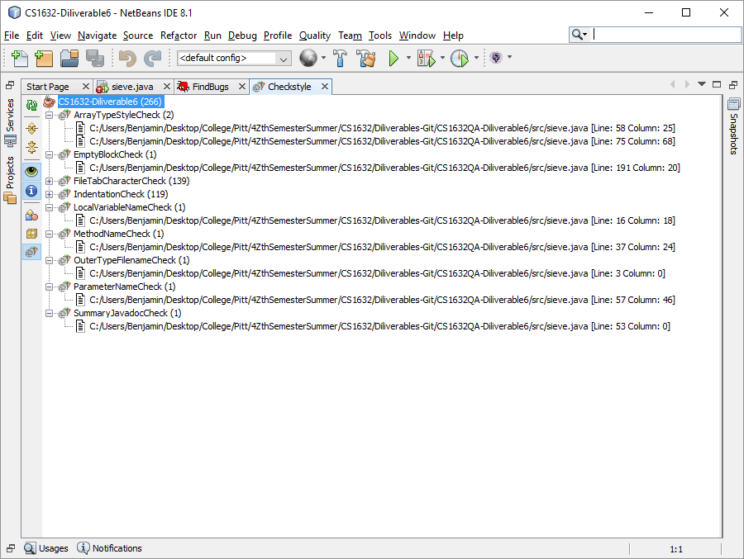

Unneeded, but PMD check:

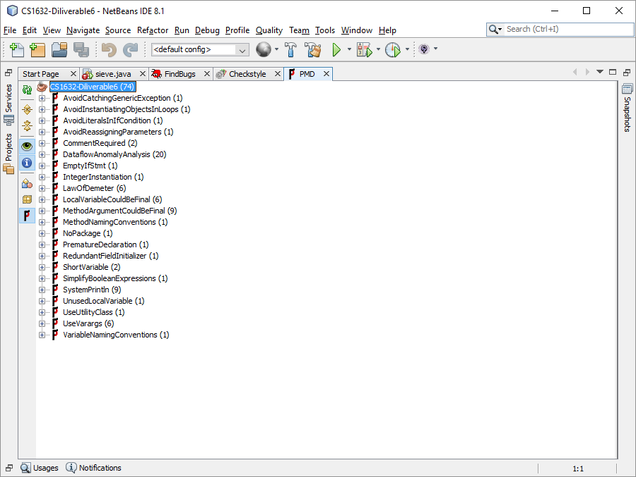

Comparison between changes