3.2.3 Deep-Learning Approaches
Deep learning (DL) is a subset of machine learning in which deeper network structures extract hierarchical features directly from the input data [4]. Traditional methods depend on the user’s knowledge of which features are relevant, whereas deep networks that take raw data as input made automatic feature extraction feasible by 2006; DL was first used for PD diagnosis in 2015, and the techniques most often used are deep belief networks, recurrent neural networks (RNNs), convolutional neural networks (CNNs) and stacked denoising auto-encoders [4]. Compared with the hand-crafted features of Section 3.2.2, DL can therefore reduce manual feature design. The approaches are reviewed here according to the input they use (Figure 6), because a model name alone does not say what data it learns from: a CNN is not necessarily trained on raw signals.
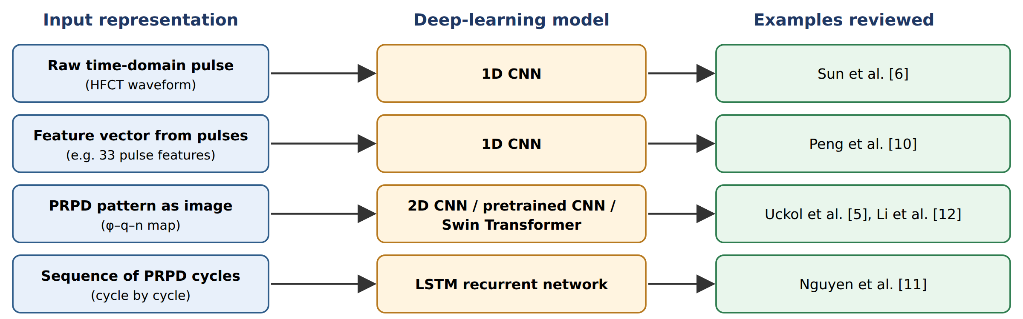
Figure 6. Deep-learning approaches grouped by input representation, with the cable and PD studies reviewed in this section (drawn by the authors).

3.2.3.1 Convolutional neural networks
A CNN performs feature extraction and classification together, without feature-engineering tools, which is why it is often described as a “black-box” model [4]. It consists of convolutional layers that extract features with learnable filters (kernels), activation layers that add nonlinearity, pooling layers that subsample the feature maps, and fully connected layers that perform the final classification [4]. Because neighbouring layers are locally connected and share weights, a CNN has far fewer parameters than a fully connected deep network, which reduces training complexity and the risk of overfitting [10]. In high-voltage applications, 1D CNNs are typically used for time-series waveforms and 2D CNNs for spectrograms or PRPD patterns [4]. Performance depends on hyperparameters such as the number of layers, kernel size, activation function and pooling method [4], [10], [5].
1D CNNs. Sun et al. fed single HFCT pulses (251 samples each) from four cable-terminal defect models directly into a 1D CNN with two convolutional, two pooling and one fully connected layer, without extracting characteristic parameters [6]. Peng et al. also used a CNN on cable PD, but its input was a vector of 33 features extracted from 3 500 PD pulses of five artificial defects in EPR cables [10]. Their final model had three convolutional layers, three pooling layers and one fully connected layer with a 1×4 kernel, the swish activation function and rank-based average pooling, chosen after comparing alternatives [10]. The two studies show that “CNN” covers both learning from raw waveforms [6] and learning from engineered features [10].
2D CNNs on PRPD images. Uckol et al. recorded PRPD patterns of five workmanship defects in 36 kV XLPE cable terminations for 30 s each and converted them into 64×64×3 RGB images, so that the CNN performed both feature extraction and classification [5]. Their network had four convolutional layers (32 to 256 filters), two pooling layers and three fully connected layers, with ReLU activation, average pooling, 3×3 kernels and stochastic gradient descent selected through tuning [5]. Pretrained image networks (AlexNet, VGG, ResNet, SqueezeNet, GoogleNet) were also tested on the same images, and the purpose-built CNN gave the highest overall accuracy and the shortest computation time [5].

3.2.3.2 Recurrent neural networks
RNNs process sequential data, updating a shared set of weights with each time step; standard RNNs suffer from vanishing gradients over long sequences, which the long short-term memory (LSTM) architecture addresses with additional internal states [4]. Nguyen et al. applied a two-layer LSTM to sequences of 60 PRPD power cycles measured with a UHF sensor in gas-insulated switchgear, with corona, floating, particle, void and noise classes, so that temporal dependencies were learned directly from the PRPD signals rather than from manually designed features [11]. The LSTM was slower to train and test than the ANN and SVM baselines because each step requires the output of the previous one [11]. A recurrent model is therefore justified when the order of the data carries information.

3.2.3.3 Auto-encoders and Transformers
An auto-encoder learns a compressed (latent) representation by training an encoder–decoder network to reconstruct its input; its feature-extraction stage can be pre-trained with unlabelled data, which is useful when labelled PD data are limited [4]. More recently, Transformer networks, which use self-attention to model dependencies across all positions of the input, have been applied to PRPD maps. Li et al. argued that CNNs capture only local image features and used a Swin Transformer, which computes attention within shifted windows to reduce computation, combined with a cosine-annealing learning rate [12]. Their dataset of 1 426 PRPD maps from a cable test platform with HFCT and UHF sensors contained corona, gas-gap, surface, suspended and no-PD classes [12]. (The neural “Transformer” should not be confused with power transformers, which appear in many PD paper titles.)

3.2.3.4 Reported performance
Table 4 summarises the deep-learning studies reviewed. In each study the DL model outperformed the baselines tested on the same data, but the margin varied from 1 percentage point [6] to 6.47 points [10], and the overall figures hide weaker classes: Peng et al. reached 80.87% and 85.42% on the two most similar defects (a protrusion and a floating protrusion) [10], and Nguyen et al. reached 79.54% on the floating class [11]. Computational cost also differs: the CNN of Peng et al. took 384.0 s to train against 6.3 s for a BPNN [10]; the purpose-built CNN of Uckol et al. took 485 s against 9 349 s for VGG-16 [5]; and the Swin Transformer of Li et al. required 4.5 GFLOPs against 15.49 GFLOPs for VGG16 [12]. Because the studies use different equipment, classes and data splits, the figures cannot be ranked against each other; the comparison of candidate methods for this project is made in Section 3.2.4.
Table 4. Deep-learning studies reviewed, with the baselines tested on the same data.
Study | Equipment and classes | Input | Model | Reported result | Baselines on same data
Peng et al. 2019 [10] | EPR cable, 5 artificial defects; HFCT | 33 features per pulse (3 500 pulses) | 1D CNN | 92.57% | SVM 87.81%, BPNN 86.10%
Uckol et al. 2021 [5] | 36 kV XLPE terminations, 5 workmanship defects | PRPD as 64×64×3 RGB image (1 200 patterns) | 2D CNN | 97.2% / 94.3% (tested on other cable set), 98.8% (mixed); overall 96.77% | AlexNet 95.90%, VGG-16 95.42%, ResNet-50 92.2% (overall)
Sun et al. 2024 [6] | Cable-terminal defect models, 4 classes; HFCT | Raw pulse, 251 samples (1 600 pulses) | 1D CNN | 95.8% | BPNN 94.8%, RBFNN 91.2%
Nguyen et al. 2018 [11] | GIS, UHF; corona, floating, particle, void, noise | Sequence of 60 PRPD cycles | LSTM (2 layers) | 96.74% (floating 79.54%) | ANN 93.01%, RBF-SVM 90.71%, linear SVM 88.63%
Li et al. 2025 [12] | Cable platform, HFCT + UHF; corona, gas gap, surface, suspended, no PD | PRPD map (1 426 maps) | Swin Transformer | 97.52% after 200 epochs | Original Swin; per-class accuracy comparable to ResNet and VGG16 at lower cost

3.2.3.5 Limitations and relevance to this project
Deep learning removes much of the manual feature design, but it needs large amounts of labelled data and is computationally intensive to train [4], its decisions are difficult to interpret [4], and its hyperparameters must still be tuned for each case [5]. In the reviewed studies, its advantage over well-designed traditional classifiers was sometimes small [6].
For this project, two deep-learning models match the data the HFCT system is expected to produce: a compact 1D CNN on raw HFCT pulses, following [6], and a compact 2D CNN on PRPD patterns, following [5], if a phase reference is available. An LSTM will be considered only if the order of the measured cycles is shown to add information, and one pretrained or Transformer model may be tested as an extension rather than as the starting point. All DL models will be compared with the SVM and random-forest baselines of Section 3.2.2 on the same data and split (Section 3.2.4).

References used in this section
[4] H. Kumar, M. Shafiq, K. Kauhaniemi, and M. Elmusrati, “A review on the classification of partial discharges in medium-voltage cables: detection, feature extraction, artificial intelligence-based classification, and optimization techniques,” Energies, vol. 17, no. 5, 1142, 2024. https://doi.org/10.3390/en17051142
[5] H. I. Uckol, S. Ilhan, and A. Ozdemir, “Workmanship defect classification in medium voltage cable terminations with convolutional neural network,” Electr. Power Syst. Res., vol. 194, 107105, 2021. https://doi.org/10.1016/j.epsr.2021.107105
[6] C. Sun et al., “Convolutional neural network-based pattern recognition of partial discharge in high-speed electric-multiple-unit cable termination,” Sensors, vol. 24, no. 8, 2660, 2024. https://doi.org/10.3390/s24082660
[10] X. Peng et al., “A convolutional neural network-based deep learning methodology for recognition of partial discharge patterns from high-voltage cables,” IEEE Trans. Power Del., vol. 34, no. 4, pp. 1460–1469, 2019. https://doi.org/10.1109/TPWRD.2019.2906086
[11] M.-T. Nguyen, V.-H. Nguyen, S.-J. Yun, and Y.-H. Kim, “Recurrent neural network for partial discharge diagnosis in gas-insulated switchgear,” Energies, vol. 11, no. 5, 1202, 2018. https://doi.org/10.3390/en11051202
[12] Y. Li et al., “Partial discharge pattern recognition based on Swin Transformer for power cable fault diagnosis in modern distribution systems,” Processes, vol. 13, no. 3, 852, 2025. https://doi.org/10.3390/pr13030852

