2.5.1 PD Classification Problem
According to IEC 60270, a partial discharge (PD) is a “localized electrical discharge that only partially bridges the insulation between conductors” [1]. PD is repetitive, intensifies existing insulation impairment and causes steady deterioration that ultimately leads to electrical breakdown [1]. Because there is a strong correlation between a PD pattern and the defect that produces it, the measured pattern can be used to identify the source [2]. PD pattern classification is therefore defined as the decision on which PD source a measured discharge pattern belongs to [2]. For many years this was done by eye, by expert inspection of PD patterns on the power-frequency ellipse of an oscilloscope, which made the result dependent on the knowledge and experience of experts [3]. The current trend is towards computer-aided classification [2].
Three related but different tasks must be kept separate. Detection answers whether PD activity is present in a measurement. Classification, the focus of this project, assigns the detected activity to a known defect or discharge type. Prediction of a discharge or failure before it occurs is a separate and harder objective that is outside the scope of this stage. The classifier also does not replace the measurement system: it interprets the measured data, and the final operational “go / no-go” decision on the equipment is based on knowledge of the danger of each defect and is usually made by people [3].

2.5.1.1 Formal definition of the task
Krivda defines the aim of classification as assigning a label (for example “treeing discharge” or “corona”) to a PD pattern of unknown origin using previously collected patterns with known labels [3]. This requires a database of labelled patterns and a partition of the feature space into regions, i.e., defined borders between the patterns of different PD sources [3]. Almost all PD classification algorithms consist of two essential steps: extraction of a feature vector (“fingerprint”) from the measured data, followed by a classification (recognition) step, and the two steps should be designed together [2]. In machine-learning terms, the task is supervised multi-class classification: an input x (a measured PD pattern or signal) is mapped to one label y from a predefined set of defect classes, using a model learned from a labelled dataset. Figure 1 places the problem within the complete diagnostic chain.
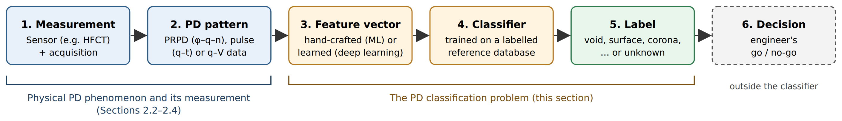
Figure 1. The PD classification problem within the diagnostic chain (drawn by the authors, after the recognition procedure of Krivda [3] and the two-step structure described by Sahoo et al. [2]).
When an unknown pattern is placed in the feature space of two known defects, four outcomes are possible (Figure 2): it is assigned to defect A, to defect B, to neither, or, where the two classes overlap, to both [3]. Overlap occurs when features are badly designed or when there is genuinely no difference between the patterns from which the features were extracted [3]. The “neither” case is important in practice: Gulski and Krivda found that neural networks recognised the defects they were trained on well, but PD patterns for which the networks were not trained might wrongly be recognised as one of the known patterns [5]. A practical classifier should therefore be able to report an unknown or uncertain result rather than force every input into a trained class.
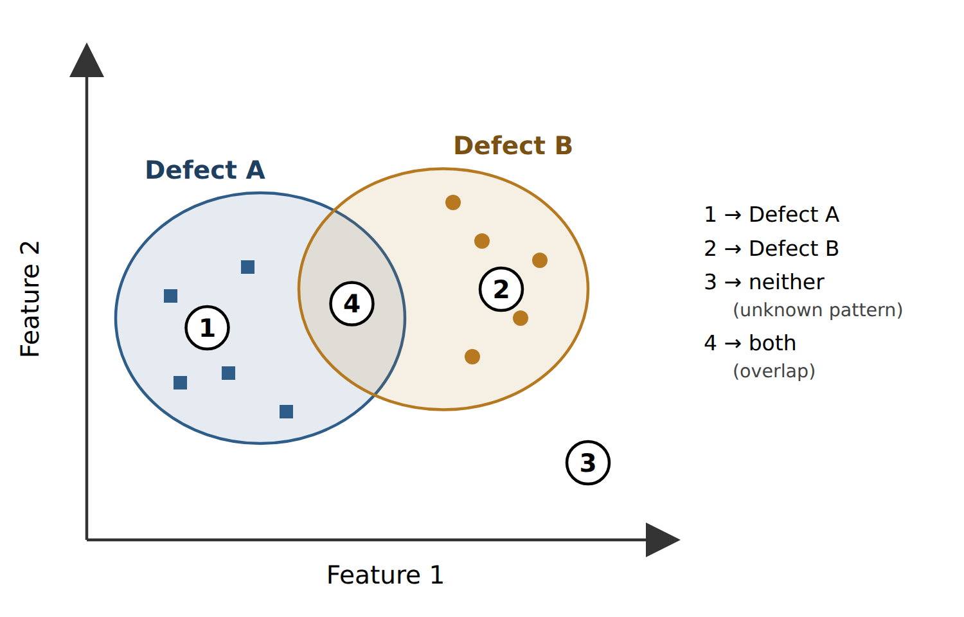
Figure 2. Possible outcomes when a pattern of unknown origin is classified against two known defects (redrawn by the authors after Krivda [3], Fig. 6).

2.5.1.2 Classes of PD in power cables
In power cables, PD is commonly categorised into three types, which do not pose an equally detrimental effect on the insulation [4]: internal discharges, which occur in voids or cavities inside solid or liquid insulation and are considered the most dangerous because they develop inside the insulation and can cause irreversible damage; surface discharges, which occur along the insulation surface when the tangential field is high, for example due to contamination or moisture; and corona discharges, produced at sharp points or edges of conductors in air, which are not typically regarded as hazardous [4]. Figure 3 shows laboratory examples of the three defect types. A void or cavity is one physical form of internal discharge, so “void” and “internal PD” describe the same class rather than two separate classes.
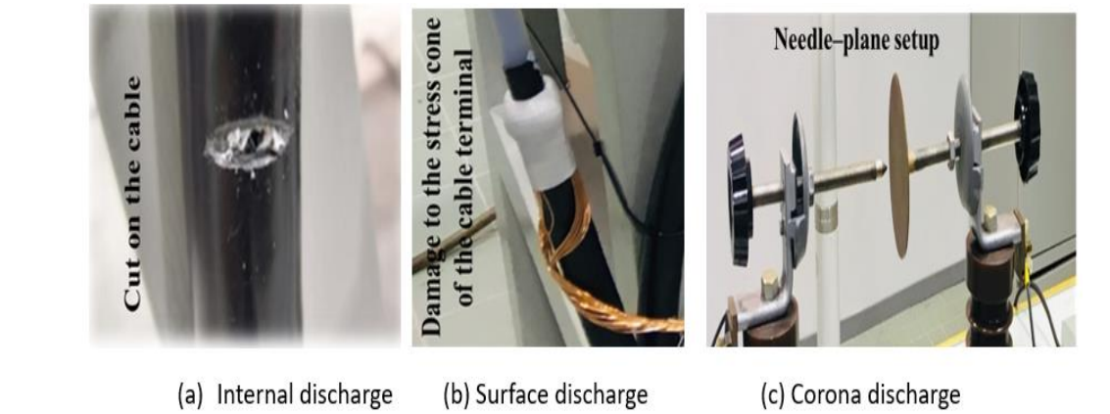
Figure 3. Laboratory defects producing (a) internal, (b) surface and (c) corona discharge. Reproduced from Kumar et al. [4], Fig. 1, under the CC BY 4.0 licence.
Published cable studies define their classes through artificially prepared defects, and the label set differs from study to study (Table 1). For example, Uckol et al. generated five workmanship defects in 36 kV XLPE cable terminations according to field experience [6], while Sun et al. built four electrode models (tip, surface, air-gap and suspension discharge) to represent cable-terminal defects [7]. Qin et al. noted that cable defects arise from multiple factors and therefore studied four composite defects [8]. The class list is therefore a design decision of each project. Following the PD types highlighted by the supervisors and the three-type categorisation of Kumar et al. [4], this project adopts four classes: (1) internal PD, including void or cavity discharge; (2) surface PD; (3) corona; and (4) noise / no PD, i.e., background recordings without an active defect. The fourth class is included because separating PD from interference is itself part of the classification task [9].
Table 1. Examples of how the PD classification problem is defined in recent cable studies.
Study | Object and insulation | Classes (labels) | Sensor / detector | Model input | Data size
Uckol et al. 2021 [6] | 36 kV XLPE cable terminations, 4 m samples | 5 workmanship defects: protrusion (3 mm needle), stress-control-tube misplacement, void (0.5 mm), corona at cable lug, irregular semi-conductive edges | OMICRON MPD600 (IEC 60270) | PRPD pattern (30 s, 1 500 cycles) converted to 64×64×3 RGB image | 1 200 PRPD patterns from two cable sets
Sun et al. 2024 [7] | Electrode models of EMU cable-terminal defects (EPDM film) | 4: tip, surface, air-gap, suspension (floating) discharge | HFCT + high-frequency oscilloscope | Single time-domain pulse, 251 samples | 1 600 signals (400 per class)
Raymond et al. 2017 [1] | Five 11 kV XLPE cable joints, 3 m samples | 5: insulation incision, axial shift, semiconductor tip, metal particle, semiconductor air gap | OMICRON MPD600, tested at 9 kV | Statistical, fractal and PCA features of PRPD patterns | 100 one-minute measurements per joint
Qin et al. 2024 [8] | 10 kV XLPE cable | 4 composite defects combining scratch, water ingress and metal impurities | HFCT (100 kHz–30 MHz) + oscilloscope | 5 entropy features after VMD of each pulse | 2 400 samples (600 per class)
Peng et al. 2019 [9] | Defects created in an HV cable | PD versus interference pulses | — | 34 pulse features, plus 119 2-D and 1 082 3-D features | 3 500 PD + 3 500 interference pulses

2.5.1.3 Input data for classification
Digital PD detectors provide three categories of pulse data [2]: (i) phase-resolved data, i.e., the three-dimensional φ–q–n pattern (discharge phase φ, charge q and discharge rate n) and its two-dimensional projections; (ii) time-resolved data (q–t), the individual pulse shapes over an interval of time; and (iii) data with neither phase nor time information, such as the variation of pulse magnitude with test voltage (q–V). Phase-resolved data contain no information on the true shape of the pulses, whereas time-resolved data show the true pulse shape, which is directly related to the physics of the defect, requires less expensive instrumentation, and changes distinctly as the insulation ages [2]. Figures 4 and 5 show one example of each representation, measured on cable defects.
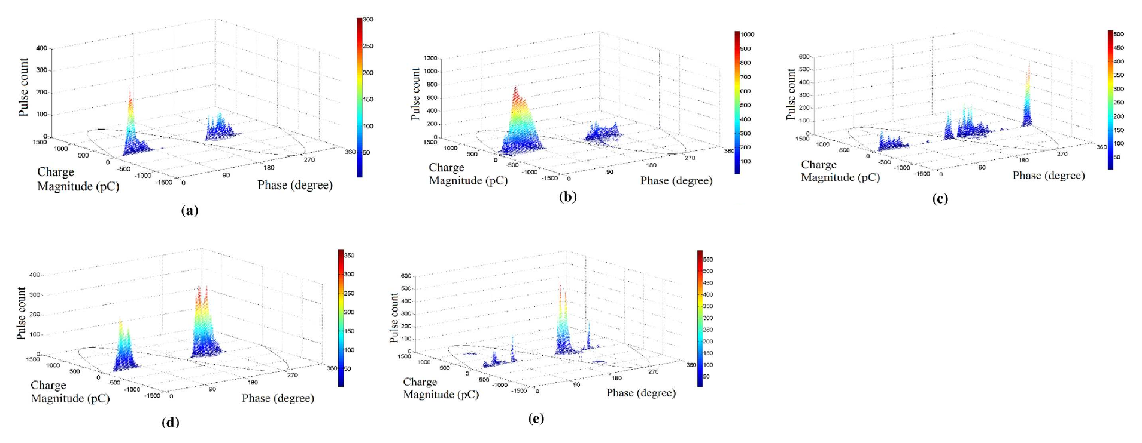
Figure 4. Phase-resolved (PRPD) patterns of five XLPE cable-joint defects: (a) insulation incision, (b) axial direction shift, (c) semiconductor layer tip, (d) metal particle on XLPE, (e) semiconductor layer air gap. Rearranged from Raymond et al. [1], Fig. 3, under the CC BY 4.0 licence.
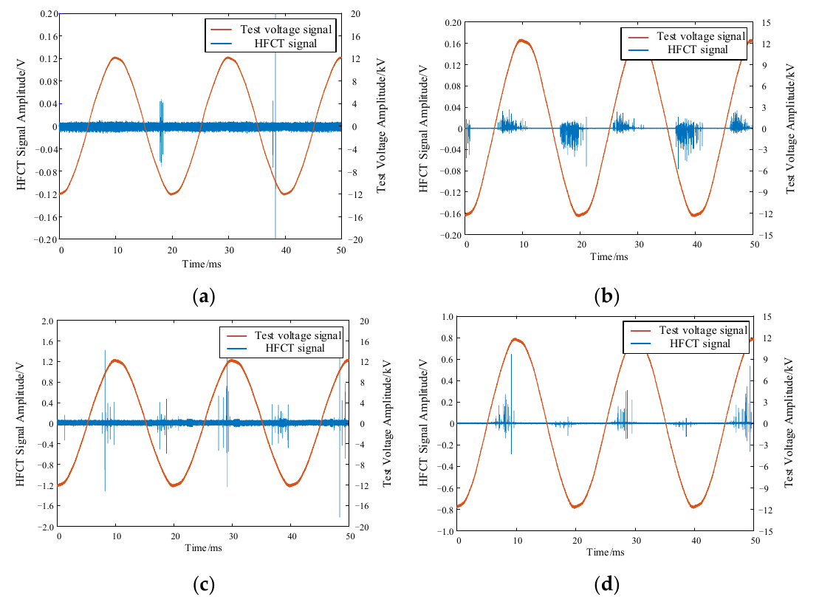
Figure 5. Time-domain HFCT signals (blue) and test voltage (red) for (a) tip, (b) surface, (c) air-gap and (d) suspended discharge. Reproduced from Sun et al. [7], Fig. 4, under the CC BY 4.0 licence.
The chosen representation shapes the rest of the problem. Uckol et al. converted PRPD patterns into RGB images so that a convolutional neural network performed both feature extraction and classification [6], whereas Sun et al. fed the measured discharge signals directly into a CNN without extracting characteristic parameters [7]. PRPD patterns are effective when the PD source is associated with one degradation process and the noise level is low compared with the PD magnitude [4]. The choice between waveform and PRPD input therefore depends on the data that the available measurement system can export, and is examined further in Sections 2.4.2 and 2.5.3.

2.5.1.4 Why PD classification is difficult
Limited success has been achieved in identifying simple PD sources, but the recognition of complex PD patterns from practical insulation systems still poses appreciable difficulty [2]. The main reasons reported in the literature are summarised below and in Table 2.
- Simultaneous sources. In practice it is very difficult to capture a single type of source; PRPD patterns are usually complex because several sources act together, and high-amplitude noise pulses can mask other sources, so identification from PRPD plots becomes nearly impossible for an operator or an automated system [4]. Figure 6 shows one power cycle at 10.5 kV in which three source types may be active at once [4]. Early work dealt mostly with single sources, and Krivda identified the recognition of multiple sources, and of the most dangerous among them, as a future requirement [3].
- Noise and interference. White noise, pulse-type (repetitive or random) noise and sinusoidal noise are commonly encountered and can mask the true PD signal, especially during online measurement [4]. Distinguishing PD from interference is itself a classification task: Peng et al. extracted 3 500 interference pulses alongside 3 500 PD pulses [9]. Raymond et al. trained classifiers on noise-free data from XLPE joints and tested them with real ground-interference noise (up to 250 pC, at random phase): the best combination, PCA features with an SVM, fell from 93.6% with 5 s of noise to 75.6% with 60 s, and an SVM using statistical features fell from 91.6% to 48.2% [1].
- Variability of the patterns. Discharge patterns change with the test voltage level, the availability of starting electrons and PD-induced ageing, and a database that covers all of these variations is very difficult to build [3].
- Amount of labelled data. The number of fingerprints for each class should be approximately 5 to 20 times the number of features (the “curse of dimensionality”) [3]. Sun et al. found that the accuracy of their CNN rose from 73.6% when 20% of the data were used for training to 98.7% with 90% [7].
- Generalisation to new specimens. Uckol et al. recorded the same five defects on two separate cable sets. Training on one set and testing on the other gave 97.2% and 94.3%, compared with 98.8% when both sets were mixed; in the harder case, 21.7% of the void patterns (26 of 120) were misclassified, all of them as irregular semi-conductive edges [6].
- Unknown defect types. Classifiers may wrongly assign a pattern they were never trained on to one of the known classes [5].
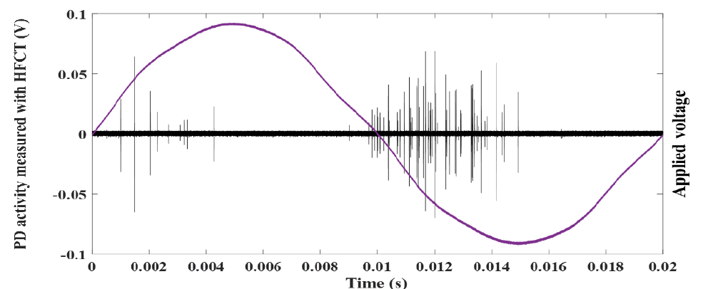
Figure 6. PD activity measured with an HFCT over one 20 ms power cycle at 10.5 kV, with internal, surface and corona sources possibly active simultaneously. Reproduced from Kumar et al. [4], Fig. 4, under the CC BY 4.0 licence.
Table 2. Main difficulties of PD classification with quantitative evidence from the reviewed studies.
Difficulty | Evidence | Source
Noise and interference | SVM with PCA features: 93.6% (5 s noise) → 75.6% (60 s noise); SVM with statistical features: 91.6% → 48.2% | Raymond et al. [1]
Earlier noise studies | ANN accuracy fell from 79% (noise-free) to 42.2% with 10% added noise, as summarised by the authors | Raymond et al. [1]
Generalisation to a new cable set | 97.2% and 94.3% when tested on the other cable set vs 98.8% on a mixed split; 21.7% of void patterns misclassified in the harder case | Uckol et al. [6]
Amount of training data | 73.6% (20% training data) → 98.7% (90% training data) | Sun et al. [7]
Data required per class | Approximately 5–20 fingerprints per feature | Krivda [3]
Early statistical methods | 70–80% success rate for GIS faults and noise identification, as reported in the survey | Sahoo et al. [2]

2.5.1.5 Implications for this project
Based on this review, the project treats PD classification as a supervised, multi-class problem in which each measured record is assigned to one of four classes: internal PD (void/cavity), surface PD, corona, or noise / no PD. In addition, the classifier will be allowed to return an “unknown” result when its confidence is low, so that patterns unlike any trained class are not forced into one of them (Figure 2, outcome 3) [3], [5]. The task is limited to classifying existing PD activity; detecting PD, predicting failure and locating defects are related but separate objectives. Three points from the literature shape the planned work. First, the class list and the input representation (time-domain waveform, PRPD pattern, or both) must be fixed together with the measurement system, because each representation keeps different information [2]. Second, noise and the possibility of simultaneous sources mean that the classifier should be tested on noisy data, including real background recordings [1], [4]. Third, because results on a single specimen can overstate performance on new specimens [6], the dataset will record which specimen and session every measurement comes from, so that training and test data can be kept separate.

References
[1] W. J. K. Raymond, H. A. Illias, and A. H. A. Bakar, “Classification of partial discharge measured under different levels of noise contamination,” PLOS ONE, vol. 12, no. 1, e0170111, 2017. https://doi.org/10.1371/journal.pone.0170111
[2] N. C. Sahoo, M. M. A. Salama, and R. Bartnikas, “Trends in partial discharge pattern classification: a survey,” IEEE Trans. Dielectr. Electr. Insul., vol. 12, no. 2, pp. 248–264, 2005. https://doi.org/10.1109/TDEI.2005.1430395
[3] A. Krivda, “Automated recognition of partial discharges,” IEEE Trans. Dielectr. Electr. Insul., vol. 2, no. 5, pp. 796–821, 1995. https://doi.org/10.1109/94.469976
[4] H. Kumar, M. Shafiq, K. Kauhaniemi, and M. Elmusrati, “A review on the classification of partial discharges in medium-voltage cables: detection, feature extraction, artificial intelligence-based classification, and optimization techniques,” Energies, vol. 17, no. 5, 1142, 2024. https://doi.org/10.3390/en17051142
[5] E. Gulski and A. Krivda, “Neural networks as a tool for recognition of partial discharges,” IEEE Trans. Electr. Insul., vol. 28, no. 6, pp. 984–1001, 1993. https://doi.org/10.1109/14.249372
[6] H. I. Uckol, S. Ilhan, and A. Ozdemir, “Workmanship defect classification in medium voltage cable terminations with convolutional neural network,” Electr. Power Syst. Res., vol. 194, 107105, 2021. https://doi.org/10.1016/j.epsr.2021.107105
[7] C. Sun et al., “Convolutional neural network-based pattern recognition of partial discharge in high-speed electric-multiple-unit cable termination,” Sensors, vol. 24, no. 8, 2660, 2024. https://doi.org/10.3390/s24082660
[8] C. Qin et al., “Partial discharge signal pattern recognition of composite insulation defects in cross-linked polyethylene cables,” Sensors, vol. 24, no. 11, 3460, 2024. https://doi.org/10.3390/s24113460
[9] X. Peng et al., “Random forest based optimal feature selection for partial discharge pattern recognition in HV cables,” IEEE Trans. Power Del., vol. 34, no. 4, pp. 1715–1724, 2019. https://doi.org/10.1109/TPWRD.2019.2918316

