Literature Review – Section Ownership and Handover Notes
This note keeps the progress-report literature review from repeating itself. Section 2.5 (ML and DL for PD classification) is drafted; material that belongs to other sections was removed from it and is collected below, with its sources, so the owners of Sections 2.2–2.4 can use it. Each topic should be written in full in one section only; other sections refer to it by number.

1. Who covers what
Topic | Write it in full in | Other sections only refer to it
Definition of PD (IEC 60270), why PD matters | 2.2.1 | 2.5.1
Physics of internal, surface and corona discharge; their severity | 2.2.2 | 2.5.1 (uses them only as class labels)
Sensors and measurement (HFCT, UHF, IEC 60270 method) | 2.2.3 | 2.5.1, 2.5.2
Noise types and measurement challenges | 2.2.4 | 2.5.1 (one sentence)
XLPE insulation; defects in cables, joints and terminations | 2.3.1, 2.3.2 | 2.5.1 (Table 1 lists defects used as classes)
History of PD diagnosis (expert by eye, conventional methods) | 2.4.1 | 2.5.1 (one sentence)
PRPD / TRPD / q–V representations and their example figures | 2.4.2 | 2.5.1.3 (only how the choice affects the classifier)
Signal processing: denoising, FFT, STFT, wavelets, time-domain features | 2.4.3 | 2.5.2.1 (only which features feed the classifiers)
Public PD datasets | 2.4.4 | 2.5.4 / 2.5.5
Data challenges: labelling, imbalance, small data, leakage | 2.4.5 | 2.5.5 (effect on model performance only)
Classification problem, class list, unknown output | 2.5.1 | —
Statistical operators, ANN, SVM, RF and their results | 2.5.2 | 2.5.4
Noise robustness numbers, generalisation to new specimens, effect of dataset size | 2.5.5 | 2.5.1, 2.5.2 (refer only)
Already written in 2.5 – please do not repeat: the detection / classification / prediction distinction; Krivda's four classification outcomes; the four project classes (internal PD incl. void, surface PD, corona, noise / no PD); Table 1 of class definitions in cable studies; the statistical operators table (Sk, Ku, Pe, cc, Q, mcc); ANN and SVM principles.

2. Material for Section 2.2.1 (PD fundamentals)
- IEC 60270 definition, as quoted in Raymond et al. (p. 2): PD is a “localized electrical discharge that only partially bridges the insulation between conductors”. PD is repetitive, intensifies existing insulation impairment and causes steady deterioration that ultimately leads to electrical breakdown (p. 2).
Source: W. J. K. Raymond, H. A. Illias, and A. H. A. Bakar, “Classification of partial discharge measured under different levels of noise contamination,” PLOS ONE, vol. 12, no. 1, e0170111, 2017. https://doi.org/10.1371/journal.pone.0170111

3. Material for Section 2.2.2 (types of PD)
- Kumar et al. (p. 2): PDs in power cables are categorised as surface, internal and corona discharges, which do not have an equally detrimental effect on insulation. Internal PDs occur in voids inside solid or liquid insulation and are considered the most dangerous, since they develop inside the insulation and can cause irreversible damage. Surface PDs occur along the insulation surface when the tangential field is high, e.g. due to non-uniform contamination or moisture. Corona discharges occur at sharp points of conductors in air and are not typically regarded as hazardous.
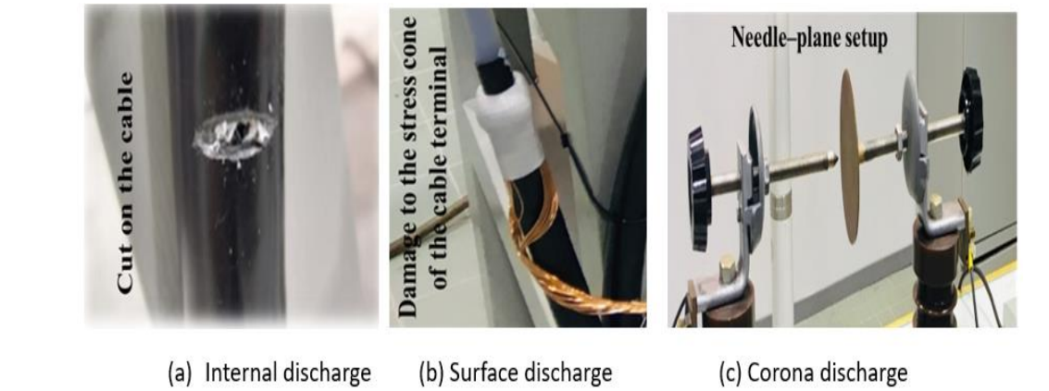
Suggested figure: laboratory defects producing (a) internal, (b) surface and (c) corona discharge. Reproduced from Kumar et al., Fig. 1, under the CC BY 4.0 licence.
Source: H. Kumar, M. Shafiq, K. Kauhaniemi, and M. Elmusrati, “A review on the classification of partial discharges in medium-voltage cables: detection, feature extraction, artificial intelligence-based classification, and optimization techniques,” Energies, vol. 17, no. 5, 1142, 2024. https://doi.org/10.3390/en17051142

4. Material for Section 2.2.4 (measurement challenges)
- Kumar et al. (p. 12): white noise, pulse-type (repetitive or random) noise and sinusoidal noise are the three types commonly encountered in PD measurement; high-level noise, especially online, can mask the true PD signal, and denoising is needed before PD characteristics can be evaluated.

5. Material for Section 2.4.2 (data and signal representations)
- Sahoo et al. (p. 248–249): digital PD detectors provide three categories of data: phase-resolved (φ–q–n and its 2-D projections), time-resolved (q–t, the individual pulse shapes) and data without phase or time information (q–V). Phase-resolved data contain no information on true pulse shape; time-resolved data show the true pulse shape, which is directly related to the physics of the defect, require less expensive instrumentation, and change distinctly with ageing.
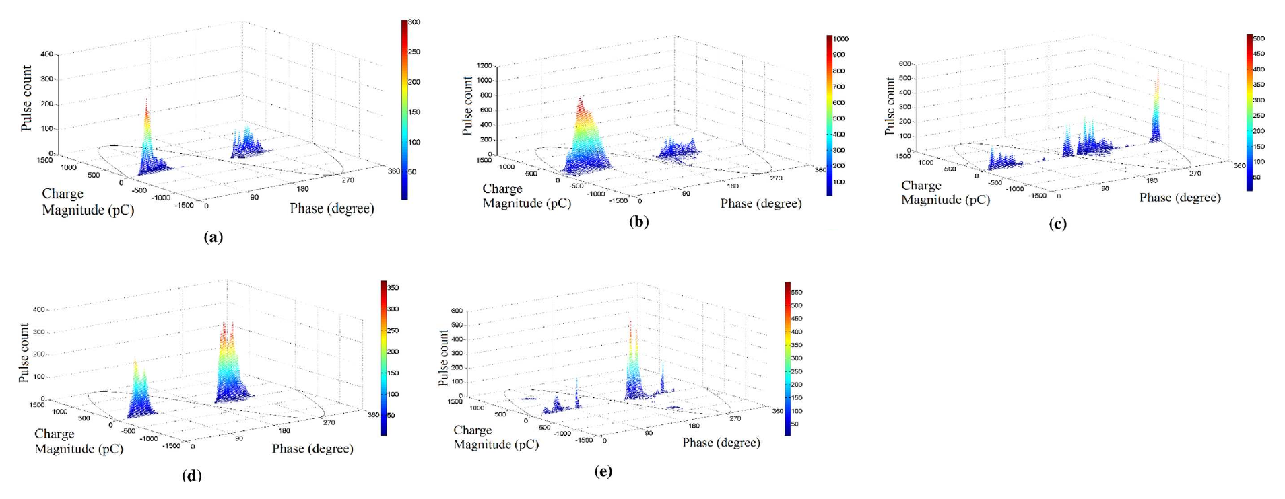
Suggested figure (PRPD): patterns of five XLPE cable-joint defects (a) insulation incision, (b) axial direction shift, (c) semiconductor layer tip, (d) metal particle on XLPE, (e) semiconductor layer air gap. Rearranged from Raymond et al., Fig. 3, CC BY 4.0.
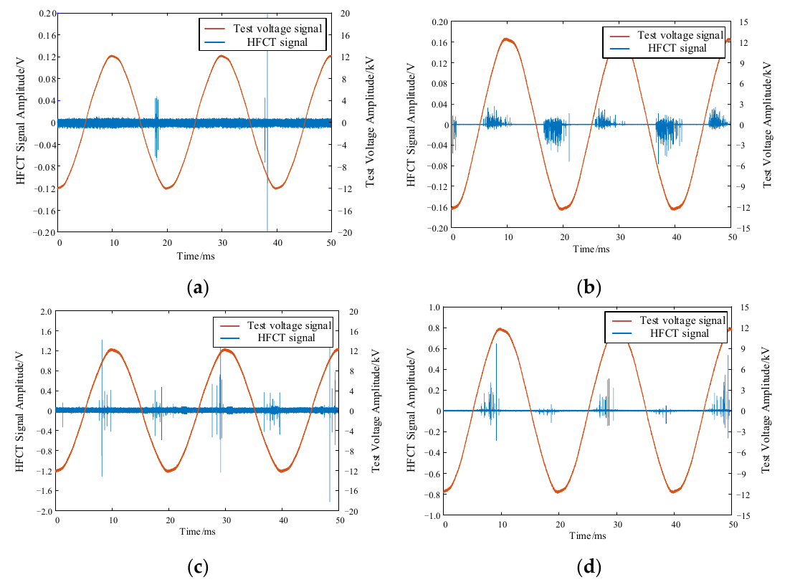
Suggested figure (time-resolved): HFCT signals and test voltage for (a) tip, (b) surface, (c) air-gap and (d) suspended discharge. Reproduced from Sun et al., Fig. 4, CC BY 4.0.
Sources: N. C. Sahoo, M. M. A. Salama, and R. Bartnikas, “Trends in partial discharge pattern classification: a survey,” IEEE Trans. Dielectr. Electr. Insul., vol. 12, no. 2, pp. 248–264, 2005. https://doi.org/10.1109/TDEI.2005.1430395 | W. J. K. Raymond, H. A. Illias, and A. H. A. Bakar, “Classification of partial discharge measured under different levels of noise contamination,” PLOS ONE, vol. 12, no. 1, e0170111, 2017. https://doi.org/10.1371/journal.pone.0170111 | C. Sun et al., “Convolutional neural network-based pattern recognition of partial discharge in high-speed electric-multiple-unit cable termination,” Sensors, vol. 24, no. 8, 2660, 2024. https://doi.org/10.3390/s24082660

6. Material for Section 2.4.3 (signal processing and feature extraction)
- Kumar et al. (p. 12): time-domain features taken directly from TRPD data include peak-to-peak intervals, zero-crossings, mean, maximum and minimum amplitudes and number of peaks, plus moments such as variance, skewness, kurtosis and RMS; general features (average discharge current, number of pulses, repetition rate, pulse charge) and pulse-specific features (pulse width, rise and decay times). These are linked to the noise-affected pulse peak value, and thresholding gives less precise classification.
- Kumar et al. (pp. 13–14): the Fourier transform loses time information; the FFT is efficient but unsuited to time-varying signals; the STFT adds time localisation but has a fixed time–frequency window; the wavelet transform analyses signals in time and frequency simultaneously.
Suggested table (adapted from Kumar et al., Table 3).
Technique | Advantages | Disadvantages
PRPD | Very effective for analysing repetitive PD patterns; provides temporal discharge information | Limited to signals with repetitive patterns; may not capture the frequency content of the signal
FFT | Computationally efficient; gives information on repetitive patterns and frequency content | No temporal information on the frequency components; may be unsuitable for non-stationary signals
DWT | Time–frequency localisation; suitable for non-stationary signals; provides high- and low-frequency components | More computationally intensive than the FFT; results depend on the choice of wavelet and decomposition level

7. Reserved for Section 2.5.5 (do not use elsewhere)
- Raymond et al.: noise-tolerance results (e.g. PCA + SVM 93.6% → 75.6% from 5 s to 60 s of noise) and Fig. 5 noise-tolerance curves.
- Uckol et al.: training on one cable set and testing on the other (97.2% and 94.3%) versus a mixed split (98.8%).
- Sun et al.: accuracy against training-data size (73.6% at 20% → 98.7% at 90%).

