2.5.2 Traditional Machine-Learning Approaches
Traditional (conventional) machine learning for PD relies on hand-crafted features. Statistical, fractal, time-domain, frequency-domain and other features are first extracted from the measured data, often with the help of signal-processing tools such as the discrete wavelet transform (DWT), and are then classified with algorithms such as artificial neural networks (ANNs), support vector machines (SVMs) and fuzzy inference systems [4]. This follows the two-step structure of Section 2.5.1: extraction of a feature vector, followed by classification [1]. A key requirement is a correctly labelled training set containing a representative number of samples from each class, with the class of every training sample determined by an expert [4].

2.5.2.1 Feature inputs
The signal-processing methods used to obtain features (time-, frequency- and wavelet-domain analysis and denoising) are covered in Section 2.4.3; this section focuses on the features that traditional classifiers take as input. For phase-resolved data, Gulski and Krivda described the shape of the distributions with a set of 15 statistical operators computed from the mean pulse-height distribution Hqn(φ) and the pulse-count distribution Hn(φ), each split into the positive and negative half-cycles of the test voltage [3]. Table 2 summarises the main operators. Other phase-resolved descriptors include fractal features (fractal dimension and lacunarity) that treat the 3-D PRPD pattern as a fractal surface [1], and features obtained by principal component analysis (PCA) [8]. For time-resolved pulses, classifiers typically use amplitude, timing and pulse-shape parameters, statistical moments, and frequency- or wavelet-domain descriptors [4].
Table 2. Main statistical operators used to describe phase-resolved PD distributions [3].
Operator | What it describes | Interpretation
Skewness (Sk) | Asymmetry of a distribution relative to a normal distribution | Sk = 0: symmetric; Sk > 0: asymmetric to the left; Sk < 0: asymmetric to the right
Kurtosis (Ku) | Sharpness of a distribution relative to a normal distribution | Ku = 0: normal; Ku > 0: sharp; Ku < 0: flat
Number of peaks (Pe) | Number of local tops in the distribution | Separates single-top distributions from bimodal or multi-peak ones
Cross-correlation factor (cc) | Difference in shape between the positive and negative half-cycle distributions | cc = 1: identical shape; cc = 0: total asymmetry
Discharge factor (Q) | Difference in mean discharge level between the two half-cycles | Q = 1: equal levels; Q = 0: total difference
Modified cross-correlation (mcc) | Combined shape and level difference | mcc = Q · cc
The choice of feature family affects the classifier. Statistical parameters allow large PD datasets to be processed quickly but can be affected by noise; signal- and image-processing features are precise but costly and need high-quality signals; and fractal features are unaffected by signal shifting, rotation and scaling but are hard to tune [4]. Most of these techniques still require a skilled operator to verify the computational parameters [4].
Feature selection. Because many candidate features can be extracted, feature selection is often needed. Peng et al. extracted 34 PD features from 3 500 PD pulses and 3 500 interference pulses recorded from defects created in a cable, generated a further 119 two-dimensional and 1 082 three-dimensional features, and used a random-forest (RF) algorithm to select the optimal features; the selected features were evaluated with a back-propagation neural network (BPNN) and an SVM, and the method was reported to be effective [9]. Feature selection matters because the amount of data required grows with the number of features (approximately 5–20 fingerprints per feature) [2].

2.5.2.2 Classifiers
Artificial neural networks. Neural networks were among the first automated PD classifiers. Gulski and Krivda fed the 15 statistical operators into three networks, a back-propagation network, a Kohonen self-organising map and a learning vector quantisation network, using PD measured with a conventional detector of 40–400 kHz bandwidth [3]. All networks recognised trained defects well; with twelve defect types the back-propagation network showed the best ability to learn, and the results were only slightly dependent on the number of processing elements, learning cycles and convergence criterion [3]. Training took about 3 min for two defects and from 30 min to 3 h for twelve defects [3].
In PD analysis a three-layer, fully connected network that maps a feature vector to one of the PD classes is frequently used, and feed-forward back-propagation is the most widely used learning mode [4]. ANNs learn from examples, are insensitive to slight changes in the input data, and can identify a fault within seconds once trained offline [4]. Their limitations include overtraining, the small number of real PD examples available, and slower identification when several errors or noise sources are present [4]. Kumar et al. also note that three-layer networks are significantly less effective than classifiers such as random forests or SVMs and need a lot of data and time to train [4].
Support vector machines. An SVM separates two classes with a decision boundary (hyperplane) chosen to maximise the margin, the distance between the hyperplane and the closest data points, which are called support vectors (Figure 4) [4]. When classes overlap, a soft-margin SVM tolerates some misclassified points, and a kernel trick maps the data into a space where they can be separated linearly; the regularisation parameter C controls the trade-off between a wide margin and training errors, which helps to prevent overfitting on noisy measurements [4]. Unlike ANNs, SVMs do not require the number of layers or neurons to be chosen in advance, and PD classification with SVMs has generally produced better results than other classifiers, including neural networks [4].
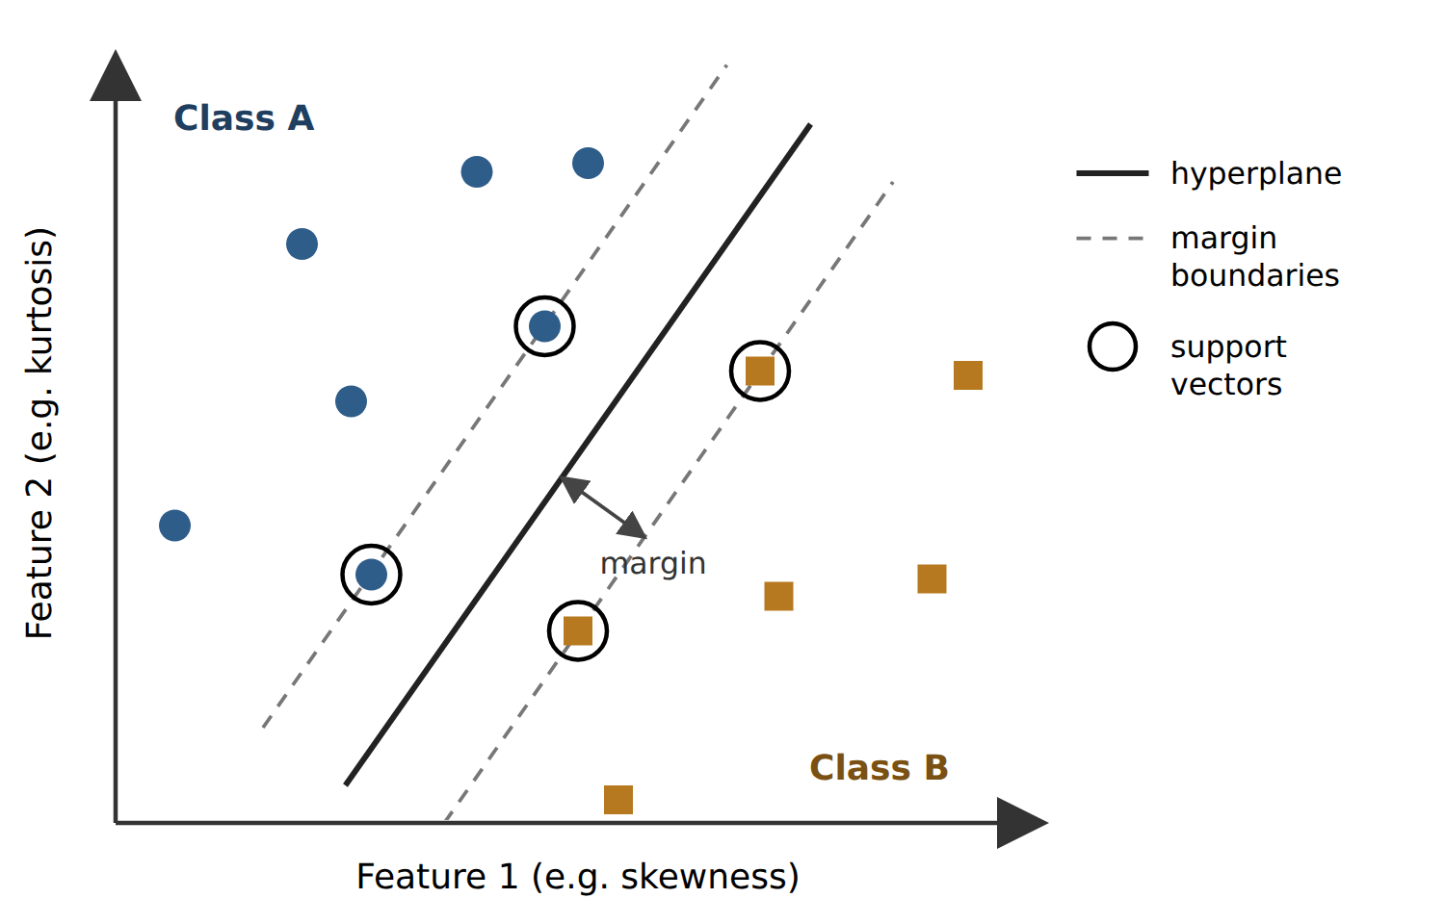
Figure 4. Principle of a support vector machine for two PD classes (drawn by the authors from the description in Kumar et al. [4]).
Other classifiers. Earlier work also used minimum-distance and nearest-neighbour classifiers, Bayes classifiers and fuzzy-logic classifiers [1], and adaptive neuro-fuzzy inference systems (ANFIS) [8]. Random forests, decision trees and logistic regression are further common machine-learning algorithms [4], and random forests have also been used for feature selection [9].

2.5.2.3 Reported performance
Table 3 summarises results reported by studies that used traditional classifiers on cable or cable-accessory defects. The values come from different datasets, class definitions and train/test splits, so they show what each method achieved in its own study and cannot be ranked directly against each other. All values in Table 3 were obtained on laboratory data without added noise; robustness to noise and generalisation are examined in Section 2.5.5.
Table 3. Results of traditional classifiers reported in the reviewed studies.
Study | Data and classes | Features | Classifiers and reported result
Raymond et al. 2017 [8] | 5 artificial defects in 11 kV XLPE cable joints; 100 PRPD measurements per joint | Statistical, fractal, PCA | Best feature set for each classifier: SVM 98.8%, ANFIS 97.0%, ANN 93.2%
Qin et al. 2024 [7] | 4 composite defects in 10 kV XLPE cable; 2 400 samples | 5 entropy features after VMD | Snake-optimised SVM 97.29%, GA-BP 88.78%, SVM 84.52%, BP 84.02%
Sun et al. 2024 [6] | 4 cable-terminal defect models; 1 600 HFCT pulses | Raw pulse (251 samples) | BPNN 94.8%, RBFNN 91.2% (CNN 95.8% on the same data)
Peng et al. 2019 [9] | 3 500 PD and 3 500 interference pulses from cable defects | 34 pulse features + 2-D/3-D features, RF selection | BPNN and SVM; RF-based selection reported as effective
Gulski and Krivda 1993 [3] | 12 artificial defect types (e.g. cavities, surface discharge, corona, treeing) | 15 statistical operators | BP, Kohonen and LVQ networks recognised trained defects; untrained patterns misclassified

2.5.2.4 Strengths, limitations and relevance to this project
- Strengths. The features have a physical meaning that engineers can interpret (Table 2), the classifiers can reach high accuracy on clean laboratory data (up to 98.8% in [8] and 97.29% in [7]), and training is fast: the SVM trained fastest in [8], and its training time was not directly affected by feature size. Traditional classifiers can also be competitive with deep learning on the same data: the BPNN in [6] reached 94.8% against 95.8% for the CNN.
- Dependence on feature design. Performance depends on which features are chosen and on expert knowledge to set and verify them [4].
- Sensitivity to noise. High accuracy on clean data is not maintained when noise is present, and the best features on clean data are not necessarily the most robust [8]; this is quantified in Section 2.5.5.
- Sensitivity to tuning. Optimising the SVM parameters raised the average accuracy from 84.52% to 97.29%, a gain of 12.77 percentage points on the same features [7].
- Data, training and unknown patterns. ANNs need sufficient real examples and can overtrain [4], and classifiers trained on known defects may assign untrained patterns to a known class [3].
For this project, traditional machine learning will provide the baseline against which the deep-learning models are judged (Section 2.5.4). An SVM and a random forest will be trained on hand-crafted features for the four classes defined in Section 2.5.1, using the same data and the same train/test split as the deep-learning models. The dependence of these methods on manual feature design motivates the deep-learning approaches reviewed in Section 2.5.3.

References
[1] N. C. Sahoo, M. M. A. Salama, and R. Bartnikas, “Trends in partial discharge pattern classification: a survey,” IEEE Trans. Dielectr. Electr. Insul., vol. 12, no. 2, pp. 248–264, 2005. https://doi.org/10.1109/TDEI.2005.1430395
[2] A. Krivda, “Automated recognition of partial discharges,” IEEE Trans. Dielectr. Electr. Insul., vol. 2, no. 5, pp. 796–821, 1995. https://doi.org/10.1109/94.469976
[3] E. Gulski and A. Krivda, “Neural networks as a tool for recognition of partial discharges,” IEEE Trans. Electr. Insul., vol. 28, no. 6, pp. 984–1001, 1993. https://doi.org/10.1109/14.249372
[4] H. Kumar, M. Shafiq, K. Kauhaniemi, and M. Elmusrati, “A review on the classification of partial discharges in medium-voltage cables: detection, feature extraction, artificial intelligence-based classification, and optimization techniques,” Energies, vol. 17, no. 5, 1142, 2024. https://doi.org/10.3390/en17051142
[6] C. Sun et al., “Convolutional neural network-based pattern recognition of partial discharge in high-speed electric-multiple-unit cable termination,” Sensors, vol. 24, no. 8, 2660, 2024. https://doi.org/10.3390/s24082660
[7] C. Qin et al., “Partial discharge signal pattern recognition of composite insulation defects in cross-linked polyethylene cables,” Sensors, vol. 24, no. 11, 3460, 2024. https://doi.org/10.3390/s24113460
[8] W. J. K. Raymond, H. A. Illias, and A. H. A. Bakar, “Classification of partial discharge measured under different levels of noise contamination,” PLOS ONE, vol. 12, no. 1, e0170111, 2017. https://doi.org/10.1371/journal.pone.0170111
[9] X. Peng et al., “Random forest based optimal feature selection for partial discharge pattern recognition in HV cables,” IEEE Trans. Power Del., vol. 34, no. 4, pp. 1715–1724, 2019. https://doi.org/10.1109/TPWRD.2019.2918316

