APPLICATION OPENED CLICKED CALCULATE WHILE EMPTY

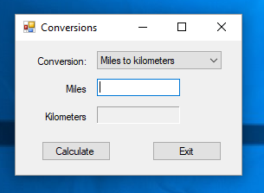 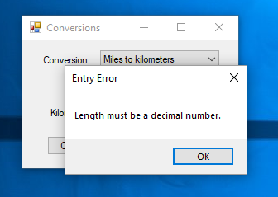

CLICKED OK AND RETURN FOCUS TO LENGTH TEXT BOX ENTER LENGTH AND CLICK CALCULATE

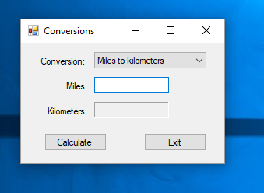 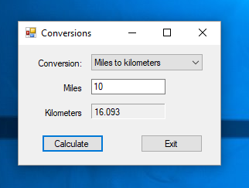

CHANGE CONVERSION METHOD ENTER LENGTH AND CLICK CALCULATE

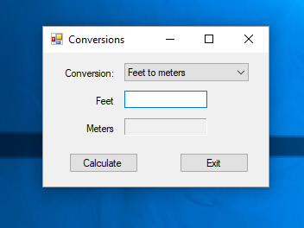 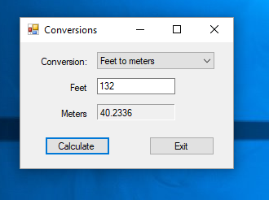

ENTERED INVALID LENGTH CLICKED CALCULATE AND GOT ERROR

