Learn Abut A Star Search
A* has the advantage over breadth-first search that it begins to search out all paths, as opposed to breadth-first just picking a single path and trying it to completion.

A* has the advantage over depth-first search in that it only begins to search all paths but only travels down the most likely shortest path, as opposed to actually exploring every path like depth-first.

Print Those Scores!
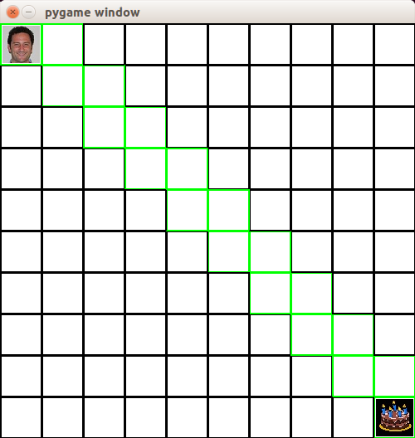

With “CODE_TO_DRAW = ''” uncommented, no scores are shown so the tiles are blank.

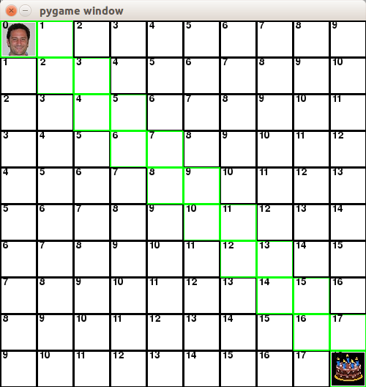

With “CODE_TO_DRAW = 'self.g-cost'” uncommented, the number shown in the tile is the total movement cost to get to that tile from the current tile.
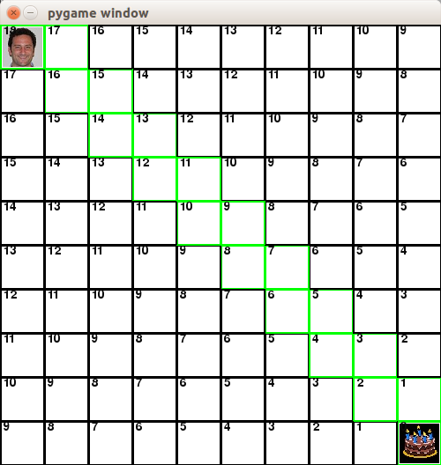

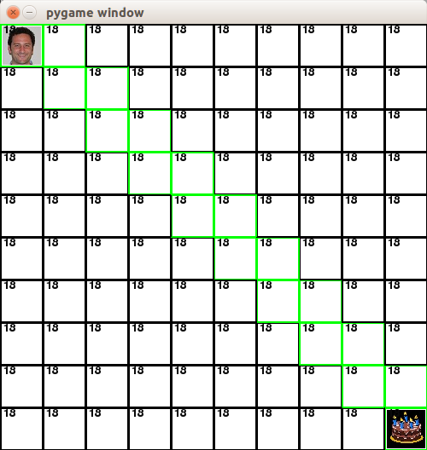
With “CODE_TO_DRAW = 'self.h-cost'” uncommented, the number shown in the tile is the number of tiles to reach the target tile from the current tile.

With “CODE_TO_DRAW = 'self.h-cost'” uncommented, the number shown in the tile is the sum of the h-score and h-score, resulting in the total score for that tile and how it relates to getting to the goal, with smaller value tiles being more desirable.

Paul Gets Diagonals
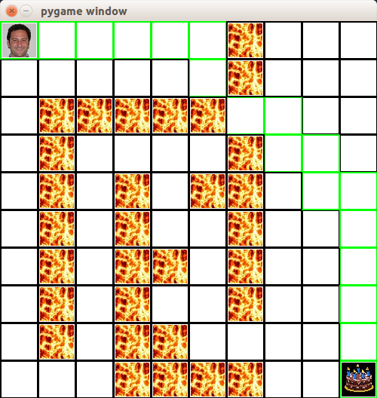

To reach his goal, Paul must either go through the much longer normal tile maze, or jump diagonally across the lava. Despite costing more movement points, moving diagonally results in a shorter overall path, as seen in the solution above.

Paul Gets Hops

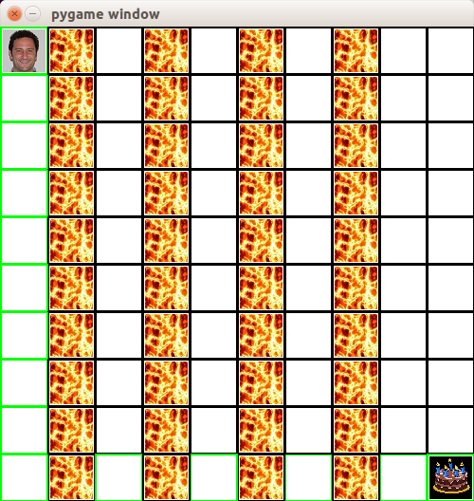

Paul needs to jump directly over several rows of lava to reach the goal this time and does so successfully as seen above.

Paul Gets Swamped

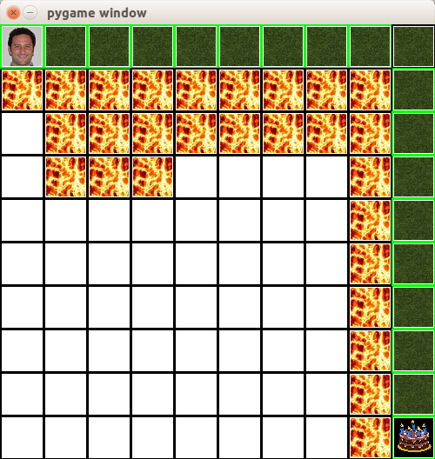

Paul is willing to take swamp paths if it is the only path to take but...

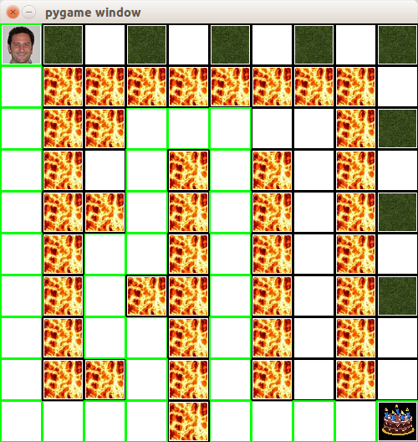

Because of the higher movement cost, other paths may be preferable.

