**Prototype Technology**

**For**

**Future HCI**

**Name** : Ian A. Drilon

**Year and Section** : BS CS 3B

**Instructor** : Prof. Josie Calfoforo

1. **DA VINCI SURGICAL SYSTEM**

The Da Vinci Surgical System helps enable your surgeon to easy control the robotic arm of a robot for surgical operation, to perform minimal invasive surgery with an advanced set of instruments and a 3D high-definition view of the surgical area. The robotic arm has the capability to peal a very small pieces of grapes, that is very example of how flexible and smooth and sense of motion of Robotic arm of a robot. Da Vinci Surgical System also used in other area such as, urology and gynecology procedures, and in several other procedures too.

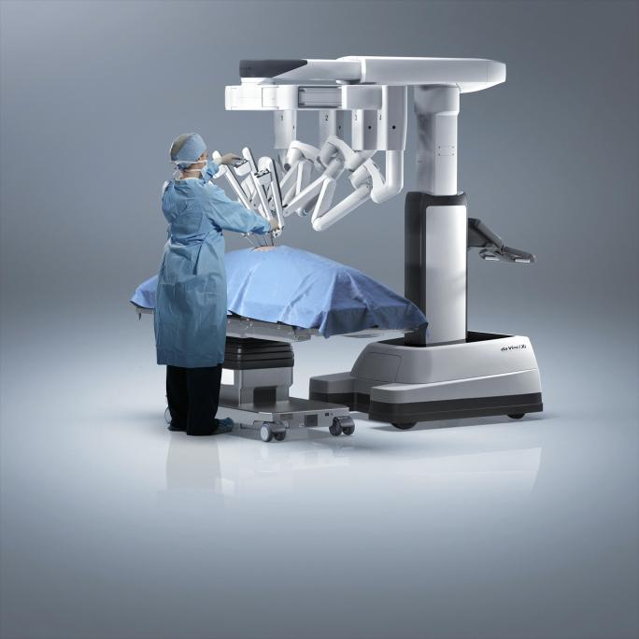

*Source :https://guttenberghospital.org/services/roboticsurgery/find-a-surgeon-preparing-fo r-surgery-surgery-news-day-of-surgery-robotic-surgery-how-does-it-work-meet-our-team-g ynecological-surgery-urology-surgery-colorectal-surgery-partial-knee-replacement-st-l/*

1. **REVOICE GLOVES**

There is a lot of different technology catered for communication especially for people with speech disabilities, most of them relay on smart devices where

Revoice Gloves is a stand alone upholds completely independently from any smart devices. Revoice Gloves special glove that will give voice to those people who cant speak or hear, its a data glove that wired into different sensors to translate hand gestures, sign language, to text and speech mainly designed for people who use sign language for their daily communication. This will be sent to a web app or in his phone where he can type that word, so every time he makes that sign that’s the word that will appear on the screen that will spoken out through the speaker. 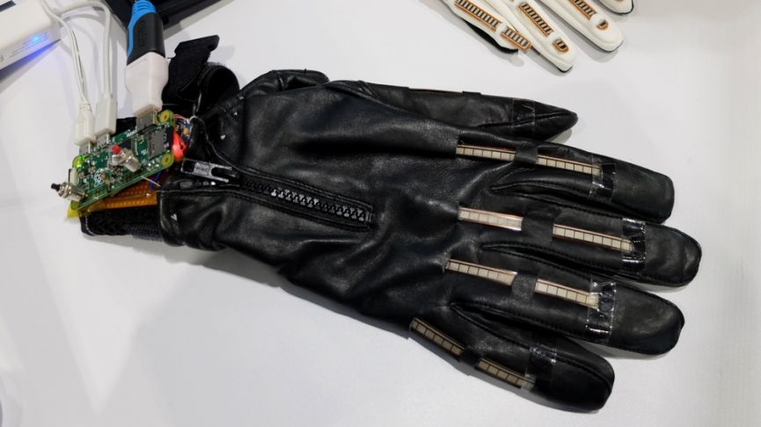

*Source :https://www.wareable.com/smart-clothing/smart-glove-sign-language-translation-r evoice-8887*

1. **UBICOUSTICS**

Microphones and other record devices can be found any many consumers electronics, despite sound being a rich signal, there devices don’t utilize their microphones for what is happenings around them, the smart watch on your wrist has no idea that you are doing something, typing or brushing your teeth. That is where Ubiscoustics come from, a real-time sound-driven activity recognition system. To tune the deep learning model, Ubicoustics needs a lot of high-quality abeled data for very specific activities, such as car running, flashing and others. Ubicoustics works accross different contexts and devices, including smart speakers, smart watches, Laptops, IOT sensors and smart phones. Ubicoustics creators believe that their work demonstrates a promising approach for robust context and activity recognition which could enable many new applications. For example smart watches could monitor a greater array of health indicators. Office computers could estimate workers interrupt-ability. IOT sensors could track equipment utilization and help schedule maintenance. Smart phones could detect tool and appliance use, and automatically display relevant information or launch complimentary applications.

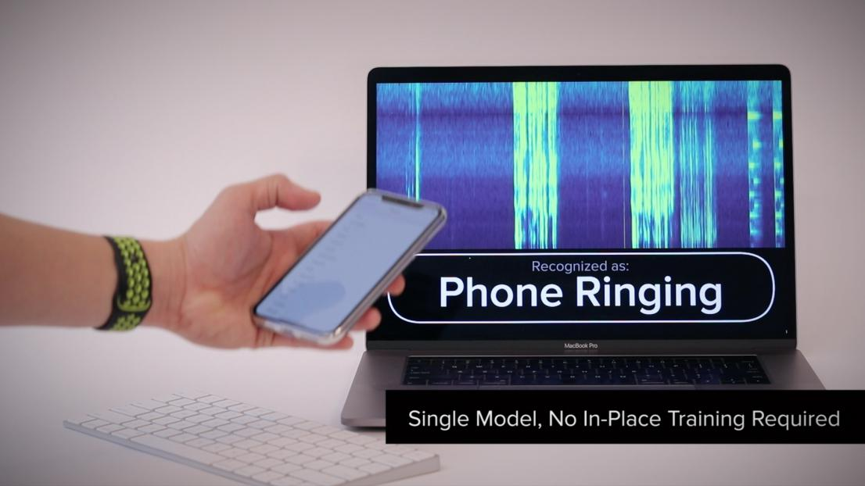

*Source : http://www.gierad.com/projects/ubicoustics*

1. **ZENSORS**

Zensors offer a real-time data platform for airports to improve customer experience and enhance operations, this includes sensing concession popularity, to optimize foot traffic and sales, monitoring line length and sharing estimated wait times with passengers to increase time at concessions ease stress and better allocate staff. Zensors also tracks seating occupancy for superior gate allocation as overall occupant density, and facilities utilization for on-demand sanitation scheduling and compliances. Zensors also detects litter, pushing real-time alert to facilities staff. Other modules track parking lot occupancy, gate equipment availability and much more. Zensors runs on an existing camera system as a cloud or on premises solution.

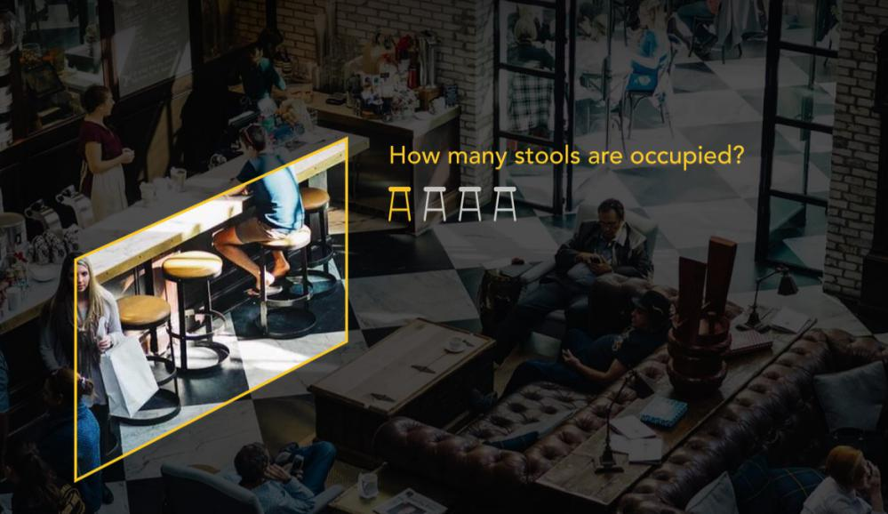

*Source : <https://www.youtube.com/watch?v=_tfzyg-lojg>*

1. **SMART WATCH REAL-TIME RECOGNITION**

Typically a smart watch has a accelerometers that around 100Hz, the creator did is to overclocked the 100Hz to 4000Hz, that will becomes high-speed, it will expand the capacity of the smart watch to sense what is in its surroundings. Example, Interacting with a coffee grinder the vibration of coffee grinder propagating from the hand of the consumer to the smart watch that he/she is wearing and it will automatically detect the vibration from coffee grinder. Also smart watch with real-time recognition can sense when you are tapping in your skin in any directions, consumer can swipe into another component of the application that built in the smart watch without even touching or swiping to the surface of the watch, just tap your skin at the right or left it will automatically swipe it. Basically Smart watch transform area around the consumer into like an input platform. Also smart watch can use motion data, like snapping your finger to turn the lights on or off, or lowering the lights or make it more brighter. Smart watch with real-time recognition is such a promising tec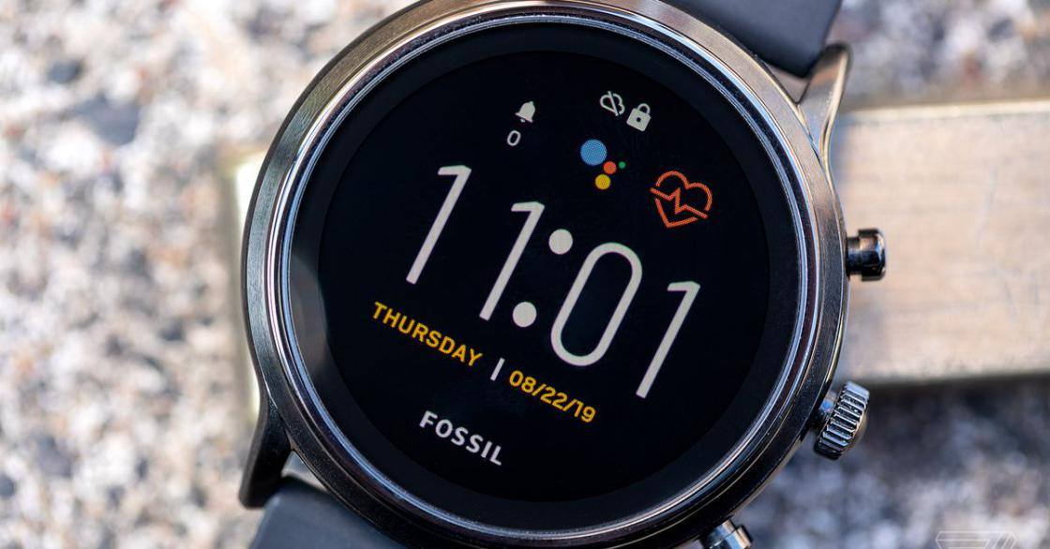hnology to Human Computer Interaction.

*Source : https://www.youtube.com/watch?v=J_oPtEjiVuA&t=210s*

1. **QEEXO FINGERSENSE**

Finger sense allow to conventionally touchscreens to know not only where a finger is touching but also how the finger is touching for example a standard fingertip touching, a knuckle or a nail. Finger sense also can detect a multi-touch and can also enable support for an inexpensive passive stylus. By incorporating finger sense directly into an android device. It opens a several possibilities for enhancing user experience. For example, knock knock can be assigned to take a screenshot or with a single knock you can rapidly capture only a region of the screen that you want to capture. Having touch event with type enables new and more powerful touch experience, for example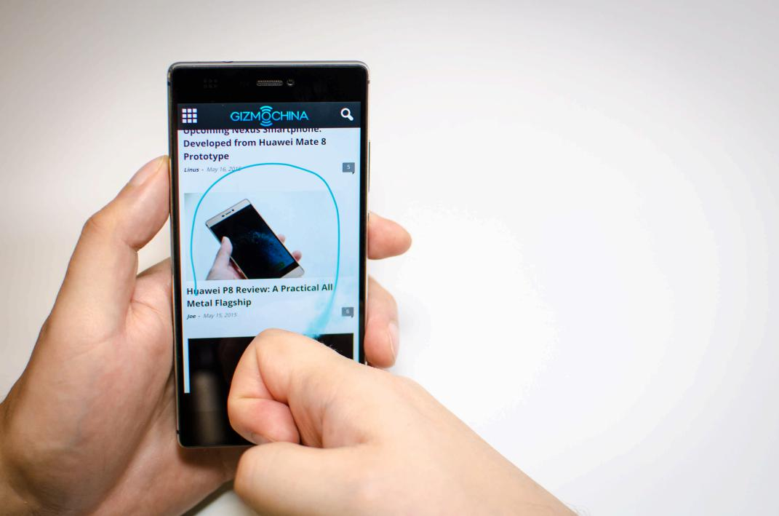 a single knuckle can be use to trigger contextual menus, allowing users to access advanced functions more quickly.

*Source : https://www.youtube.com/watch?v=sCE8FYwQjz8*

1. **KINECT**

Gone will be days when you moved the mouse when playing an online game, The idea today is to let the player engage in the game with her entire body and direct on-screen motion with actual physical movement. That is where Microsoft Kinect was breakthrough in this regar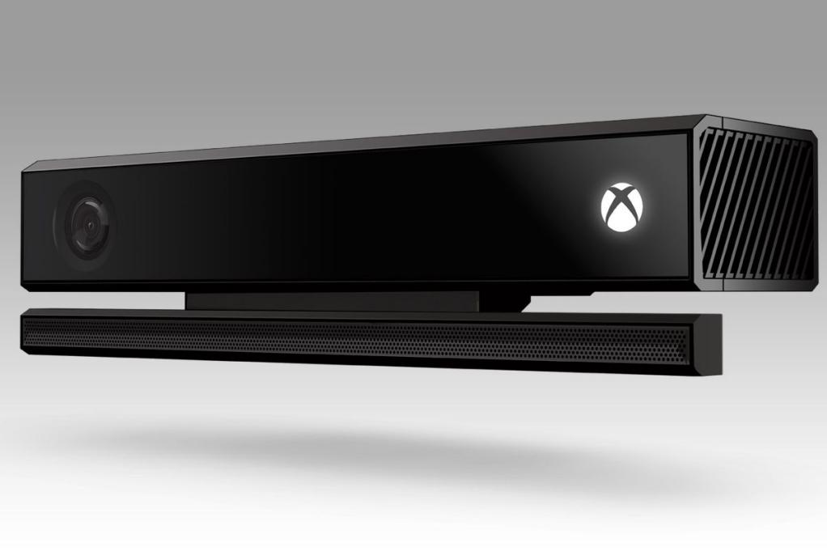d. Leap Motion with its extensive list of hardware, and software devices, sensors is contributing to hand and finger tracking.

*Source : https://developer.microsoft.com/en-us/windows/kinect/*

1. **VOICE GUIDED INTERFACE**

Voice guided interface is still a prototype that picking plenty of pace. Assistance like Siri, conrtana etc. Shall soon phase out as NLU (Natural Language Understanding) is complemented with NL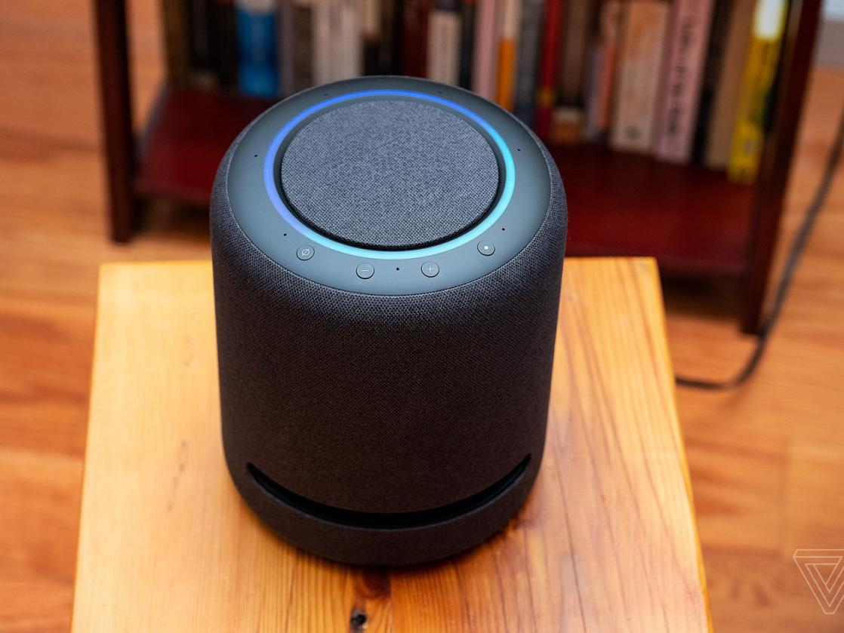G(Natural Language Generation). Alexa by (Amazon) functions by hearing you. And so will many other devices.

*Source : https://www.interaction-design.org/literature/topics/voice-user-interfaces*

1. **EYE TRACKING**

Eye tracking is, simply the observation and recording the eye behavior such as pupil dilation and movement. It has applications in many areas, including psychological research and packaging design.

Eye trackers are often integrated into lab set-ups, for example in a game lab or in a simulator. Remote eye tracking devices and computer-monitor eye trackers are stationary and are also commonly used n a office setting. In both set-ups they can be used to obtain data such as pupil height and width, ocular torsion, pupil position, velocity of eye movement/saccades, and location and duration of eye fixation. Office software, games, or the applications can be evaluated by differentiating between participants with and without previous task-experience. When a participant has previous ex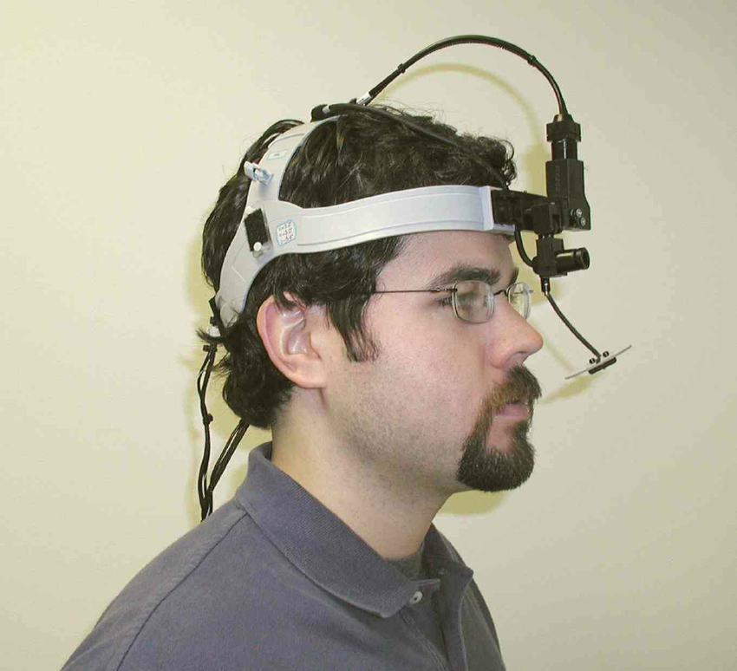perience with a website, game, or other application, the scan path of the eyes will most likely have fewer fixations than the scan path of a participant with no previous experience.

*Source : <https://www.tobiidynavox.com/about/about-us/how-eye-tracking-works/>*

1. **VIRTUAL REALITY**

The primary subject of virtual reality is simulating the vision, Every headset aims to perfect their approach to creating an immersive 3D environment. Each VR headset puts up a screen (or two - one for each eye) in front of eyes thus, eliminating any interaction with the real w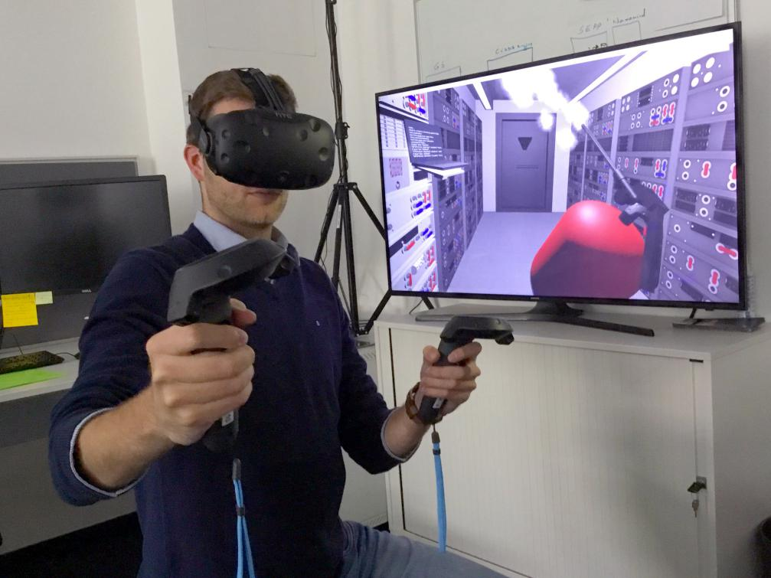orld.

*Source : https://thinkmobiles.com/blog/what-is-vr/*