

Increasing Energy Efficiency in the Water Sector (IEE)

Renewable Energy in the Water Sector (REW)

**Manual**

**Open Source Energy Water Model Jordan (*enwajo*)**

**Background**

As part of the Renewable Energy in the Water Sector (REW) project, the new open source energy water model – *enwajo* – has been developed for and with the Jordanian water and energy sector. This model aims to support the integrated planning among both sectors and to understand the challenges of each other. With this approach a unique and useful tool is provided to strengthen the exchange and to make use of synergies over time. Doing so *enwajo* addresses one key challenge in the Jordanian Water and Energy sector.

The following manual provides a short overview about how to install *enwajo* and how to use it to create benefits for the water and energy sector. The first version of the model was developed to assess the effect of a pumped hydro storage on the Jordanian energy system. Due to the open source approach, adaptations for different assessments are possible.

**Developed by:**

Ein Bild, das Messer, Tisch enthält.

September 2020

Table of Contents

Introduction 3

*enwajo* – Installation Guide 4

Install Python 4

Install the new energy water model *enwajo* 5

Usage of *enwajo* 6

Examples 11

Included Examples 11

Support 13

## Introduction

**Why an open source approach has been selected?**

To enable a common understanding of the following manual, let us understand what is to gain and what we are doing by using an open source energy system modeling tool.

1. Using an energy system model can **improve the understanding of the system** set up itself. Especially the included result plots, which are automatically generated, can show you e.g. the energy mix specific for every hour of the year.
2. Create a **cost-optimized** potential **future energy system** using backcasting rather than forecasting. One does not have to follow expected trends and fixed contracts but can analyze freely various electricity mixes and adjust to flexible developments.
3. The power of **open source** models is extraordinary. First and foremost (!) open source does not mean your results or input data are publicly shared and available. This is not the case. It simply means, the source code itself is openly available and can be inspected, used and altered by everyone. This leads to the following positive benefits:
   1. Enables any user to change the input data, constraints and any other aspect of the model. This increases transparency and reproducibility of results.
   2. Low cost of ownership, as no licensing costs are required.
   3. Flexible adjustment to new given circumstances within the system.
   4. Increased transparency can increase acceptance of proposed models.

**Who should use the new model and how to apply *enwajo*?**

Energy system modelling can be beneficial and is accessible for anyone in the energy or water or any other relevant sector. Or, to be honest, anyone who is interested. Using an open source tool can improve the understanding between sectors, as well as the application of different forms of energy (e.g. renewable or fossil in combination with storage) and the system itself. It can be a facilitator to make use of synergies in both sectors and therefore provides huge potential for planners and decision makers in the Jordanian water and energy sector.

The new energy water model – *enwajo* – is easy to install and to run. Following the step-by-step manual below might seem intimidating at first but is really simple and easy to follow without extensive modeling or programming knowledge.

## ***enwajo* – Installation Guide**

### Install Python

1. Uninstall Anaconda (if it was previously installed).
2. Uninstall Python and Python Launcher (if another version from 3.7.6 was previously installed).
3. Download and install Python 3.7.6 from:

<https://www.python.org/ftp/python/3.7.6/python-3.7.6-amd64.exe> .

If the link does not work, you can find the file at:

<https://www.python.org/downloads/release/python-376/> .

* 1. Make sure to enable option "Add Python 3.7 to PATH".
  2. 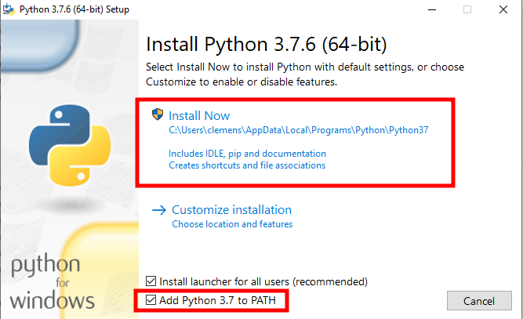Use the standard installation option.

If you do not have Admin privileges, uncheck the option “Install launcher for all users”.

* 1. At the end of the wizard, use the option to "Disable path length limit", if available.
  2. To finish the installation, please reboot your machine.

### **Install the new energy water model *enwajo***

1. Download Source Code as a zip file from: <https://github.com/znes/enwajo/releases> .
2. Unzip it to a location of your choosing.
3. Install the necessary packages with double clicking on install.py .
4. To test the installation:
   1. Run the model with double clicking on run.py
   2. Follow the instructions in the console output
   3. When prompted choose a scenario folder, e.g. scenarios/example1

If you have any problems on the way, create an issue at:

<https://github.com/znes/enwajo/issues> .

## **Usage of *enwajo***

*enwajo* was designed to simulate the cost optimized operation of an energy system. The methodology is described in the mathematical model description in the docs folder. Additionally, you can see all relevant constraints in the file **model.py**. Here you can modify and add constraints as well, if you want to adapt the model for other purposes.

The energy system to analyze is defined with scenario parameters. A new scenario always consists of a separate folder with a config.toml file and an input subfolder:

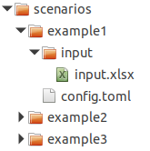

The **config.toml** file is just a plain text file in a specific format (toml) and holds general parameters like:

* the amount of timesteps (t_start, t_end) to use for the simulation,
* colors for the plots ([colors} section),
* if you want to model with minimum load constraints for the power plants (pmin=true),
* if you want to include part load efficiencies (eta_partial=true).

It can be opened and edited with a normal text editor like **Notepad**. Here is a small example about how you can use the **config.toml** file:

Example: config.toml

Because the runtime of the model depends on the size of variables you can start with only a small amount of timesteps for the development of a scenario. E.g. with only the first 24 timesteps which would represent the first day of the year:

t_start = 0

# end timestep (8760 for a whole year)

t_end = 24

On that basis you can find a convenient setting of scenario assumptions like installed power plants and total demand of electricity. The runtime for a model run will be very short. Then you can simulate a whole year in hourly resolution. You just have to change the following in the config.toml file:

t_start = 0

# end timestep (8760 for a whole year)

t_end = 8760

The **input.xlsx** file – which is the main file for you to easy enter key scenario parameters according to your needs – holds all necessary scenario assumptions. It is separated into different worksheets:

The **worksheet conventional** holds all necessary parameter for conventional power plants. Every carrier assigned has to be specified in the carrier worksheet as well. p_max and p_min have only to be specified if you want to model with minimum load constraints (see example2 below). a and b have only to be specified if you want to model with part load efficiencies (see example3 below).



The **worksheet renewable** contains all parameter for fluctuating power sources. In addition to a conventional power plant, a scaled profile (normalized with the nominal power) has to be added in the **worksheet profiles**. This profile restrict the maximum power output for every hour.



The **worksheet demand** contains the annual electricity demand in MWh. It refers to a scaled demand-profile (normalized with the annual demand) in the **worksheet profiles**.

The **worksheet storage** holds all parameter for storage units (e.g. pumped hydro storage, batteries).



The **worksheet carrier** contains information on the energy carrier being used as fuel/source for conventional and renewable power plants.



You can either edit an already existing scenario or create a new scenario by copying and already existing scenario folder. In the examples section below you can find relevant screenshots.

To run the model, just double click on **run.py** and follow the instructions in the console output:

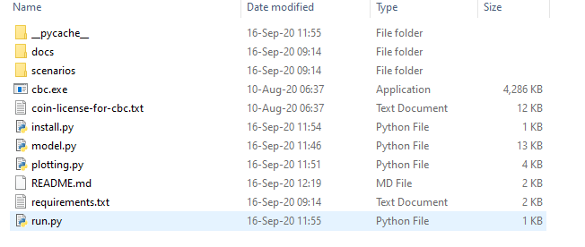

A new window will open which displays the console output:

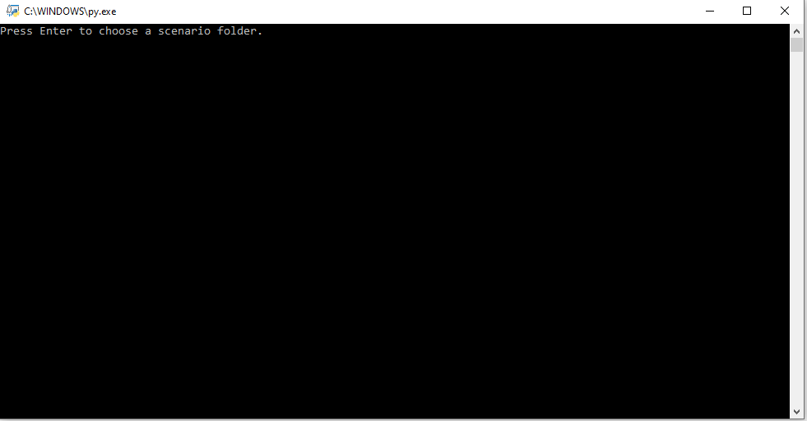

When prompted choose the respective scenario folder, you want to model.

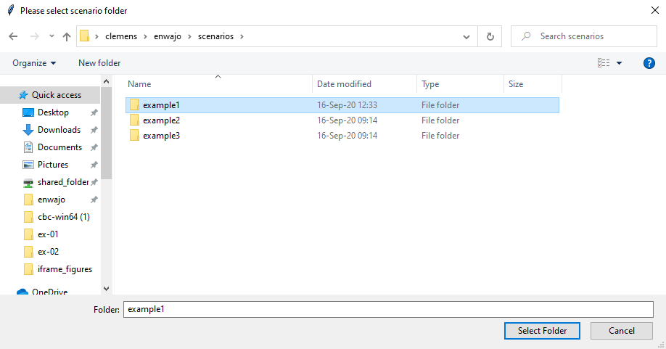

After selecting a scenario folder, the respective scenario is being simulated.

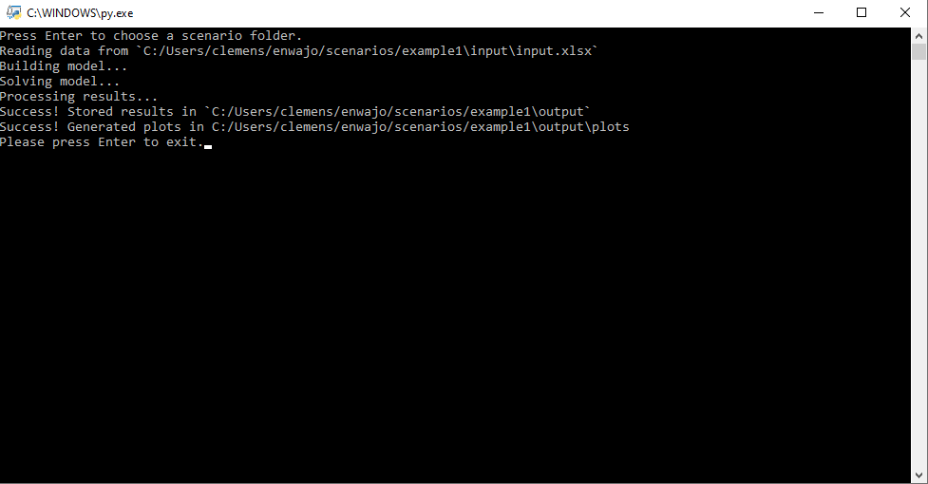

When the model is finished the results will be saved in a subfolder called output in the scenario folder:

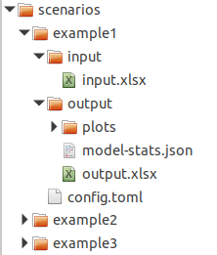

All relevant data is stored in the file output.xlsx and you can find some standard plots in the same folder.

## Examples

### Included Examples

There are three example scenarios included with the model, from which you can learn. They only differ slightly to illustrate the flexibility of the model itself when it comes to depth of detail.

**example1** is a more or less realistic and simple scenario of the Jordanian energy system.

scenarios/example1/input/input.xlsx:

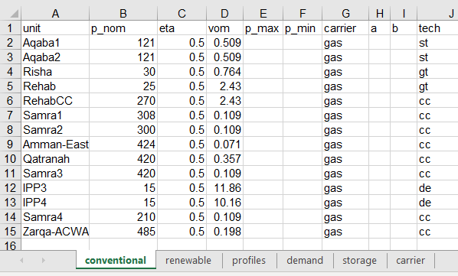

scenarios/example1/conf.toml:

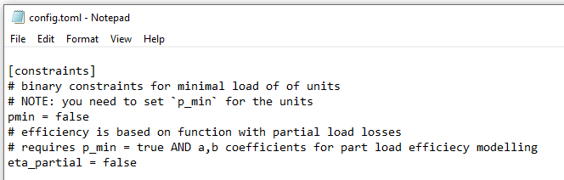

**example2** adds a more in detail representation of the power plants with introducing minimum load constraints. Observe the differences in the input.xlsx and conf.toml files as compared to example1.

scenarios/example2/input/input.xlsx:

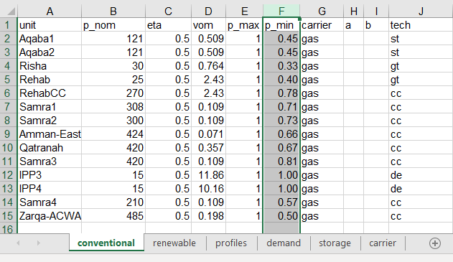

scenarios/example2/conf.toml:

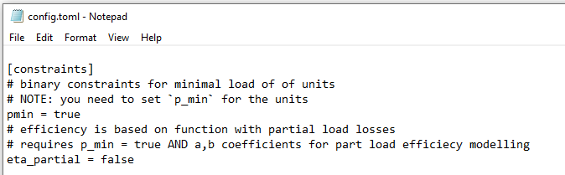

**example3** adds even more detail with introducing part load efficiencies of the power plants. You can find the description on how the part load efficiencies are modeled in the mathematical model description in the docs folder.

The best way to understand the structure is to open the necessary files yourself. Have a look at the differences between the three scenarios in input.xlsx and config.toml. Run the examples and compare the results (e.g. output/plots/hourly-dispatch.html).

## Support

If you need help, you can contact the trained expert in your institution. For contact details refer to:

GIZ Jordan, Thomas Fink, [thomas.fink@giz.de](mailto:thomas.fink@giz.de)

If you encounter any problems, find a bug or have a question, feel free to create an issue at:

<https://github.com/znes/enwajo/issues> .