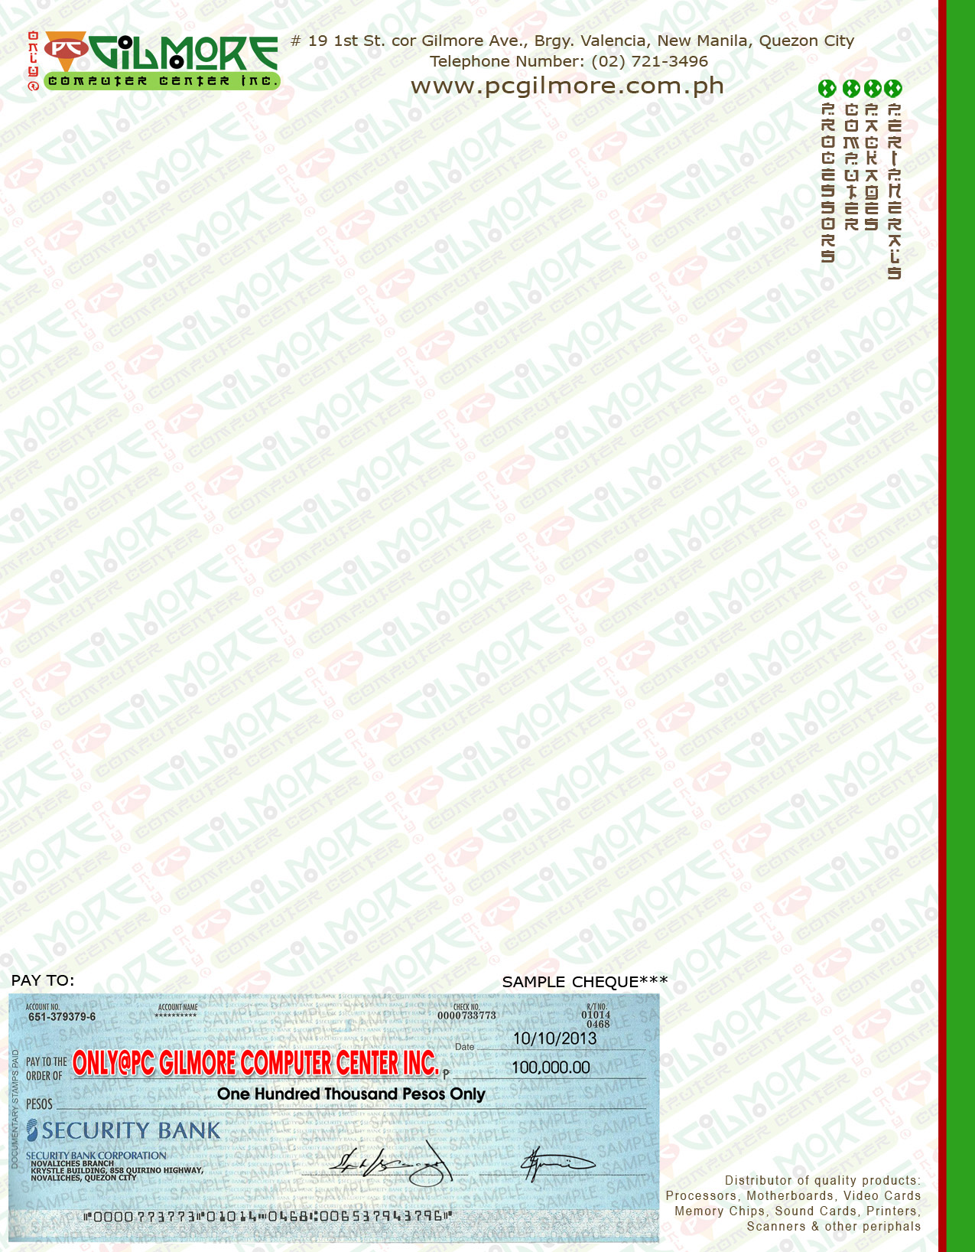

**.**

**FEBRUARY 11, 2016**

**Attn: SIR JORAM SALINAS**

**Dear Sir/Mam,**

**Thank you very much for your enquiry. We are pleased to quote you as follows:**

**Terms and Conditions:**

* Availability : ORDER BASIS

**Prices are vat exc.**

* Cash/Check (3days clearing) Payable to ONLY @ PC GILMORE COMPUTER CENTER INC.
* BDO Account: Only @ Pcgilmore computer center Inc.
* Account Number: 220123969
* Only @ PC Gilmore Computer Center Inc. is not liable for any freight charges and damages incurred during shipment done by a third party.
* Prices may change without prior notice
* Validity of quotation: 7 days

**Sincerely Yours,**

**MYLENE CAYOG**

**Sales Representative**

**7213496/09122548781**