The Effects of type and token frequency on generalizations

Corresponding Author (znh@uoregon.edu)¹, Zachary Nicholas Houghton^{1,2,3}, Zara Harmon⁴, Vsevolod Kapatsinski¹
¹Department of Linguistics, University of Oregon, ²Department of Linguistics, University of California, Davis, ³Vail Systems, Inc., ⁴Max Planck Institute for Psycholinguistics
Learning is crucial for adapting to novel environments. Language learning is no different: the ability to use language beyond the exact contexts in which it is learned is crucial. As such, linguistic generalizations have been discussed and debated for greatly [1].
Linguistic generalizations can take various different forms. For example, language learners crucially must learn to generalize a form to novel contexts [2]. Linguistic productivity has been demonstrated to be driven by accessibility: both type frequency and token frequency lead to increased probability of a form being used in a novel context [3].
Beyond linguistic productivity, it is perhaps equally as important to be able to generalize a word’s meaning beyond the context it is learned in. For example, one has to learn that the one-eyed, pirate cat that wanders the neighborhood is still a cat, despite the fact that a learner may never have encountered a one-eyed cat before.
It is unclear, however, whether generalizations are driven by the same factors or whether different types of generalizations are driven by different factors. For example, it is possible that linguistic productivity and semantic extension are both driven by accessibility. The present study investigates this by deploying an artificial language learning experiment in which type and token frequency of different suffixes are manipulated (Figure 1). Specifically, two suffixes are taught to correspond to the “big plural” (several big creatures) meaning, while two alternative suffixes are taught to correspond to the “diminutive singular” (a single small creature) meaning. In training, each of these suffixes is paired with various creatures. We manipulate the number of creatures each suffix occurs with (a token-frequency manipulation) as well as the number of different types of creatures each suffix occurs with (a type-frequency manipulation). In testing, we examine how learners extend these suffixes to a novel meaning (diminutive plural) which is partially compatible with each suffix. Additionally, some creatures are seen in training while others are not, thus contexts can be novel in stem or novel in meaning. We tested participants in production, comprehension, and form-choice.
Our results suggest that both type and token frequency play a role in semantic extension, suggesting that both semantic extension and linguistic productivity are driven by the same underlying factors (Figures 2 and 3). Further, logistic perceptron simulations are able to account for the results fairly well (Figure 4), and perform best when semantic cues are more salient than phonological cues, and configural cues are included, suggesting that both may play a role in linguistic generalization.
References
[1] Xu, F., & Tenenbaum, J. B. (2007). Word learning as Bayesian inference. Psychological review, 114(2), 245.
[2] Berko, J. (1958). The child's learning of English morphology. Word, 14(2-3), 150-177.
[3] Jarosz, G., Hughes, C., Lamont, A., Prickett, B., Baird, M., Kim, S., & Nelson, M. (2025). Type and token frequency jointly drive learning of morphology. Journal of Memory and Language, 104666.\
Figures and Tables
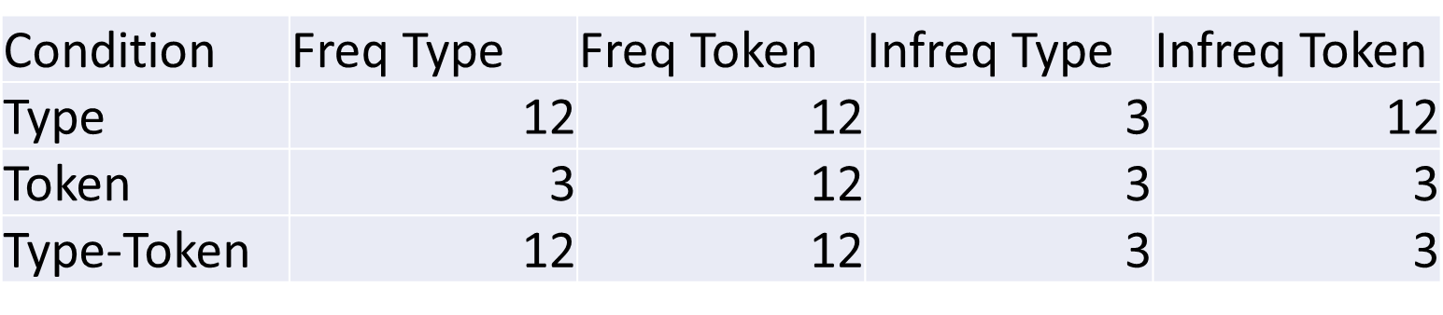
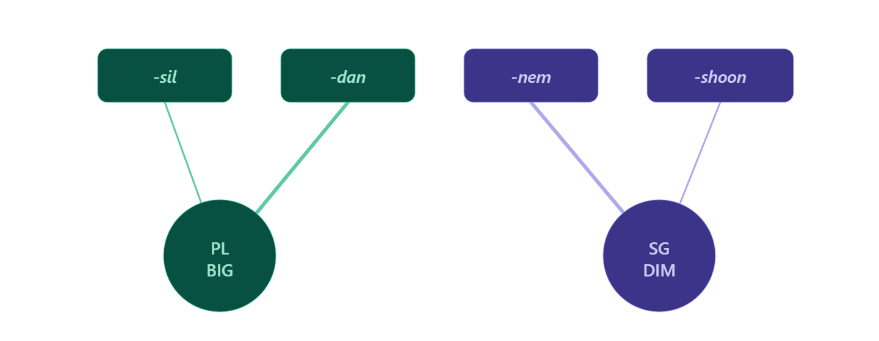
Figure 1. Suffix description (left) and conditions description (right). Frequent/infrequent suffix was either nem or dan (counterbalance to account for potential suffix-specific biases).
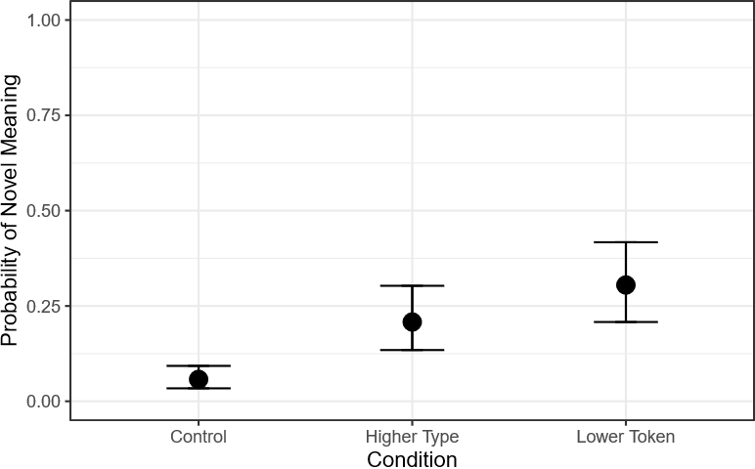
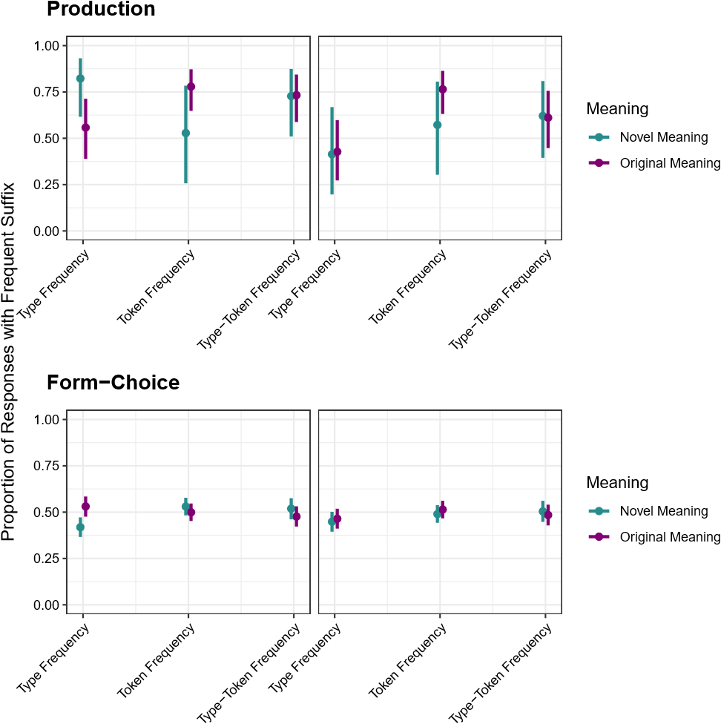
Figure 2. Left plot shows the statistical model estimates for task-interaction model. The x-axis indicates the. The y-axis corresponds to the proportion of responses with a frequent suffix. Blue points indicate that the meaning was novel while purple points indicate that the meaning was original. The facet indicates whether the stem was novel or familiar. The production results are shown in the top plot and the form-choice results are shown in the bottom plot. The right plot shows comprehension results.

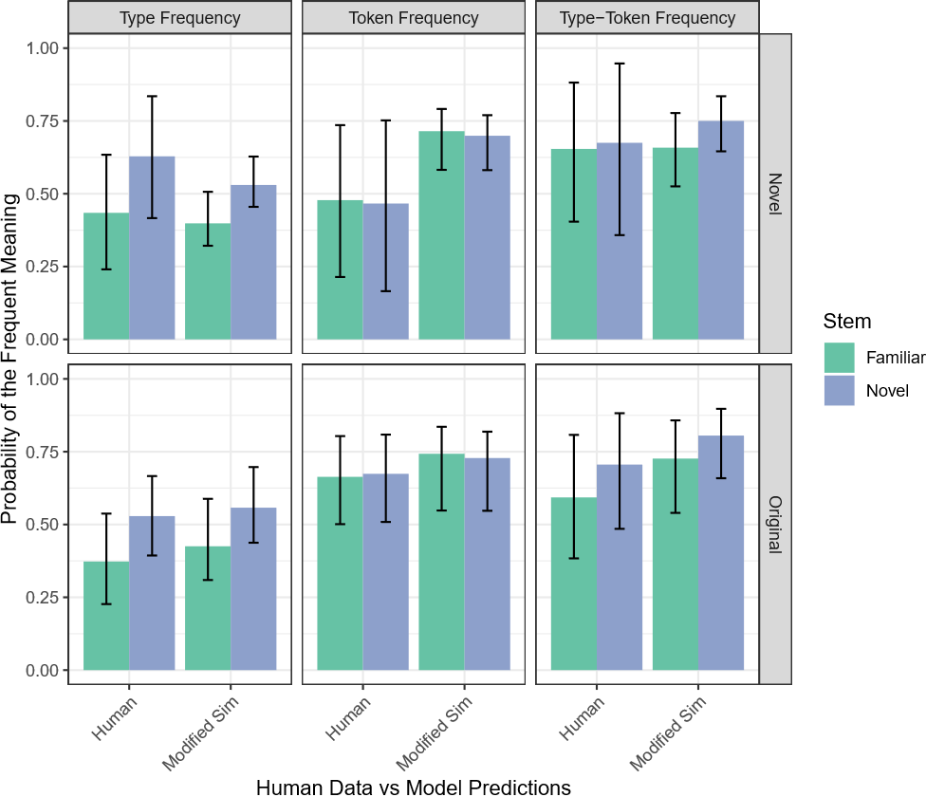
Figure 3. Plot of logistic perceptron side-by-side with human results. The y-axis is the probability of producing the frequent meaning. The top facet corresponds to novel meanings and the bottom axis corresponds to original meanings. X-axis presents the human results and the logistic perceptron. The results demonstrate that the model qualitatively captures the results in the Type Frequency and Type-Token Frequency conditions, but falls short of capturing the human results in the Token Frequency condition.

