МИНИСТЕРСТВО НАУКИ И ВЫСШЕГО ОБРАЗОВАНИЯ РОССИЙСКОЙ ФЕДЕРАЦИИ ФЕДЕРАЛЬНОЕ ГОСУДАРСТВЕННОЕ БЮДЖЕТНОЕ ОБРАЗОВАТЕЛЬНОЕ УЧРЕЖДЕНИЕ ВЫСШЕГО ОБРАЗОВАНИЯ «БЕЛГОРОДСКИЙ ГОСУДАРСТВЕННЫЙ ТЕХНОЛОГИЧЕСКИЙ УНИВЕРСИТЕТ им. В.Г.ШУХОВА»

(БГТУ им. В.Г.Шухова)

**Лабораторная работа №1**

дисциплина «Технологии web-программирования»

тема: «HTML. Разработка макетов и верстка шаблонов web-приложения с помощью языков HTML и CSS»

Выполнил: студент группы ВТ-41

Ковалёв И. Д.

Проверил:

Картамышев С. В.

Белгород 2020

**Цель работы**: Изучить основы работы протокола передачи гипертекста HTTP. Изучить основы разметки страниц с помощью языка HTML. Изучить основы вёрстки страниц, адаптированных под различные устройства. Изучить основы работы задания стилей для разметки страницы с помощью языка CSS. Разработать макеты и «сверстать» страницы для web-приложения.

**Задание к лабораторной работе:**

1. Выбрать шаблон или разработать свой для web-приложения. Шаблон должен включать минимум страницы (главная, контентная страница, страница авторизации/регистрации).
2. Сделать макеты страниц с помощью языка разметки HTML.
3. Стилизовать страницы с помощью языка CSS.
4. Продемонстрировать внешний вид разработанных страниц.

**Скриншоты разработанных шаблонов**

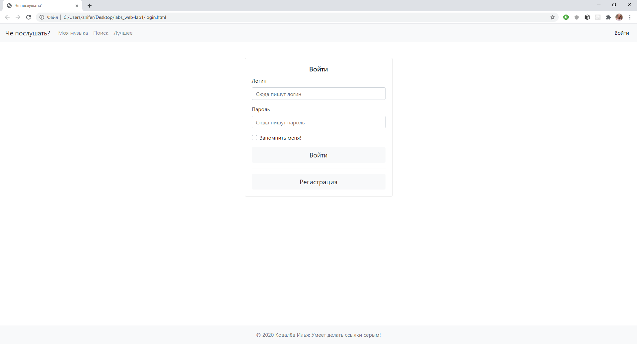

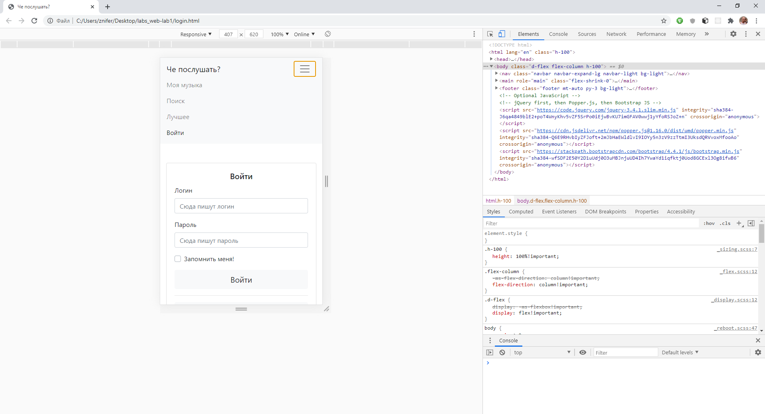

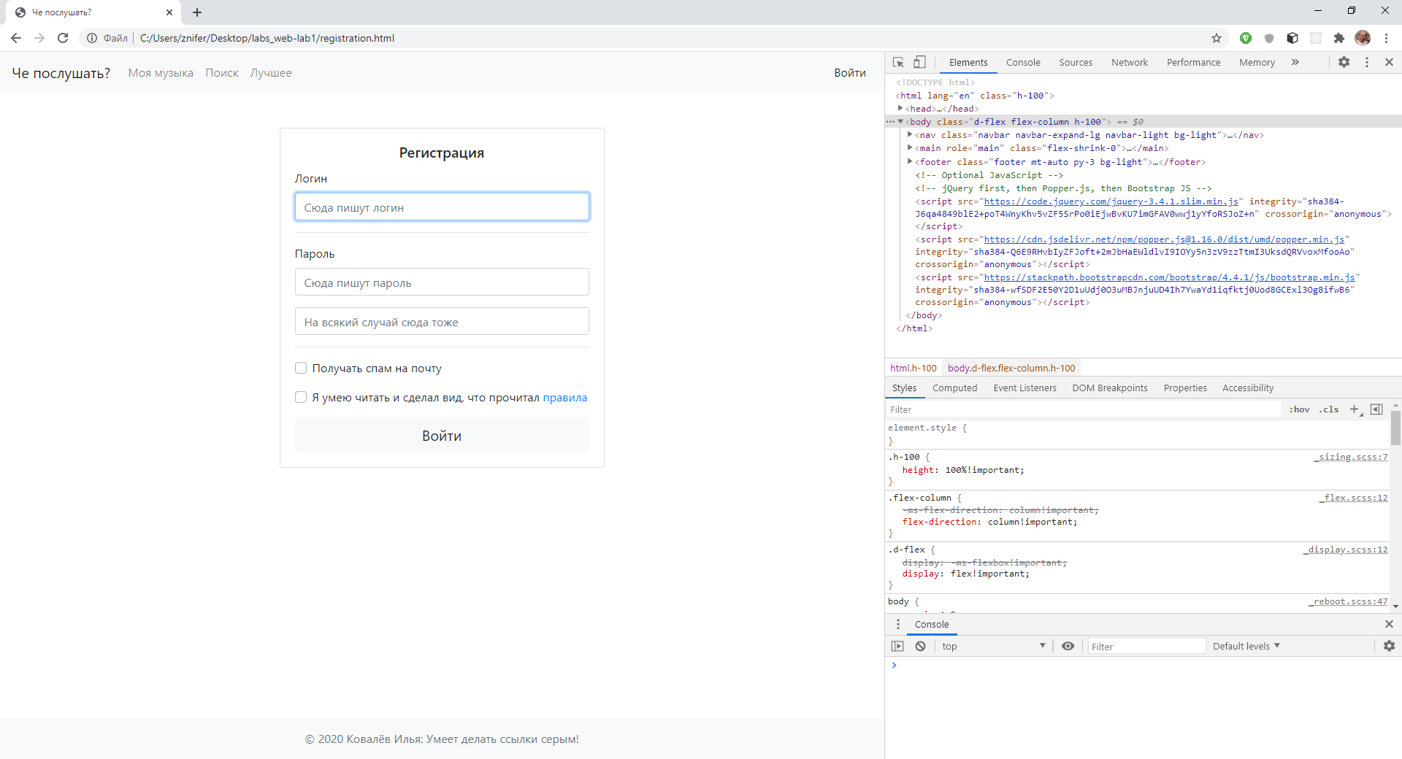

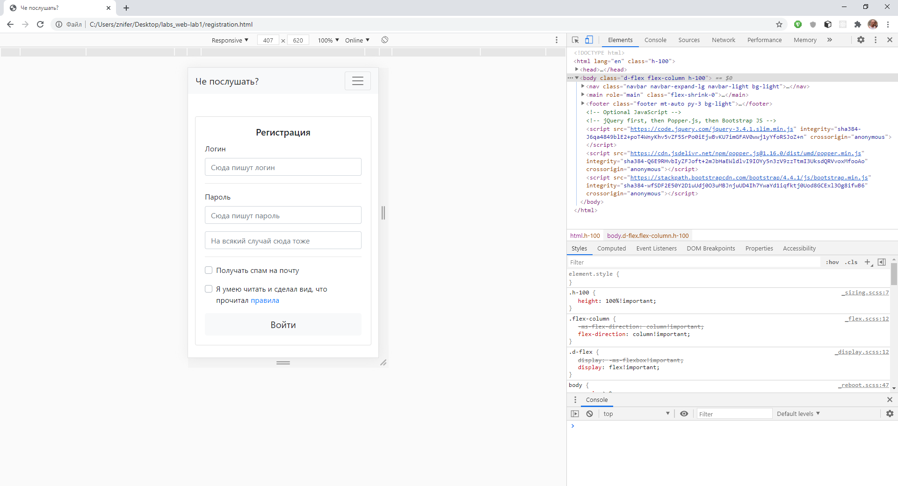

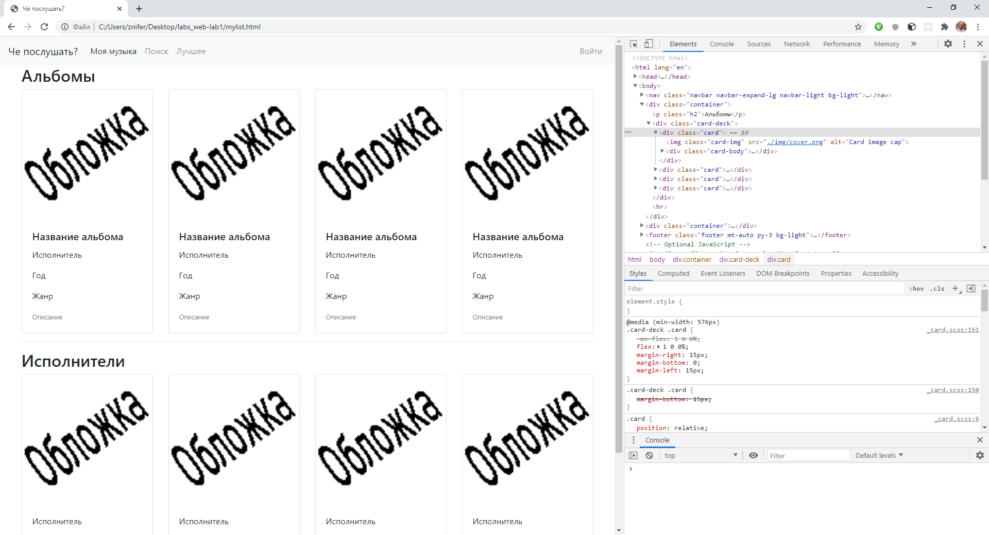

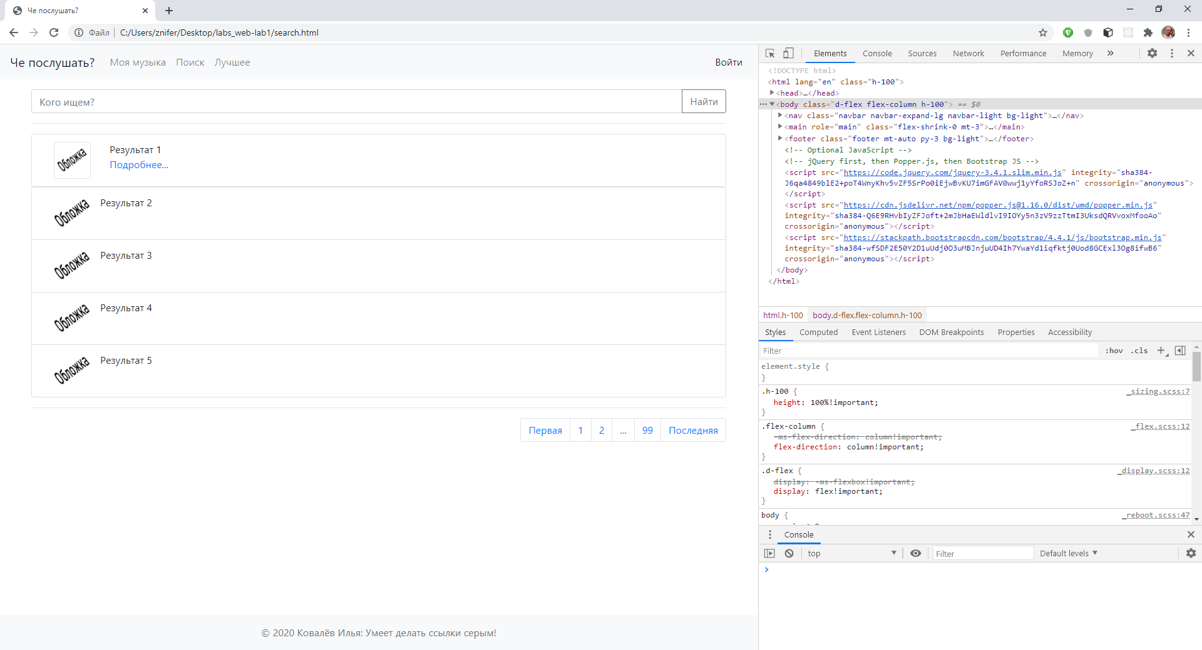

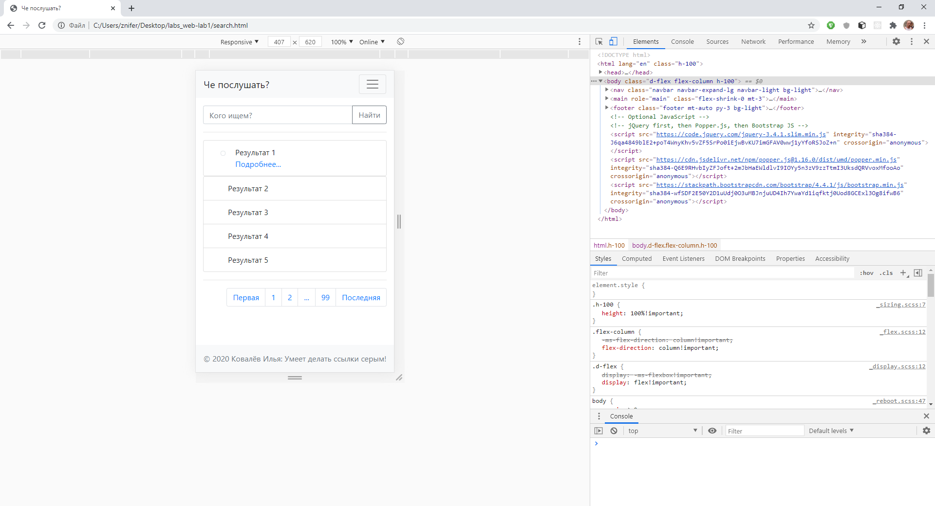

**Код разработанных шаблонов**

**Содержимое файла Login.html:**

<!doctype html>

<html lang="en" class="h-100">

    <head>

        <!-- Required meta tags -->

        <meta charset="utf-8">

        <meta name="viewport" content="width=device-width, initial-scale=1">

        <!-- Bootstrap CSS -->

        <link rel="stylesheet" href="https://stackpath.bootstrapcdn.com/bootstrap/4.4.1/css/bootstrap.min.css" integrity="sha384-Vkoo8x4CGsO3+Hhxv8T/Q5PaXtkKtu6ug5TOeNV6gBiFeWPGFN9MuhOf23Q9Ifjh" crossorigin="anonymous">

        <title>Че послушать?</title>

    </head>

    <body class="d-flex flex-column h-100">

        <nav class="navbar navbar-expand-lg navbar-light bg-light">

            <a class="navbar-brand" href="#">Че послушать?</a>

            <button class="navbar-toggler" type="button" data-toggle="collapse" data-target="#navbarText" aria-controls="navbarText" aria-expanded="false" aria-label="Toggle navigation">

                <span class="navbar-toggler-icon"></span>

            </button>

            <div class="collapse navbar-collapse" id="navbarText">

                <ul class="navbar-nav mr-auto w-100">

                    <li class="nav-item">

                        <a class="nav-link" href="mylist.html">Моя музыка</a>

                    </li>

                    <li class="nav-item">

                        <a class="nav-link" href="search.html">Поиск</a>

                    </li>

                    <li class="nav-item">

                        <a class="nav-link" href="top.html">Лучшее</a>

                    </li>

                </ul>

                <ul class="navbar-nav mr-auto justify-content-end">

                    <li id="login-link">

                        <a class="nav-link active" href="login.html">Войти</a>

                    </li>

                </ul>

            </div>

        </nav>

        <main role="main" class="flex-shrink-0">

            <div class="container">

                <div class="row">

                    <div class="col-sm-9 col-md-7 col-lg-5 mx-auto">

                        <div class="card card-signin my-5">

                            <div class="card-body">

                                <h5 class="card-title text-center">Войти</h5>

                                <form class="form-signin">

                                    <div class="form-group">

                                        <label for="inputEmail">Логин</label>

                                        <input type="email" id="inputEmail" class="form-control" placeholder="Сюда пишут логин" required autofocus>

                                    </div>

                                    <div class="form-group">

                                        <label for="inputPassword">Пароль</label>

                                        <input type="password" id="inputPassword" class="form-control" placeholder="Сюда пишут пароль" required>

                                    </div>

                                    <div class="custom-control custom-checkbox mb-3">

                                        <input type="checkbox" class="custom-control-input" id="customCheck1">

                                        <label class="custom-control-label" for="customCheck1">Запомнить меня!</label>

                                    </div>

                                    <button class="btn btn-lg btn-block bg-light" type="submit">Войти</button>

                                    <hr>

                                    <a class="btn btn-lg btn-block bg-light" type="submit" href="registration.html">Регистрация</a>

                                </form>

                            </div>

                        </div>

                    </div>

                </div>

            </div>

        </main>

        <footer class="footer mt-auto py-3 bg-light">

            <div class="container text-center text-muted">

                © 2020 Ковалёв Илья:

                <a href="https://github.com/znifer/" class="text-muted">Умеет делать ссылки серым!</a>

        </footer>

        <!-- Optional JavaScript -->

        <!-- jQuery first, then Popper.js, then Bootstrap JS -->

        <script src="https://code.jquery.com/jquery-3.4.1.slim.min.js" integrity="sha384-J6qa4849blE2+poT4WnyKhv5vZF5SrPo0iEjwBvKU7imGFAV0wwj1yYfoRSJoZ+n" crossorigin="anonymous"></script>

        <script src="https://cdn.jsdelivr.net/npm/popper.js@1.16.0/dist/umd/popper.min.js" integrity="sha384-Q6E9RHvbIyZFJoft+2mJbHaEWldlvI9IOYy5n3zV9zzTtmI3UksdQRVvoxMfooAo" crossorigin="anonymous"></script>

        <script src="https://stackpath.bootstrapcdn.com/bootstrap/4.4.1/js/bootstrap.min.js" integrity="sha384-wfSDF2E50Y2D1uUdj0O3uMBJnjuUD4Ih7YwaYd1iqfktj0Uod8GCExl3Og8ifwB6" crossorigin="anonymous"></script>

    </body>

</html>

**Содержимое файла Mylist.html:**

<!doctype html>

<html lang="en">

    <head>

        <!-- Required meta tags -->

        <meta charset="utf-8">

        <meta name="viewport" content="width=device-width, initial-scale=1">

        <!-- Bootstrap CSS -->

        <link rel="stylesheet" href="https://stackpath.bootstrapcdn.com/bootstrap/4.4.1/css/bootstrap.min.css" integrity="sha384-Vkoo8x4CGsO3+Hhxv8T/Q5PaXtkKtu6ug5TOeNV6gBiFeWPGFN9MuhOf23Q9Ifjh" crossorigin="anonymous">

        <title>Че послушать?</title>

    </head>

    <body>

        <nav class="navbar navbar-expand-lg navbar-light bg-light">

            <a class="navbar-brand" href="#">Че послушать?</a>

            <button class="navbar-toggler" type="button" data-toggle="collapse" data-target="#navbarText" aria-controls="navbarText" aria-expanded="false" aria-label="Toggle navigation">

                <span class="navbar-toggler-icon"></span>

            </button>

            <div class="collapse navbar-collapse" id="navbarText">

                <ul class="navbar-nav mr-auto w-100">

                    <li class="nav-item">

                        <a class="nav-link active" href="mylist.html">Моя музыка</a>

                    </li>

                    <li class="nav-item">

                        <a class="nav-link" href="search.html">Поиск</a>

                    </li>

                    <li class="nav-item">

                        <a class="nav-link" href="top.html">Лучшее</a>

                    </li>

                </ul>

                <ul class="navbar-nav mr-auto justify-content-end">

                    <li id="login-link">

                        <a class="nav-link" href="login.html">Войти</a>

                    </li>

                </ul>

            </div>

        </nav>

        <div class="container">

            <p class="h2">Альбомы</p>

            <div class="card-deck">

                <div class="card">

                    <img class="card-img" src="./img/cover.png" alt="Card image cap">

                    <div class="card-body">

                        <h5 class="card-title">Название альбома</h5>

                        <p class="card-text">Исполнитель</p>

                        <p class="card-text">Год</p>

                        <p class="card-text">Жанр</p>

                        <p class="card-text"><small class="text-muted">Описание</small></p>

                    </div>

                </div>

                <div class="card">

                    <img class="card-img" src="./img/cover.png" alt="Card image cap">

                    <div class="card-body">

                        <h5 class="card-title">Название альбома</h5>

                        <p class="card-text">Исполнитель</p>

                        <p class="card-text">Год</p>

                        <p class="card-text">Жанр</p>

                        <p class="card-text"><small class="text-muted">Описание</small></p>

                    </div>

                </div>

                <div class="card">

                    <img class="card-img" src="./img/cover.png" alt="Card image cap">

                    <div class="card-body">

                        <h5 class="card-title">Название альбома</h5>

                        <p class="card-text">Исполнитель</p>

                        <p class="card-text">Год</p>

                        <p class="card-text">Жанр</p>

                        <p class="card-text"><small class="text-muted">Описание</small></p>

                    </div>

                </div>

                <div class="card">

                    <img class="card-img" src="./img/cover.png" alt="Card image cap">

                    <div class="card-body">

                        <h5 class="card-title">Название альбома</h5>

                        <p class="card-text">Исполнитель</p>

                        <p class="card-text">Год</p>

                        <p class="card-text">Жанр</p>

                        <p class="card-text"><small class="text-muted">Описание</small></p>

                    </div>

                </div>

            </div>

        <hr>

        </div>

        <div class="container">

            <p class="h2">Исполнители</p>

            <div class="card-deck">

                <div class="card">

                    <img class="card-img" src="./img/cover.png" alt="Card image cap">

                    <div class="card-body">

                        <p class="card-text">Исполнитель</p>

                        <p class="card-text">Жанр</p>

                        <p class="card-text"><small class="text-muted">Описание</small></p>

                    </div>

                </div>

                <div class="card">

                    <img class="card-img" src="./img/cover.png" alt="Card image cap">

                    <div class="card-body">

                        <p class="card-text">Исполнитель</p>

                        <p class="card-text">Жанр</p>

                        <p class="card-text"><small class="text-muted">Описание</small></p>

                    </div>

                </div>

                <div class="card">

                    <img class="card-img" src="./img/cover.png" alt="Card image cap">

                    <div class="card-body">

                        <p class="card-text">Исполнитель</p>

                        <p class="card-text">Жанр</p>

                        <p class="card-text"><small class="text-muted">Описание</small></p>

                    </div>

                </div>

                <div class="card">

                    <img class="card-img" src="./img/cover.png" alt="Card image cap">

                    <div class="card-body">

                        <p class="card-text">Исполнитель</p>

                        <p class="card-text">Жанр</p>

                        <p class="card-text"><small class="text-muted">Описание</small></p>

                    </div>

                </div>

            </div>

        <hr>

        </div>

        <footer class="footer mt-auto py-3 bg-light">

            <div class="container text-center text-muted">

                © 2020 Ковалёв Илья:

                <a href="https://github.com/znifer/" class="text-muted">Умеет делать ссылки серым!</a>

            </span>

        </footer>

        <!-- Optional JavaScript -->

        <!-- jQuery first, then Popper.js, then Bootstrap JS -->

        <script src="https://code.jquery.com/jquery-3.4.1.slim.min.js" integrity="sha384-J6qa4849blE2+poT4WnyKhv5vZF5SrPo0iEjwBvKU7imGFAV0wwj1yYfoRSJoZ+n" crossorigin="anonymous"></script>

        <script src="https://cdn.jsdelivr.net/npm/popper.js@1.16.0/dist/umd/popper.min.js" integrity="sha384-Q6E9RHvbIyZFJoft+2mJbHaEWldlvI9IOYy5n3zV9zzTtmI3UksdQRVvoxMfooAo" crossorigin="anonymous"></script>

        <script src="https://stackpath.bootstrapcdn.com/bootstrap/4.4.1/js/bootstrap.min.js" integrity="sha384-wfSDF2E50Y2D1uUdj0O3uMBJnjuUD4Ih7YwaYd1iqfktj0Uod8GCExl3Og8ifwB6" crossorigin="anonymous"></script>

    </body>

</html>

**Содержимое файла Registration.html:**

<!doctype html>

<html lang="en" class="h-100">

    <head>

        <!-- Required meta tags -->

        <meta charset="utf-8">

        <meta name="viewport" content="width=device-width, initial-scale=1">

        <!-- Bootstrap CSS -->

        <link rel="stylesheet" href="https://stackpath.bootstrapcdn.com/bootstrap/4.4.1/css/bootstrap.min.css" integrity="sha384-Vkoo8x4CGsO3+Hhxv8T/Q5PaXtkKtu6ug5TOeNV6gBiFeWPGFN9MuhOf23Q9Ifjh" crossorigin="anonymous">

        <title>Че послушать?</title>

    </head>

    <body class="d-flex flex-column h-100">

        <nav class="navbar navbar-expand-lg navbar-light bg-light">

            <a class="navbar-brand" href="#">Че послушать?</a>

            <button class="navbar-toggler" type="button" data-toggle="collapse" data-target="#navbarText" aria-controls="navbarText" aria-expanded="false" aria-label="Toggle navigation">

                <span class="navbar-toggler-icon"></span>

            </button>

            <div class="collapse navbar-collapse" id="navbarText">

                <ul class="navbar-nav mr-auto w-100">

                    <li class="nav-item">

                        <a class="nav-link" href="mylist.html">Моя музыка</a>

                    </li>

                    <li class="nav-item">

                        <a class="nav-link" href="search.html">Поиск</a>

                    </li>

                    <li class="nav-item">

                        <a class="nav-link" href="top.html">Лучшее</a>

                    </li>

                </ul>

                <ul class="navbar-nav mr-auto justify-content-end">

                    <li id="login-link">

                        <a class="nav-link active" href="login.html">Войти</a>

                    </li>

                </ul>

            </div>

        </nav>

        <main role="main" class="flex-shrink-0">

            <div class="container">

                <div class="row">

                    <div class="col-sm-9 col-md-7 col-lg-5 mx-auto">

                        <div class="card card-signin my-5">

                            <div class="card-body">

                                <h5 class="card-title text-center">Регистрация</h5>

                                <form class="form-signin">

                                    <div class="form-group">

                                        <label for="inputEmail">Логин</label>

                                        <input type="email" id="inputEmail" class="form-control" placeholder="Сюда пишут логин" required autofocus>

                                    </div>

                                    <hr>

                                    <div class="form-group">

                                        <label for="inputPassword">Пароль</label>

                                        <input type="password" id="inputPassword" class="form-control" placeholder="Сюда пишут пароль" required>

                                    </div>

                                    <div class="form-group">

                                        <input type="password" id="inputPassword" class="form-control" placeholder="На всякий случай сюда тоже" required>

                                    </div>

                                    <hr>

                                    <div class="custom-control custom-checkbox mb-3">

                                        <input type="checkbox" class="custom-control-input" id="customCheck1">

                                        <label class="custom-control-label" for="customCheck1">Получать спам на почту</label>

                                    </div>

                                    <div class="custom-control custom-checkbox mb-3">

                                        <input type="checkbox" class="custom-control-input" id="customCheck2">

                                        <label class="custom-control-label" for="customCheck2">Я умею читать и сделал вид, что прочитал <a href="https://www.youtube.com/watch?v=dQw4w9WgXcQ">правила</a></label>

                                    </div>

                                    <button class="btn btn-lg btn-block bg-light" type="submit">Войти</button>

                                </form>

                            </div>

                        </div>

                    </div>

                </div>

            </div>

        </main>

        <footer class="footer mt-auto py-3 bg-light">

            <div class="container text-center text-muted">

                © 2020 Ковалёв Илья:

                <a href="https://github.com/znifer/" class="text-muted">Умеет делать ссылки серым!</a>

            </span>

        </footer>

        <!-- Optional JavaScript -->

        <!-- jQuery first, then Popper.js, then Bootstrap JS -->

        <script src="https://code.jquery.com/jquery-3.4.1.slim.min.js" integrity="sha384-J6qa4849blE2+poT4WnyKhv5vZF5SrPo0iEjwBvKU7imGFAV0wwj1yYfoRSJoZ+n" crossorigin="anonymous"></script>

        <script src="https://cdn.jsdelivr.net/npm/popper.js@1.16.0/dist/umd/popper.min.js" integrity="sha384-Q6E9RHvbIyZFJoft+2mJbHaEWldlvI9IOYy5n3zV9zzTtmI3UksdQRVvoxMfooAo" crossorigin="anonymous"></script>

        <script src="https://stackpath.bootstrapcdn.com/bootstrap/4.4.1/js/bootstrap.min.js" integrity="sha384-wfSDF2E50Y2D1uUdj0O3uMBJnjuUD4Ih7YwaYd1iqfktj0Uod8GCExl3Og8ifwB6" crossorigin="anonymous"></script>

    </body>

</html>

**Содержимое файла Search.html:**

<!doctype html>

<html lang="en" class="h-100">

    <head>

        <!-- Required meta tags -->

        <meta charset="utf-8">

        <meta name="viewport" content="width=device-width, initial-scale=1">

        <!-- Bootstrap CSS -->

        <link rel="stylesheet" href="https://stackpath.bootstrapcdn.com/bootstrap/4.4.1/css/bootstrap.min.css" integrity="sha384-Vkoo8x4CGsO3+Hhxv8T/Q5PaXtkKtu6ug5TOeNV6gBiFeWPGFN9MuhOf23Q9Ifjh" crossorigin="anonymous">

        <title>Че послушать?</title>

    </head>

    <body class="d-flex flex-column h-100">

        <nav class="navbar navbar-expand-lg navbar-light bg-light">

            <a class="navbar-brand" href="#">Че послушать?</a>

            <button class="navbar-toggler" type="button" data-toggle="collapse" data-target="#navbarText" aria-controls="navbarText" aria-expanded="false" aria-label="Toggle navigation">

                <span class="navbar-toggler-icon"></span>

            </button>

            <div class="collapse navbar-collapse" id="navbarText">

                <ul class="navbar-nav mr-auto w-100">

                    <li class="nav-item">

                        <a class="nav-link" href="mylist.html">Моя музыка</a>

                    </li>

                    <li class="nav-item">

                        <a class="nav-link" href="search.html">Поиск</a>

                    </li>

                    <li class="nav-item">

                        <a class="nav-link" href="top.html">Лучшее</a>

                    </li>

                </ul>

                <ul class="navbar-nav mr-auto justify-content-end">

                    <li id="login-link">

                        <a class="nav-link active" href="login.html">Войти</a>

                    </li>

                </ul>

            </div>

        </nav>

        <main role="main" class="flex-shrink-0 mt-3">

            <div class="container">

                <div class="input-group">

                    <input type="text" class="form-control" placeholder="Кого ищем?">

                    <div class="input-group-append">

                      <button class="btn btn-outline-secondary" type="button">Найти</button>

                    </div>

                  </div>

                <hr>

                <ul class="list-group">

                    <li class="list-group-item d-flex">

                        <div class="col-md-1 col-sm-1 col-1">

                            <img class="img-thumbnail" src="./img/cover.png" alt="Картинка в отпуске">

                        </div>

                        <div class="container">

                            <div class="text-inline">

                                Результат 1

                            </div>

                            <div class="text-inline">

                                <a data-toggle="collapse" href="#result-collapse-1" role="button" aria-expanded="false" aria-controls="result-collapse-1">Подробнее...</a>

                                <div class="collapse" id="result-collapse-1">

                                    <div class="text-justify">

                                        У попа была собака, он ее любил<br>

                                        Она съела кусок мяса<br>

                                        Он ее убил!<br>

                                        УБИИИИИИИИИИИИИИЛ<br>

                                        ЛА ЛАЛА ЛА ЛА ЛАААААА<br>

                                        В ЗЕМЛЮ ЗАКОПАЛ<br>

                                        НАДПИСЬ НАПИСАЛ<br>

                                        ЧТО!!!<br>

                                        У попа была собака, он ее любил<br>

                                        Она съела кусок мяса<br>

                                        Он ее убил!<br>

                                        УБИИИИИИИИИИИИИИЛ<br>

                                        ЛА ЛАЛА ЛА ЛА ЛАААААА<br>

                                        В ЗЕМЛЮ ЗАКОПАЛ<br>

                                        НАДПИСЬ НАПИСАЛ<br>

                                        ЧТО!!!<br>

                                    </div>

                                </div>

                            </div>

                        </div>

                    </li>

                </ul>

                <ul class="list-group">

                    <li class="list-group-item d-flex">

                        <div class="col-md-1 col-sm-1 col-1">

                            <img class="card-img" src="./img/cover.png" alt="Картинка в отпуске">

                        </div>

                        <div class="text-inline">

                            Результат 2

                        </div>

                    </li>

                    <li class="list-group-item d-flex">

                        <div class="col-md-1 col-sm-1 col-1">

                            <img class="card-img" src="./img/cover.png" alt="Картинка в отпуске">

                        </div>

                        <div class="text-inline">

                            Результат 3

                        </div>

                    </li>

                    <li class="list-group-item d-flex">

                        <div class="col-md-1 col-sm-1 col-1">

                            <img class="card-img" src="./img/cover.png" alt="Картинка в отпуске">

                        </div>

                        <div class="text-inline">

                            Результат 4

                        </div>

                    </li>

                    <li class="list-group-item d-flex">

                        <div class="col-md-1 col-sm-1 col-1">

                            <img class="card-img" src="./img/cover.png" alt="Картинка в отпуске">

                        </div>

                        <div class="text-inline">

                            Результат 5

                        </div>

                    </li>

                  </ul>

                <hr>

                <div class="d-flex flex-row-reverse">

                    <div class="d-flex">

                        <nav aria-label="Page navigation">

                            <ul class="pagination">

                                <li class="page-item"><a class="page-link" href="#">Первая</a></li>

                                <li class="page-item"><a class="page-link" href="#">1</a></li>

                                <li class="page-item"><a class="page-link" href="#">2</a></li>

                                <li class="page-item"><a class="page-link" href="#">...</a></li>

                                <li class="page-item"><a class="page-link" href="#">99</a></li>

                                <li class="page-item"><a class="page-link" href="#">Последняя</a></li>

                            </ul>

                        </nav>

                    </div>

                </div>

            </div>

        </main>

        <footer class="footer mt-auto py-3 bg-light">

            <div class="container text-center text-muted">

                © 2020 Ковалёв Илья:

                <a href="https://github.com/znifer/" class="text-muted">Умеет делать ссылки серым!</a>

            </span>

        </footer>

        <!-- Optional JavaScript -->

        <!-- jQuery first, then Popper.js, then Bootstrap JS -->

        <script src="https://code.jquery.com/jquery-3.4.1.slim.min.js" integrity="sha384-J6qa4849blE2+poT4WnyKhv5vZF5SrPo0iEjwBvKU7imGFAV0wwj1yYfoRSJoZ+n" crossorigin="anonymous"></script>

        <script src="https://cdn.jsdelivr.net/npm/popper.js@1.16.0/dist/umd/popper.min.js" integrity="sha384-Q6E9RHvbIyZFJoft+2mJbHaEWldlvI9IOYy5n3zV9zzTtmI3UksdQRVvoxMfooAo" crossorigin="anonymous"></script>

        <script src="https://stackpath.bootstrapcdn.com/bootstrap/4.4.1/js/bootstrap.min.js" integrity="sha384-wfSDF2E50Y2D1uUdj0O3uMBJnjuUD4Ih7YwaYd1iqfktj0Uod8GCExl3Og8ifwB6" crossorigin="anonymous"></script>

    </body>

</html>