DROP CONSTRAINT [语句](http://doc.cockroachchina.baidu.com/#develop/sql-statements/overview/) 是ALTER TABLE 的一部分，会删除 列Check 和 Foreign Key 约束.

Note: 关于其他约束的删除， 请看 [Constraints: Remove Constraints](http://doc.cockroachchina.baidu.com/#develop/sql-statements/DROP-CONSTRAINT/constraints.html#remove-constraints).

概要

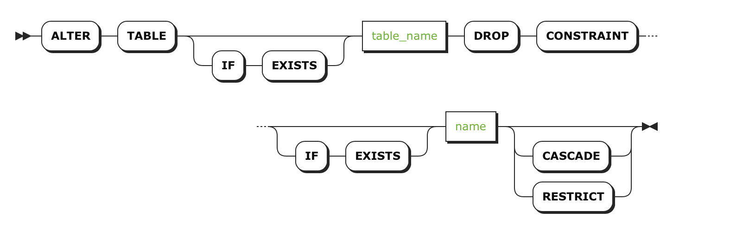

所需权限

用户必须拥有要操作表的 CREATE [权限](http://doc.cockroachchina.baidu.com/#deploy/access-management/privileges/)。

参数

| **Parameter** | **Description** |
| --- | --- |
| table_name | 要删除约束的表名 |
| name | 要删除约束的列的名字 |

查看结构变化

当我们变更表结构时，CockroachDB会把这个操作注册成一个job，可以通过SHOW JOBS查看。

例子

> **SHOW** **CONSTRAINTS** **FROM** orders;

+--------+---------------------------+-------------+-----------+----------------+

| Table | Name | Type | Column(s) | Details |

+--------+---------------------------+-------------+-----------+----------------+

| orders | fk_customer_ref_customers | FOREIGN KEY | customer | customers.[id] |

| orders | primary | PRIMARY KEY | id | NULL |

+--------+---------------------------+-------------+-----------+----------------+

> **ALTER** **TABLE** orders **DROP** **CONSTRAINT** fk_customer_ref_customers;

**ALTER** **TABLE**

> **SHOW** **CONSTRAINTS** **FROM** orders;

+--------+---------+-------------+-----------+---------+

| Table | Name | Type | Column(s) | Details |

+--------+---------+-------------+-----------+---------+

| orders | primary | PRIMARY KEY | id | NULL |

+--------+---------+-------------+-----------+---------+

Note: 不能删除 primary约束，因为该约束表示的是 [Primary Key](http://doc.cockroachchina.baidu.com/#develop/sql-statements/DROP-CONSTRAINT/primary-key.html)。

See Also

* [DROP COLUMN](http://doc.cockroachchina.baidu.com/#develop/sql-statements/RENAME-SEQUENCE/)
* [DROP INDEX](http://doc.cockroachchina.baidu.com/#develop/sql-statements/DROP-INDEX/)
* [ALTER TABLE](http://doc.cockroachchina.baidu.com/#develop/sql-statements/ALTER-TABLE/)