New in v2.0: The DROP SEQUENCE [语句](http://doc.cockroachchina.baidu.com/#develop/sql-statements/overview/) 会删除数据库中的序列。

Required Privileges

用户必须拥有要删除序列的 DROP [权限](http://doc.cockroachchina.baidu.com/#deploy/access-management/privileges/) 。

概要

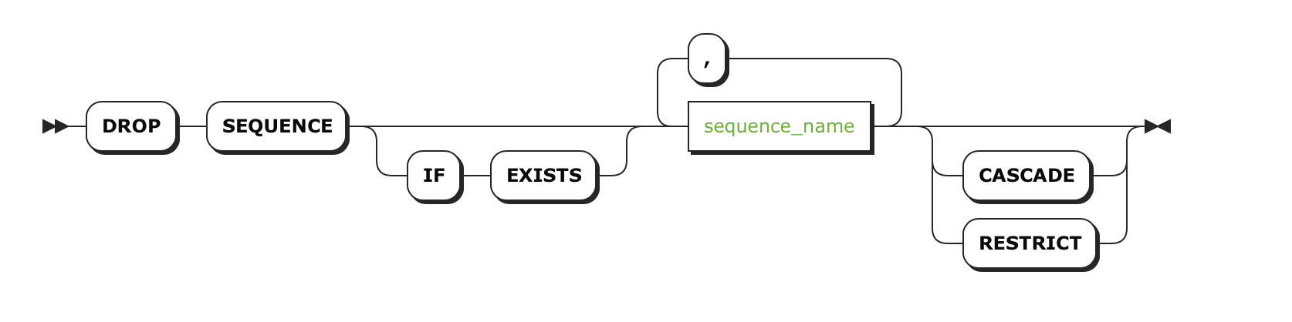

参数

| **Parameter** | **Description** |
| --- | --- |
| IF EXISTS | 如果要删除的序列存在，就删除该序列；如果不存在，不用返回错误。 |
| sequence_name | 要删除的序列的名字。 通过 SHOW CREATE TABLE 可以查看表使用的序列。 |
| RESTRICT | *(Default)* 如果有对象依赖要删除的序列 (例如 [constraints](http://doc.cockroachchina.baidu.com/#develop/constraints/overview/) and tables) ，该序列不能删除 |
| CASCADE | 尚未实现。当前只能删除没有对象依赖的序列。 |

例子

删除一个序列 (无依赖)

在这个例子中，没有对象依赖于被删除的序列。

> **SELECT** * **FROM** information_schema.sequences;

+------------------+-----------------+--------------------+-----------+-------------------+-------------------------+---------------+-------------+----------------------+---------------------+-----------+--------------+

| sequence_catalog | sequence_schema | sequence_name | data_type | numeric_precision | numeric_precision_radix | numeric_scale | start_value | minimum_value | maximum_value | increment | cycle_option |

+------------------+-----------------+--------------------+-----------+-------------------+-------------------------+---------------+-------------+----------------------+---------------------+-----------+--------------+

| def | db_2 | test_4 | INT | 64 | 2 | 0 | 1 | 1 | 9223372036854775807 | 1 | NO |

| def | test_db | customer_seq | INT | 64 | 2 | 0 | 101 | 1 | 9223372036854775807 | 2 | NO |

| def | test_db | desc_customer_list | INT | 64 | 2 | 0 | 1000 | -9223372036854775808 | -1 | -2 | NO |

| def | test_db | test_sequence3 | INT | 64 | 2 | 0 | 1 | 1 | 9223372036854775807 | 1 | NO |

+------------------+-----------------+--------------------+-----------+-------------------+-------------------------+---------------+-------------+----------------------+---------------------+-----------+--------------+

(4 rows)

> **DROP** SEQUENCE customer_seq;

**DROP** SEQUENCE

> **SELECT** * **FROM** information_schema.sequences

+------------------+-----------------+--------------------+-----------+-------------------+-------------------------+---------------+-------------+----------------------+---------------------+-----------+--------------+

| sequence_catalog | sequence_schema | sequence_name | data_type | numeric_precision | numeric_precision_radix | numeric_scale | start_value | minimum_value | maximum_value | increment | cycle_option |

+------------------+-----------------+--------------------+-----------+-------------------+-------------------------+---------------+-------------+----------------------+---------------------+-----------+--------------+

| def | db_2 | test_4 | INT | 64 | 2 | 0 | 1 | 1 | 9223372036854775807 | 1 | NO |

| def | test_db | desc_customer_list | INT | 64 | 2 | 0 | 1000 | -9223372036854775808 | -1 | -2 | NO |

| def | test_db | test_sequence3 | INT | 64 | 2 | 0 | 1 | 1 | 9223372036854775807 | 1 | NO |

+------------------+-----------------+--------------------+-----------+-------------------+-------------------------+---------------+-------------+----------------------+---------------------+-----------+--------------+

(4 rows)

> **DROP** SEQUENCE customer_seq **CASCADE**;

**DROP** SEQUENCE

See Also

* [CREATE SEQUENCE](http://doc.cockroachchina.baidu.com/#develop/sql-statements/CREATE-SEQUENCE/)
* [ALTER SEQUENCE](http://doc.cockroachchina.baidu.com/#develop/sql-statements/ALTER-SEQUENCE/)
* [RENAME SEQUENCE](http://doc.cockroachchina.baidu.com/#develop/sql-statements/RENAME-SEQUENCE/)
* [Functions and Operators](http://doc.cockroachchina.baidu.com/#develop/functions-and-operators/)
* [Other SQL Statements](http://doc.cockroachchina.baidu.com/#develop/sql-statements/overview/)