RENAME INDEX [语句](http://doc.cockroachchina.baidu.com/#develop/sql-statements/overview/) 用于更改表的索引名。

注意：无法重命名与视图相关联的索引名。 查看 [视图依赖](http://doc.cockroachchina.baidu.com/#develop/sql-statements/RENAME-INDEX/views.html#view-dependencies) 以获取更多细节。

概要

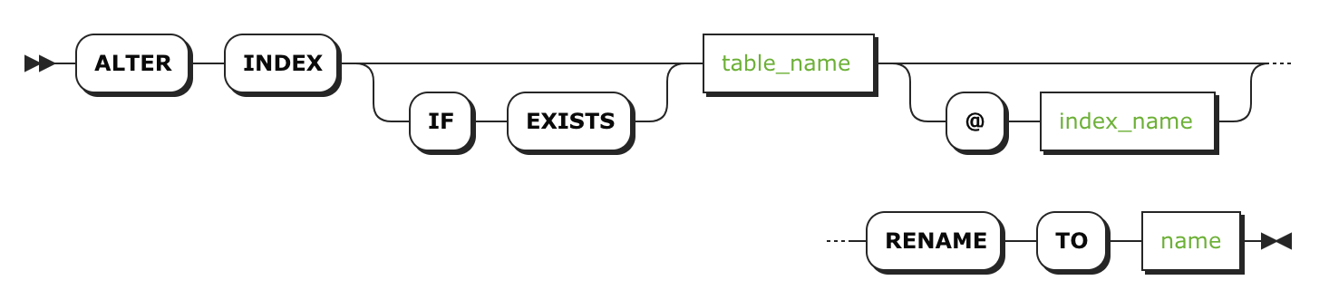

所需权限

用户必需具有该表的 CREATE [权限](http://doc.cockroachchina.baidu.com/#deploy/access-management/privileges/)

参数

| **参数** | **描述** |
| --- | --- |
| IF EXISTS | 仅在需要更改索引名称存在时才会执行操作 |
| table_name | 需要变更的索引所在的表名 |
| index_name | 当前需要变更的索引原名 |
| name | [name](https://www.cockroachlabs.com/docs/stable/sql-grammar.html#name) 索引变更至的新名称，新名称在该数据库中必须具有唯一性且遵循[标识符规则](http://doc.cockroachchina.baidu.com/" \l "develop/sql-syntax/keywords-and-identifiers/#identifiers) |

例子

索引重命名

SHOW INDEXES FROM users;

+-------+----------------+--------+-----+--------+-----------+---------+----------+

| Table | Name | Unique | Seq | Column | Direction | Storing | Implicit |

+-------+----------------+--------+-----+--------+-----------+---------+----------+

| users | primary | true | 1 | id | ASC | false | false |

| users | users_name_idx | false | 1 | name | ASC | false | false |

| users | users_name_idx | false | 2 | id | ASC | false | true |

+-------+----------------+--------+-----+--------+-----------+---------+----------+

(3 rows)

**ALTER** **INDEX** users@users_name_idx **RENAME** **TO** name_idx;

结果

**SHOW** INDEXES **FROM** users;

+-------+----------+--------+-----+--------+-----------+---------+----------+

| Table | Name | Unique | Seq | Column | Direction | Storing | Implicit |

+-------+----------+--------+-----+--------+-----------+---------+----------+

| users | primary | true | 1 | id | ASC | false | false |

| users | name_idx | false | 1 | name | ASC | false | false |

| users | name_idx | false | 2 | id | ASC | false | true |

+-------+----------+--------+-----+--------+-----------+---------+----------+

(3 rows)

其他

* [索引](http://doc.cockroachchina.baidu.com/#develop/performance-optimization/indexes/)
* [CREATE INDEX](http://doc.cockroachchina.baidu.com/#develop/sql-statements/CREATE-INDEX/)
* [RENAME COLUMN](http://doc.cockroachchina.baidu.com/#develop/sql-statements/RENAME-COLUMN/)
* [RENAME DATABASE](http://doc.cockroachchina.baidu.com/#develop/sql-statements/RENAME-DATABASE/)
* [RENAME TABLE](http://doc.cockroachchina.baidu.com/#develop/sql-statements/RENAME-TABLE/)