RESET [语句](http://doc.cockroachchina.baidu.com/#develop/sql-statements/overview/) 重置当前会话[变量](http://doc.cockroachchina.baidu.com/" \l "develop/sql-statements/SET(session-variable)/) 为默认值.

所需权限

重置会话设定不需要任何[权限](http://doc.cockroachchina.baidu.com/" \l "deploy/access-management/privileges/)

概要

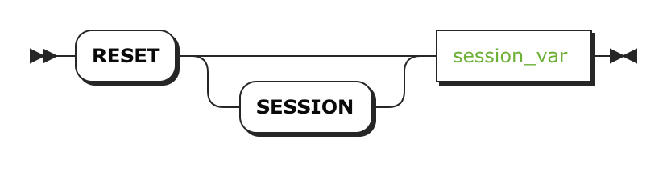

参数

| **参数** | **描述** |
| --- | --- |
| session_var | 当前会话[变量](http://doc.cockroachchina.baidu.com/" \l "develop/sql-statements/SET(session-variable)/#supported-variables)的名字 |

示例

注意：你也可以用 [SET .. TO DEFAULT](http://doc.cockroachchina.baidu.com/#develop/sql-statements/RESET-(session-variable)/set-vars.html#reset-a-variable-to-its-default-value) 去重置会话变量。

**SET** default_transaction_isolation = **SNAPSHOT**;

**SHOW** default_transaction_isolation;

+-------------------------------+

| default_transaction_isolation |

+-------------------------------+

| SNAPSHOT |

+-------------------------------+

(1 row)

RESET default_transaction_isolation;

SHOW default_transaction_isolation;

+-------------------------------+

| default_transaction_isolation |

+-------------------------------+

| SERIALIZABLE |

+-------------------------------+

(1 row)

其他

* [SET (session variable)](http://doc.cockroachchina.baidu.com/#develop/sql-statements/SET(session-variable)/)
* [SHOW (session variables)](http://doc.cockroachchina.baidu.com/#develop/sql-statements/SHOW(session-variables)/)