RESUME JOB [语句](http://doc.cockroachchina.baidu.com/#develop/sql-statements/overview/) 允许您继续已[暂停的](http://doc.cockroachchina.baidu.com/" \l "develop/sql-statements/PAUSE-JOB/) [备份](http://doc.cockroachchina.baidu.com/#develop/sql-statements/BACKUP/)，[回复](http://doc.cockroachchina.baidu.com/#develop/sql-statements/RESTORE/), 和 [导入](http://doc.cockroachchina.baidu.com/#develop/sql-statements/IMPORT/) 作业。

注意：无法暂停表变更作业。

所需权限

默认上只有 root 用户可以控制 job

概要

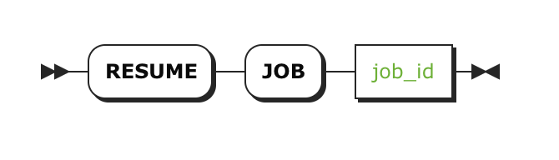

参数

| **参数** | **描述** |
| --- | --- |
| job_id | 想要继续的job ID, 可以通过 [SHOW JOBS](http://doc.cockroachchina.baidu.com/#develop/sql-statements/SHOW-JOBS/)找到 |

示例

暂停 & 继续一个恢复Job

**SHOW** JOBS;

+*----------------+---------+-------------------------------------------+...*

| id | type | description |...

+*----------------+---------+-------------------------------------------+...*

| 27536791415282 | **RESTORE** | **RESTORE** db.* **FROM** 'azure://backup/db/tbl' |...

+*----------------+---------+-------------------------------------------+...*

**PAUSE** JOB 27536791415282;

继续恢复作Job：

**RESUME** JOB 27536791415282;

其他

* [PAUSE JOB](http://doc.cockroachchina.baidu.com/#develop/sql-statements/PAUSE-JOB/)
* [SHOW JOBS](http://doc.cockroachchina.baidu.com/#develop/sql-statements/SHOW-JOBS/)
* [CANCEL JOB](http://doc.cockroachchina.baidu.com/#develop/sql-statements/CANCEL-JOB/)
* [BACKUP](http://doc.cockroachchina.baidu.com/#develop/sql-statements/BACKUP/)
* [RESTORE](http://doc.cockroachchina.baidu.com/#develop/sql-statements/RESTORE/)
* [IMPORT](http://doc.cockroachchina.baidu.com/#develop/sql-statements/IMPORT/)